Supplementary information:

Selected Spectroscopic data and procedures:
Ph₂PCF₂Br (1)
Neat CF₂Br₂ (0.892mL, 2.05g, 9.76 mmols) was added to a cold solution of Ph₂PSiMe₃ (0.5 mL, 0.51g, 1.95 mmols) in diethyl ether. After swirling this reaction flask and leaving for one hour, all volatiles were removed to give the pure product. Selected data:
[ δ_{P} = 28.5, t, ²J_{P-F} = 68 Hz; δ_{F} = -42, d, ²J_{P-F} = 68 Hz].

General procedure for catalytic reactions
To a Schlenk flask containing Ph₂PCF₂Br (0.232g, 0.736 mmols, 1 equiv.) was added [Ni(dippf)Cl₂], (12 mg, 2.209 x 10⁻⁵ mols, 3 %) followed by dry acetonitrile (8 mL). Ph₂PSiMe₃ (0.220g, 0.847 mmols, 1.25 equiv.) was then added via a syringe, the tube was wrapped in tin foil and heated to the desired temperature. The progress of the reaction was monitored by ³¹P NMR. Under optimised conditions (Ph₂P)₂CF₂ of sufficient purity for further reactions could be obtained by filtration through a plug of alumina. Selected data (Ph₂P)₂CF₂ (2) [δ_{P} = 5.5, t, ²J_{P-F} = 73Hz; δ_{F} = -95, t, ²J_{F-P} = 73 Hz].

General procedure for metal complexes:
The solid metal precursors were added to solutions of (Ph₂P)CF₂Br in dry dichloromethane, and monitored by ³¹P NMR. The complexes were isolated and stored in air by removal of solvent and precipitation and/or washing with hexane.
The cis geometry of [cis-Pt(Ph₂PCF₂Br)₂Cl₂], (3) was readily assigned by examination of ¹J_{P-Pt} coupling constants [δ_{P} = 44.7, tt + satellites, ¹J_{P-Pt} = 3850 Hz, ²J_{P-F} = 51 Hz, ⁵J_{P-F} = 7.3 Hz].
The magnitude of ¹J_{P-Rh} in complex (4) is fairly typical of a rhodium (III) phosphine complex of this type [ δ_{P} = 54, dt, ¹J_{P-F} = 154 Hz, ²J_{P-F} = 64 Hz]. Both ¹J_{P-Pt} and ¹J_{P-Rh} are larger than that found in the corresponding Ph₂PCH₃ complexes [¹J_{P-Pt} = 3621Hz; ¹J_{P-Rh} = 146 Hz].

Crystal structure determination of trans-[Pd(Cy₃P)₂Br₂].
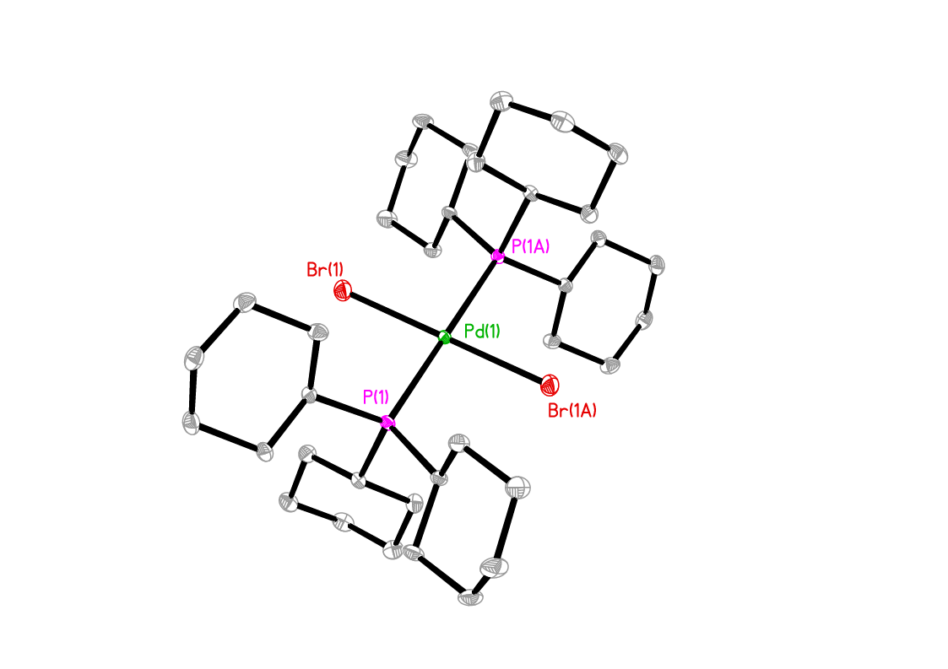

Thermal Ellipsoid (30%) Structure for trans-[Pd(Cy₃P)₂Br₂]
(Hydrogens excluded for clarity).

Table 2. Crystal data and structure refinement for trans-[Pd(Cy₃P)₂Br₂].
Empirical formula C18 H33 Br P Pd 0.50
Formula weight 413.52
Temperature 173(2) K
Wavelength 0.71073 Å
Crystal system Triclinic
Space group P-1
Unit cell dimensions a = 9.9954(15) Å α = 112.589(2)°
b = 10.1866(15) Å β = 109.652(2)°
c = 10.7114(16) Å γ = 92.205(2)°
Volume 930.5(2) Å3
Z 2
Reflections collected 9717
Independent reflections 4201 [Rint = 0.0232]
Completeness to θ = 27.53° 98.3 %
Absorption correction sadabs
Refinement method Full-matrix least-squares on F2
Data / restraints / parameters 4201 / 0 / 187
Goodness-of-fit on F2 S = 1.100
R indices [for 3440 reflections with I>2σ(I)] R1 = 0.0392, wR2 = 0.1172
R indices (for all 4201 data) R1 = 0.0483, wR2 = 0.1211
Weighting scheme w-1 = σ2(Fo2) + (aP)2 + (bP),
where P = [max(Fo2, 0) + 2Fc2]/3
a = 0.5810, b = 2.1044
Largest diff. peak and hole 1.428 and -1.457 eÅ-3

Table 3. Bond lengths [Å] and angles [°] for trans-[Pd(Cy₃P)₂Br₂].
_____________________________________________________
Pd(1)-P(1)#1 2.3631(10)
Pd(1)-P(1) 2.3631(10)
Pd(1)-Br(1)#1 2.4363(5)
Pd(1)-Br(1) 2.4363(5)
P(1)-C(13) 1.845(4)
P(1)-C(7) 1.852(4)
P(1)-C(1) 1.854(4)

P(1)#1-Pd(1)-P(1) 180.00(5)
P(1)#1-Pd(1)-Br(1)#1 89.15(3)
P(1)-Pd(1)-Br(1)#1 90.85(3)
P(1)#1-Pd(1)-Br(1) 90.85(3)
P(1)-Pd(1)-Br(1) 89.15(3)
Br(1)#1-Pd(1)-Br(1) 180.0
C(13)-P(1)-C(7) 104.22(18)
C(13)-P(1)-C(1) 109.53(19)
C(7)-P(1)-C(1) 102.91(18)
C(13)-P(1)-Pd(1) 113.10(13)
C(7)-P(1)-Pd(1) 110.69(13)
C(1)-P(1)-Pd(1) 115.34(13)
_____________________________________________________________
Symmetry transformations used to generate equivalent atoms: #1 -x+1,-y+1,-z

