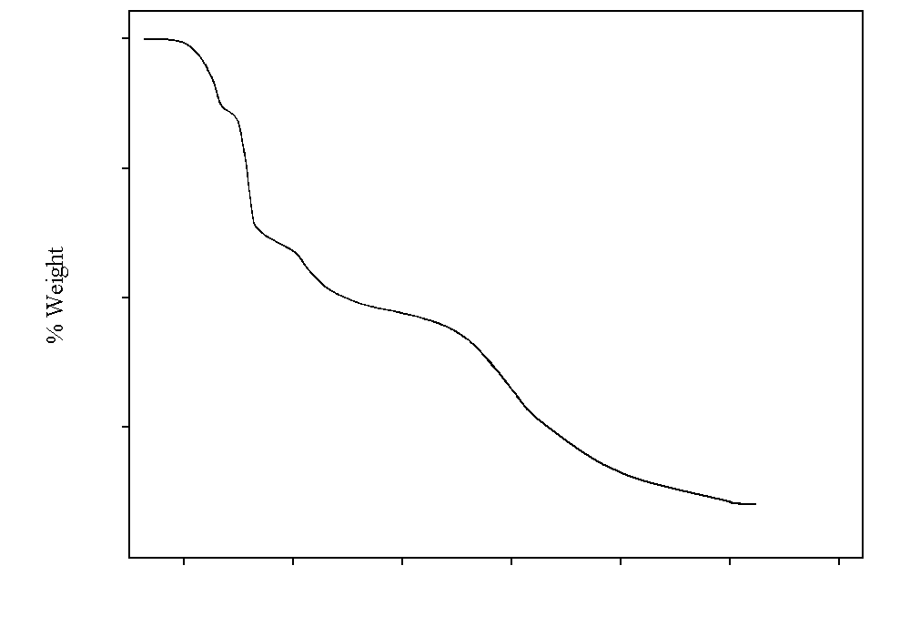
100 300 500 700 900 1100 1300 ºC
100
75
50
25
S1.- TGA for compound 4
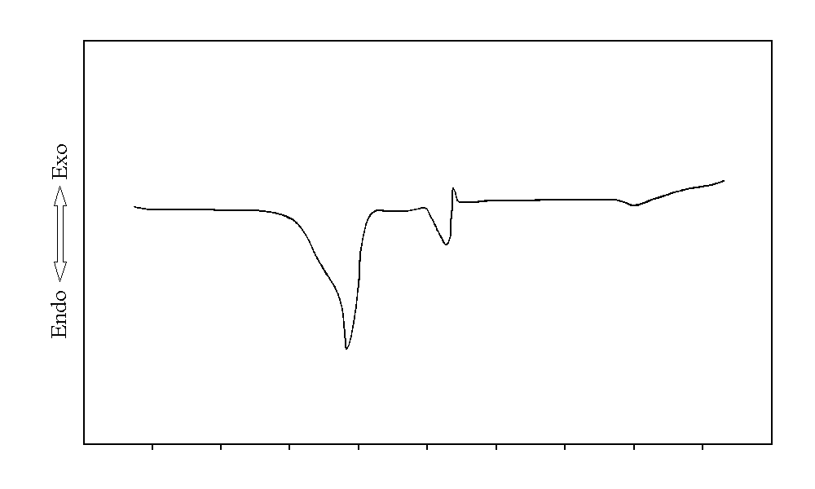
40 120 200 280 360 ºC

S2.- DSC for compound 4
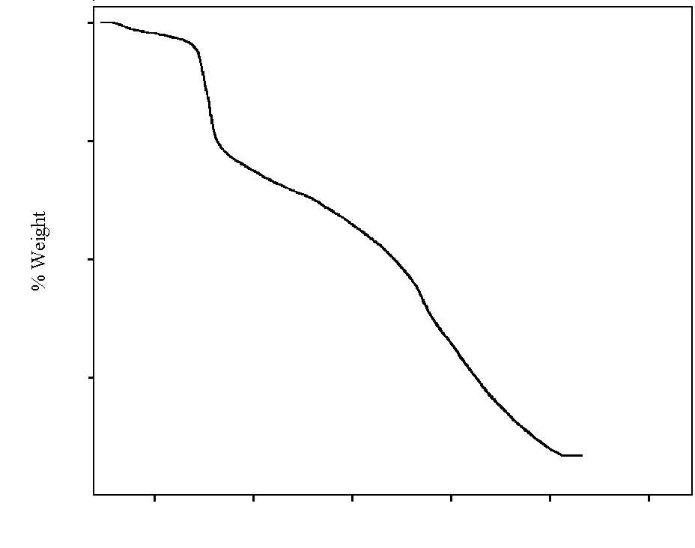
100 300 500 700 900 1100 ºC
100
75
50
25

