Electronic Supplementary Information

Novel one-dimensional structures and solution behaviour of copper(II) bromide and chloride complexes of a new pentapyridyldiamine ligand

David G. Lonnon‡, Donald C. Craig‡, Stephen B. Colbran‡*
and Paul V. Bernhardt§

‡School of Chemical Sciences, University of New South Wales, Sydney, NSW 2052, Australia and the §Department of Chemistry, University of Queensland, St Lucia, Brisbane, Queensland, QLD 4072, Australia

 | ν– / cm^{–1}
 | py | py | py | other
L | 1587s | 1566m | 1469m
[Cu₂(L)Br₂](ClO₄)₂ | 1607s | 1571m | 1480m | 1084s (ClO₄–)
[Cu₂(L)Br₂][BF₄]₂ | 1607s | 1571m | 1478m | 1200-1000s (BF₄–)
[Cu₂(L)Br₃](ClO₄) | 1609s | 1570m | 1477m | 1084s (ClO₄–)
[Cu₂(L)Br₃]₂[Cu₂Br₄] | 1607s | 1571m | 1478m
[Cu₂(L)Br₃]Br | 1607s | 1571m | 1478m
[Cu₂(L)Cl₃]Cl | 1607s | 1571m | 1478m
[Cu₂(L)Cl₃][PF₆] | 1607s | 1571m | 1478m | 837s (PF₆–)

ESI Table 1: Selected bands from FTIR infrared spectra of solid-state species in KBr disks.
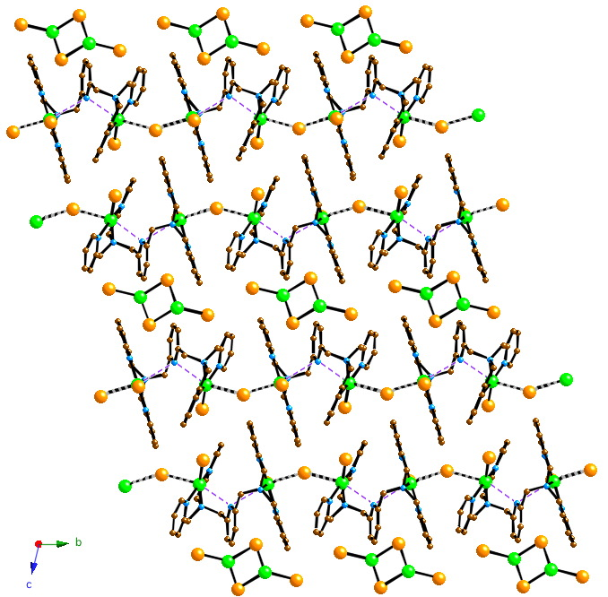
(a)

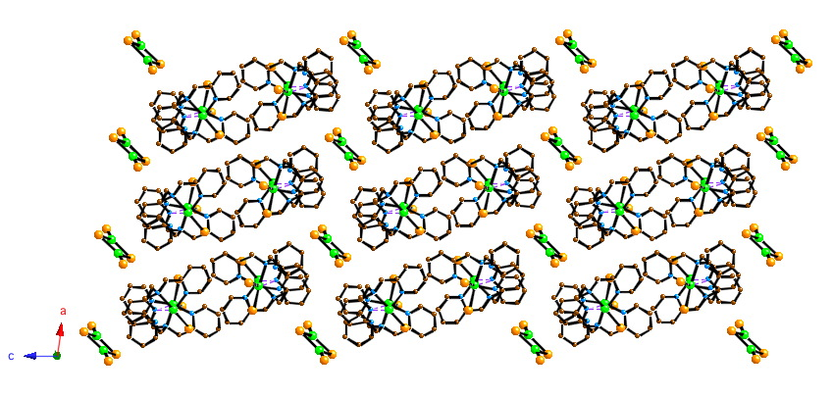
(b)

ESI Fig. 1. Views of the crystal structure of [Cu₂(L)Br₃]₂[Cu₂Br₄], illustrating: (a) the chains of bromide-bridged [Cu₂(L)Br₂]²⁺ tectons and interspersed [Cu₂Br₄]^{2–} counter ions; (b) the packing of the chains and [Cu₂Br₄]^{2–} counter ions. H-atoms are omitted for clarity.

Complex | λ_{max} / nm (ε / dm³ mol⁻¹ cm⁻¹)
 | CH₃CN | DMF | MeNO₂ | KBr Disc
[Cu₂(L)Br₂](ClO₄)₂ | 290 (3700)  320 (3800)  672 (230) | 290 (3800)  320 (3800)  691 (220) |  | 658
[Cu₂(L)Br₂][BF₄]₂ | 290 (3900)  320 (3900)  666 (245) | 290 (3900)  320 (3900)  685 (230) |  | 691
[Cu₂(L)Br₃](ClO₄) | 290 (3700)  320 (3700)  741 (340)  934 sh (205) | 290 (3700)  320 (3700)  716 (160)  975 sh (60) | 707 (160)  960 sh (70) | 678
[Cu₂(L)Br₃]₂[Cu₂Br₄] | 290 (4000)  320 (3900)  751 (775)  942 sh (495) | 290 (4000)  320 (4000)  729 (510)  948 sh (225) | 746 (615)  915 sh (310) | 653
[Cu₂(L)Br₃]Br | 290 (3900)  320 (3900)  758 (365)  932 sh (250) | 290 (3900)  320 (3800)  733 (180)  954 sh (100) |  | 652
[Cu₂(L)Cl₃]Cl | 294 1350  452 (260)  691 (185) | 294 (1340)  451 (230)  719 (170)  920 sh (115) | 450 (310)  719 (165)  900 sh (105) | 614
[Cu₂(L)Cl₃][PF₆] | 294 (1357)  740 (285)  932 sh (170) | 295 (1355)  733 (235)  952 sh (115) | 702 (255)  915 sh (130) | 593

ESI Table 2: UV-Vis-NIR spectroscopic data.

