SUPPORTING INFORMATION

Fused pyridazines: rigid multidentates for design and fine-tuning the structure of hybrid organic/inorganic frameworks†
Pavlo V. Solntsev,ª Joachim Sieler^{c}, Harald Krautscheid^{c} and Konstantin V. Domasevitch*ª
ª Inorganic Chemistry Department, Kiev University, Volodimirska Street 64, Kiev 01033, Ukraine.
E-mail: dk@anorgchemie.univ.kiev.ua
^{b} Institut für Anorganische Chemie, Universität Leipzig, Linnéstraße 3, D-04103 Leipzig, Deutschland

1. Synthesis
1,2,3,6,7,8-Hexahydro-cinnolino[5,4,3-cde]cinnoline (L)
and its 2,2,7,7-tetramethyl derivative (Me₄L)
were prepared in one stage reacting 1,3-cyclohexanedione (5,5-dimethyl-1,3-cyclohexanedione) and hydrazine.

J.K. Stille and R. Ertz, J. Am. Chem. Soc., 1964, 86, 661.

2. Crystallography

The intensity data for 3, 4 were collected at room temperature on a Stoe Image Plate Diffraction System [1] using MoKα graphite monochromated radiation (λ = 0.71073 Å): φ oscillation scans 0 – 150°, step Δφ = 0.9°. Crystallographic measurements for 1, 2, 5-8 were made at 223 K using a Siemens SMART CCD area-detector diffractometer (graphite monochromated Mo-Kα radiation, λ = 0.71073 Å, omega scans, Δω 0.2º, exposition time 30 sec per frame, empirical absorption corrections using SADABS). The data frames were integrated using SAINT. The structures were solved by direct methods and refined in the anisotropic approximation using SHELXS-86 [2] and SHELXL-97 [3]. Details are given below.
Graphical representation of the crystal structures was made using program Diamond [4].

1. Stoe & Cie (2000). IPDS Software. Stoe & Cie GmbH, Darmstadt, Germany.
2. G.M. Sheldrick, Acta Crystallogr., 1990, A46, 467.
3. G.M. Sheldrick, SHELXL97, A system of computer programs for X-ray structure determination, University of Göttingen, Göttingen, Germany, 1997.
4. K. Brandenburg, Diamond 2.1c, Crystal Impact GbR, Bonn, 1999.

Table 1.
Selected bond lengths (Å) and angles (º) for 5 (For atom numbering scheme see Figs. 9-11).
Cu(1)-N(1) | 2.056(4) | Cu(2)-I(3) | 2.5130(12)
Cu(1)-N(2) | 2.066(4) | Cu(3)-N(3) | 2.04(2)
Cu(1)-I(1) | 2.6232(8) | Cu(3)-I(2)#3 | 2.549(3)
Cu(1)-I(2) | 2.6521(8) | Cu(3)-I(1) | 2.5893(16)
Cu(2)-I(4) | 2.512(3) | Cu(3)-I(1)#3 | 2.5893(16)
Cu(2)-I(3)#2 | 2.5130(12)
N(1)-Cu(1)-N(2) | 113.86(16) | N(3)-Cu(3)-I(1) | 108.3(4)
N(1)-Cu(1)-I(1) | 99.04(12) | I(2)#3-Cu(3)-I(1) | 114.54(6)
N(2)-Cu(1)-I(1) | 112.90(12) | N(3)-Cu(3)-I(1)#3 | 108.3(4)
N(1)-Cu(1)-I(2) | 113.23(12) | I(2)#3-Cu(3)-I(1)#3 | 114.54(6)
N(2)-Cu(1)-I(2) | 107.67(12) | I(1)-Cu(3)-I(1)#3 | 100.48(8)
I(1)-Cu(1)-I(2) | 110.04(3) | Cu(3)#1-I(1)-Cu(1) | 65.55(6)
I(4)-Cu(2)-I(3)#2 | 119.99(5) | Cu(3)-I(1)-Cu(1)#4 | 65.55(6)
I(4)-Cu(2)-I(3) | 119.99(5) | Cu(1)-I(1)-Cu(1)#4 | 78.32(3)
I(3)#2-Cu(2)-I(3) | 120.02(9) | Cu(1)#5-I(2)-Cu(1) | 73.79(3)
N(3)-Cu(3)-I(2)#3 | 110.1(7) | Cu(2)#6-I(3)-Cu(2) | 119.98(9)

Symmetry transformations used to generate equivalent atoms: #1 y,-x+y,-z+1 #2 -y+1,x-y,z #3 x-y,x,-z+1 #4 -x,-x+y,-z+1 #5 -x+y,y,z #6 -x+y+1,-x+1,z

Table 2.
Selected bond lengths (Å) and angles (º) for 6 (For atom numbering scheme see Fig. 13).
Cu(1)-N(1) | 2.048(6) | Cu(1)-I(1) | 2.6461(9)
Cu(1)-N(1)#1 | 2.048(6) | Cu(1)-I(1)#2 | 2.6462(9)
N(1)-Cu(1)-N(1)#1 | 126.9(3) | N(1)#1-Cu(1)-I(1)#2 | 94.87(16)
N(1)-Cu(1)-I(1) | 94.87(16) | I(1)-Cu(1)-I(1)#2 | 118.39(5)
N(1)#1-Cu(1)-I(1) | 111.91(14) | Cu(1)#3-I(1)-Cu(1) | 76.78(2)
N(1)-Cu(1)-I(1)#2 | 111.91(14) | C(1)-N(1)-Cu(1) | 123.2(4)

Symmetry transformations used to generate equivalent atoms: #1 y-1/3,x+1/3,-z+4/3
#2 -x+y-1/3,-x+1/3,z+1/3 #3 -y+1/3,x-y+2/3,z-1/3

Refinement of structures

Structures Cu₂I₂(Me₄L)(CH₃CN) 7 and Cu₄I₄(L)(CH₃CN)₂ 8

The refinements were standard. All non-hydrogen atoms were refined anisotropically, all CH₂ and CH₃ hydrogens were placed in calculated positions with isotropic U values set invariant at 0.08 Å².
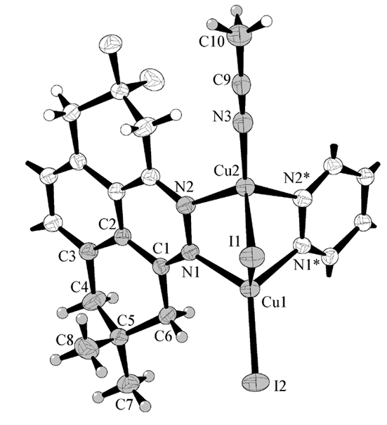
Fig. 1. Atom labelling scheme for structure Cu₂I₂(Me₄L)(CH₃CN) 6 :
50% thermal ellipsoids. Unique part of the structure is marked in grey. Atoms I2-Cu1-Cu2-N3-C9-C10 are situated on a mirror plane (site letter 4c) and centroid of the ligand is in the center of inversion.
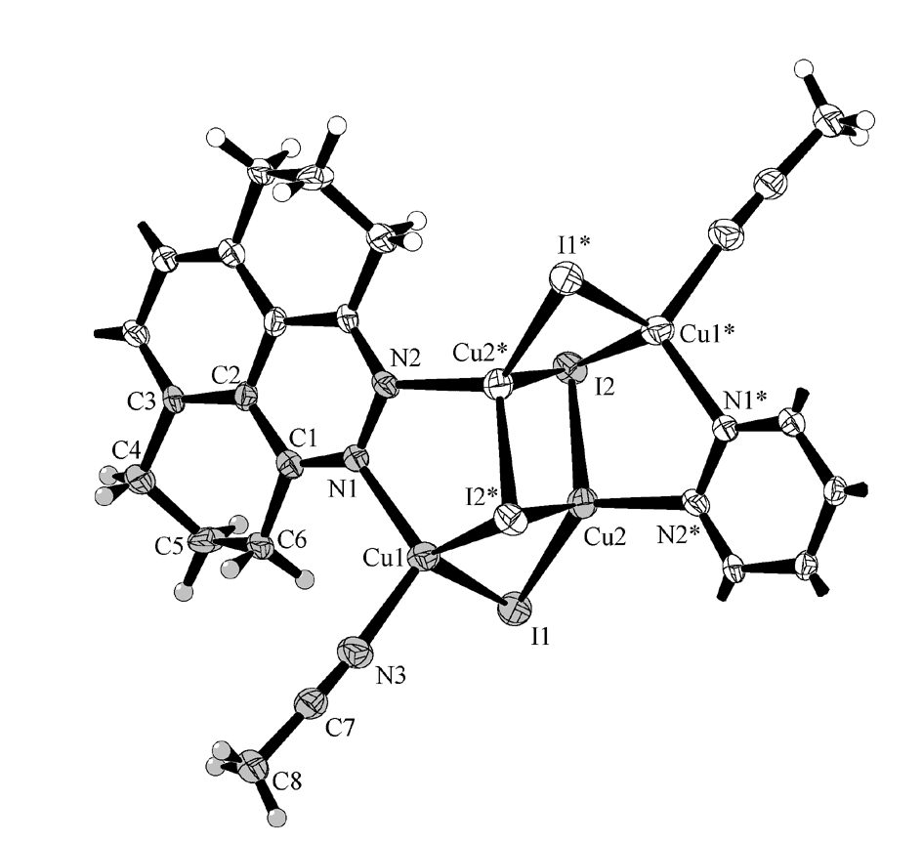
Fig. 2. Atom labelling scheme for structure Cu₄I₄(L)(CH₃CN)₂ 7 :
50% thermal ellipsoids. Unique part of the structure is marked in grey. Both the organic ligand and Cu₄I₄ cluster possess inversion symmetry.
Structures Cu₂Br₂(L)⋅CH₂Cl₂ 1 and Cu₂I₂(L)⋅CHCl₃ 4

For structure Cu₂I₂(L)⋅CHCl₃ 4 all non-hydrogen atoms of the framework were refined anisotropically, hydrogens were placed in calculated positions with isotropic U values set invariant at 0.08 Å². Solvate chloroform molecule is equally disordered over two closely situated and overlapping positions those are related by mirror plane. Atoms of chlorofom molecule were left isotropic and the hydrogen atoms were not included. C-Cl separations were fixed at 1.73(1) Å, typical for chloroform molecule. This model gave reasonable Cl-C-Cl angles at 99-110º and istropic U values were 0.29-0.35 Å², that is characteristic for guest molecules situated in large framework cavities.
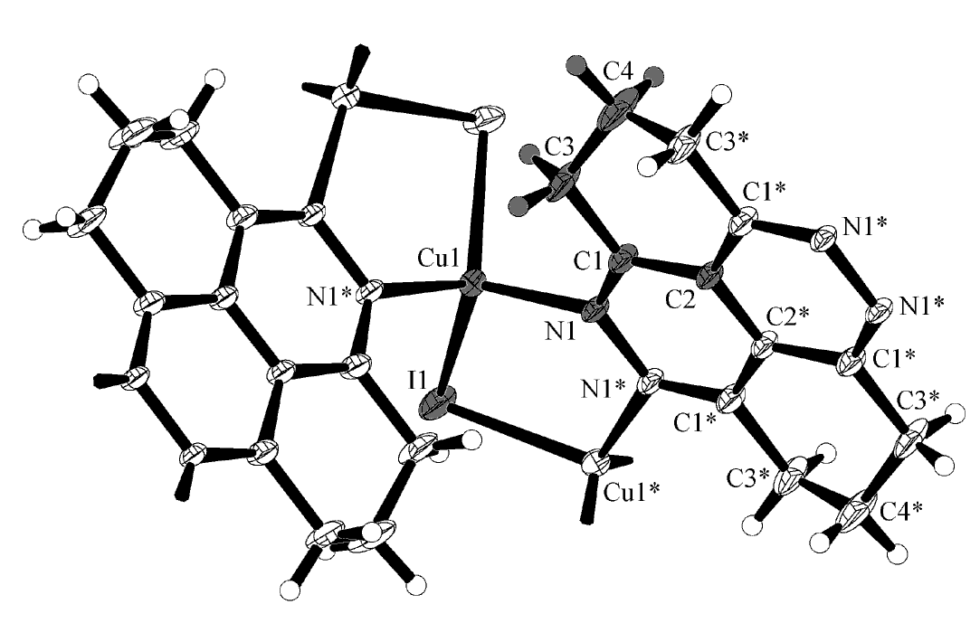
Fig. 3. Atom labelling scheme for structure Cu₂I₂(L)⋅CHCl₃ 4: 50% thermal ellipsoids. Unique part of the structure is marked in grey. Solvate chloroform molecule is not shown.
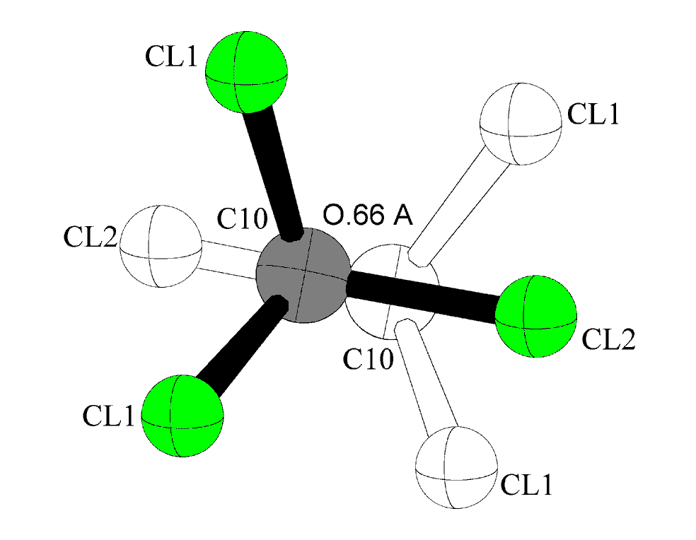
Fig. 4. Refined disordering model for solvate chloroform molecule in Cu₂I₂(L)⋅CHCl₃ 4.

For Cu₂Br₂(L)⋅CH₂Cl₂ 1 non-hydrogen atoms of framework were anisotropic, and hydrogens were idealized with U values set invariant at 0.08 Å². Solvate dichloromethane is disordered over two overlapping positions. Due to a very close situation of chlorine and carbon atoms (0.7 Å) from two disordering components it was not possible to resolve this disorder. It was resolved in part, and all atoms were refined isotropically as carbons. No constraints in geometry were applied. The resulting geometry is reasonable, with angle at the carbon atom at 112º, and C-Cl separations at 1.59 and 1.82 Å.
Important moment for refinement of this structure is a choice of a correct space group symmetry. In general, like isomorphous centrosymmetric structure Cu₂I₂(L)⋅CHCl₃ 4, this structure is sustained with copper-halogenide helices of opposite chirality and is achiral. However, unlike Cu₂I₂(L)⋅CHCl₃ 4, it was possible to refine structure in centrosymmetric group I4₁/amd only to poor visibility of the network (best R1 value was 0.13) and with very high anisotropy for thermal motion of bromine atoms. Here is clear reason for acentric structure of the compound - Cu₄Br₂(L) fragment in structure Cu₂Br₂(L)⋅CH₂Cl₂ 1 could not be centrosymmetric (like in Cu₂I₂(L)⋅CHCl₃ 4) due to a little distortion of N-Cu-Br coordination that led to situation of bromine atoms slightly above the ligand plane (See Fig. 7). Thus the compound completely retains connectivity of the iodide analog and actually retains symmetry of the pattern, but
center of inversion is eliminated and unique part of the structure is doubled. Refinement in acentric space group I4₁md was successful and led to satisfactory convergence. Absolute structure was not determined and refinement of Flack x parameter gave value 0.38(4).
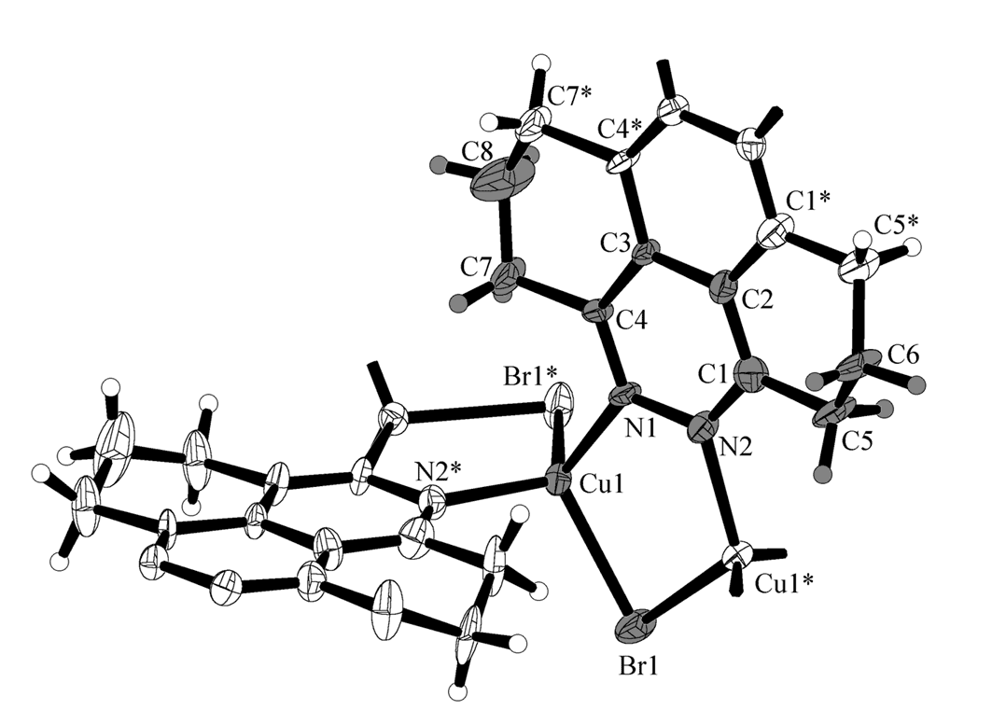
Fig. 5. Atom labelling scheme for structure Cu₂Br₂(L)⋅CH₂Cl₂ 1: 50% thermal ellipsoids. Unique part of the structure is marked in grey. Note anisotropy of thermal motion for C6, C8.
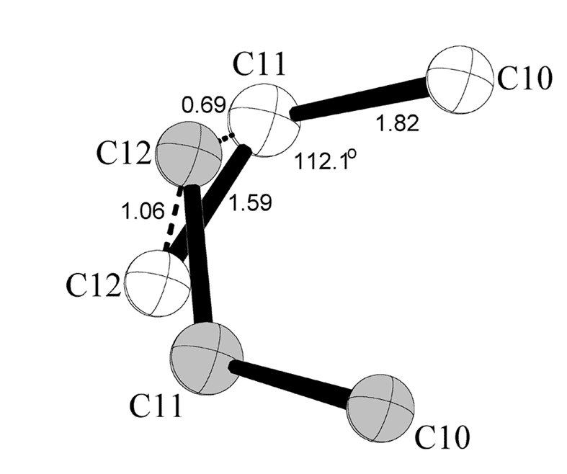
Fig. 6. Refined disordering model for solvate dichloromethane molecule in Cu₂Br₂(L)⋅CH₂Cl₂ 1.
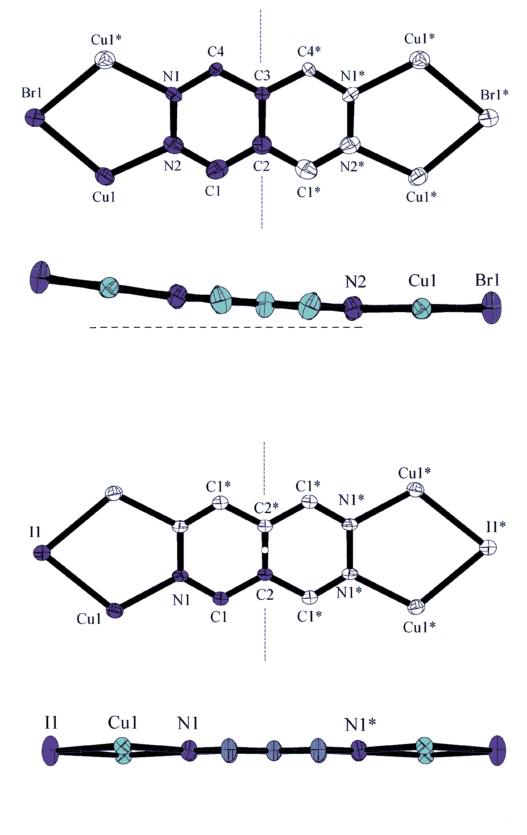 | Mirror plane symmetry of the Cu₄Br₂(L) fragment in structure Cu₂Br₂(L)⋅CH₂Cl₂ 1 (unique part is in dark): Distortion of the pattern effects non-coplanar situation of the bromine atoms with respect to the ligand frame and precludes appearance of center of inversion. This lowers space group symmetry from I4₁/amd (centric) to I4₁md (acentric).  Mirror plane and inversion symmetry of the Cu₄I₂(L) fragment in structure Cu₂I₂(L)⋅CHCl₃ 4 (unique part is in dark):  Centrosymmetric group  I4₁/amd
Fig. 7. The reason for space group difference between isomorphous compounds Cu₂Br₂(L)⋅CH₂Cl₂ 1 and Cu₂I₂(L)⋅CHCl₃ 4.

Structures Cu₂Br₂(L) 2 and Cu₂I₂(L) 3.

In these structures the fragments Cu₄I₂(L) (or Cu₄Br₂(L)) are planar and are situated on a mirror plane. Considering non-planar structure of cyclohexane part of the ligand, this becames possible with equal disordering of two -CH₂- groups above and below plane of the ligand frame. Refined disordering scheme is shown in Fig. 8. Due to a nature of disorder, the hydrogen atoms were not added. All non-hydrogen atoms were refined anisotropically.
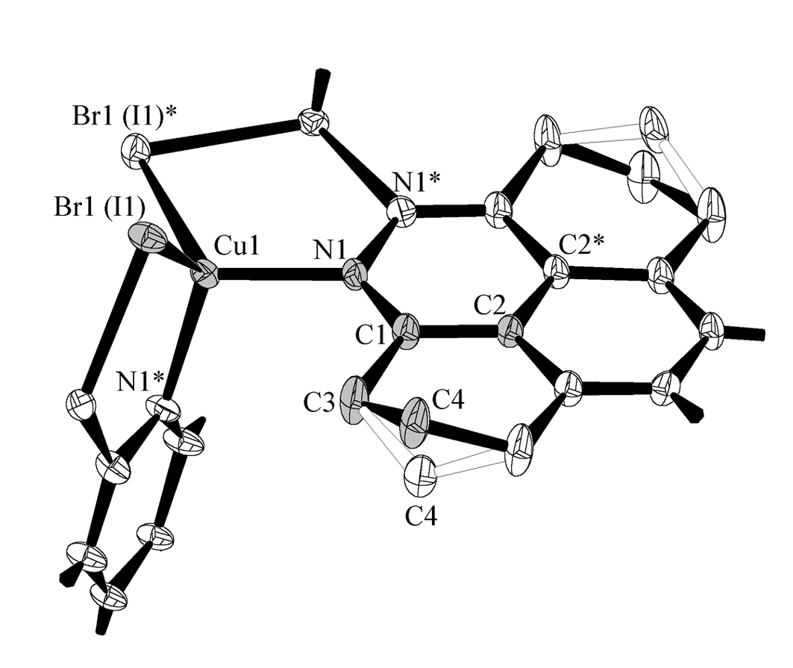
Fig. 8. Atom labelling scheme for structures Cu₂Br₂(L) 2 and Cu₂I₂(L) 3.
40% thermal ellipsoids. Unique part of the structure is marked in grey. Atoms N1, C1, C3, C4 are in general positions. Atom C4 is disordered over two symmetry related sites.

Structure Cu₁₂I₁₂{Cu(CH₃CN)}₃(L)₆Cu₃I₆⋅CH₃CN 5 :

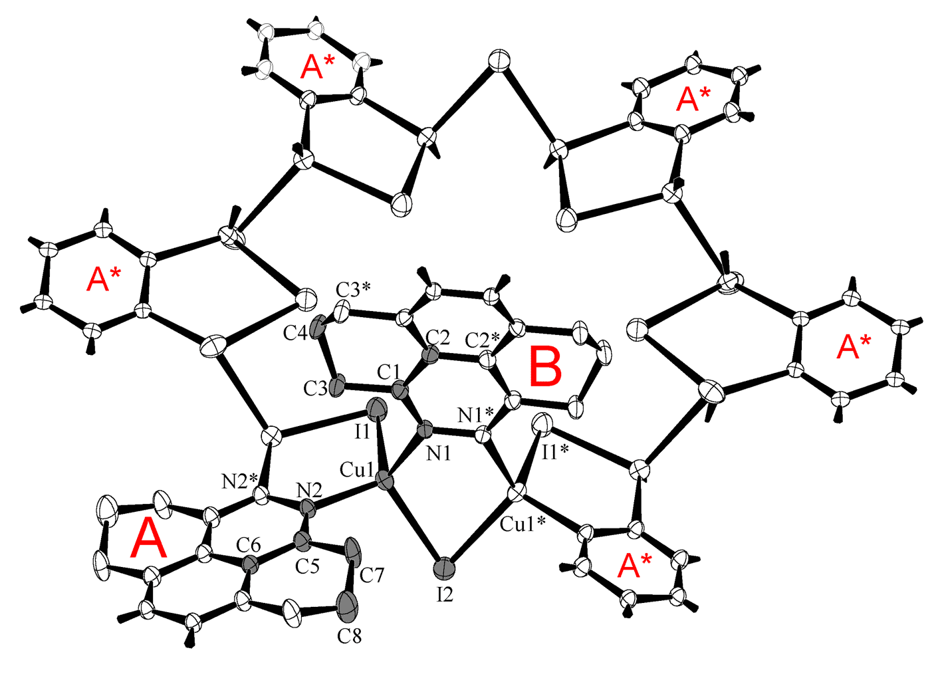
Fig. 9. Atom labelling scheme for structure Cu₁₂I₁₂{Cu(CH₃CN)}₃(L)₆Cu₃I₆⋅CH₃CN 4.
50% thermal ellipsoids. Unique part of the structure is marked in grey. Set of ligands “A” connects Cu₁₂I₁₂ fragments in the plane (See Fig. 3B of mns), while set of ligands “B” (only one unique “B” is shown) connects Cu₁₂I₁₂ into the tubes (See Fig. 3 of mns). Not shown here: Cu₃I₆³⁻ anion, disordered Cu⁺ cations and disordered CH₃CN molecules.

The structure includes tubular hexagonal framework (See Fig. 3 of mns) and a set of guest components – 1) copper atoms disordered within Cu₁₂I₁₂ macrocycle, 2) CH₃CN molecules those are coordinated by above copper atoms, 3) finite Cu₃I₆³⁻ anions those compensate positive charge and are situated in the holes of structure, 4) guest CH₃CN molecules situated within “tubes”. Fig. 11 shows refined disordering model for Cu(CH₃CN) fragment. Three copper atoms are disordered by symmetry over six equivalent positions within Cu₁₂I₁₂ macrocycle, above and below its plane. This model is very reasonable, with typical tetrahedral four-coordination of copper atom [CuI₃N] and typical bond lengths and angles. Cu(CH₃CN) fragments corresponding to adjacent Cu₁₂I₁₂ macrocycles within “tube” are related by symmetry and overlap in such a manner that CH₃ acenonitrile group of one fragment and acetonitrile nitrogen atom of
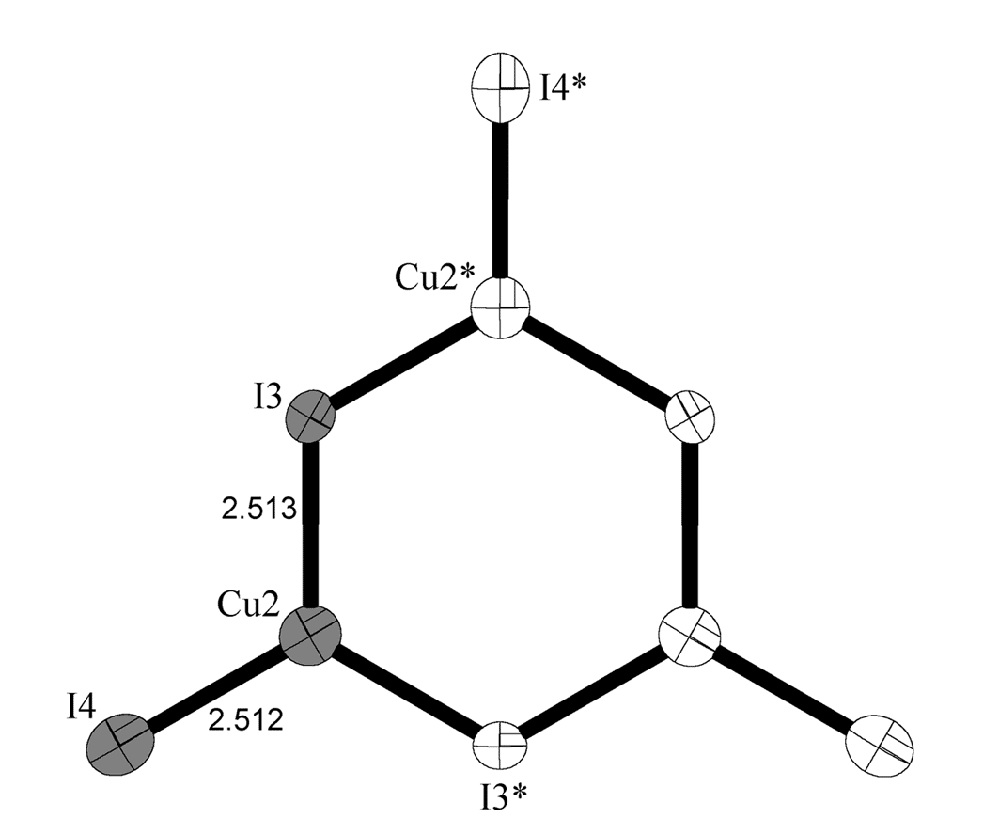
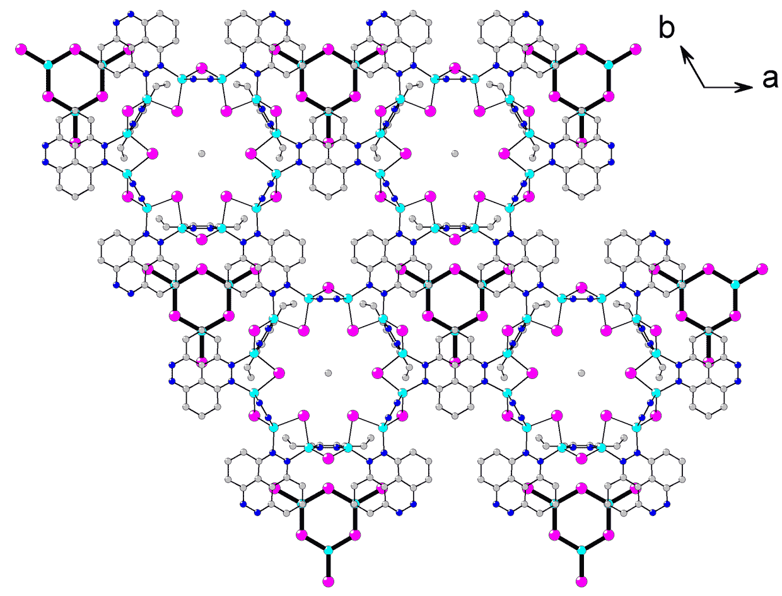
Fig. 10. Structure Cu₁₂I₁₂{Cu(CH₃CN)}₃(L)₆Cu₃I₆⋅CH₃CN 4 :
Cu₃I₆³⁻ anion with atom labelling scheme and 50% thermal ellipsoids (unique part is in grey).
Second part of the figure shows where the Cu₃I₆³⁻ anions are situated in the crystal – this is exactly the same projection like in Fig.3B of the mns, and the anion populate holes between the tubes. Guest CH₃CN molecules are located inside the tubes, orthogonal to the figure plane and here they look like single atoms.

another component are not separable. Thus the side carbon atom of these acenonitrile molecules was not located and it was refined as plane symmetry N-C-N group. Real distribution of disoredered copper atoms corresponds to three-fold axis symmetry and thus two possible orientations of Cu₃ triangles within central I₆ hexagon (See Fig. 11) contribute to the observed pattern. Thus occupation factors for these Cu(CH₃CN) fragments were 0.5 of expected site multiplicities.
All non-nydrogen atoms of the structure were refined anisotropically, hydrogen atoms were added only to the ligand CH₂ groups, with invariant U values at 0.08 Å². No hydrogen atoms were added to disordered acetonitrile moieties.
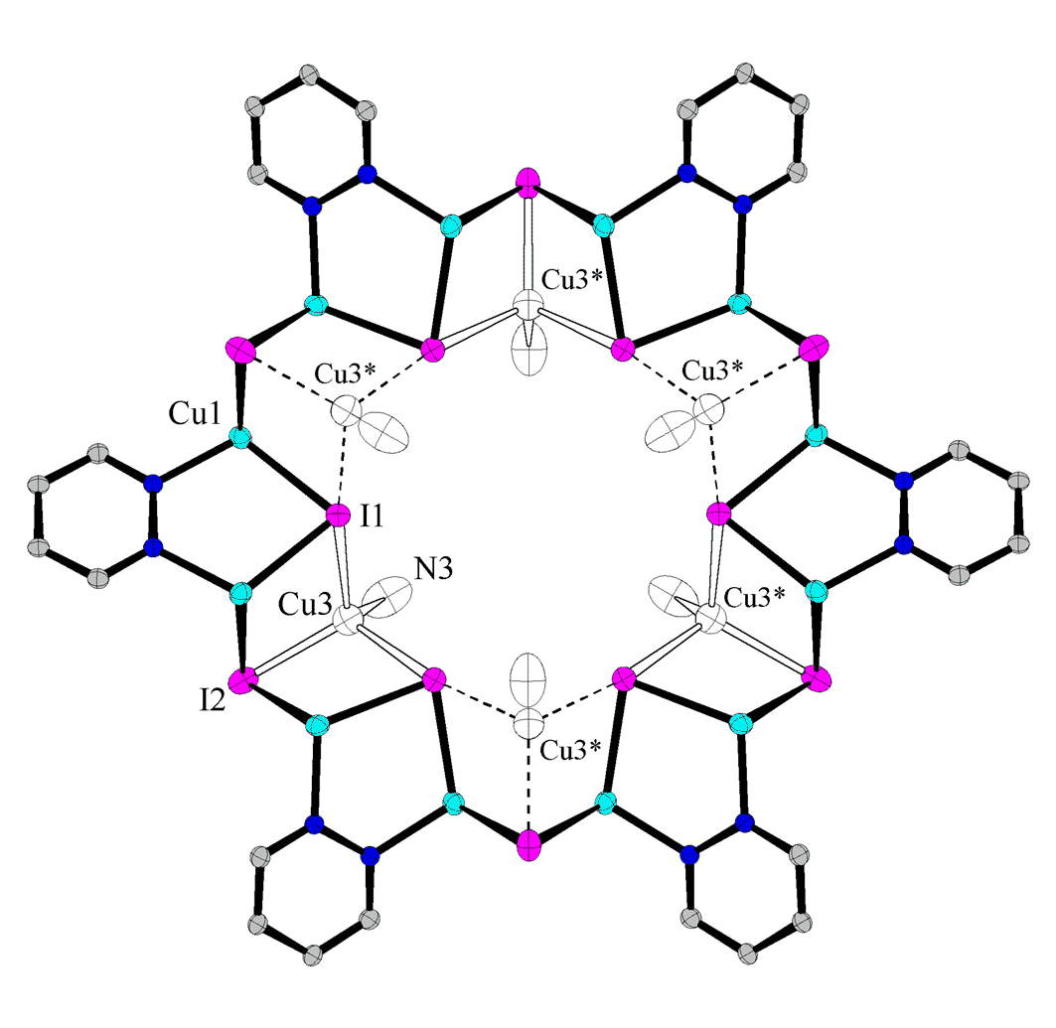
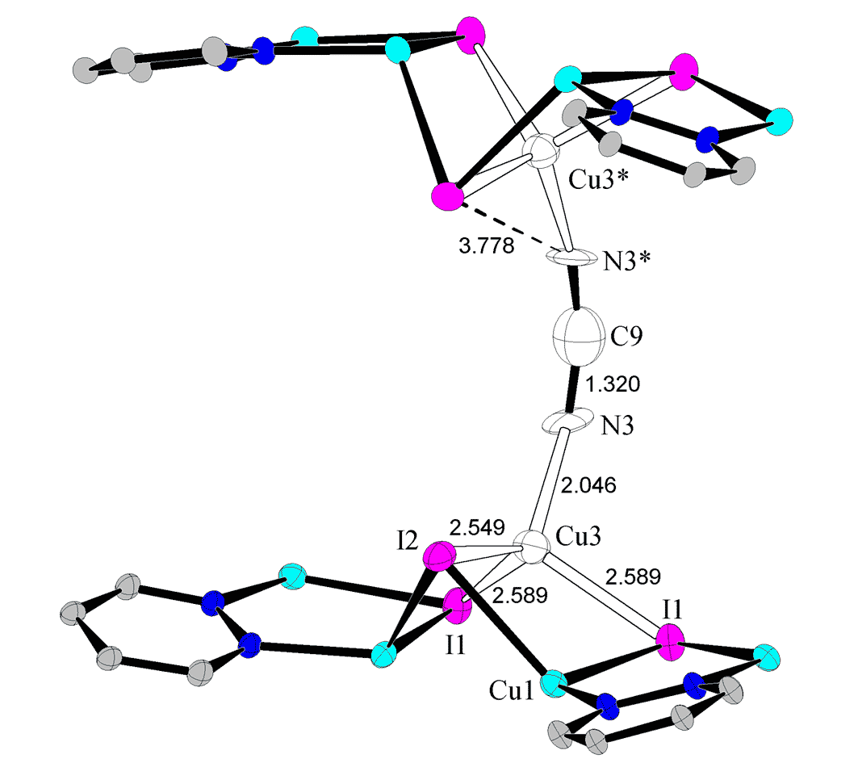

Fig. 11. Structure Cu₁₂I₁₂{Cu(CH₃CN)}₃(L)₆Cu₃I₆⋅CH₃CN 4 :
Disordering scheme for copper atom inside Cu₁₂I₁₂ cycle. 50% thermal ellipsoids.

Solvate acetonitrile molecules (one per Cu₁₂I₁₂ unit) are situated inside large tubes and are disordered (See Fig. 12) over two closely situated position related by symmetry. Atoms of these solvate moleculaes were refined with 0.5 occupancies, in accordance with clear model presented below (alterations of two sites those are marked with black and white bonds), and these atoms were left isotropic; U(iso) values were reasonable (0.08 to 0.11 Å²). No restraints of geometry were applied.
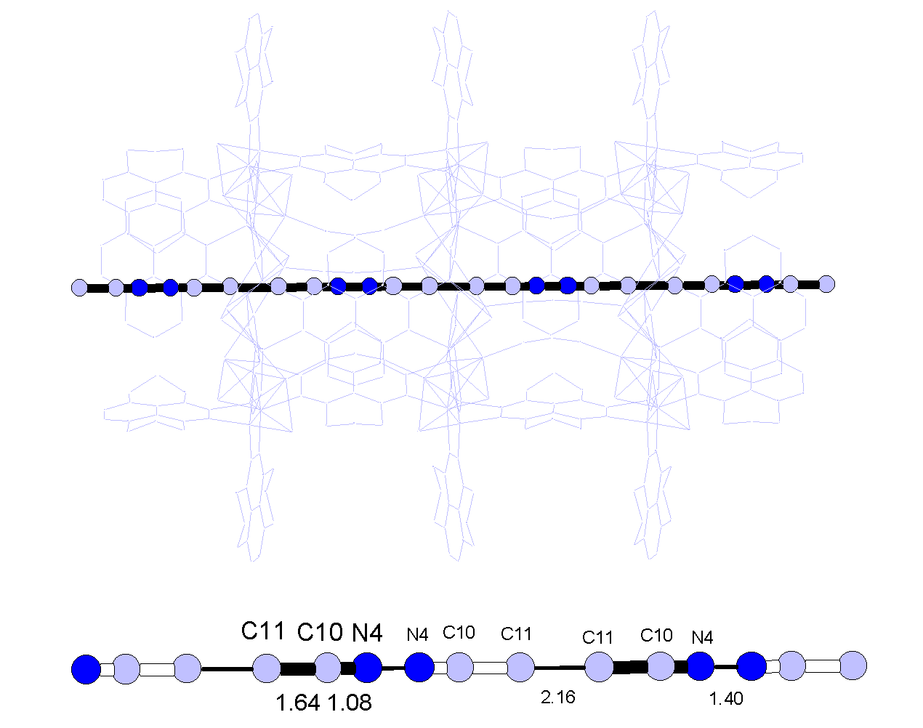

Fig. 12. Disorder of solvate acetonitrile molecules inside large tubes in structure 5 and the refined disordering model.

Structure Cu₂I₂(Me₄L)⋅CH₂Cl₂ 6 :
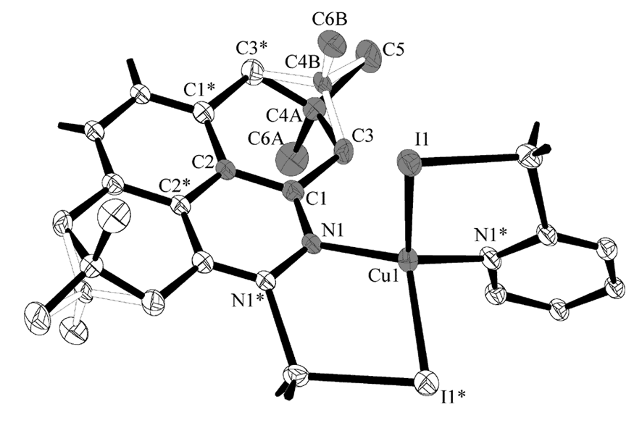
Fig. 13. Atom labelling scheme for structure Cu₂I₂(Me₄L)⋅CH₂Cl₂ 6 and refined disordering model for C(CH₃)₂ linkage of the ligand. 40% thermal ellipsoids. Unique part of the structure is marked in grey.

All non-hydrogen atoms were refined anisotropically. The ligand adopts mirror plane and inversion symmetry and thus C(CH₃)₂ linkage of cyclohexane part is equally disordered in such a manner that position of one methyl carbon atom (C5, see Fig. 12) is the same for both orientations and only two carbon atoms of C-CH₃ are disordered over two symmetry related positions (occupancy factors 0.5). Guest dichloromethane molecules are also disordered from both sides of the ligand, and their position depends on orientation of disordered C-CH₃ linkage. No geometry constraints were applied and refined geometry was reasonable. Due to a nature of the disorder, no hydrogen atoms were added.

