Electronic Supplementary Data File

Semiquinones strengthen antiferromagnetic coupling in 1:1 rare earth-radical complexes†

Andrea Caneschi,ª Andrea Dei,ª Dante Gatteschi,*ª Sandrine Poussereau,ª Lorenzo Soraceª

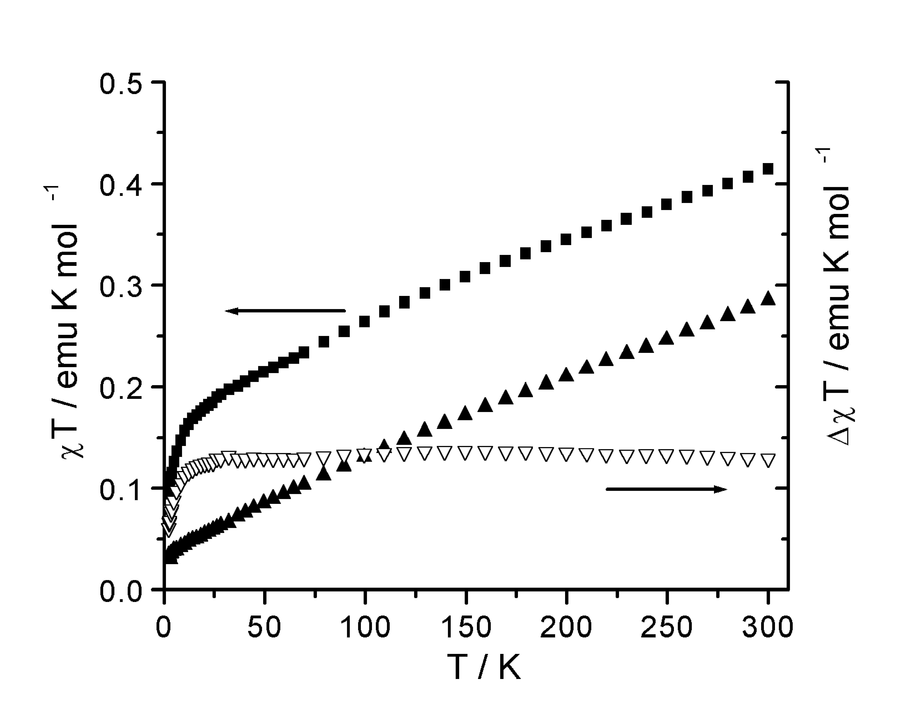

Figure S1 T vs. T curve for Sm(DTBSQ)(HBPz₃)₂ (full squares) and Sm(Trp)(HBPz₃)₂ (full triangles) and corresponding ΔχT= χT_{SmSQ} - χT_{SmTrp} curve (empty triangles). Right and left ordinate scales are the same

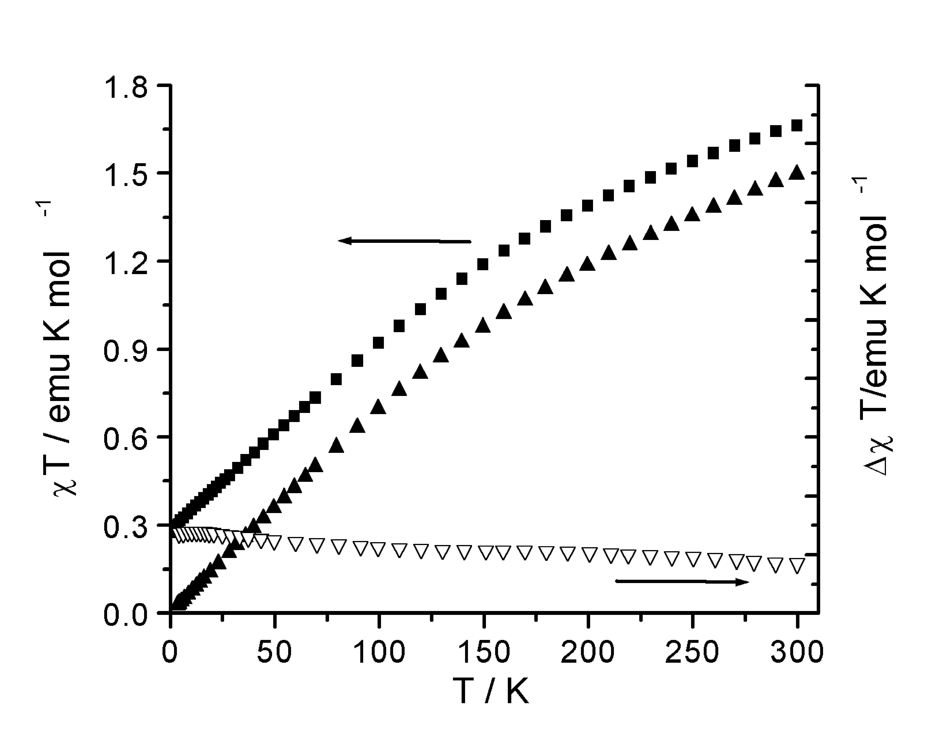

Figure S2 χT vs. T curve for Eu(DTBSQ)(HBPz₃)₂ (full squares) and Eu(Trp)(HBPz₃)₂ (full triangles) and corresponding ΔχT= χT_{EuSQ} - χT_{EuTrp} curve (empty triangles). Right and left ordinate scales are the same

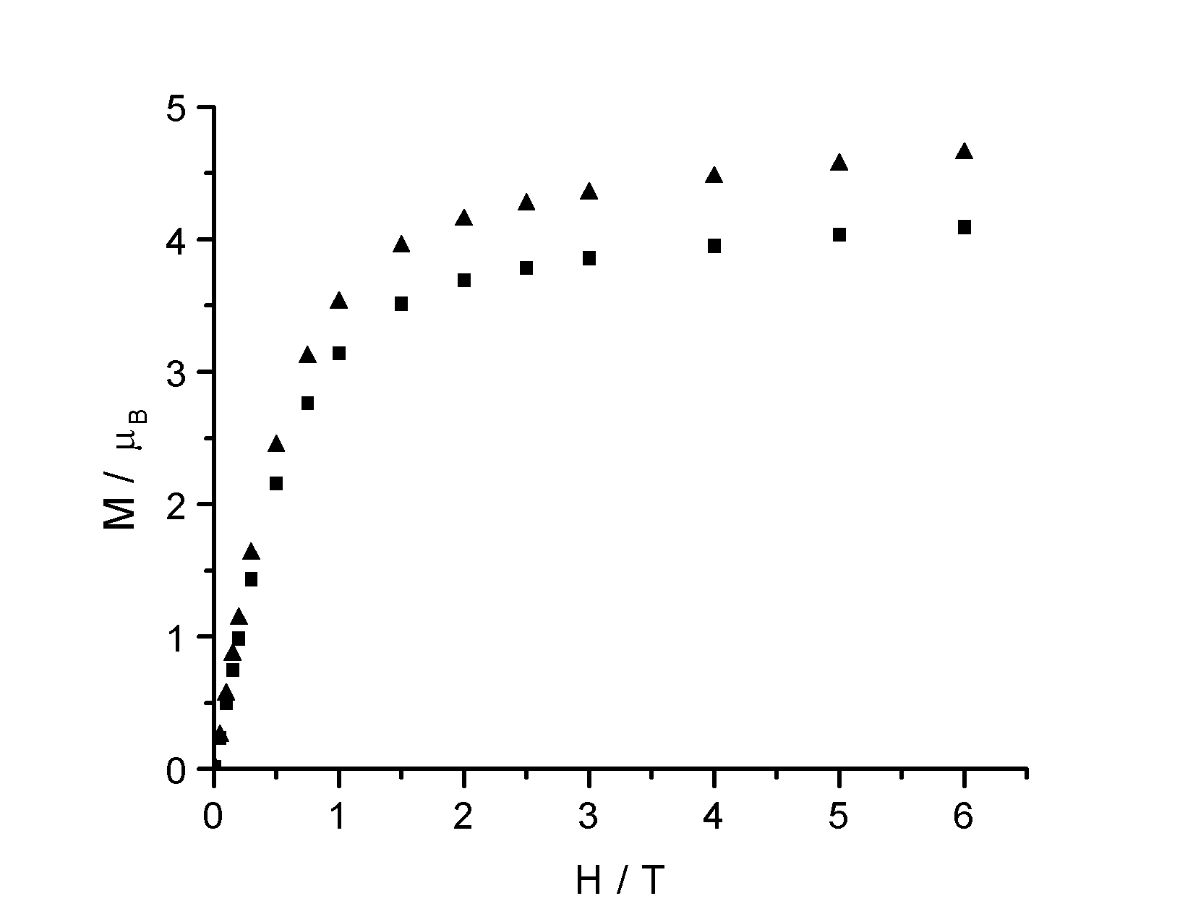

Figure S3 Magnetisation vs. field curve measured at 2.4 K for Tb(DTBSQ)(HBPz₃)₂ (full squares) and Tb(Trp)(HBPz₃)₂ (full triangles).

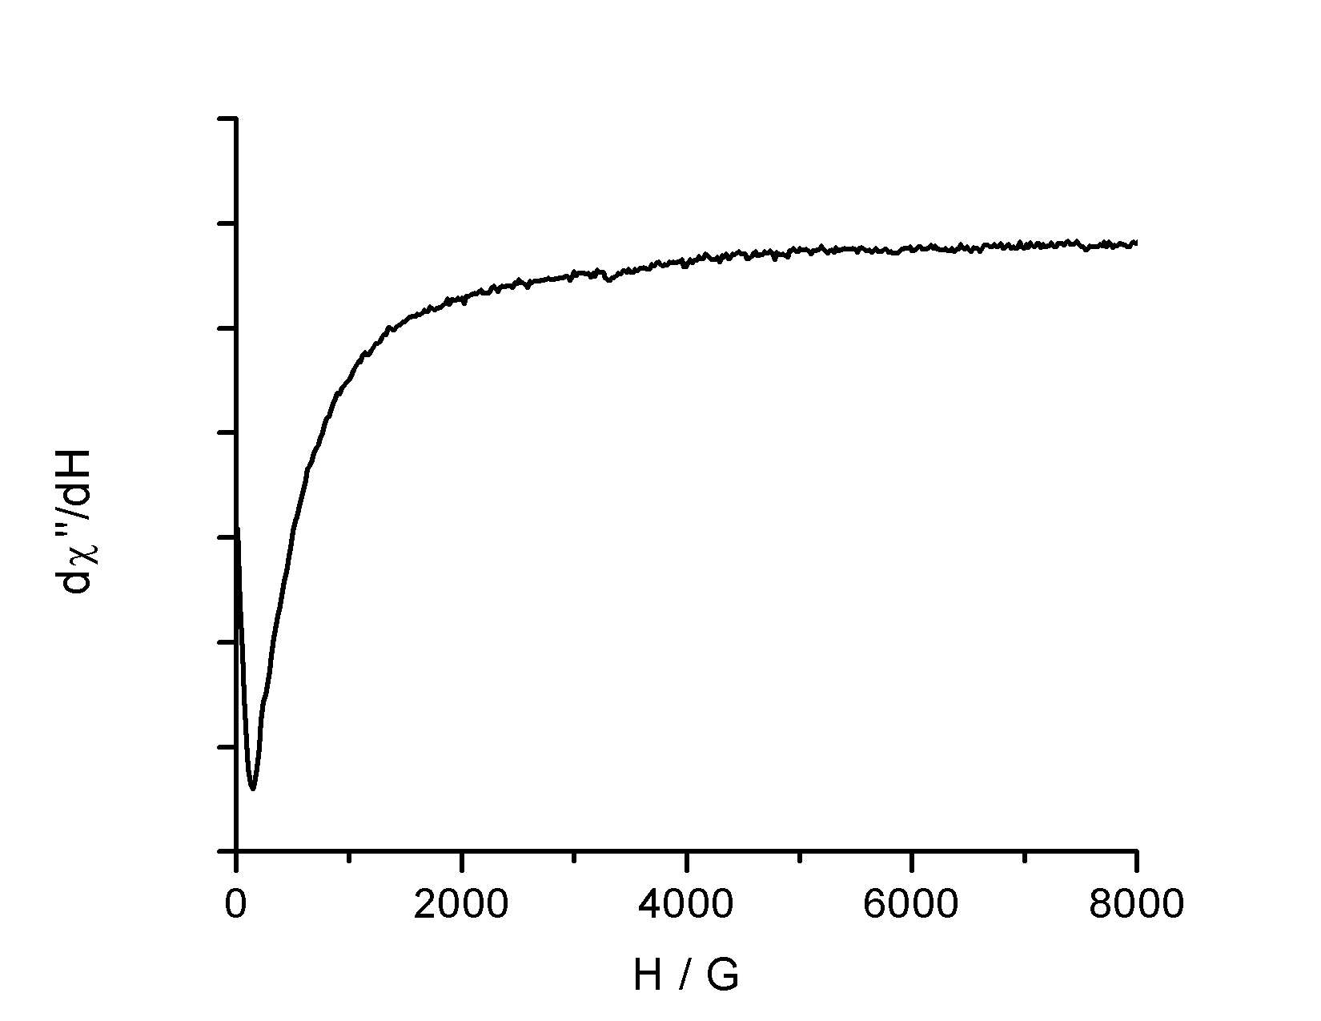

Figure S4 X-Band EPR spectrum at 4 K of DySQ complex

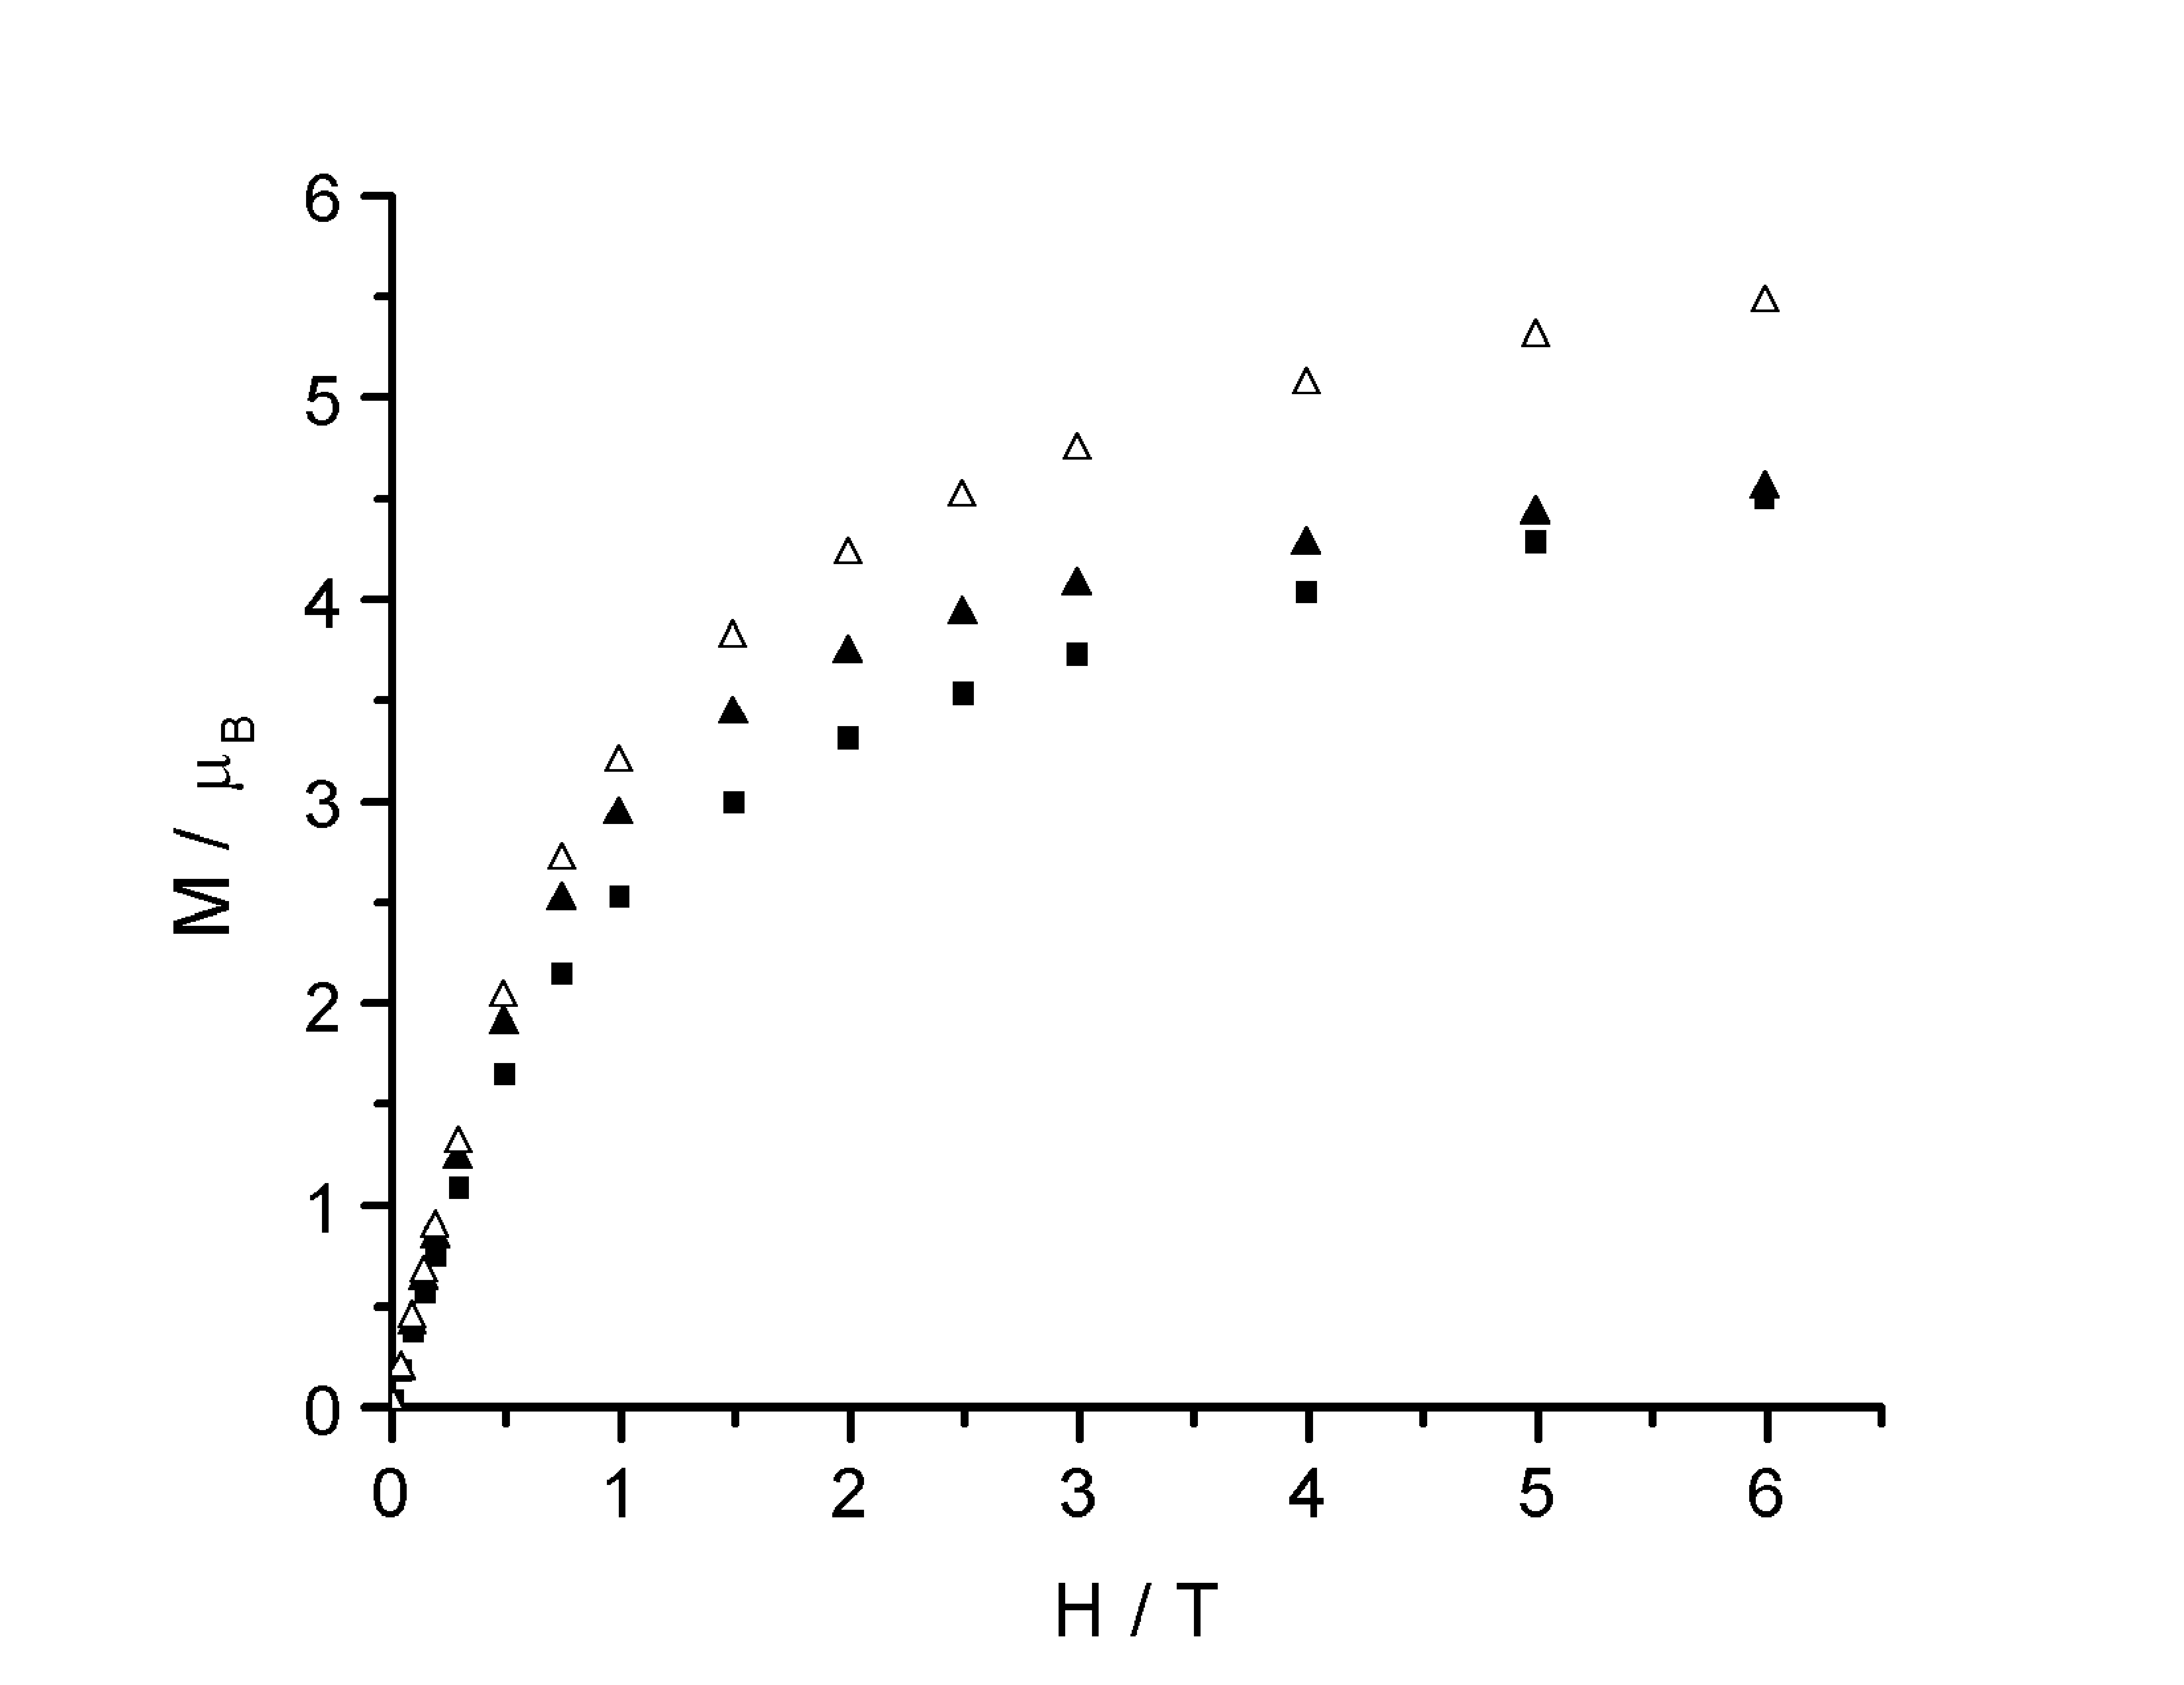

Figure S5 M vs H curve measured at 2.5 K for Er(DTBSQ)(HBPz₃)₂ (full squares) and Er(Trp)(HBPz₃)₂ (full triangles) and calculated magnetisation for Er(DTBSQ)(HBPz₃)₂ (empty triangles) in the assumption of uncorrelated spin system.

