Supplementary Data
for

Three-ring, branched cyclam derivatives and their interaction with nickel(II), copper(II), zinc(II) and cadmium(II)

Ying Dong, Leonard F. Lindoy*, Peter Turner and Gang Wei

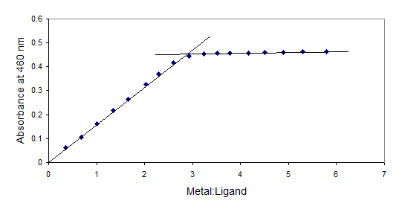
Fig. 1S Spectrophotometric titration curve for the addition of nickel(II) nitrate hexahydrate to 3 (4.92 × 10⁻³ mol dm⁻³) in dimethylsulfoxide (3 cm³).

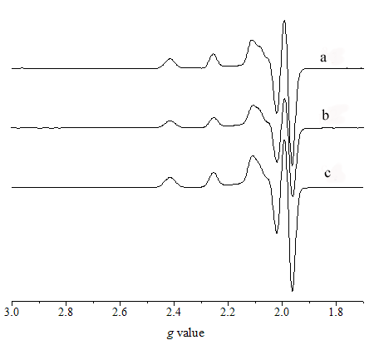

Fig. 2S EPR spectra for the copper(II) perchlorate complexes of (a) 1, (b) 2 and (c)4.

Fig. 3S EPR spectrum for the copper(II) perchlorate complex of 3.

Figure 4S Cyclic voltammogram for [Ni(2)](ClO₄)₂. Experimental conditions: glassy carbon working electrode, 100 mV/s scan rate, 1 mmol dm⁻³ solution in acetonitrile, 0.1 mol dm⁻³

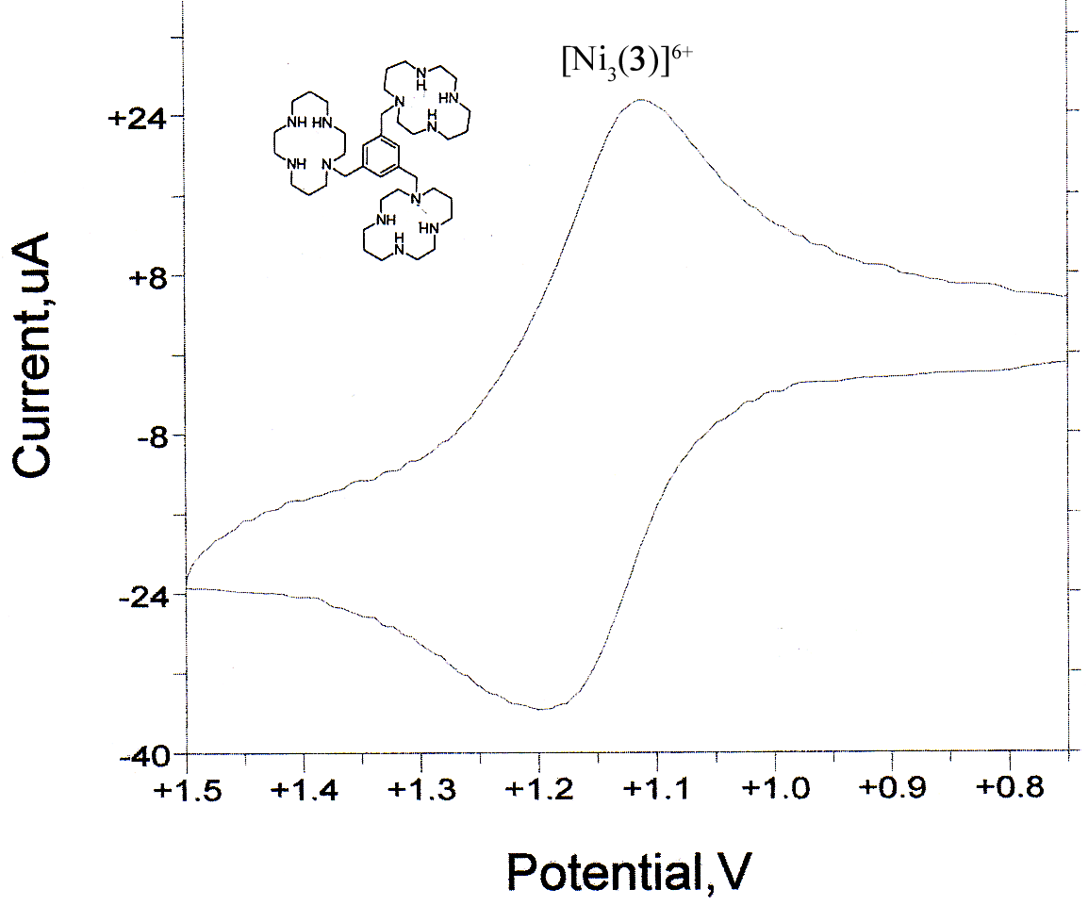
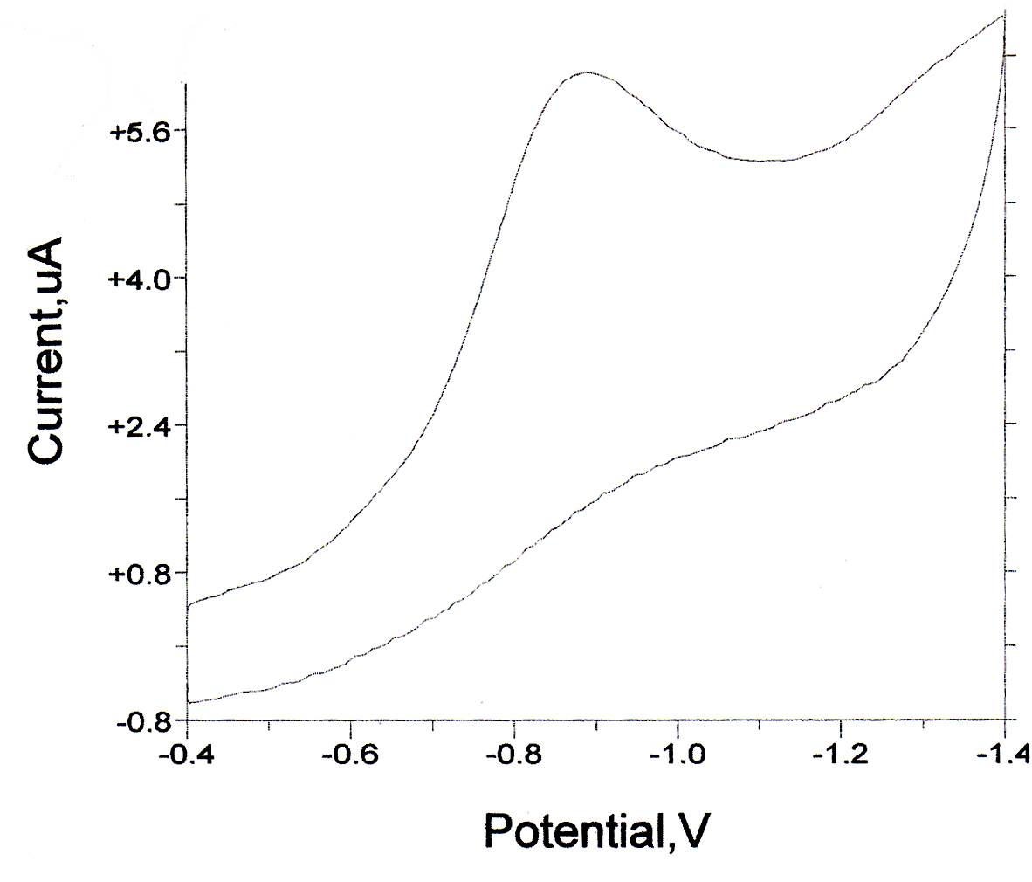
Figure 5S Cyclic voltammogram for [Ni₃(3)](ClO₄)₆. Experimental conditions: glassy carbon working electrode, 100 mV/s scan rate, 1 mmol dm⁻³ solution in acetonitrile, 0.1 mol dm⁻³

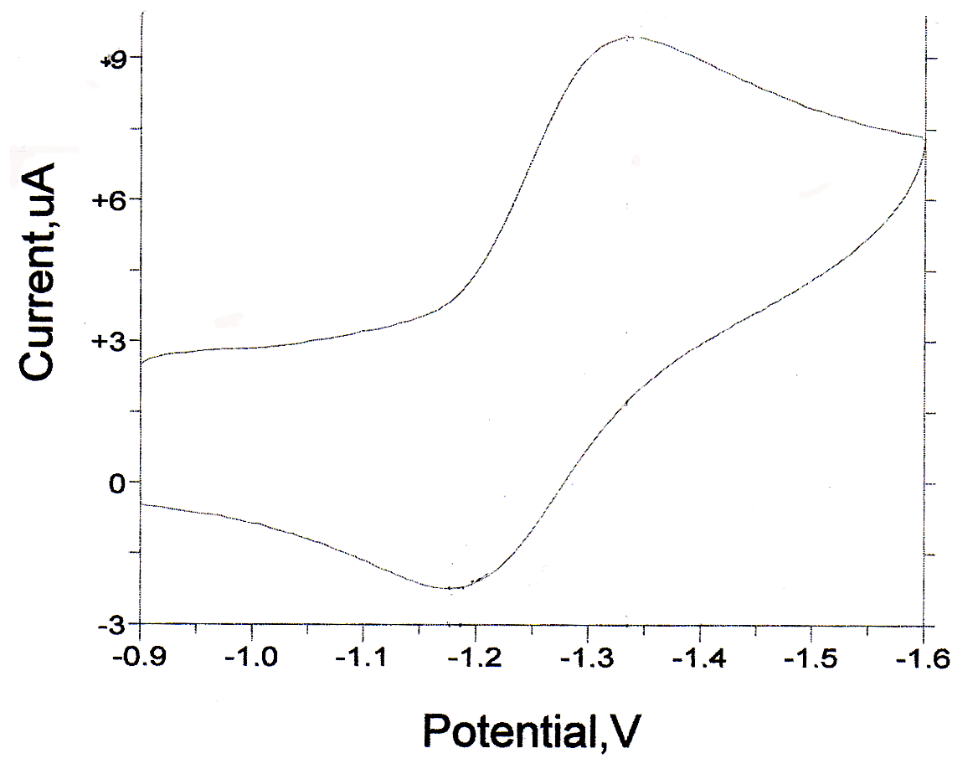
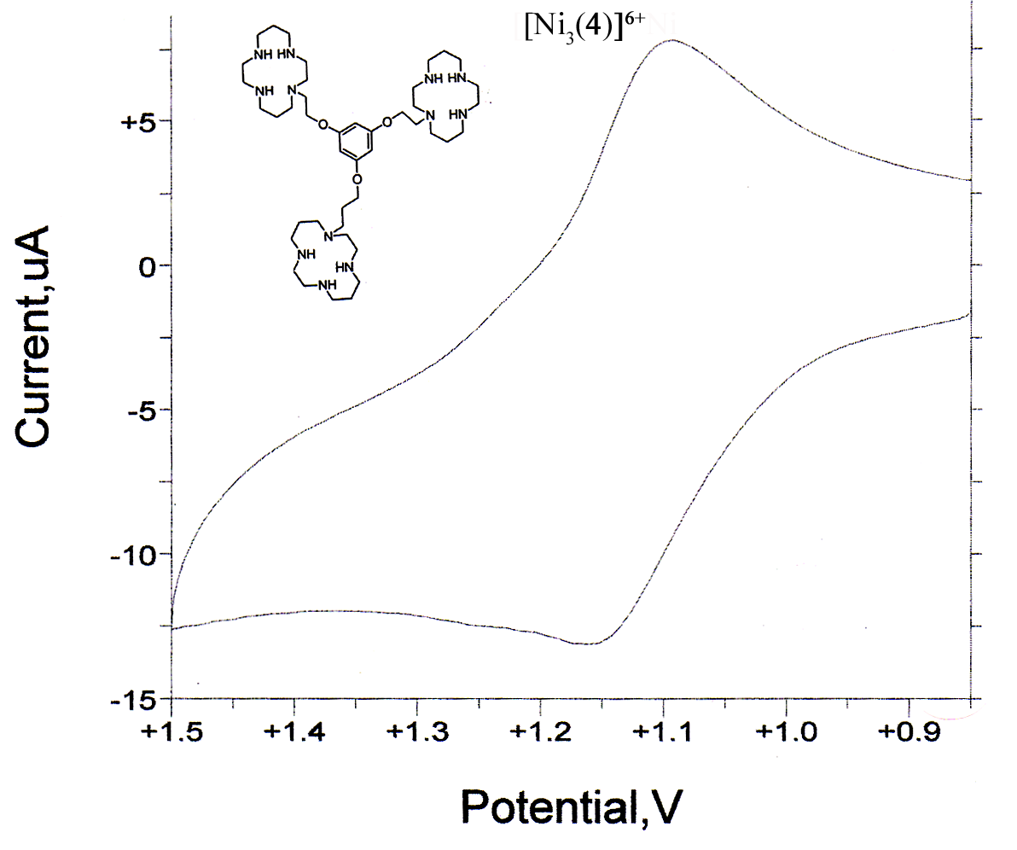

Figure 6S Cyclic voltammogram for [Ni₃(4)](ClO₄)₆. Experimental conditions: glassy carbon working electrode, 100 mV/s scan rate, 1 mmol dm⁻³ solution in acetonitrile, 0.1 mol dm⁻³

