Reactions of thiosemicarbazones derived from β-keto amides and β-keto esters with Zn(II) and Cd(II) acetates: Influence of metal, substitution, reagent ratio and temperature on metal-induced cyclization

José S. Casas, María V. Castaño, María S. García-Tasende, Enrique Rodríguez-Castellón, Agustín Sánchez , Luisa M. Sanjuán and José Sordo

Supplementary Material

SM1

Analytical and spectrocopic data for the ligands
The IR spectra of all the ligands were interpreted in accordance with the literature¹ and the ¹H and ¹³C NMR spectra of both types of ligand on the basis of previous work,^{2b,c} signal integrations and, in some cases, DEPT, HMBC and HMQC experiments. The NMR spectra of HTSC¹ and HTSC⁵ show just one set of signals, and those of HTSC³ and HTSC⁴ two sets [except for C(7)H₃ in both ¹H spectra and for C(1)S in the ¹³C NMR spectrum of HTSC³], suggesting that two conformers exist in solution (only signals for the major conformer are included). The ¹H and ¹³C NMR spectra of HL³ and HL⁴ are simple and show only one set of signals, while the ¹H spectrum of HL⁵ shows very broad duplicated signals for most groups and its ¹³C spectrum only shows signals for C(1)S and R₁, suggesting an equilibrium among different conformers of this ligand in DMSO solution.

HTSC¹. Mp: 180°C. Anal. Calcd. for C₁₂H₁₆N₄O₂S: C, 51.4; H, 5.7; N, 20.0; S, 11.4 %. Found: C, 51.5; H, 5.8; N, 20.0; S, 11.0 %. MS (EI), m/z (%): 280 (3.0) [M], 158 (33.3) [M-NHPh(OCH₃)], 123 (100.0) [NH₂Ph(OCH₃)], 60 (29.1) [C(S)NH₂]. IR: 3421s, 3286s, 3324s, 3170m, ν(N-H); 1652vs, ν(C=O); 1603vs, ν(C=N); 1549s, 1244s,br, ν(NH-Ph(OCH₃)); 1450sh, δ(O-CH₃); 1244s,br, 1032m, ν(C-O); 1095m, 827m, ν(C=S). ¹H NMR: δ[N(2)H] = 10.16s(1); δ[N(4)H] = 9.92s(1); δ[N(1)H₂] = 8.14s(1), 7.60s(1); δ[C(8-11)H] = 7.46d(2), 6.87d(2); δ[C(12)H₃] = 3.70s(3); δ[C(3)H₂] = 3.28s(2); δ[C(5)H₃] = 1.96s(3). ¹³C NMR: δ[C(1)] = 178.7; δ[C(4)] = 166.6; δ[C(9)] = 155.2; δ[C(2)] = 148.9; δ[C(6)] = 131.2; δ[C(7,11)] = 120.7; δ[C(8,10)] = 113.8; δ[C(12)] = 55.0; δ[C(3)] = 46.3; δ[C(5)] = 16.7. HTSC². IR: 3486s, 3354s, 3220s, ν(N-H); 1723s, ν(C=O); 1528s, ν(C=N); 1475m, δ(O-CH₂); 1182s, ν(C-O); 1085m, 852m, ν(C=S). ¹H NMR: δ[N(2)H] = 10.11s(1); δ[N(1)H₂] = 8.19s(1), 7.50s(1); δ[C(7)H₂] = 4.09c(2); δ[C(3)H] = 3.39c(1); δ[C(5)H₃] = 1.88s(3); δ[C(6)H₃] = 1.21d(3); δ[C(8)H₃] = 1.15t(3). ¹³C NMR: δ[C(1)] = 178.9; δ[C(4)] = 172.0; δ[C(2)] = 150.8,; δ[C(7)] = 60.4; δ[C(3)] = 47.7; δ[C(6)] = 14.8; δ[C(5)] = 14.1; δ[C(8)] = 13.9. HTSC³. Mp: 85°C. Anal. Calcd. for C₇H₁₃N₃O₂S: C, 41.4; H, 6.4; N, 20.7; S, 15.8 %. Found: C, 40.3; H, 6.9; N, 21.9; S, 16.6 %. MS (EI), m/z (%): 203 (77.6) [M], 174 (92.0) [M-CH₂CH₃], 172 (10.8) [M-OCH₃], 130 (100.0) [M-CH₂C(O)OCH₃], 60 (90.5) [C(S)NH₂]. IR: 3405s, 3267s, 3192s,br, 3155s, ν(N-H); 1735vs, ν(C=O); 1592vs, ν(C=N); 1434m, δ(O-CH₃); 1231s, ν(C-O); 1095m, 849m, ν(C=S). ¹H NMR: δ[N(2)H] = 10.29s(1); δ[N(1)H₂] = 8.12s(1), 7.54s(1); δ[C(7)H₃] = 3.62s(3); δ[C(3)H₂] = 3.58s(2); δ[C(5)H₂] = 2.41c(2); δ[C(6)H₃] = 1.01t(3). ¹³C NMR: δ[C(1)] = 179.1; δ[C(4)] = 170.3; δ[C(2)] = 151.1; δ[C(7)] = 52.2; δ[C(3)] = 35.6; δ[C(5)] = 30.5; δ[C(6)] = 10.4. HTSC⁴. Mp: 85°C. Anal. Calcd. for C₇H₁₃N₃O₃S: C, 38.3; H, 6.0; N, 19.2; S, 14.6 %. Found: C, 37.5; H, 6.4; N, 20.7; S, 16.1 %. MS (EI), m/z (%): 219 (12.1) [M], 188 (8.4) [M-OCH₃], 174 (81.2) [M-CH₂OCH₃], 60 (23.8) [C(S)NH₂]. IR: 3424s, 3261s, 3213s, 3170s, ν(N-H); 1733s, ν(C=O); 1607s, ν(C=N); 1477m, δ(O-CH₂); 1455m, 1435w, δ(O-CH₃); 1238s, ν(C-O); 1076s, 850m, ν(C=S). ¹H NMR: δ[N(2)H] = 10.52s(1); δ[N(1)H₂] = 8.24s(1), 7.78s(1); δ[C(5)H₂] = 3.94s(2); δ[C(7)H₃] = 3.62s(3); δ[C(3)H₂] = 3.58s(2); δ[C(6)H₃] = 3.18s(3). ¹³C NMR: δ[C(1)] = 179.6; δ[C(4)] = 168.5; δ[C(2)] = 144.1; δ[C(5)] = 74.9; δ[C(6)] = 58.0; δ[C(7)] = 52.2; δ[C(3)] = 33.0. HTSC⁵. Mp: 80°C. Anal. Calcd for C₁₂H₁₅N₃O₂S: C, 54.3; H, 5.7; N, 16.0; S, 12.1 %. Found: C, 54.0; H, 5.8; N, 16.1; S, 12.5 %. MS (EI), m/z (%): 265 (28.4) [M], 220 (19.3) [M-OEt], 178 (62.1) [M-CH₂C(O)OEt], 160 (100.0) [M-OEt-C(S)NH₂], 60 (33.2) [C(S)NH₂]. IR: 3408s, 3225s,br, 3152s, ν(N-H); 1723vs, ν(C=O); 1595vs, ν(C=N); 1465m, δ(O-CH₂); 1248vs, ν(C-O); 1090m, 844m, ν(C=S). ¹H NMR: δ[N(2)H] = 10.61s(1); δ[N(1)H₂] = 8.38s(1), 8.03s(1); δ[C(6,10)H] = 7.87d(2); δ[C(7-9)H] = 7.38m(3); δ[C(3)H₂] = 4.06s(2); δ[C(11)H₂] = 4.05c(2); δ[C(12)H₃] = 1.15t(3). ¹³C NMR: δ[C(1)] = 179.1; δ[C(4)] = 168.2; δ[C(2)] = 142.3; δ[C(5)] = 136.7; δ[C(6,10)] = 129.2; δ[C(7,9)] = 128.2; δ[C(8)] = 126.4; δ[C(11)] = 60.7; δ[C(3)] = 33.4; δ[C(12)] = 13.9. HL¹. IR: 3269vs, 3164vs, ν(N-H); 1654vs,br, ν(C=O); 1592vs, 1550vs, 1507m ν(ring); 1336s, ν(C-N); 1093s, 875m, ν(C=S). ¹H NMR: δ[N(3)H] = 11.98s(1); δ[N(1)H₂] = 10.36s(1), 9.66s(1); δ[C(3)H] = 5.16s(1); δ[C(5)H₃] = 2.17s(3). ¹³C NMR: δ[C(1)] = 175.8; δ[C(4)] = 163.3; δ[C(2)] = 152.7; δ[C(3)] = 91.4; δ[C(5)] = 12.1. HL². IR: 3275vs, 3228s, ν(N-H); 1664vs, ν(C=O); 1600sh, 1581vs,br, 1512m ν(ring); 1331s, ν(C-N); 1105s, 902m, ν(C=S). MS (EI), m/z (%): 171 (75) [M], 111 (100) [M-C(S)NH₂], 97 (42) [M-NC(S)NH₂]. ¹H NMR: δ[N(3)H] = 10.50s(1); δ[N(1)H₂] = 10.39s(1), 9.63s(1); δ[C(5)H₃] = 2.13s(3); δ[C(6)H₃] = 1.65s(3). ¹³C NMR: δ[C(1)] = 175.9; δ[C(4)] = 163.1; δ[C(2)] = 149.9; δ[C(3)] = 98.7; δ[C(5)] = 10.7; δ[C(6)] = 6.0. HL³. Mp: 165°C. Anal. Calcd for C₆H₉N₃OS: C, 42.1; H, 5.3; N, 24.5; S, 18.7 %. Found: C, 42.5; H, 4.8; N, 24.6; S, 19.3 %. MS (EI), m/z (%): 171 (39.8) [M], 111 (28.3) [M-C(S)NH₂], 97 (82.0) [M-NC(S)NH₂], 60 (31.1) [C(S)NH₂]. IR: 3275s, 3177s, 3084s, ν(N-H); 1657vs, ν(C=O); 1596vs, 1546vs, 1500w ν(ring); 1337s, ν(C-N); 1093s, 874s, ν(C=S). ¹H NMR: δ[N(3)H] = 11.99s(1); δ[N(1)H₂] = 10.37s(1), 9.69s(1); δ[C(3)H] = 5.21s(1); δ[C(5)H₂] = 2.52c(2); δ[C(6)H₃] = 1.13t(3). ¹³C NMR: δ[C(1)] = 175.9; δ[C(4)] = 163.3; δ[C(2)] = 158.2; δ[C(3)] = 89.9; δ[C(5)] = 19.3; δ[C(6)] = 12.0. HL⁴. Mp: 160°C. Anal. Calcd. for C₆H₉N₃O₂S: C, 38.5; H, 4.8; N, 22.4; S, 17.1 %. Found: C, 36.3; H, 4.0; N, 21.2; S, 18.2 %. MS (EI), m/z (%): 187 (35.4) [M], 127 (6.2) [M-C(S)NH₂], 60 (48.1) [C(S)NH₂]. IR: 3293s, 3215s, 3131s, ν(N-H); 1651vs, ν(C=O); 1597vs, 1559m, 1507w, ν(ring); 1467m, δ(O-CH₂); 1299s, ν(C-N); 1120s, 871s, ν(C=S). ¹H NMR: δ[N(3)H] = 12.13s(1); δ[N(1)H₂] = 10.36s(1), 9.79s(1); δ[C(3)H] = 5.30s(1); δ[C(5)H₂] = 4.34s(2); δ[C(6)H₃] = 3.20s(3). ¹³C NMR: δ[C(1)] = 176.0; δ[C(2)] = 145.1; δ[C(3)] = 89.3; δ[C(5)] = 65.5; δ[C(6)] = 58.2. HL⁵. Mp: 198°C. Anal. Calcd. for C₁₀H₉N₃OS: C, 54.8; H, 4.1; N, 19.2; S, 14.6 %. Found: C, 54.5; H, 4.2; N, 19.1; S, 14.6 %. MS (EI), m/z (%): 219 (31.2) [M], 159 (100.0) [M-C(S)NH₂], 60 (17.2) [C(S)NH₂]. IR: 3294s, 3158m,sh, 3117s, ν(N-H); 1652vs, ν(C=O); 1586vs, 1546sh, ν(ring); 1330m, ν(C-N); 1104s, 880s, ν(C=S). ¹H NMR: δ[N(3)H] = 12.25sbr, 11.96sbr, (1); δ[N(1)H₂] = 10.12s,br, 9.64s,br, 10.28s,br, 9.74s,br, (2); δ[C(6,10)H] = 7.88s,br, (2); δ[C(7-9)H] = 7.45s,br, (3); δ[C(3)H] = 6.25s,br, 5.97s,br, (1). ¹³C NMR: δ[C(1)] = 176.2; δ[C(7-9)] = 128.6; δ[C(6,10)] = 126.5

ST1. Complexes obtained in the assayed experimental conditions

Ligand | Zn |  |  |  | Cd
Ligand | 1:1 |  | 1:2 |  | 1:1 |  | 1:2
Ligand | r.t. | reflux | r.t. | reflux | r.t. | reflux | r.t. | reflux
HTSC¹ | [Zn(TSC¹)₂] | * | [Zn(TSC¹)₂] | [Zn(TSC¹)₂] | [CdL¹₂]·3H₂O | [CdL¹₂]·3H₂O | [CdL¹₂]·3H₂O | [CdL¹₂]·3H₂O
HTSC² | [Zn(L²-H)] | [Zn(L²-H)] | [ZnL²₂(H₂O)] | [ZnL²₂(H₂O)] | [CdL²₂] | [CdL²₂] | [CdL²₂]  [CdL²₂(H₂O)]·2DMSO | [CdL²₂]
HTSC³ | [Zn(L³-H)] | [Zn(L³-H)] | [ZnL³₂] | [ZnL³₂] (6 h)  [Zn(L³-H)](24 h) | [CdL³₂]·H₂O | [CdL³₂]·H₂O | [CdL³₂]·H₂O | [CdL³₂]·H₂O
HTSC⁴ | [Zn(L⁴-H)] | [Zn(L⁴-H)] | [Zn(TSC⁴)₂](10’)  [ZnL⁴₂](6 h) | [ZnL⁴₂]  [ZnL⁴₂]·0.5H₂O | [Cd(TSC⁴)₂] | [CdL⁴₂]·H₂O | [Cd(TSC⁴)₂] | [CdL⁴₂]·H₂O
HTSC⁵ | * | *  [ZnL⁵₂]·MeOH | [ZnL⁵₂]·MeOH | [ZnL⁵₂]·MeOH | [CdL⁵₂]·MeOH | [CdL⁵₂]·MeOH | [CdL⁵₂]·MeOH  [CdL⁵₂(DMSO)]·2DMSO | [CdL⁵₂]·MeOH

* unidentified product or mixture.

ST2. IR spectra of the new complexes
Compound | ν(N-H) | ν(C=O) | ν(ring) | ν(C=N)  (ν(C-N)) | δ(O-CH₃)/  δ(O-CH₂) | ν(C-O) | ν(C=S)
[Zn(TSC¹)₂]ª | 3460m, 3440m, 3346m, 3298m, 3187m | 1677m |  | 1616s | 1442w | 1241s, 1038m | 796w
[Zn(L²-H] | 3291s | 1613vs | 1613vs, 1525vs | 1385vs |  |  | 815m
[CdL²₂] | 3449s, 3157s, 3125s | 1629s | 1580vs, 1511s | 1387vs |  |  | 1018m, 754m
[ZnL³₂] | 3409m,br, 3314m,br | 1600vs,br | 1600vs,br, 1496m | 1364s |  |  | 818m
[Zn(L³-H)] | 3320vs,br, 2244vs, 3221s, 3161s, 3130s | 1601vs,br | 1601vs,br, 1498m | 1364s |  |  | 820m
[CdL³₂]⋅H₂O | 3312s,br [+ν(O-H)] | 1620s | 1590vs, 1488m | 1386s |  |  | 892m
[Zn(TSC⁴)₂] | 3439s, 3307m, 3179m | 1721vs |  | 1602s | 1466vs  1431m | 1250sh | 1014m, 744s
[ZnL⁴₂] | 3324sh, 3201vs,br, 3115s, 3066s,br | 1658sh | 1606vs, 1510sh | 1387vs | 1490s |  | 823m
[Zn(L⁴-H)] | 3305vs,br, 3188vs,br | 1603vs,br | 1603vs,br, 1507sh | 1369vs,br | 1489s |  | 847m
[Cd(TSC⁴)₂] | 3432s, 330sm, 3175m | 1721vs |  | 1600s | 1468vs  1435m | 1250sh | 1014m, 739s
[CdL⁴₂]⋅H₂O | 3475s, 3268s,br, 3138s [+ν(O-H)] | 1630sh | 1590vs, 1503m | 1363s | 1476s |  | 806s
[ZnL⁵₂]⋅MeOH | 3369s,br, 3174vs,br, 3031vs,br | 1645vs | 1614vs, 1579vs | 1396vs,br |  |  | 933s, 751s
[CdL⁵₂]⋅MeOH | 3457m, 3305s,br, 3184s,br, 3063s,br [+ν(O-H)] | 1610vs | 1588vs, 1575vs | 1391vs |  |  | 924s, 751s
ªν(NHPh(OCH₃): 1547m, 1241s.

ST3. ¹H NMR spectra of the new HTSC^{n} and L^{n} complexes
Compound | δ[N(1)H₂] | δ[R₁] | δ[R₂] | δ[R₃]
[Zn(TSC¹)₂]ª | 6.78s(2) | 2.07s, 2.03s, (3) [C(5)H₃] | 3.72sbr(2) C(3)H₂] | 7.42d(2), 6.85d(2) [C(8-11)H]  3.69s(3) [C(12)H₃]
[CdL²₂] | 11.93s(1) 9.68s(1) | 1.96s(3) [C(5)H₃] | 1.57s(3) [C(6)H₃].
[ZnL³₂] | 11.34s(1) 10.32s(1) | 2.39c(2) [C(5)H₂]  1.08t(3).[C(6)H₃] | 4.87s(1) [C(3)H]
[CdL³₂]⋅H₂O | 11.77s(1) 9.73s(1 | 2.38c(2) [C(5)H₂]  1.01t(3) [C(6)H₃] | 4.71s(1) [C(3)H]
[Zn(TSC⁴)₂] | 6.70s(2) | 4.17s(2) [C(5)H₂]  3.13s(3) C(6)H₃] | 3.26 [C(3)H₂] | 3.58s(3) [C(7)H₃]
[ZnL⁴₂] | 11.31s(1) 10.46s(1) | 4.23s(2) [C(5)H₂]  3.17s(3).[C(6)H₃] | 4.93s(1) [C(3)H₂]
[Cd(TSC⁴)₂] | 6.33s(2) | 4.17s(2) [C(5)H₂]  3.16s(3) [C(6)H₃] | 3.33s(2) [C(3)H₂] | 3.58s(3) [C(7)H₃]
[CdL⁴₂]⋅H₂O | 11.81s(1) 9.96s(1) | 4.15s(2) [C(5)H₂  3.14s(3).[C(6)H₃] | 4.82s(1) [C(3)H]
[ZnL⁵₂]⋅MeOH^{b} | 11.40s,br(1) 10.62s,br(1) | 7.35m(5) [C(6-10)H] | 5.30s(1) [C(3)H]
[CdL⁵₂]⋅MeOH^{c} | 11.85s(1), 9.79s(1) | 7.64d(2) [C(6,10)H]  7.37m(3) [C(7-9)H] | 5.20s(1) [C(3)H]
ªδ[N(4)H]: 9.94s(1). ^{b}δ[CH₃OH] = 4.09c(1); δ[CH₃OH] = 3.17d(3). ^{c} δ[CH₃OH] = 4.10c(1); δ[CH₃OH] = 3.11d(3).

ST4. ¹³C and ¹¹³Cd NMR spectra of some new complexes
Compound | δ[C(1)] | δ[C(2)] | δ[C(3)] | δ[C(4)] | δ[R₁] | δ[R₃] | δ[¹¹³Cd]
[Zn(TSC¹)₂] | 171.5 | 158.8 | a | 166.6 | 23.6 [C(5)] | 155.4 [C(9)], 132.2 [C(6)]  120.8 [C(7,11)], 114.0 C(8,10)]  55.3 [C(12)]
[CdL²₂]^{b} | 176.4 | 156.1 | 91.5 | 165.4 | 13.4 |  | 288
[ZnL³₂] | 173.8 | 163.0 | 85.0 | 165.8 | 21.9 [C(5)], 12.8 [C(6)]
[ZnL³₂]* | 176.4 | 162.7 | 89.0, 86.0 | 166.6, 164.5 | 23.0 [C(5)], 17.4, 12.8 [C(6)]
[Zn(L³-H)]* | 174.8 | 158.7 | 88.5 | 163.4 | 21.0 [C(5)], 12.5, 9.6 [C(6)]
[CdL³₂]⋅H₂O | 176.1 | 162.5 | 83.7 | 166.7 | 21.9 [C(5)], 13.2 [C(6)] |  | 282
[Zn(TSC⁴)₂] | 174.0 | 152.7 | 35.0 | 168.3 | 72.1 [C(5)], 57.5 [C(6)] | 51.8 [C(7)]
[ZnL⁴₂] | 174.5 | 157.4 | 84.8 | 165.6 | 67.2 [C(5)], 58.1 [C(6)]
[Cd(TSC⁴)₂] | 174.1 | 149.3 | 35.2 | 169.1 | 71.5 [C(5)], 57.8 [C(6)] | 52.0 [C(7)] | 448 (439, 371)
[CdL⁴₂]⋅H₂O | 176.4 | 157.2 | 83.9 | 166.6 | 67.6 [C(5)], 57.7 [C(6)] |  | 280
[ZnL⁵₂]⋅MeOH | 174.2 | 159.2 | 86.6 | 166.1 | 131.2 [C(5)], 130.4 [C(6,10)]  128.7 [C(7,9)], 127.0 [C(8)]
[CdL⁵₂]⋅MeOH | 176.0 | 158.0 | 84.5 | 167.0 | 132.0 [C(5)], 129.0 [C(6,10)]  128.0 [C(7,9)], 127.0 [C(8)] |  | 278
ªNot observed. ^{b}δ[C(6)] = 7.2. * Solid state ¹³C NMR.

ST5. Hydrogen bond lengths [Å] and angles [°] in ligands and complexes
D-H⋅⋅⋅A | d(D-H) | d(H⋅⋅⋅A) | d(D⋅⋅⋅A) | >DHA
 | HL^{3 a}
N(1)-H(1A)⋅⋅⋅O(1) | 0.86 | 1.94 | 2.634(4) | 136.9
N(1)-H(1B)⋅⋅⋅S(1)^{i} | 0.86 | 2.57 | 3.413(4) | 168.9
N(3)-H(3N)⋅⋅⋅O(1)^{ii} | 0.86 | 1.92 | 2.746(3) | 161.1
 | HL^{5 b}
N(1)-H(1A)⋅⋅⋅O(1) | 0.90 | 1.94 | 2.664(3) | 136
N(1)-H(1B)⋅⋅⋅S(1)^{i} | 0.89 | 2.54 | 3.404(2) | 162
N(3)-H(3N)⋅⋅⋅O(1)^{ii} | 0.86 | 2.08 | 2.924(2) | 165
 | [ZnL⁴₂]⋅0.5H₂O ^{c}
N(1)-H(1A)⋅⋅⋅O(1) | 0.86 | 2.03 | 2.696(4) | 134.1
N(1)-H(1B)⋅⋅⋅O(1)^{ii} | 0.86 | 1.97 | 2.804(4) | 163.8
 | [CdL²₂(H₂O)]⋅2DMSO ^{d}
N(1)-H(1A)⋅⋅⋅O(1) | 0.86 | 2.03 | 2.711(3) | 135.0
N(1)-H(1A)⋅⋅⋅O(2D) | 0.86 | 2.45 | 2.902(3) | 113.2
N(1)-H(1B)⋅⋅⋅O(1D) | 0.86 | 2.12 | 2.961(3) | 165.9
O(1w)-H(1w)⋅⋅⋅O(1)^{ii} | 1.04 | 1.77 | 2.807(2) | 174
 | [CdL⁵₂(DMSO)]⋅DMSO ^{e}
N(1)-H(1A)⋅⋅⋅O(1) | 0.86 | 1.93 | 2.617(6) | 136.3
N(1)-H(1B)⋅⋅⋅O(11)^{ii} | 0.86 | 1.94 | 2.770(5) | 163.0
N(11)-H(11A)⋅⋅⋅O(11) | 0.86 | 1.96 | 2.646(6) | 135.6
N(11)-H(11B)⋅⋅⋅O(2D) | 0.86 | 1.96 | 2.749(7) | 151.2
ªi = -x, y, -z+2; ii = x, y, z-1; ^{b}i = -x, -y, -z+1; ii= x-1, y, z;; ^{c} ii = –x+5/2, y-1/2, -z+5/4; ^{d}ii = -x+1/2, -y+1/2, -z;
^{e} ii = x-1, y, z

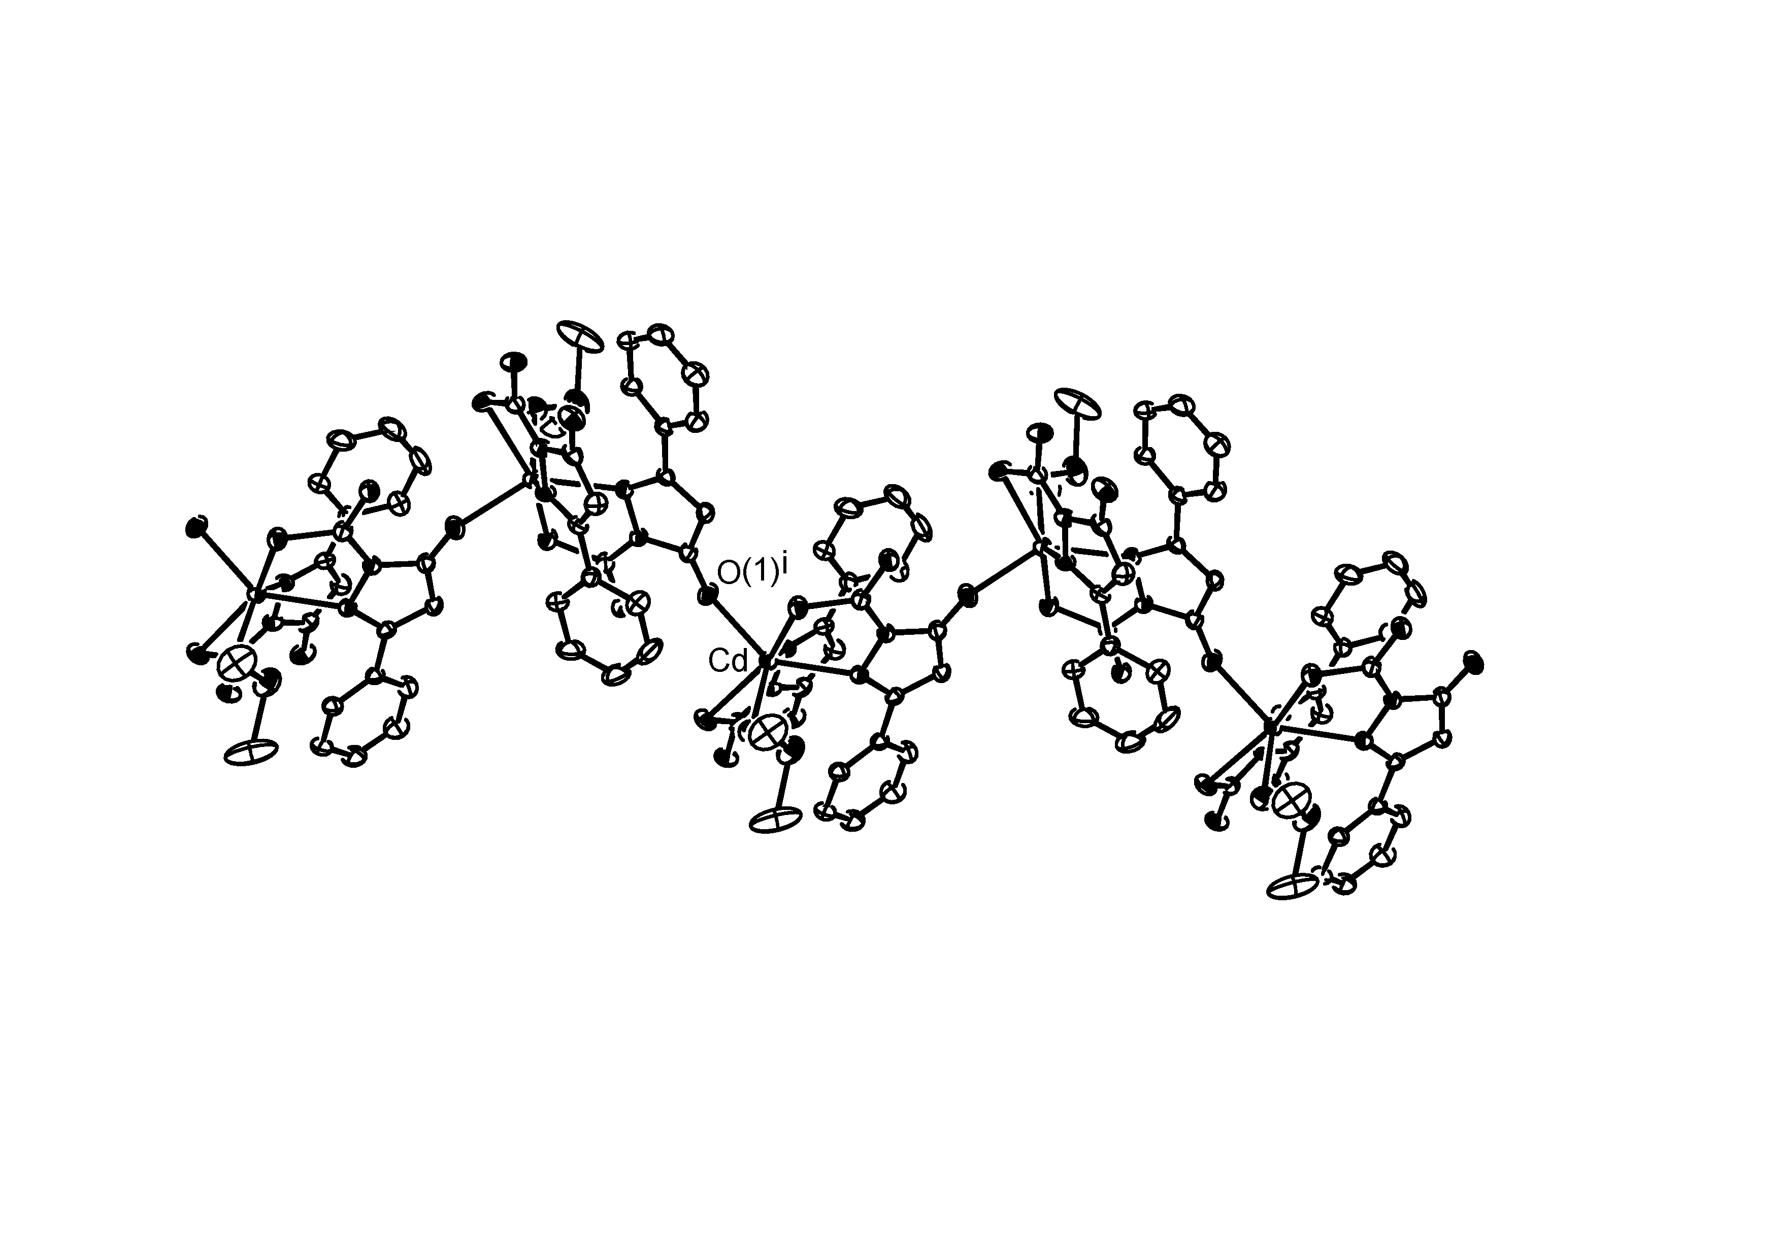

SF1. Intermolecular interactions in [CdL⁵₂(DMSO)]·DMSO.

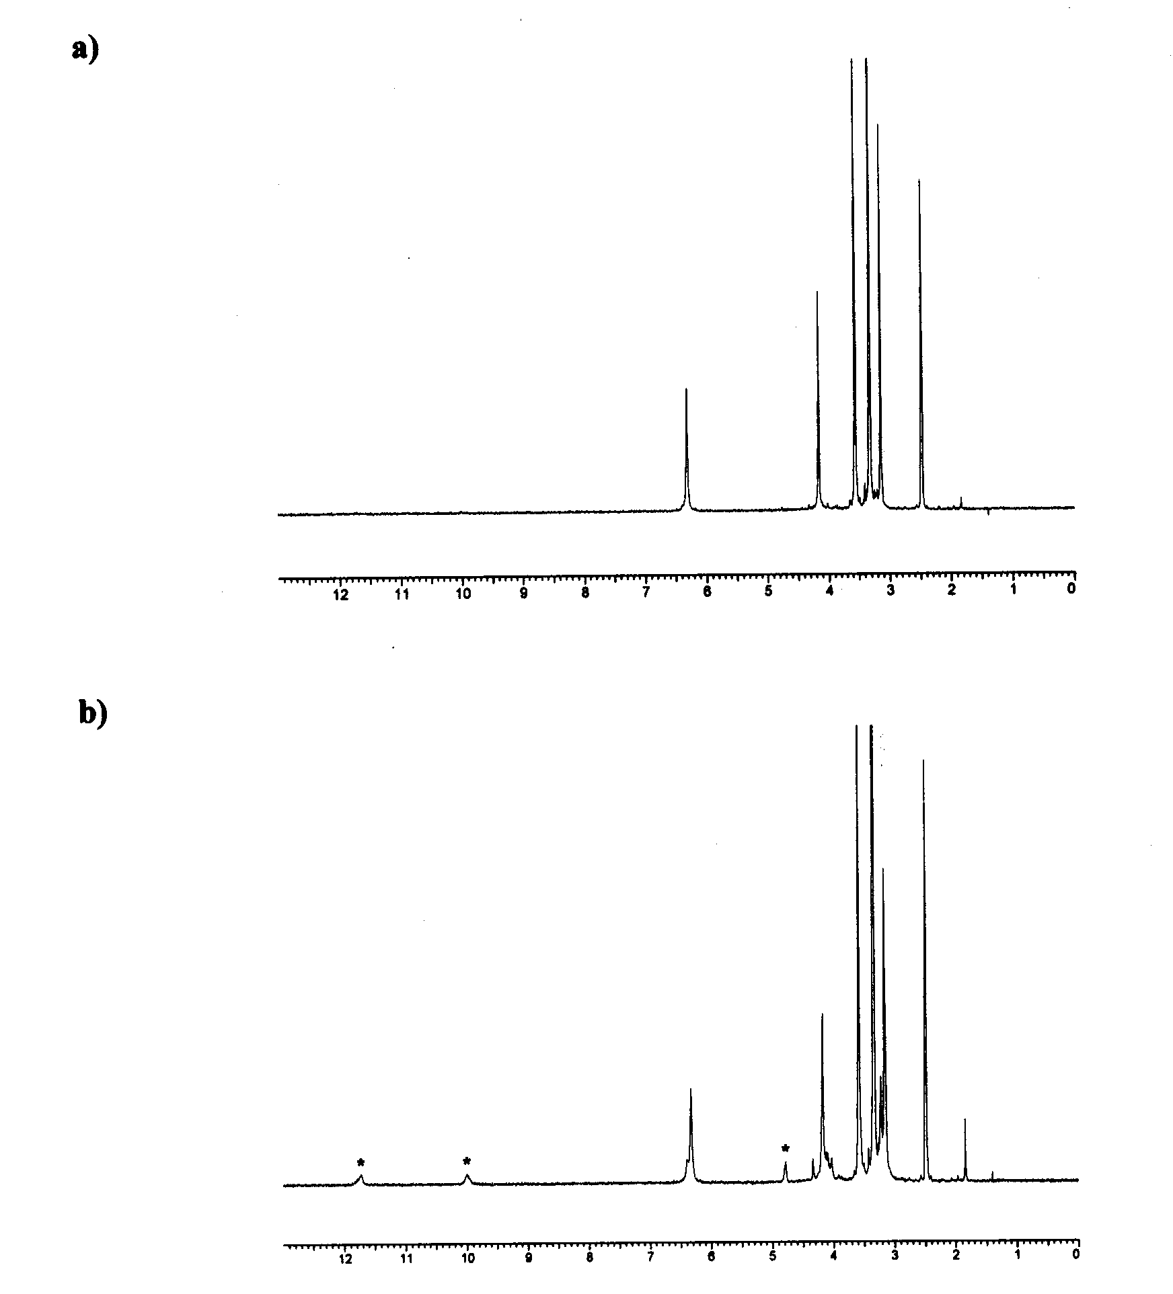

SF2.- a) ¹H NMR spectrum of [Cd(TSC⁴)₂] at room temperature; b) ¹H NMR spectrum of the same sample after 1 hour heating at 90ºC. Signals marked with an asterisk correspond to the pyrazolonate ligand.

SF3. O 1s core level spectra for [ZnL⁴₂]·H₂O and [Zn(L⁴-H)]

