Supplementary Figures:

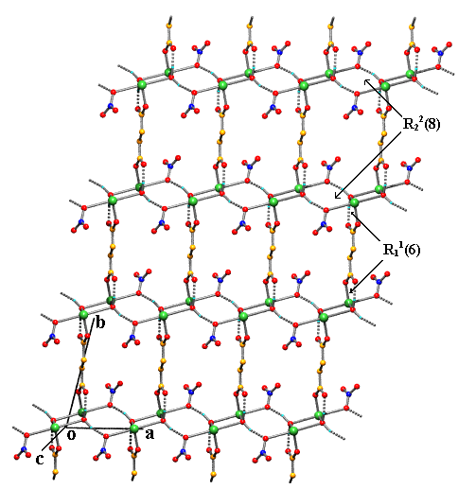

Supplementary Figure 1. A brick-wall sheet of 2 in ac-plane showing the recurrence of R₂²(8) and R₁¹(6) synthon (H-bonds are shown as dotted lines; phen is omitted for clarity).

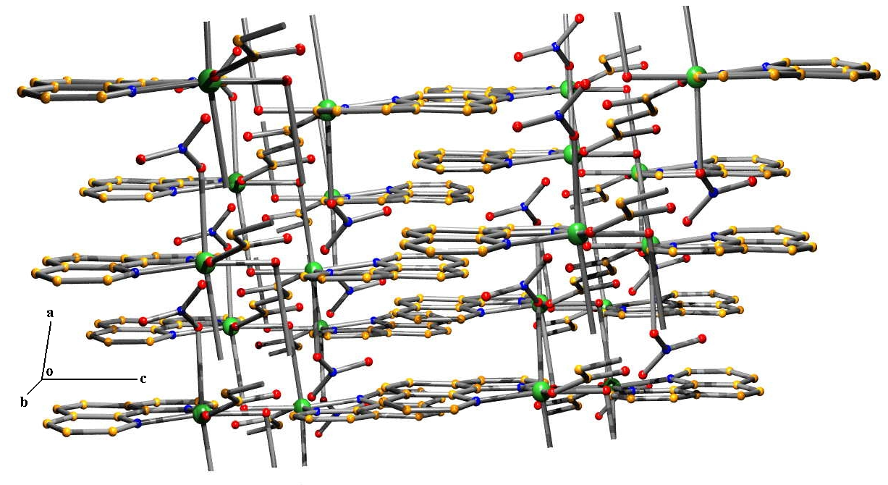

Supplementary Figure 2. The 3D supramolecular continuum of 2 constructed by π−π interaction.
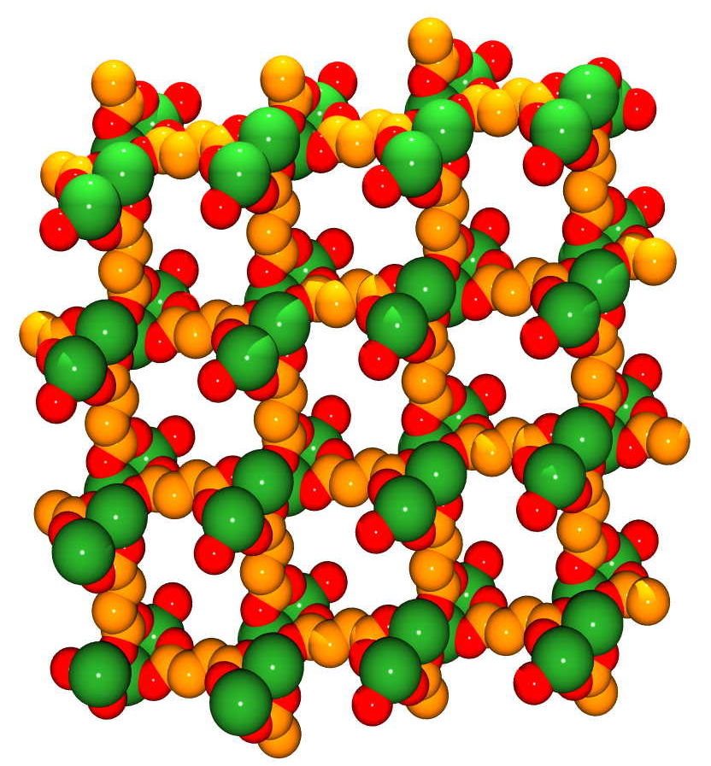

Supplementary Figure 3: A CPK diagram of square-grid [Cu(succinate)_{0.5}]_{n} in complex (3)corrugated sheets with grid dimensions of 9.591x9.591 Å in the bc-plane.

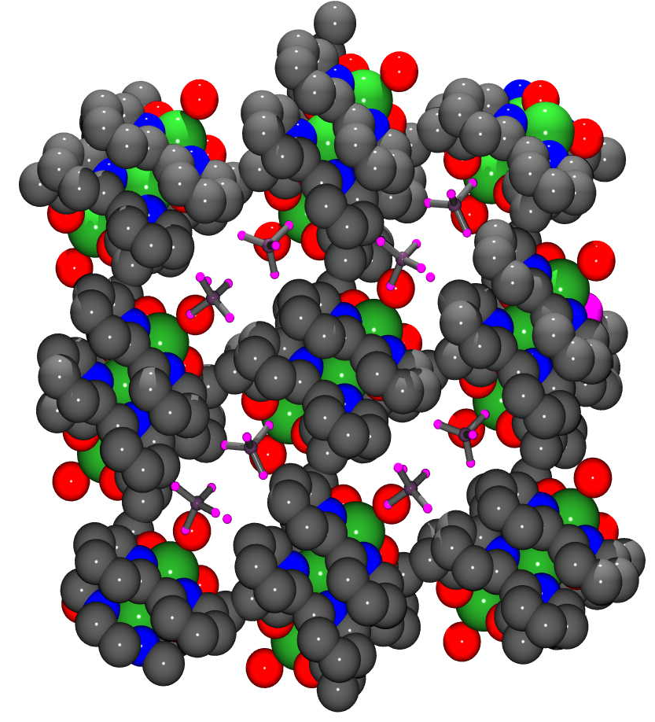

Supplementary Figure 4: CPK view of 2D networks of (3) in the [100] direction showing channels containing perchlorate anion and water.

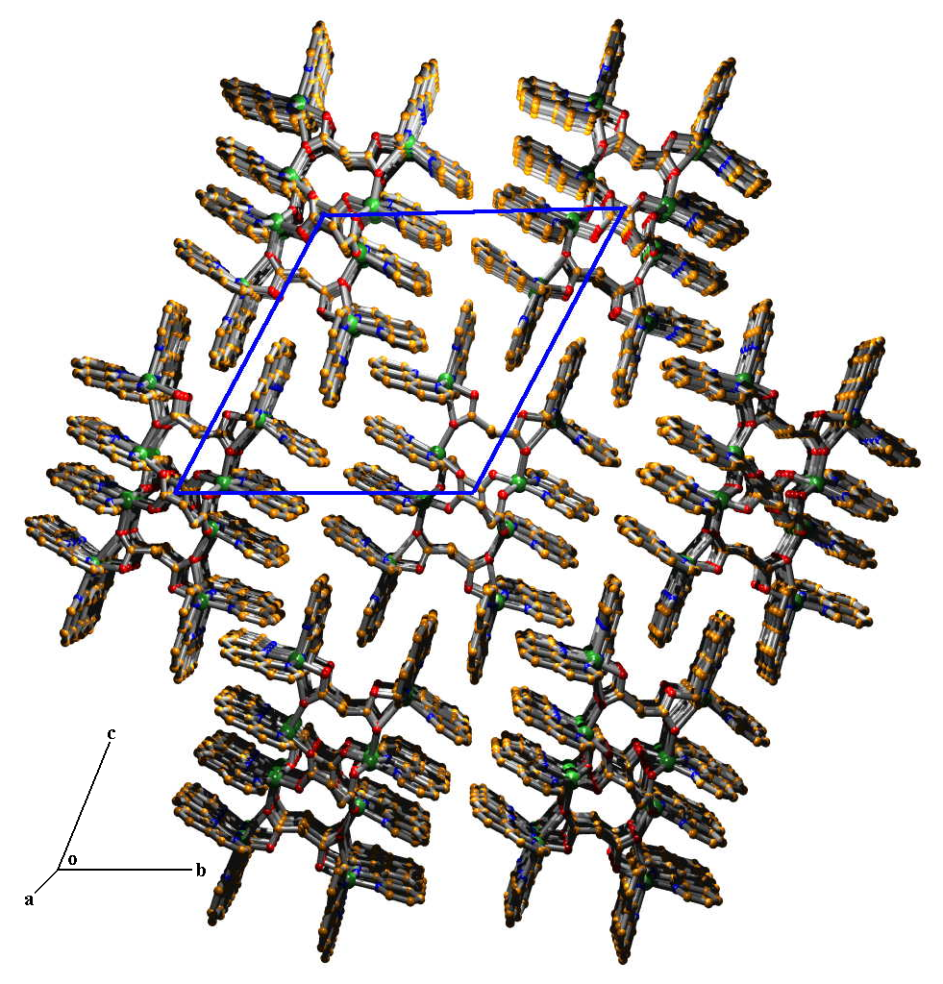

Supplementary Figure 5: A hexagonal array formed by the cationic part [Cu₈L₄(phen)₁₂]⁸⁺ of 4 surrounded by six same cation.
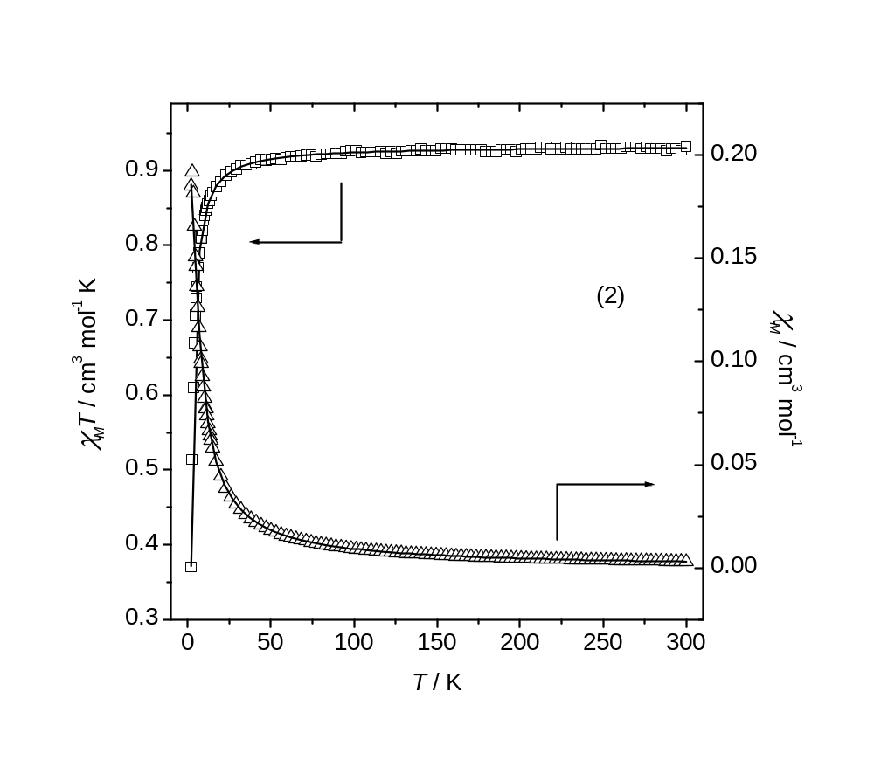

Supplementary Figure 6. Plot of the temperature dependence of χ_{M} and χ_{M}T for 2 (solid lines represent the best fit obtained).

