Table 1. Experimental data for X-ray diffraction studies
 | LiL¹ | 3 | 4 | 8 | 12 | 13
Molecular formula | C₁₀₈H₁₁₃₂Li₄N₄P₄.3(C₅H₁₂) | C₂₇H₃₄NOP | C₅₄H₆₈Cl₂N₂P₂Pt.2(CH₂Cl₂) | C₅₄H₆₆Cl₄N₂P₂PtTi.4(C₆D₆) | C₅₇H₇₀Cl₇N₂OP₂RhTi | C₆₄H₆₉ClN₃OP₃PtSi₃Ti.2(C₆D₆)
Formula weight | 1854.25 | 419.52 | 1242.89 | 1526.42 | 1260.05 | 1520.14
Crystal system | Monoclinic | Triclinic | Triclinic | Triclinic | Triclinic | Monoclinic
a/Å | 28.5865(16) | 8.5913(5) | 14.2195(6) | 13.8106(6) | 11.7085(11) | 13.7651(3)
b/Å | 12.2440(4) | 11.8796(8) | 14.8092(9) | 15.2893(10) | 16.9770(15) | 23.4683(6)
c/Å | 32.9959(19) | 13.3003(9) | 15.4020(11) | 19.2600(13) | 17.5902(16) | 22.7171(5)
α/º | 90 | 114.750(3) | 114.459(2) | 107.863(2) | 108.187(2) | 90
β/º | 90.091(2) | 102.930(4) | 99.179(4) | 97.797(4) | 108.333(2) | 94.088(2)°.
γ/º | 90 | 92.017(4) | 95.075(4) | 103.977(4) | 104.021(2) | 90
space group | C2/c (No. 15) | P₁ (No. 2) | P₁ (No. 2) | P-1 (No.2) | P-1 | P2₁/n (No.14)
Cell volume (Å³) | 11549(1) | 1188.69(14) | 2871.1(3) | 3658.0(4) | 2919.9(8) | 7319.9(3)
Z | 4 | 2 | 2 | 2 | 2 | 4
μ (mm⁻¹) | 0.11 | 0.134 | 2.82 | 2.25 | 0.835 | 2.21
T_{min}/T_{max} | not applied | not applied | 0.863, 0.952 | 0.709, 0.761 | 0.925, 1.00 | 0.708, 0.784
Total reflections | 21796 | 7517 | 19811 | 19127 | 24508 | 32818
Independent reflections, R(int) | 7027 (0.110) | 3507 (0.041) | 9870 (0.086) | 9883 (0.062) | 13013 (0.028) | 12819 (0.062)
R₁, wR₂ [I>2σI] | 0.072, 0.174 | 0.0437, 0.1037 | 0.062, 0.115 | 0.052, 0.121 | 0.0411, 0.0919 | 0.051, 0.110

Table 2. Selected bond lengths (Å) and angles (º) for structurally characterised compounds
LiL¹ | Li1-N1 1.937(9); Li1-N2 1.936(8); Li2-C1 2.325(9); Li2-C2 2.417(9); Li2-C3 2.707(9); Li2-C4 2.606(9); Li2-C5 2.477(9); Li2-C6 2.365(9); Li2-C28’ 2.460(9); Li2-C29’ 2.501(9); Li2-C30’ 2.651(9); Li2-C31’ 2.456(9); Li2-C32’ 2.359(9); Li2-C33’ 2.375(9) see also Fig 3 | N1-Li1-N2 155.2(5); Li1-N1-C3 122.4(4); Li1-N1-C19 119.6(4); C3-N1-C19 118.0(4); cent-Li2-cent 174.0(5); dihedral C1-C6/C28’-C33’ 0.7
3 | N-C3 1.370(3); N-C19 1.462(3); P-O 1.4924(17); P-C1 1.805(2)  see also Fig 3 | C3-N-C19 126.3(2), O-P-C1 112.05(9); O-P-C7 112.11(9); O-P-C13 113.39(10); C1-P-C7 106.81(10), C1-P-C13 106.10(9); C7-P-C13 105.89(10)
4 | Pt-P1 2.253(2); Pt-P2 2.271(2); Pt-Cl1 2.334(2); Pt-Cl2 2.3755(4) | Cl1-Pt-Cl2 87.34(6); Cl1-Pt-P2 85.53(6); Cl2-Pt-P1 90.09(8); P1-Pt-P2 97.18(8)
8 | Ti-N1 1.899(6); Ti-N2 1.898(6); Ti-Cl3 2.255(2); Ti-Cl4 2.239(2); Pt-P1 2.2556(19); Pt-P2 2.2699(19); Pt-Cl1 2.3292(18); Pt-Cl2 2.340(2) | N1-Ti-N2 117.3(2); N1-Ti-Cl3 107.80(19); N1-Ti-Cl4 108.84(19); N2-Ti-Cl3 111.30(18); N2-Ti-Cl4 108.84(19); Cl3-Ti-Cl4 102.68(9); P1-Pt-P2 99.28(7); P1-Pt-Cl1 90.27(7); Cl1-Pt-Cl2 86.64(7); P2-Pt-Cl2 83.81(7)
12 | Ti1-N1 1.881(3); Ti1-N2 1.889(3); Ti1-Cl1 2.2410(9); Ti1-Cl2 2.2760(10); Rh1-P1 2.3218(8); Rh-P2 2.3378(8); Rh1-Cl3 2.3678(8); Rh1-C55 1.813(4); C55-O1 1.116(4) | N1-Ti1-N2 114.61(11); N1-Ti1-Cl1 110.96(8); N1-Ti1-Cl2 105.73(8); N2-Ti1-Cl1 112.99(8); N2-Ti1-Cl2 108.97(8); Cl1-Ti1-Cl2 102.58(4); P1-Rh1-P2’ 176.76(3); Cl3-Rh1-C55 172.37(11); P1-Rh1-C55 90.73(10); Cl3-Rh1-P2’ 91.88(3)
13 | Ti-N1 1.905(5); Ti-N2 1.904(5); Ti-N3 1.894(5); Ti-Cl 2.246(2); Pt-P1 2.335(2); Pt-P2 2.331(2); Pt-P3 2.337(2); Pt-C64 1.884(7); C64-O 1.166(8) | Cl-Ti-N1 110.18(17); Cl-To-N2 107.48(17); Cl-Ti-N3 112.31(17); N1-Ti-N2 109.0(2); N1-Ti-N3 109.3(2), N2-Ti-N3 108.5(2); C64-Pt-P1 111.1(2); C64-Pt-P2 114.7(2); C64-Pt-P3 112.7(2); P1-Pt-P2 105.36(6); P1-Pt-P3 106.25(6); P2-Pt-P3 106.06(6); Pt-C64-O 179.0(7)

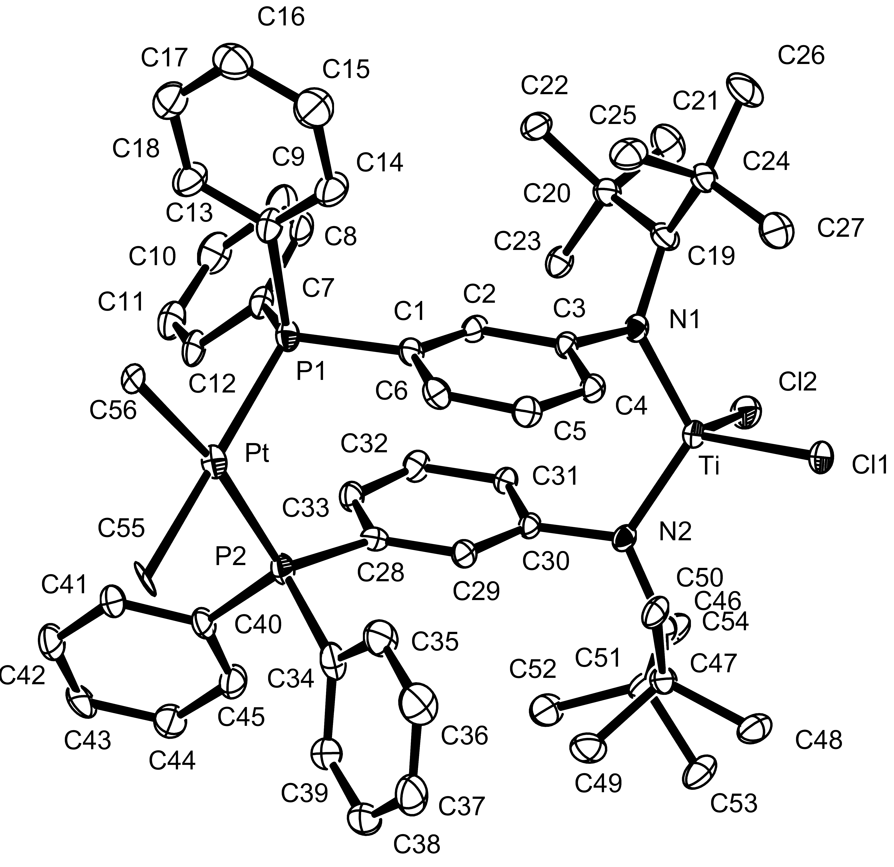
Ortep (50 % ellipsoids) diagram of the Ti···PtMe₂ complex, 9 (all hydrogens omitted for clarity)

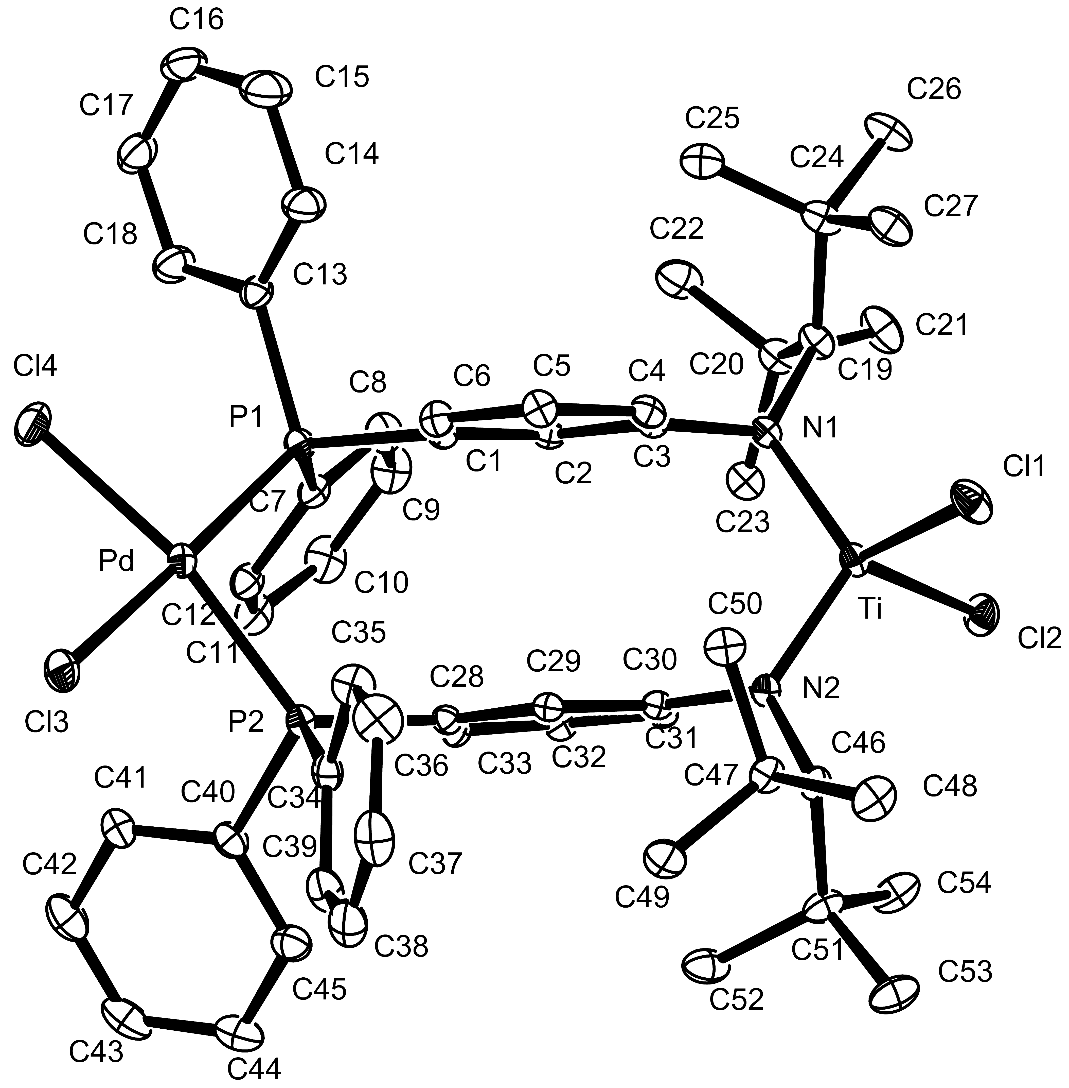

Ortep (50 % ellipsoids) diagram of the Ti···Pd complex, 10 (all hydrogens omitted for clarity)

