Kinetic Studies of Some Substituted Hexarhodium Carbonyl Clusters †
Claudia Babij,ª David H. Farrar,ª Igor O. Koshevoy,^{b} Anthony J. Poë,ª* and Sergey P. Tunik^{b}*
ª Department of Chemistry, University of Toronto, 80 St. George Street, Toronto, Ontario, Canada M5S 3H6. E-mail apoe@chem.utoronto.ca
^{b} Department of Chemistry, St. Petersburg University, Universitetskii pr., 26, St. Petersburg, 198504, Russian Federation, e-mail: stunik@chem.spbu.ru

Table S1 Kinetic data for the reactions of the Rh₆(CO)₁₅P(p-XC₆H₄)₃ clusters with bromide in the presence of oxygen and acid in CHCl₃.
X | T/ºC | [NBu₄Br]/mM | [TFA]/mM | 10⁴ k_{obs}/s⁻¹
CF₃ | 25.4 | 118 | 102 | 0.749
 |  | 146 | 102 | 0.734
 |  | 172 | 102 | 0.731
 |  | 211 | 102 | 0.749
 | 32.1 | 145 | 80 | 1.858
 |  | 173 | 80 | 1.884
 |  | 204 | 80 | 1.866
 | 35.8 | 118 | 102 | 2.955
 |  | 146 | 102 | 3.010
 |  | 172 | 102 | 2.976
 |  | 211 | 102 | 3.041
 | 46.5 | 118 | 102 | 12.54
 |  | 146 | 102 | 12.22
 |  | 211 | 102 | 12.43
Cl | 25.5 | 88 | 72 | 0.950
 |  | 158 | 72 | 0.950
 |  | 197 | 72 | 0.966
 | 32.1 | 145 | 80 | 2.491
 |  | 173 | 80 | 2.476
 |  | 204 | 80 | 2.587
 |  | 173 | 160 | 2.546
 | 38.4 | 145 | 80 | 5.053
 |  | 173 | 80 | 5.055
 |  | 204 | 80 | 5.183
 | 38.7 | 114 | 86 | 5.350
 |  | 142 | 86 | 5.481
 |  | 178 | 86 | 5.347
 | 44.6 | 114 | 86 | 10.42
 |  | 142 | 86 | 10.02
 |  | 178 | 86 | 10.08
 | 48.7 | 116 | 123 | 17.50
 |  | 148 | 123 | 17.32
 |  | 188 | 123 | 17.53
F | 21.4 | 123 | 100 | 0.680
 |  | 155 | 100 | 0.682
 |  | 204 | 100 | 0.706
 | 27.1 | 128 | 116 | 1.546
 |  | 155 | 116 | 1.545
 |  | 183 | 116 | 1.673
 | 36.8 | 128 | 116 | 5.807
 |  | 155 | 116 | 5.684
 |  | 183 | 116 | 5.765
 | 40.7 | 123 | 100 | 10.60
 |  | 155 | 100 | 10.68
 |  | 204 | 100 | 10.65
 | 45.9 | 128 | 116 | 20.36
 |  | 155 | 116 | 19.42
 |  | 183 | 116 | 20.35
H | 23.6 | 125 | 120 | 1.207
 |  | 161 | 120 | 1.168
 |  | 188 | 120 | 1.151
 | 31.4 | 125 | 120 | 3.130
 |  | 161 | 120 | 3.147
 |  | 188 | 120 | 3.145
 | 35.7 | 130 | 94 | 5.634
 |  | 166 | 94 | 5.787
 |  | 192 | 94 | 5.725
 | 41.6 | 130 | 94 | 12.81
 |  | 166 | 94 | 12.70
 |  | 192 | 94 | 12.72
 | 45.4 | 125 | 120 | 20.78
 |  | 161 | 120 | 23.08
 |  | 188 | 120 | 20.26
 | 50.2 | 130 | 94 | 36.17
 |  | 166 | 94 | 35.89
 |  | 192 | 94 | 36.19
MeO | 20.6 | 130 | 98 | 0.972
 |  | 155 | 98 | 0.969
 |  | 205 | 98 | 0.924
 | 35.1 | 128 | 93 | 5.590
 |  | 159 | 93 | 5.977
 |  | 200 | 93 | 5.814
 | 37.7 | 116 | 123 | 8.352
 |  | 148 | 123 | 8.537
 |  | 188 | 123 | 8.309
 | 37.9 | 130 | 98 | 8.648
 |  | 155 | 98 | 8.583
 |  | 205 | 98 | 9.087
 | 43.6 | 130 | 98 | 16.31
 |  | 155 | 98 | 15.89
 |  | 205 | 98 | 16.43
 | 49.6 | 128 | 93 | 32.34
 |  | 159 | 93 | 32.40
 |  | 200 | 93 | 33.99

Table S2 Kinetic data for the reaction of Rh₆(CO)₁₅PPh₃ with bromide under an oxygen-free atmosphere in CHCl₃, T = 38.5 ºC.
[Rh₆(CO)₁₅PPh₃]/mM | [NBu₄Br]/mM | 10³ k_{obs}/ s⁻¹
0.13 | 1.7 | 0.370
 | 3.2 | 0.430
 | 4.0 | 0.481
 | 12.8 | 0.595
 | 25.2 | 0.676
0.34 | 1.9 | 0.385
 | 4.7 | 0.481
 | 12.3 | 0.574
 | 18.8 | 0.634
 | 39.8 | 0.707
 | 50.2 | 0.725
 | 68.0 | 0.771
 | 75.2 | 0.757
 | 90.7 | 0.817
 | 93.1 | 0.803
0.82 | 2.67 | 0.389
 | 6.03 | 0.526
 | 14.3 | 0.660
 | 26.2 | 0.731

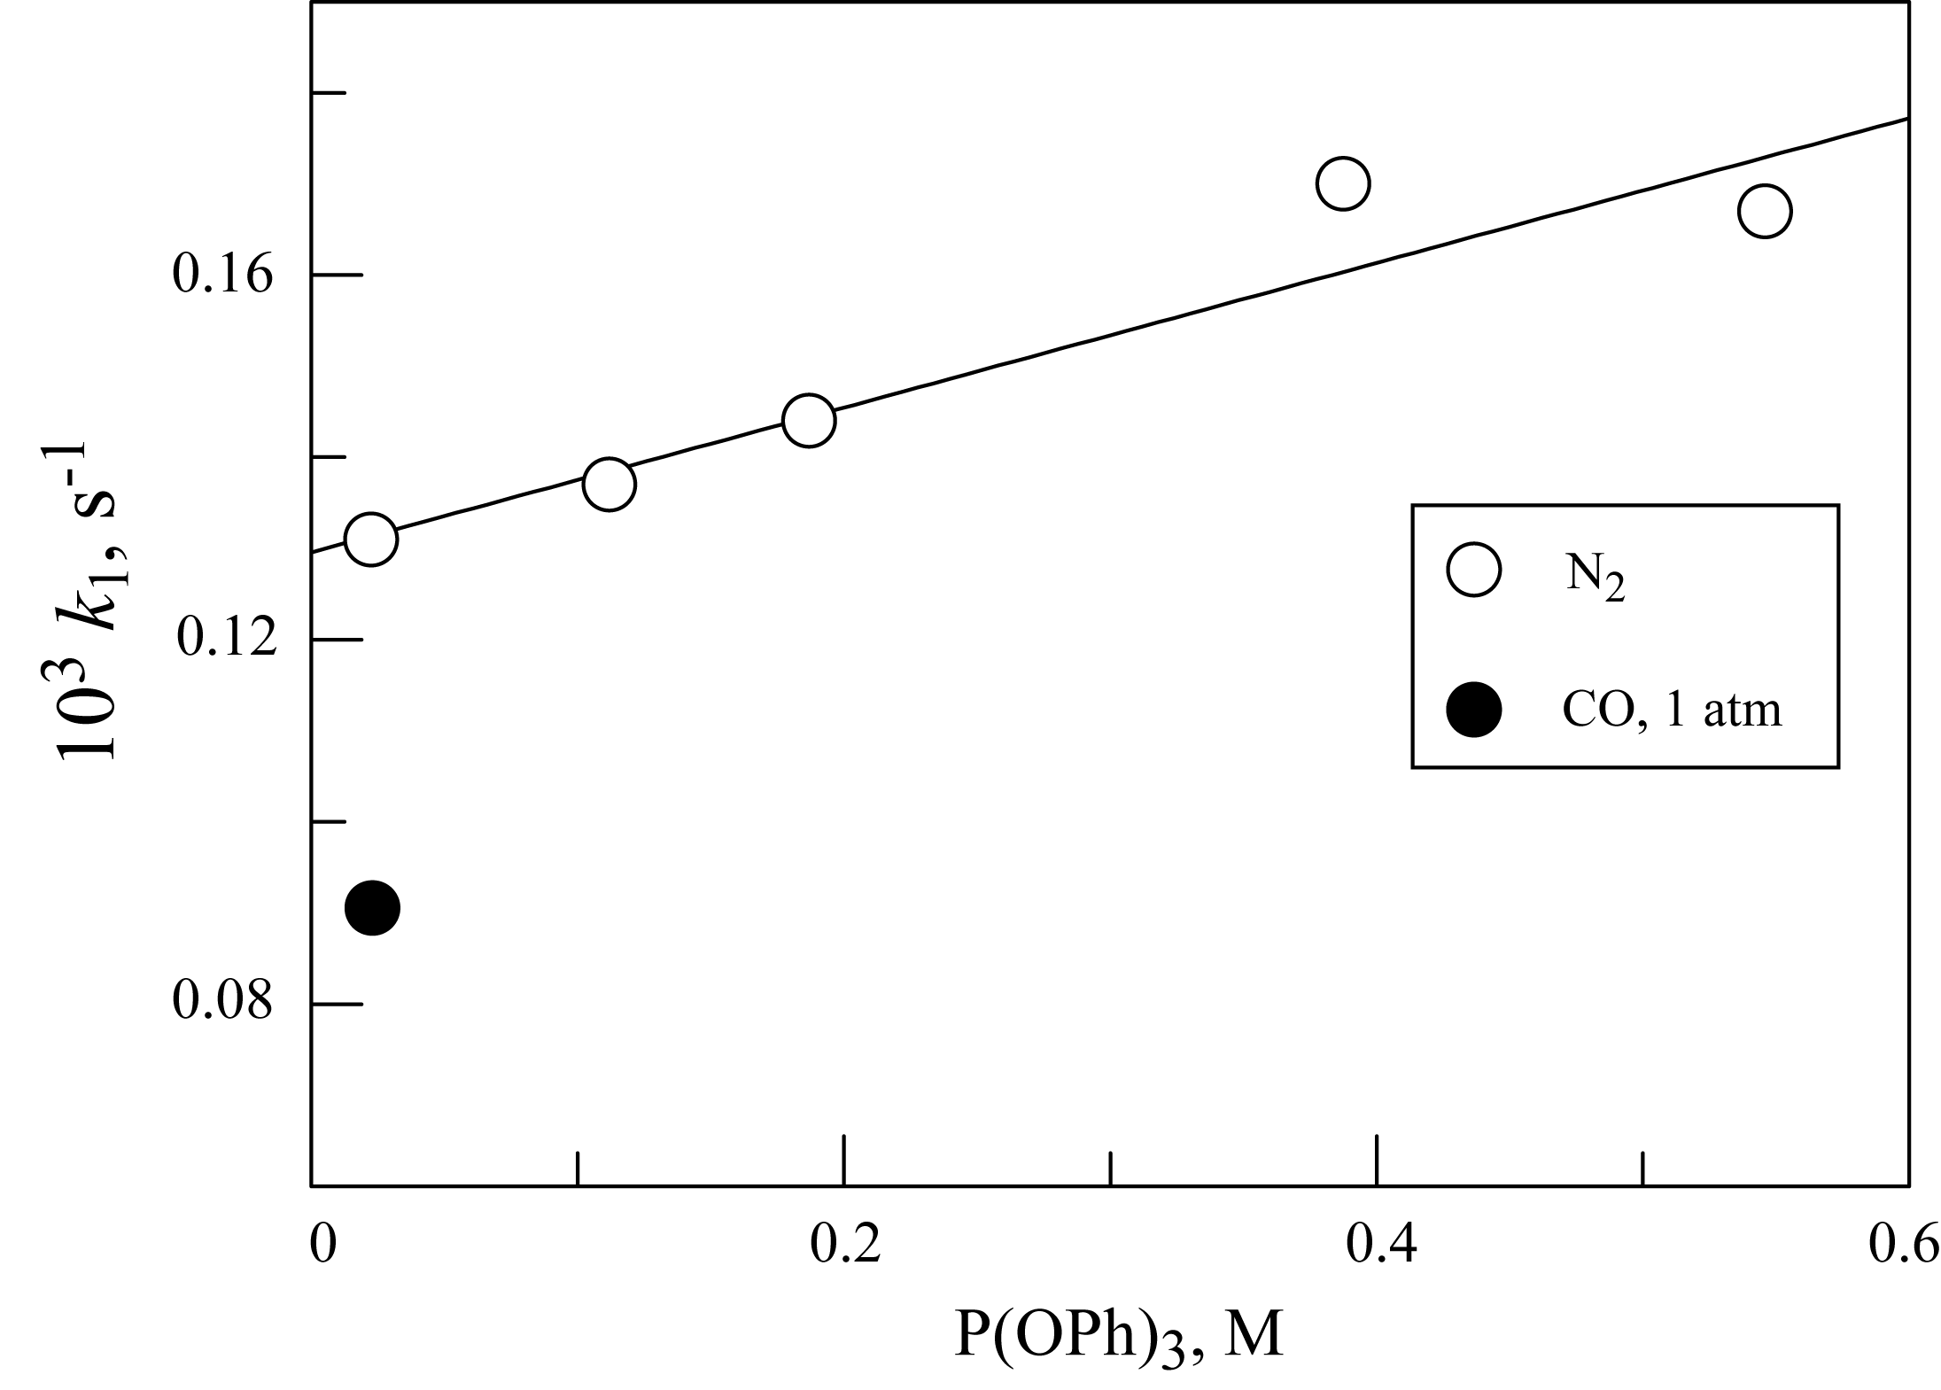
Fig. S1 Concentration dependence of k_{obs} for the reaction of Rh₆(CO)₁₅PPh₃ with P(OPh)₃ in oxygen-free CHCl₃ at 25.5 ºС. The reaction under 1 atm of CO was done at 26.5 ºC.

Reactions of hydroxide with Rh₆(CO)₁₆
Rh₆(CO)₁₆ reacts very rapidly at 25 °C in dichloromethane under nitrogen with Bu₄NOH to form a green solution which subsequently turns brown over several minutes with evolution of CO₂. Although the ultimate products are not well defined when the reactions are carried out under ‘kinetic conditions’, the initial step is believed to involve reversible addition of a hydroxide ion to form the hydroxycarbonyl [Rh₆(CO)₁₅(COOH)]⁻. Stopped flow measurements provide values of k₁ (15 × 10³ M⁻¹ s⁻¹), k₋₁ (7 s⁻¹) and K = k₁/k₋₁ (2 × 10³ M⁻¹) for addition and release of the hydroxide ion in CH₂Cl₂ at 25 °C.
These results are of interest because they show a remarkably high rate of formation of the hydroxycarbonyl adduct, much greater than those observed for M(CO)₅ (M= Fe, Ru or Os)¹, or for the reactions of MeO⁻ with M₃(CO)₁₂ (M = Fe, Ru or Os),² and it is interesting that a second hydroxide ion appears to be required before CO₂ is produced from this cluster.

1 R. J. Trautman, D. C. Gross, and P. C. Ford, J. Am. Chem. Soc., 1985, 107, 2355.
2 D. C. Gross and P. C. Ford, J. Am. Chem. Soc., 1985, 107, 585.

