Design and Synthesis of Heterobimetallic Donor-Acceptor Chemodosimetric Ensembles for the Detection of Sulfhydryl-Containing Amino Acids and Peptides

Cheuk-Fai Chowª, Hongyan Suiª, Michael H. W. Lam*ª, Wai-Yeung Wong^{b}

ª Department of Biology & Chemistry, City University of Hong Kong, 83 Tat Chee Ave., Hong Kong SAR, China
^{b} Department of Chemistry, Hong Kong Baptist University, Waterloo Road, Kowloon Tong, Hong Kong SAR, China

Supplementary Information
Figure S1 - Typical absorption spectra of cis-Fe^{II}(bpy)₂(CN)₂ (-----) and cis-{Fe^{II}(bpy)₂[CN⎯Pt(DMSO)Cl₂]₂} (1) (⎯⎯) in aqueous DMF (1:1 v/v) (pH 7) at room temperature.

Figure S2 – Absorption spectra of cis-Ru^{II}(bpy)₂(CN)₂ (-----) and cis-{Ru^{II}(bpy)₂[CN⎯Pt(DMSO)Cl₂]₂} (2) (⎯⎯) in aqueous DMF (1:1 v/v) (pH 7) at room temperature.

Figure S3 – Typical luminescent spectra of cis-Ru^{II}(bpy)₂(CN)₂ (-----) and cis-{Ru^{II}(bpy)₂[CN⎯Pt(DMSO)Cl₂]₂} (2) (⎯⎯) in aqueous DMF (1:1 v/v) (pH 7) at room temperature. Emission spectra were obtained with 467 nm excitation.

Figure S4 – Absorption spectra of cis-Os^{II}(bpy)₂(CN)₂ (-----) and cis-{Os^{II}(bpy)₂[CN⎯Pt(DMSO)Cl₂]₂} (3) (⎯⎯) in aqueous DMF (1:1 v/v) (pH 7) at room temperature.

Figure S5 – (i) Electrospray mass spectra of cis-{Fe^{II}(bpy)₂[CN⎯Pt(DMSO)Cl₂]₂} (1) in aqueous DMF (1:1 DMF:pH 7 v/v). (ii) Isotopic distribution of ES-MS of the [M+DMF-Cl]⁺ peak of (1) (C₂₉FeH₃₅N₇O₃S₂Cl₃Pt₂) at m/z 1146 in aqueous DMF (1:1 DMF:pH 7 v/v).

(i)

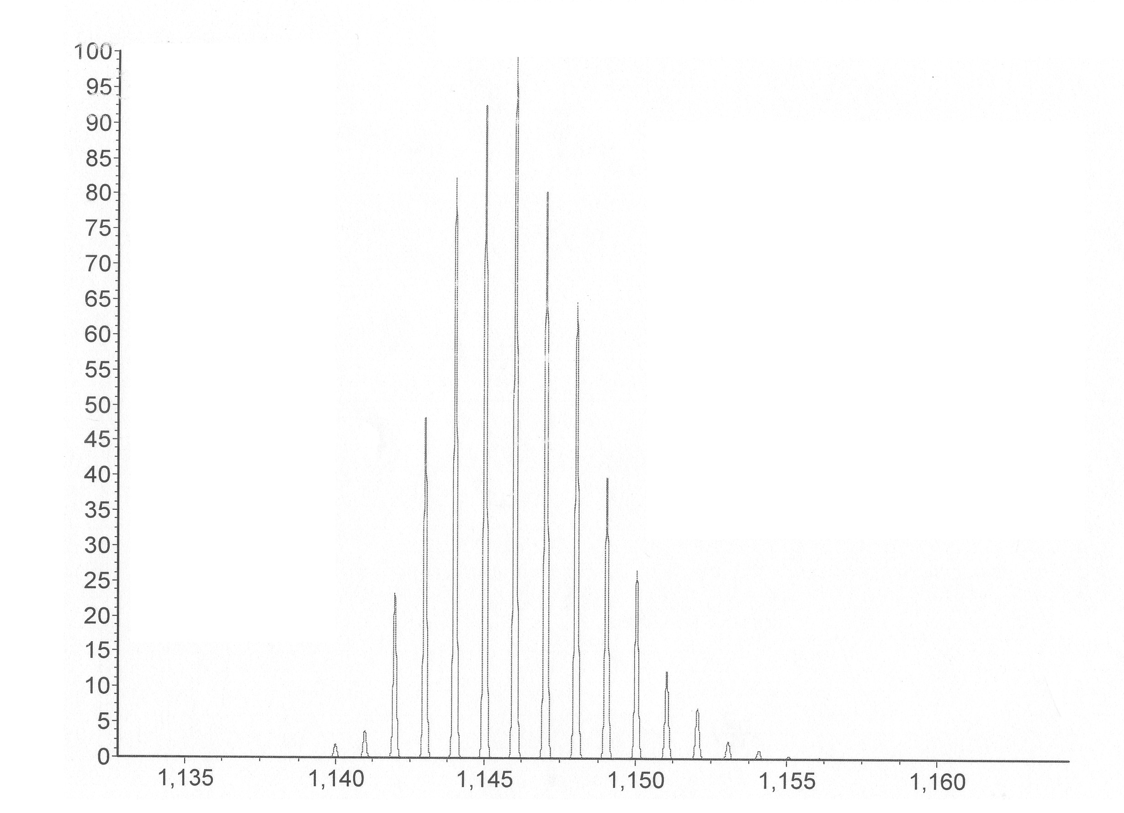
simulation of the [M+DMF-Cl]⁺ (C₂₉FeH₃₅N₇O₃S₂Cl₃Pt₂)
at m/z 1146.
(ii)

Figure S6 – (i) Electrospray mass spectra of cis-{Ru^{II}(bpy)₂[CN⎯Pt(DMSO)Cl₂]₂} (2) in aqueous DMF (1:1 DMF:pH 7 v/v). (ii) Isotopic distribution of ES-MS of the [M-Cl]⁺ peak of (2) (C₂₆H₂₈N₆O₂S₂Cl₃RuPt₂) at m/z 1118 in aqueous DMF (1:1 DMF:pH 7 v/v).

(i)

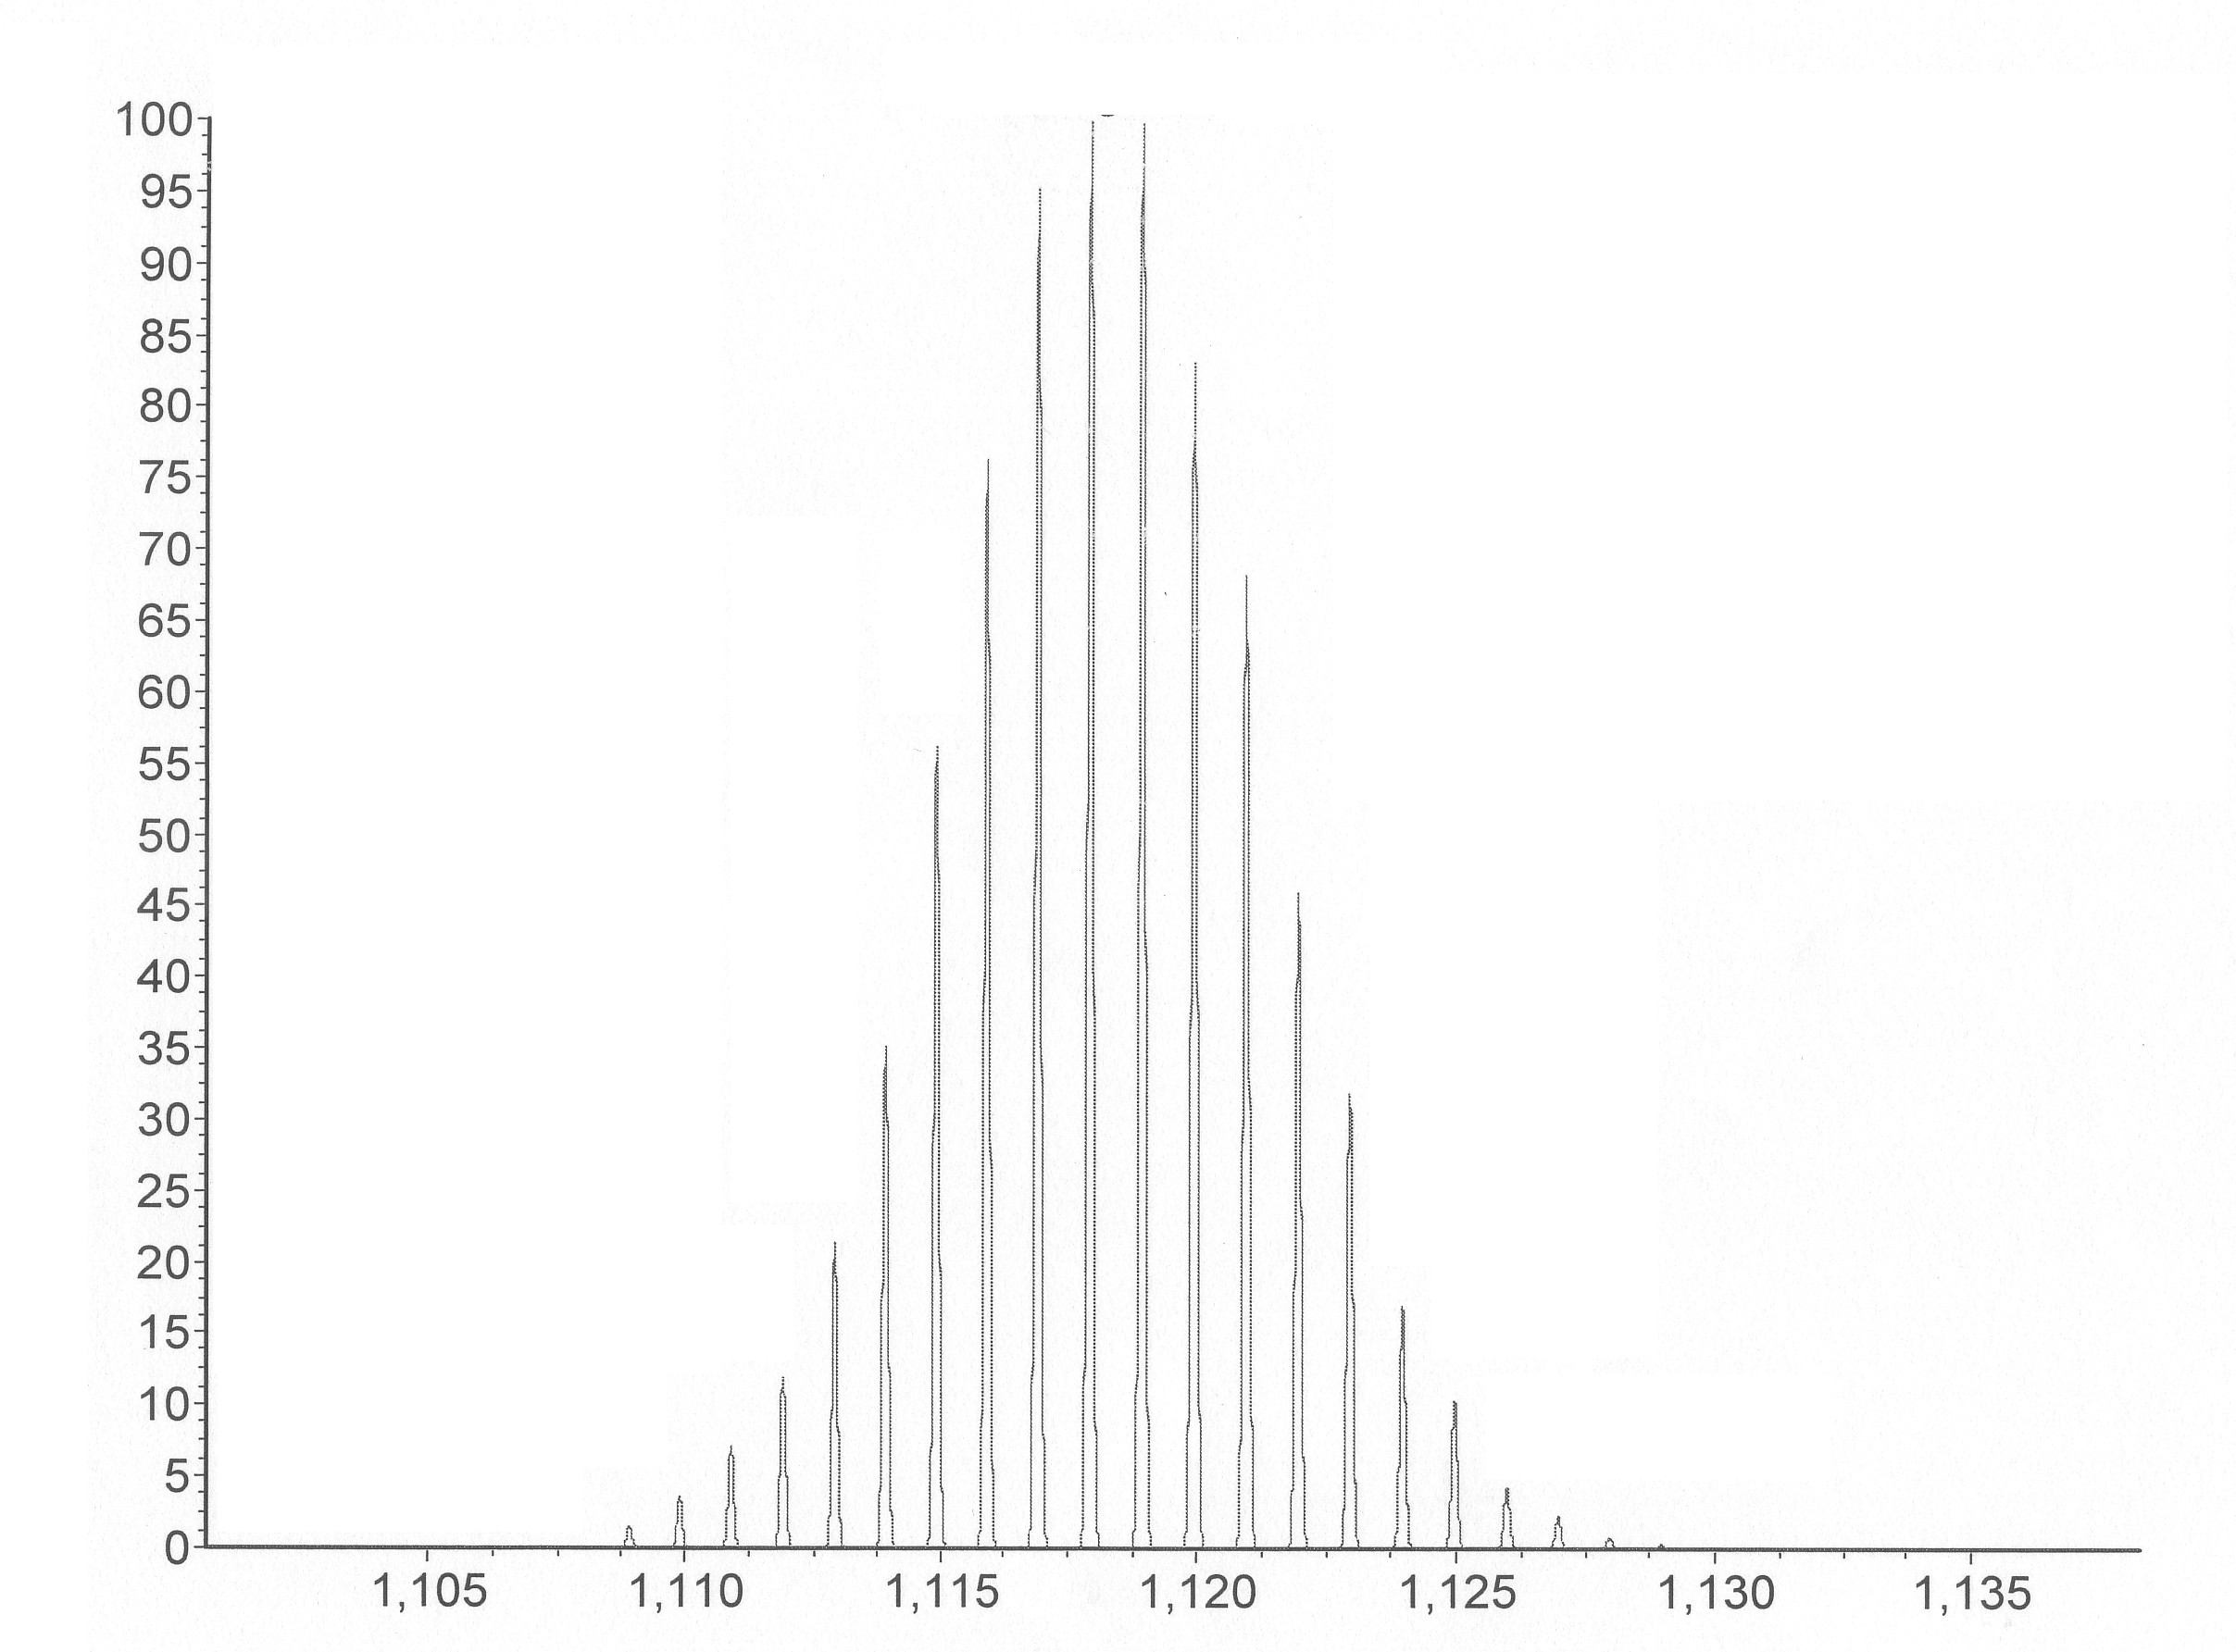
simulation of the [M-Cl]⁺ (C₂₆H₂₈N₆O₂S₂Cl₃RuPt₂) at m/z 1118

(ii)

(ii)
Figure S7 – (i) Electrospray mass spectra of cis-{Os^{II}(bpy)₂[CN⎯Pt(DMSO)Cl₂]₂} (3) in aqueous DMF (1:1 DMF:pH 7 v/v). (ii) Isotopic distribution of ES-MS of the [M+DMF-Cl]⁺ peak of (3) (C₂₉H₃₅N₇O₃OsS₂Cl₃Pt₂) at m/z 1280 in aqueous DMF (1:1 DMF:pH 7 v/v).

(i)
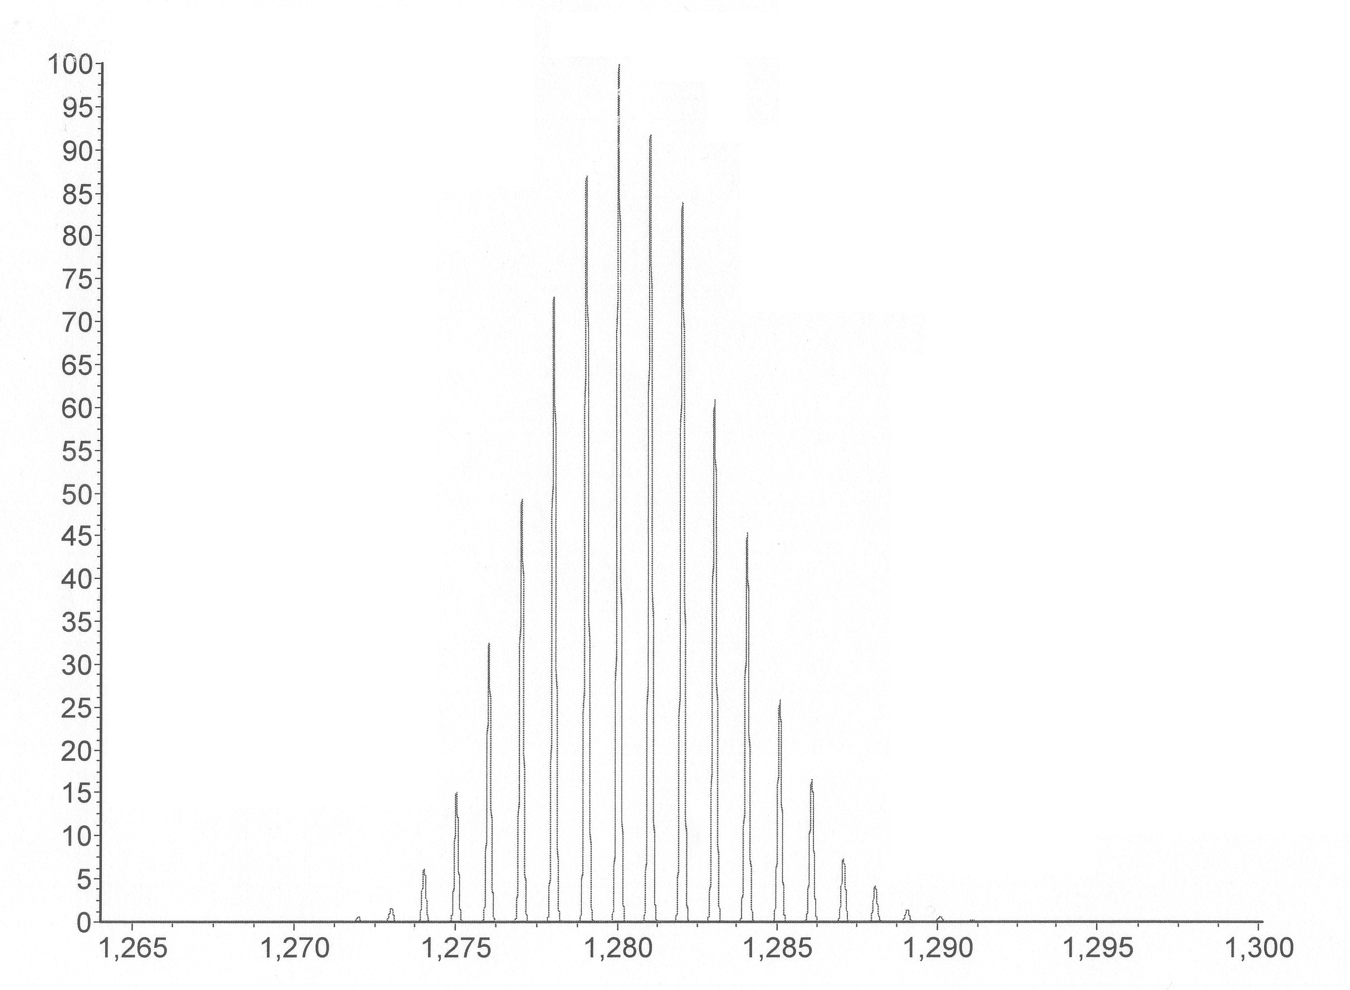
simulation of the [M+DMF-Cl]⁺ (C₂₉H₃₅N₇O₃OsS₂Cl₃Pt₂)
at m/z 1280.
(ii)

Figure S8 – Responses of the in-situ formed donor-acceptor ensembles to common amino acids and GSH. E5 represents the {cis-[Ru^{II}(bpy)₂(CN)₂] + CrCl₃} ensemble; E6 represents the {cis-[Ru^{II}(bpy)₂(CN)₂] + MnCl₂} ensemble; E7 represents the {cis-[Ru^{II}(bpy)₂(CN)₂] + CoCl₂}; E8 represents the {cis-[Ru^{II}(bpy)₂(CN)₂] + NiCl₂} ensemble; E9 represents the {cis-[Ru^{II}(bpy)₂(CN)₂] + CuCl₂} ensemble; E10 represents the {cis-[Ru^{II}(bpy)₂(CN)₂] + ZnCl₂} ensemble.

S10
S13

Figure S9 – Spectroscopic titration of Pt(DMSO)₂Cl₂ (2 × 10⁻⁵ M) with common amino acids and GSH in aqueous DMF (buffered at pH 7 by HEFES), ionic strength = 0.01 M, at 25 °C. For GSH and Hcys, change in absorbance at 275 nm was monitored. For Ala, Asn, Gln, Ser and Val, change in absorbance at 295 nm was monitored. For Asp, His, Glu, Gly, Leu, Lys, Met, Phe and Pro, change in absorbance at 325 nm was monitored. For Arg, change in absorbance at 395 nm was monitored.

Figure S9 – Spectroscopic titration of Pt(DMSO)₂Cl₂ (2 × 10⁻⁵ M) with common amino acids and GSH in aqueous DMF (buffered at pH 7 by HEFES), ionic strength = 0.01 M, at 25 °C. For GSH and Hcys, change in absorbance at 275 nm was monitored. For Ala, Asn, Gln, Ser and Val, change in absorbance at 295 nm was monitored. For Asp, His, Glu, Gly, Leu, Lys, Met, Phe and Pro, change in absorbance at 325 nm was monitored. For Arg, change in absorbance at 395 nm was monitored.

Figure S9 – Spectroscopic titration of Pt(DMSO)₂Cl₂ (2 × 10⁻⁵ M) with common amino acids and GSH in aqueous DMF (buffered at pH 7 by HEFES), ionic strength = 0.01 M, at 25 °C. For GSH and Hcys, change in absorbance at 275 nm was monitored. For Ala, Asn, Gln, Ser and Val, change in absorbance at 295 nm was monitored. For Asp, His, Glu, Gly, Leu, Lys, Met, Phe and Pro, change in absorbance at 325 nm was monitored. For Arg, change in absorbance at 395 nm was monitored.

Table S1 – Comparison of the energy of formation of adducts between various amino acids, GSH, cis-[Ru^{II}(bpy)₂(CN)₂] and K₂Ru^{II}(^{t}Bubpy)(CN)₄ and different acceptor metal centers.

 | cis-Ru(bpy)₂(CN)₂ | K₂Ru(^{t}Bubpy)(CN)₄ | GSH | Cys | Hcys | Met | His | Ser | Asp | Glu | Arg | Gly | Ala | Val | Leu | Asn | Gln | Lys | Phe | Pro
CrCl₃·6H₂O | 11.8^{(a)} | 18.3^{(a)} | No ref. | 50.2^{(b)} | No ref. | 44.5^{(b)} | No ref. | 49.6^{(b)} | 75.3^{(b)} | 71.3^{(b)} | 45.6^{(b)} | 51.3^{(b)} | 50.8^{(b)} | 47.4^{(d)} | 50.8^{(b)} | 43.9^{(b)} | No ref. | 46.2^{(b)} | No ref. | No ref.
MnCl₂·4H₂O | 17.2^{(a)} | 21.5^{(a)} | 20.5^{(b)} | 28.5^{(b)} | No ref. | 29.1^{(b)} | 21.7^{(b)} | 15.4^{(b)} | 22.8^{(b)} | 20.0^{(b)} | 16.0^{(b)} | 17.7^{(b)} | 16.5^{(b)} | 16.0^{(b)} | 18.3^{(b)} | 17.7^{(b)} | 18.3^{(b)} | 12.6^{(b)} | 18.3^{(b)} | 15.4^{(b)}
FeCl₂·4H₂O | 16.1^{(a)} | 18.9^{(a)} | 18.0^{(a)} | 18.0^{(a)} | 18.7^{(a)} | 7.8^{(a)} | 15.3^{(a)} | 14.5^{(a)} | 7.7^{(a)} | 14.3^{(a)} | 10.1^{(a)} | 12.1^{(a)} | 5.4^{(a)} | 11.2^{(a)} | u.d. | 14.2^{(a)} | 11.5^{(a)} | 7.4^{(a)} | 10.6^{(a)} | 7.7^{(a)}
CoCl₂·6H₂O | 8.2^{(a)} | 27.0^{(a)} | 29.1^{(b)} | 49.6^{(b)} | No ref. | 25.1^{(b)} | 40.5^{(b)} | 26.8^{(b)} | 35.9^{(b)} | 28.5^{(b)} | 24.5^{(b)} | 28.5^{(b)} | 26.2^{(b)} | 26.2^{(b)} | 25.7^{(b)} | 26.2^{(b)} | 24.5^{(b)} | 29.1^{(b)} | 24.0^{(b)} | 30.2^{(b)}
NiCl₂·6H₂O | 10.6^{(a)} | 23.1^{(a)} | 33.7^{(b)} | 53.6^{(b)} | No ref. | 31.9^{(b)} | 50.7^{(b)} | 30.8^{(b)} | 43.9^{(b)} | 38.2^{(b)} | 29.1^{(b)} | 34.2^{(b)} | 32.5^{(b)} | 31.4^{(b)} | 31.9^{(b)} | 33.7^{(b)} | 30.8^{(b)} | 34.8^{b)} | 30.2^{(b)} | 34.8^{(b)}
CuCl₂·2H₂O | 18.5^{(a)} | 29.4^{(a)} | No ref. | 39.9^{(b)} | No ref. | 46.2^{(b)} | 59.3^{(b)} | 46.8^{(b)} | 51.3^{(b)} | 48.5^{(b)} | 45.1^{(b)} | 48.5^{(b)} | 47.9^{(b)} | 46.8^{(b)} | 48.5^{(b)} | 45.6^{(b)} | 43.9^{(b)} | 47.9^{(b)} | 46.8^{(b)} | 51.9^{(b)}
ZnCl₂ | 11.7^{(a)} | 27.0^{(a)} | 52.5^{(b)} | 54.2^{(b)} | No ref. | 26.2^{(b)} | 38.8^{(b)} | 27.4^{(b)} | 35.9^{(b)} | 35.4^{(b)} | 24.5^{(b)} | 30.2^{(b)} | 28.0^{(b)} | 26.8^{(b)} | 28.0^{(b)} | 26.8^{(b)} | 26.2^{(b)} | 38.2^{(b)} | 28.0^{(b)} | 31.4^{(b)}
Pd(DMSO)₂Cl₂ | 26.0^{(a)} | 31.1^{(a)} | No ref. | 155.7^{(b)} | No ref. | 95.8^{(b)} | 84.1^{(b)} | 62.8^{(b)} | 59.3^{(b)} | 59.3^{(b)} | No ref. | 62.8^{(b)} | 65.0 ^{(b)} | 65.0 ^{(b)} | 65.0 ^{(b)} | 73.0^{(b)} | 62.8^{(b)} | 65.6^{(b)} | 62.2^{(b)} | 66.2^{(b)}
Pt(DMSO)₂Cl₂ | 24.6^{(a)} | 31.4^{(a)} | 27.7^{(a)} | 27.4^{(a)} | 27.4^{(a)} | 25.8^{(a)} | 14.4^{(a)} | 5.8^{(a)} | 14.4^{(a)} | 12.9^{(a)} | 3.9^{(a)} | 11.7^{(a)} | 12.8^{(a)} | 13.8^{(a)} | 9.9^{(a)} | 12.6^{(a)} | 14.9^{(a)} | 12.2^{(a)} | 9.6^{(a)} | 11.6^{(a)}

Note: ª ΔGº were measured by spectroscopic titration in DMF: phosphate pH 7 aqueous buffer (v/v 1:1), ionic strength 0.01M at 25°C (Figure S9).

^{b} ΔGº cited from SC-Database. Data were obtained at 25°C in aqueous media.
n.d. – too small to be determined

