Ternary iron(II) complex with an emissive imidazopyridine arm from Schiff base cyclizations and its oxidative DNA cleavage activity
Arindam Mukherjee, Shanta Dhar, Munirathinam Nethaji, and Akhil R. Chakravarty*
Department of Inorganic and Physical Chemistry, Indian Institute of Science, Bangalore 560012, India. Fax: 91-80-23600683; Tel: 91-80-22932533; E-mail: arc@ipc.iisc.ernet.in
This submission was created using the RSC Article Template (DO NOT DELETE THIS TEXT)
(LINE INCLUDED FOR SPACING ONLY - DO NOT DELETE THIS TEXT)

Supplimentary Information

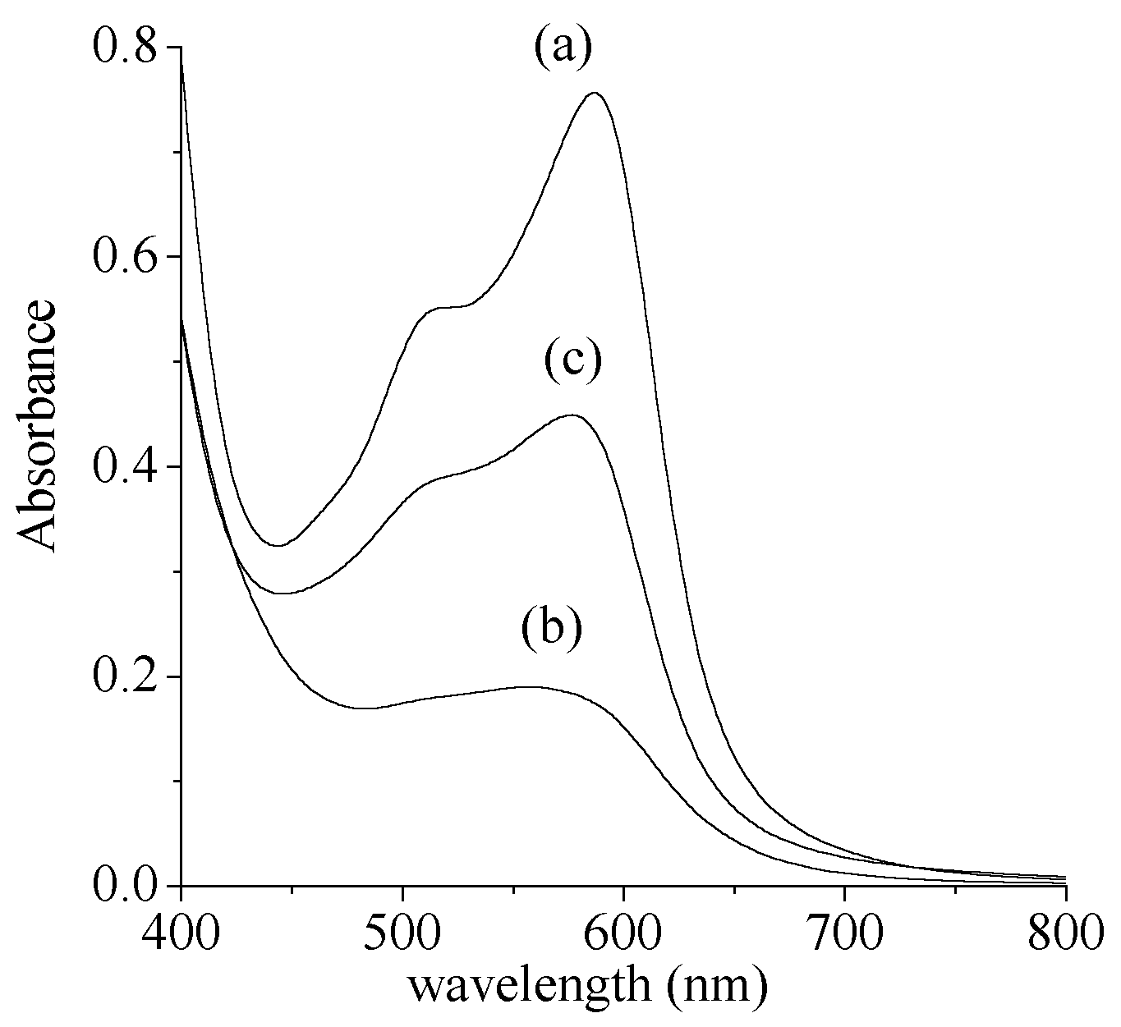
Fig. S1 Visible spectral traces showing the conversion of 1 (a) to its oxidized species (b) on treatment with Ce(IV) ion and regeneration of ~50% of 1 on addition of sodium ascorbate (c) in 2% aqueous MeCN.
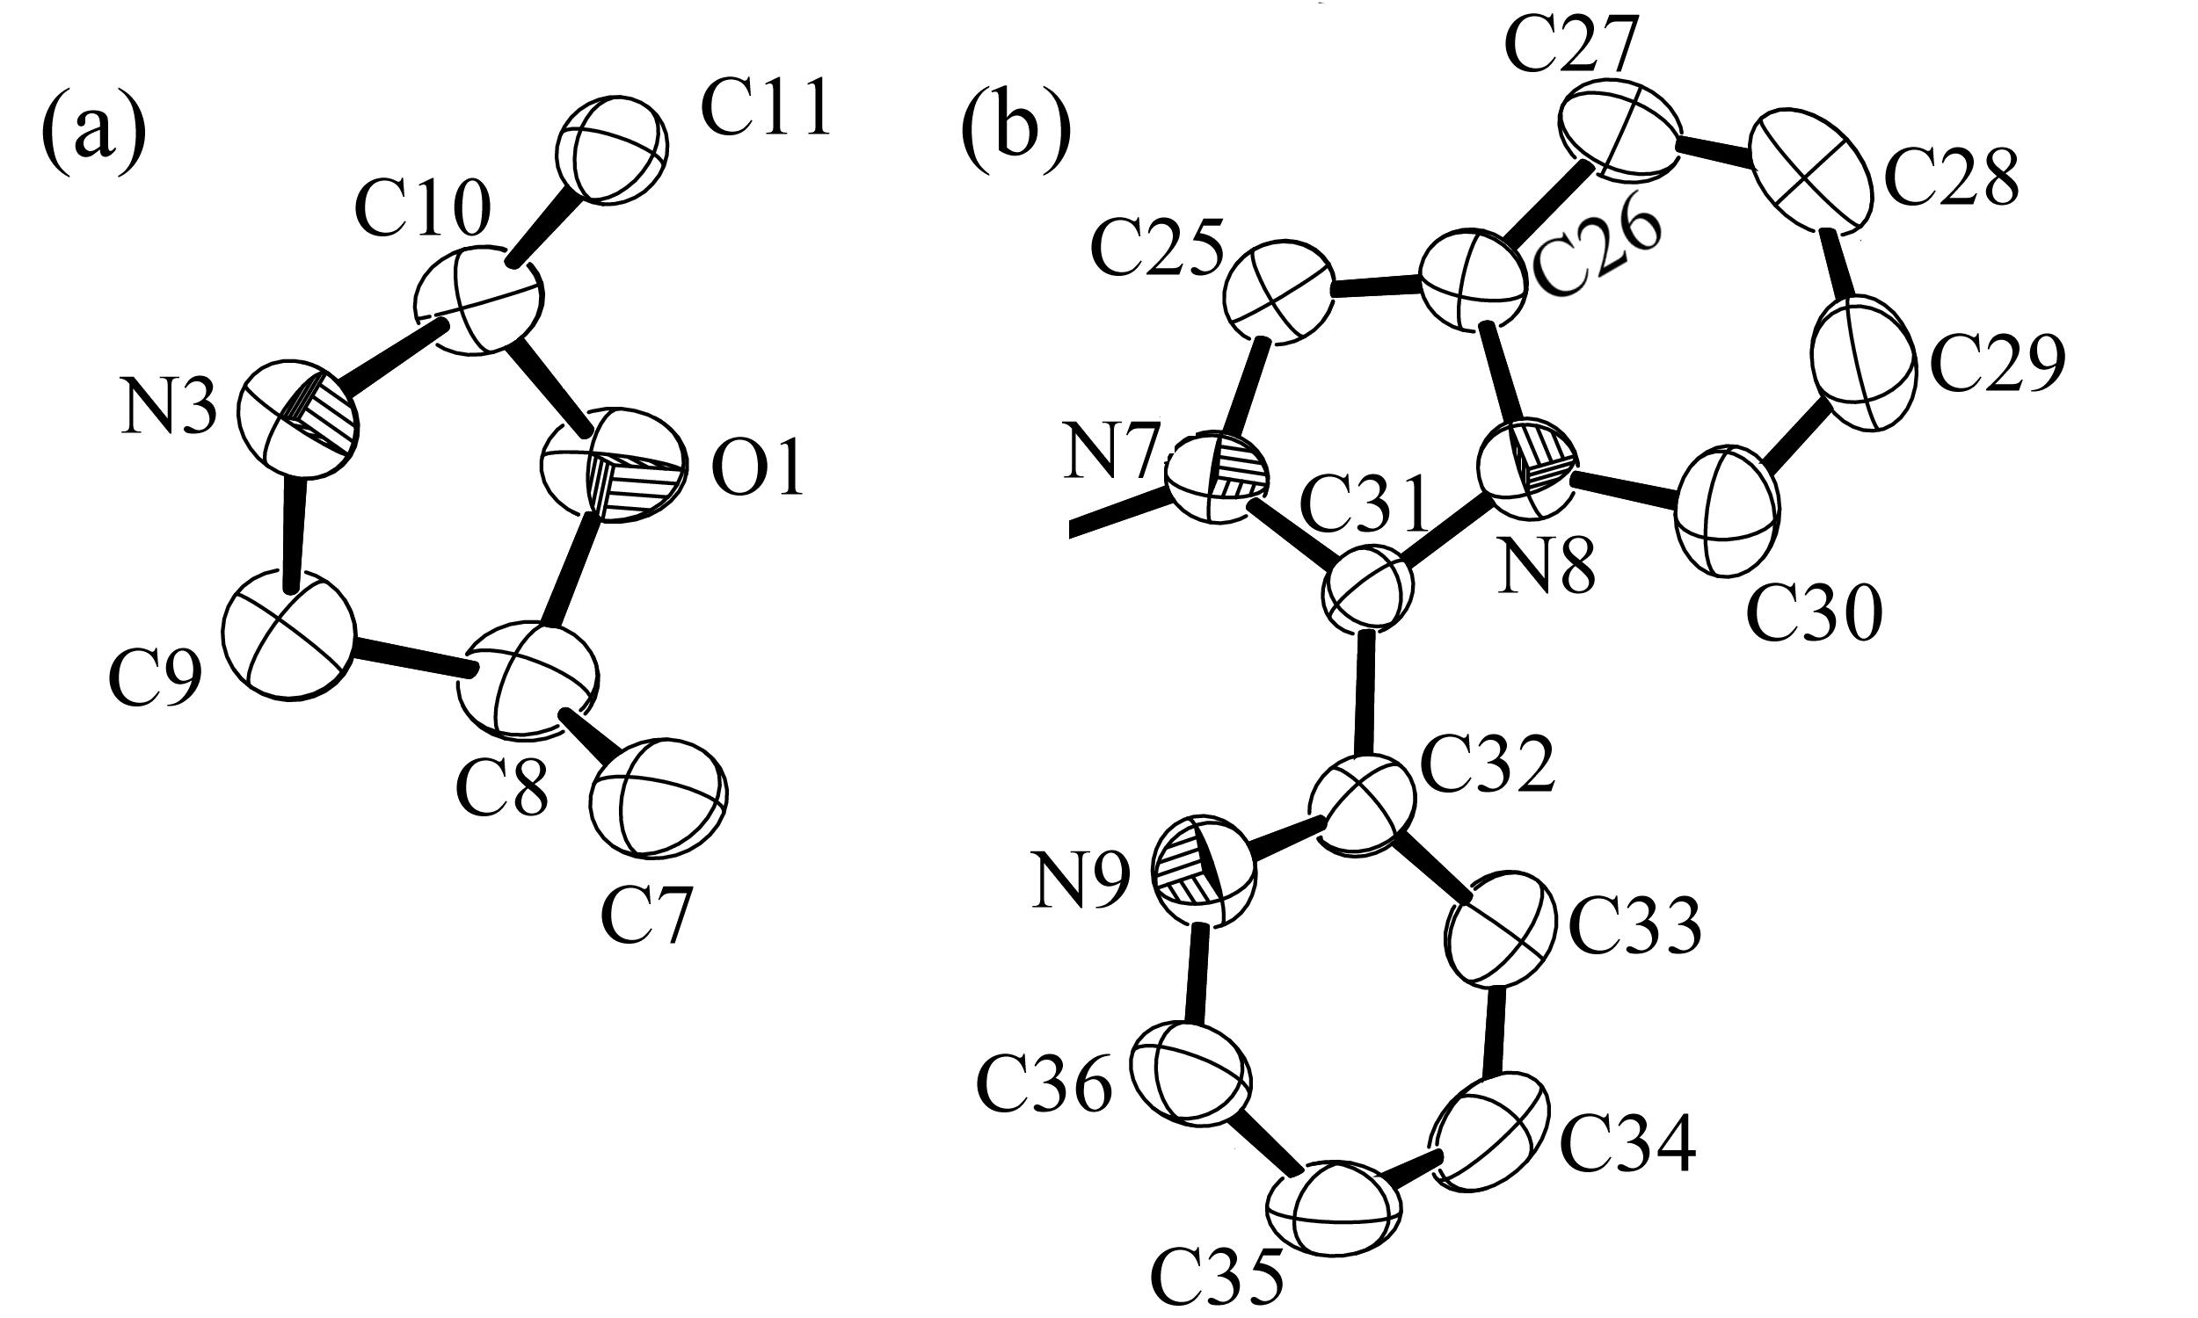
Fig. S2 Structure of the five-membered ring of L’ (a) and imidazopyridine moiety of L” (b) from Schiff base cyclization reactions forming 1.

