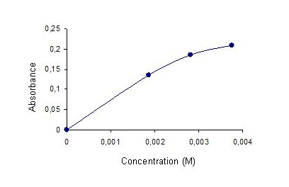

Release of iron from ferritin by catechol at concentrations 1.87, 2.81 and 3.75 mM. The amount of iron removed was ligand concentration-dependent, although the increase was not linear with the concentration of catechol.

Wavelength nm
B
A

Wavelength nm
C

Spectral changes accompanying iron removal from ferritin by catechol. Anaerobic conditions: A) [ferritin]= 0.19 mg/ml, [catechol]= 3.75 mM, pH 7.4, 25ºC, B) [ferritin]= 0.19 mg/ml, [catechol]= 1.81 mM, pH 7.4, 25ºC; C) [ferritin]= 0.19 mg/ml, [catechol]= 2.81 mM, pH 7.4, 25ºC. Each spectrum was taken at successive 10-min intervals after the start of reaction

