Supporting Information

Charge-Transfer Guest Interactions in Luminescent MOFs: Implications for Solid-state Temperature and Environmental Sensing
Patrick L. Feng, Kirsty Leong, and Mark D. Allendorf

Sandia National Laboratories, Livermore, CA 94550-0969
E-mail: plfeng@sandia.gov; mdallen@sandia.gov

KEYWORDS: Metal-Organic Frameworks, charge-transfer complex, ratiometric, fluorescence, sensing

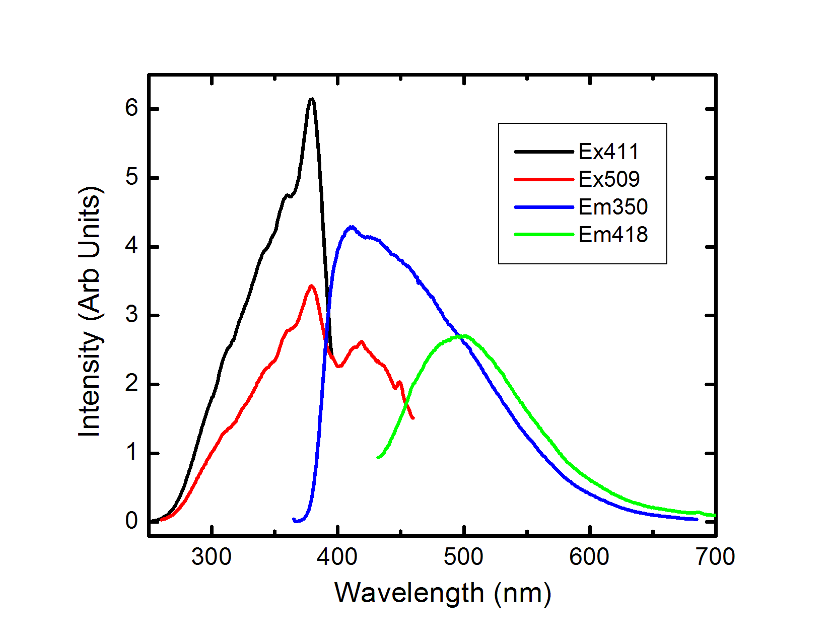
Figure S1. Steady-state photoluminescence spectra for complex 2, highlighting the wavelength-dependent excitation and emission characteristics.

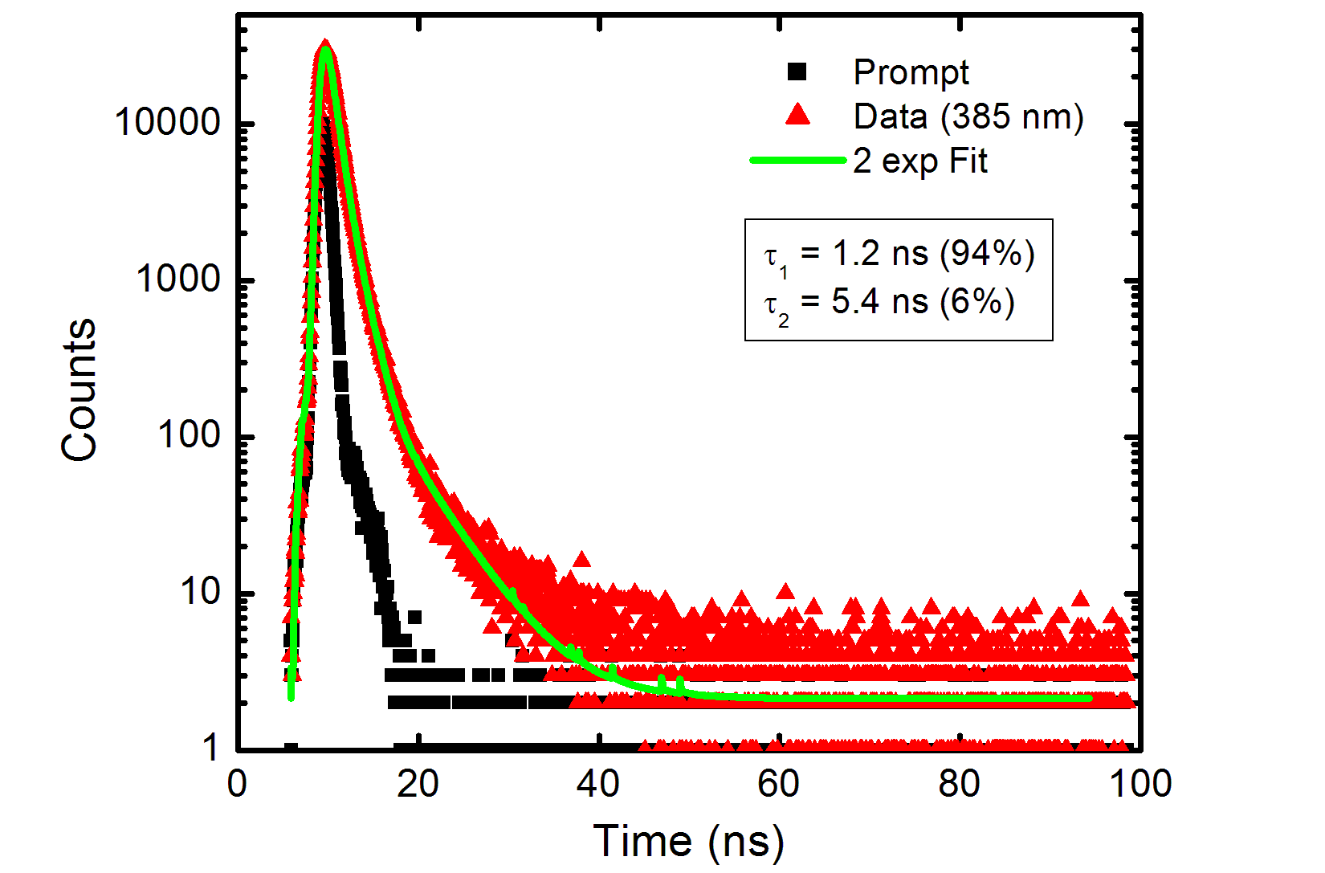
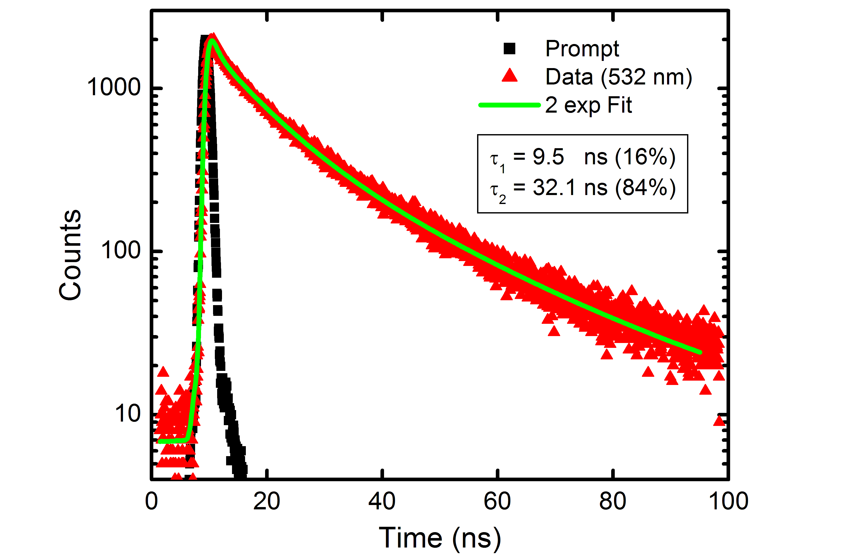

Figure S2. Time-resolved photoluminescence data collected at the monomer emission maximum of 385nm (top) and charge-transfer emission at 532nm (bottom) for complex 1b, both collected at an excitation wavelength of (λ_{ex} = 341 nm).

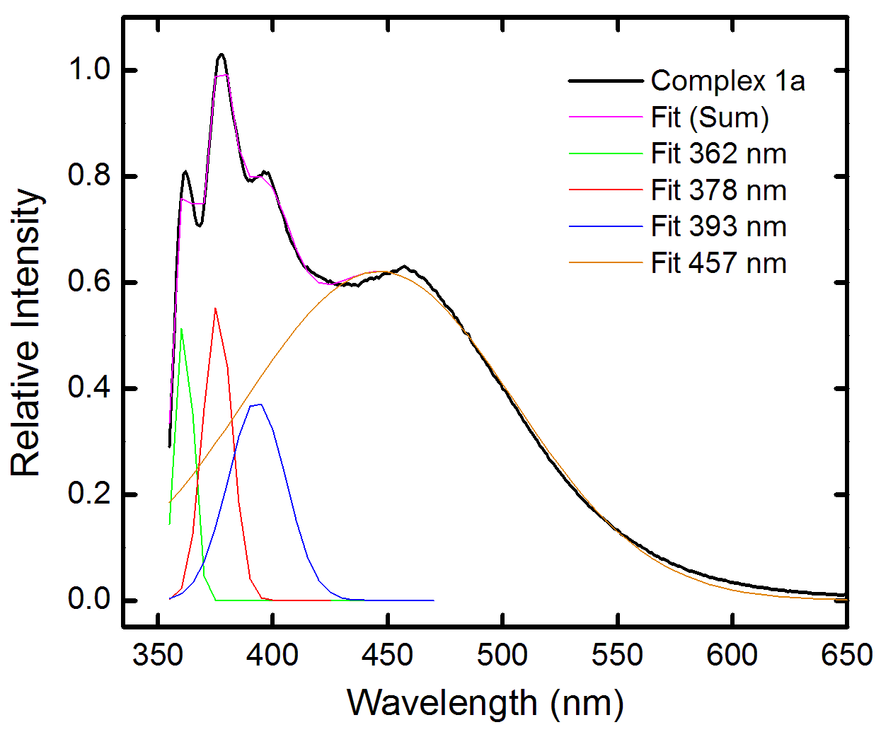
Figure S3. Representative Gaussian fit for the photoluminescence spectrum of 1a, collected at λ_{ex}=340nm.

Table S1. Gaussian fitting parameters corresponding to the fits shown in Figure S3.
Gaussian Fit
R^2 =0.99868
y0 0 ±0
362 nm
Center 361.36145 ±0.07375
Width 7.78245 ±0.14925
Area 5324605.83599 ±133884.95693
378 nm
Center 375.75704 ±0.10477
Width 12.4626 ±0.37759
Area 8692210.7243 ±563224.84184
393 nm
Center 392.94668 ±0.70019
Width 25.322 ±1.05575
Area 11934167.70365 ±762781.17073
457 nm
Center 446.23444 ±0.54683
Width 117.25208 ±0.81584

