Triethoxysilyl Substituted Aminoethanethiol Ligands for Zinc and Cadmium Complexes and Aminoethanethiol-modified Silica Gel. Evaluation of the Corresponding Supported Molecular Trap for Metallic Pollutant Uptake (Cd²⁺, Hg²⁺ and Pb²⁺).

C. Bresson, M.-J. Menu*, M. Dartiguenave and Y. Dartiguenave

Supplementary material

Figure and table captions

Figure 1 : Mass spectra (ESI) of {Cd[(EtO)₃Si(CH₂)₃NH₂(CH₂)₂S]Cl₂}₂, 2a
a) c = 0.015 g.L⁻¹ b) c = 0.030 g.L⁻¹ c) c = 0.150 g.L⁻¹

Table 1 : Evolution of the ratio I_{t}/I_{d} of tetramer and dimer relatives intensities with the sample concentration

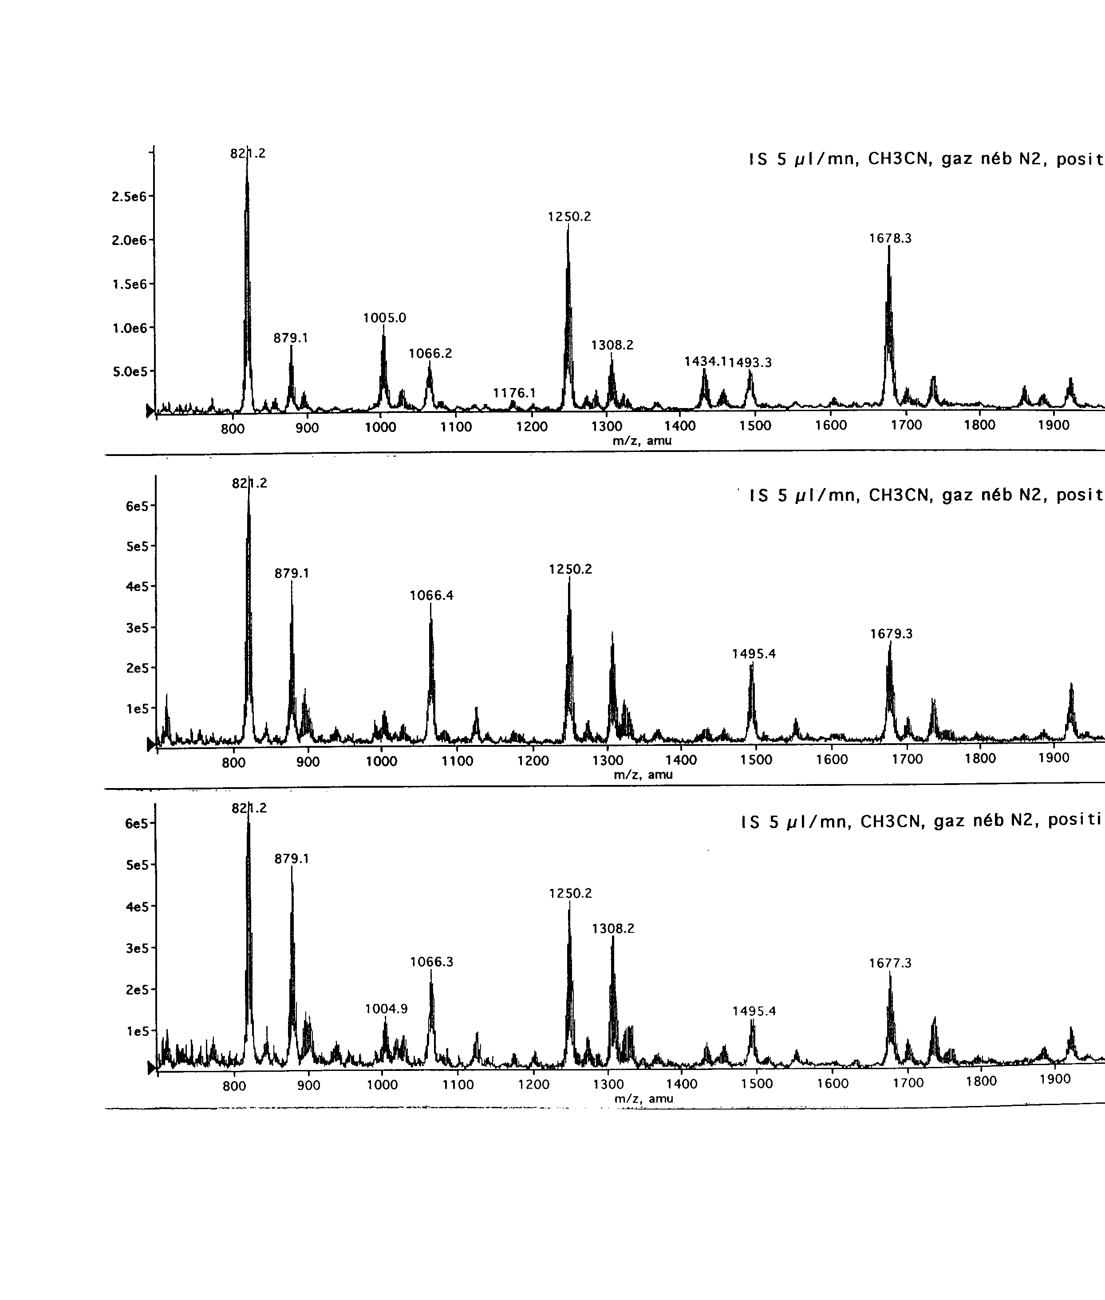
Figure 1 : Mass spectra (ESI) of {Cd[(EtO)₃Si(CH₂)₃NH₂(CH₂)₂S]Cl₂}_{2,} 2a
a) c = 0.015 g/L ; b) c = 0.03 g/L ; c) c = 0.15 g/L
Dimer
Dimer
Dimer
Tetramer
Tetramer
Tetramer
a)
b)
c)
Trimer
Trimer
Trimer

Table 1 : Evolution of the ratio It/Id of tetramer and dimer relatives intensities with the sample concentration

Concentration (g.L⁻¹) | I_{t}/I_{d}
0.015 | 0.36
0.030 | 0.37
0.300 | 0.54
1.500 | 0.61

