Supplementary Material (ESI) for Green Chemistry
This journal is © The Royal Society of Chemistry 2007

Halide-free Highly-pure Imidazolium Triflate Ionic Liquids: Preparation and Use in Palladium-Catalysed Allylic Alkylation

Loïc Leclercq,ª Isabelle Suisse,ª Guy Nowogrockiª and Francine Agbossou-Niedercorn*ª

ª Unité Catalyse et Chimie du Solide UMR CNRS 8181, ENSCL (CHIMIE), BT C7, BP 90108, 59652 Villeneuve d’Ascq Cedex, France. Fax: 33 3 20 43 65 85; Tel 33 3 20 43 49 27; E-mail: francine.agbossou@ensc-lille.fr

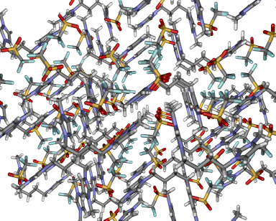

The cation coordination environment in 16 obtained by X-ray diffraction structure analysis.

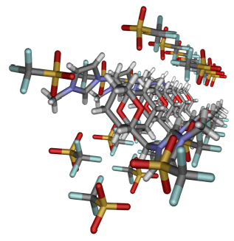

A view of the molecular arrangement in 16 obtained by X-Ray crystal structure analysis.

