Supplementary data

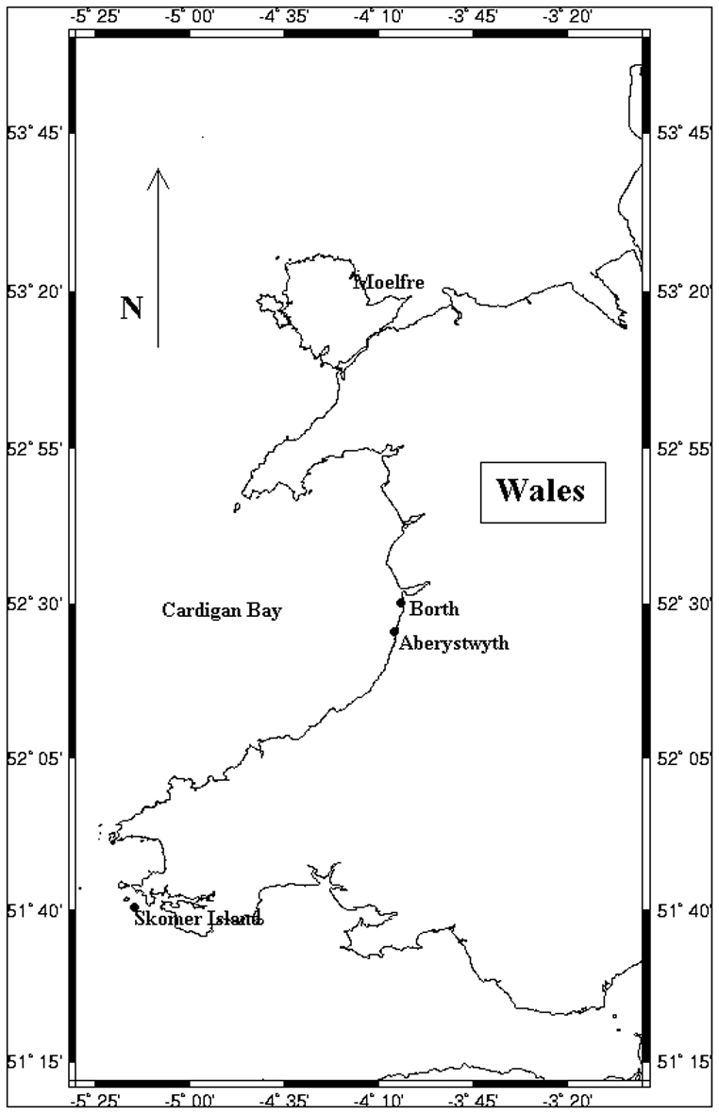
Map 1 Map of Cardigan Bay showing sample site for Arctica islandica (Borth) and sample sites for temperature measurement (Skomer in the south and Moelfre in the north).
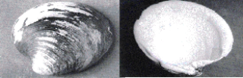
Fig. 1 View of unarticulated Arctica shell. Showing external Periostracum (dark colouring) and internal nacreous layer (light coloured). Shell show is 8cm by 10cm.

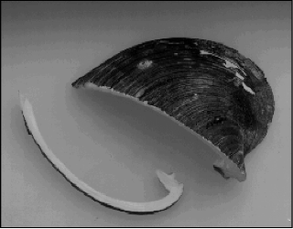
Fig. 2 Sawn left valve of Arctica shell with 10mm thick section for analyses also shown. Section shown is 8cm long.

