This journal © The Royal Society of Chemistry 2007

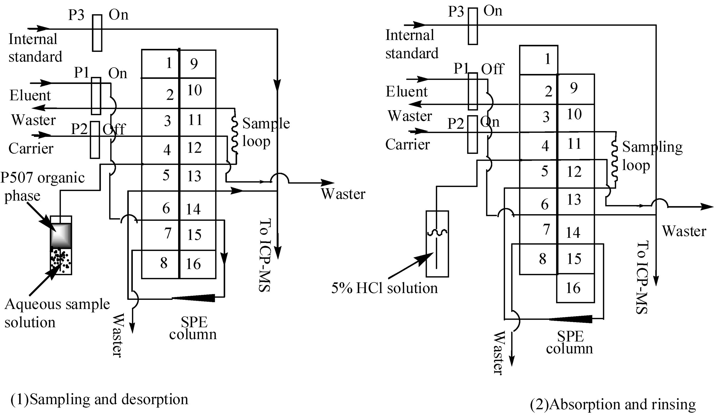

Fig. S1 Schematic diagram of the manifold for on-line pre-concentration/separation: P1, pump 1; P2, pump 2; P3, pump 3.

