Electronic supplementary information

Photo-induced chemical vapor generation with formic acid: novel interface for high performance liquid chromatography-atomic fluorescence spectrometry hyphenated system and application in speciation of mercury

Yong-guang Yin, Jing-fu Liu, Bin He, Er-le Gao, Gui-bin Jiang*

State Key Laboratory of Environmental Chemistry and Ecotoxicology, Research Center for Eco-Environmental Sciences, Chinese Academy of Sciences, P.O. Box 2871, Beijing 100085, China. Fax: +86-10-62849179; Tel: +86-10-62849334; E-mail: gbjiang@rcees.ac.cn

Figures

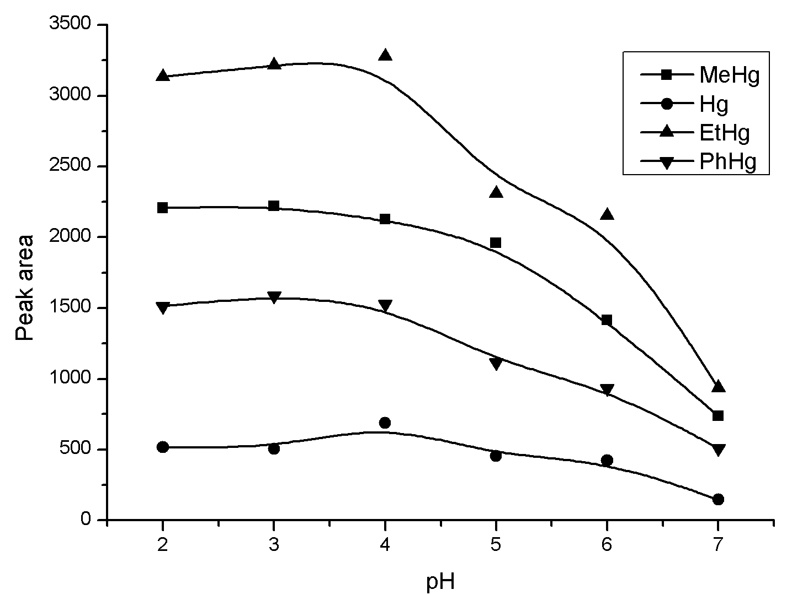
Fig. S1 Effect of pH on the fluorescence intensities of mercury compounds. Concentration of mercury species: 100 μg L⁻¹. Flow rate of formic acid: 3.1 mL min⁻¹. Other conditions were given in Table 1.

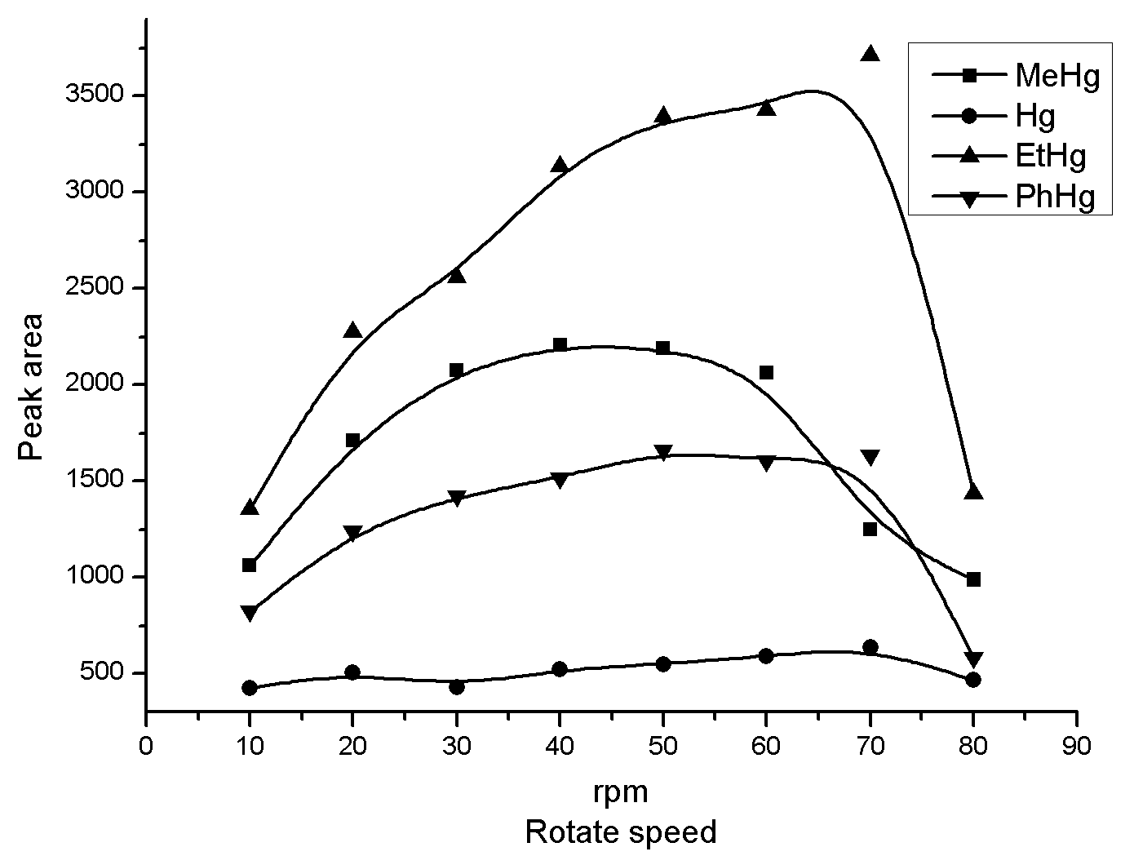
Fig. S2 Effect of flow rate of formic acid on the fluorescence intensities of mercury compounds. Concentration of mercury species: 100 μg L⁻¹. Other conditions were given in Table 1.
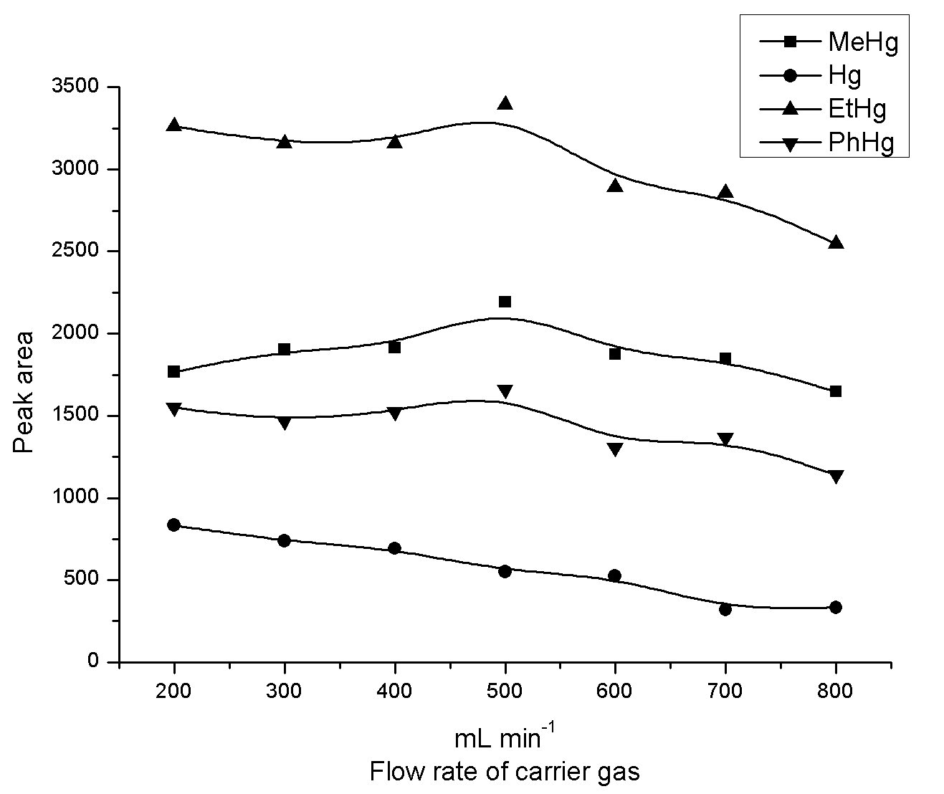
Fig. S3 Effect of flow rate of carrier gas on the fluorescence intensities of mercury compounds. Concentration of mercury species: 100 μg L⁻¹. Other conditions were given in Table 1.

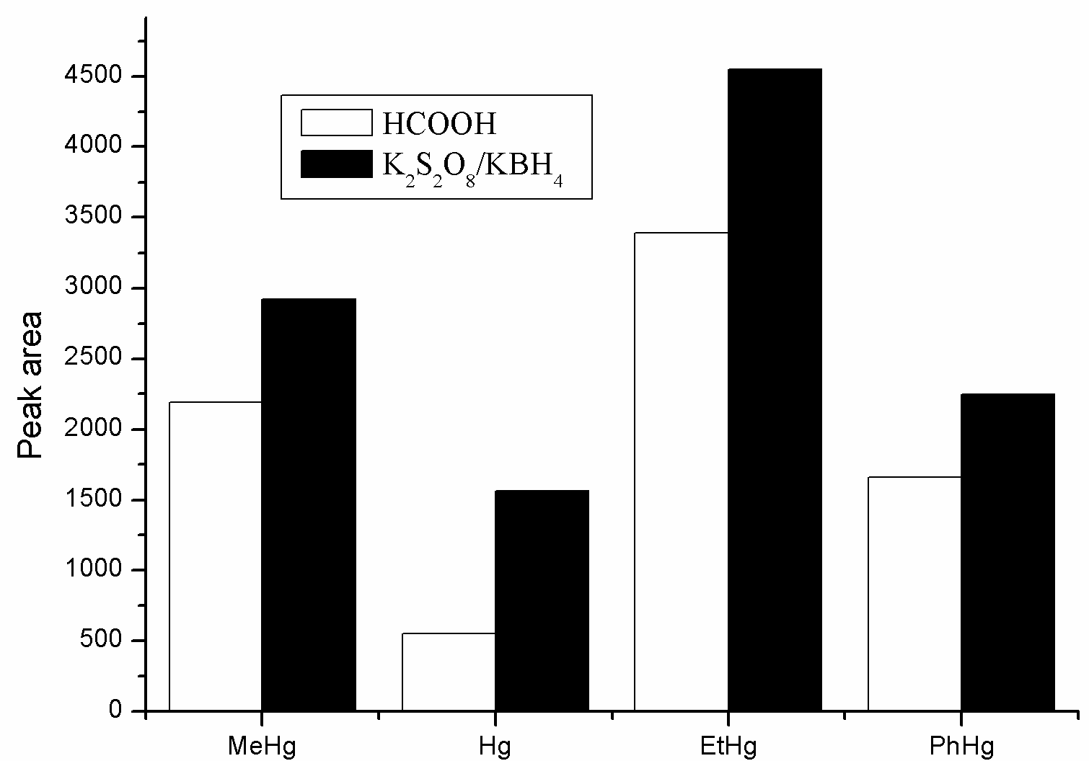
Fig. S4 Fluorescence intensities of mercury compounds obtained using the UV K₂S₂O₈/ KBH₄ CVG system and the proposed UV CVG system

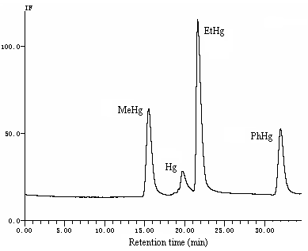

Fig. S5 Chromatogram of four mercury species using the developed HPLC-UV-CVG-AFS system. Concentration of mercury species: 100 μg L⁻¹.

