Phase Behaviour, Magnetic and Electronic Properties
in the Series Co_{1-x}Ni_{x}Cr₂S₄ (0≤x<1)

Paz Vaqueiro, Stefan Sommer and Anthony V. Powell*

Department of Chemistry, Heriot-Watt University,

Edinburgh, UK EH14 4AS

Supplementary information

Observed (crosses), calculated (upper full line) and difference (lower full line) profiles for the spinel phases. Reflection positions are marked.

CoCr₂S₄
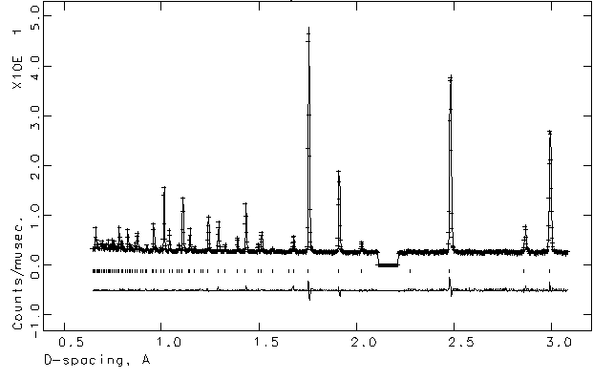
Co_{0.9}Ni_{0.1}Cr₂S₄
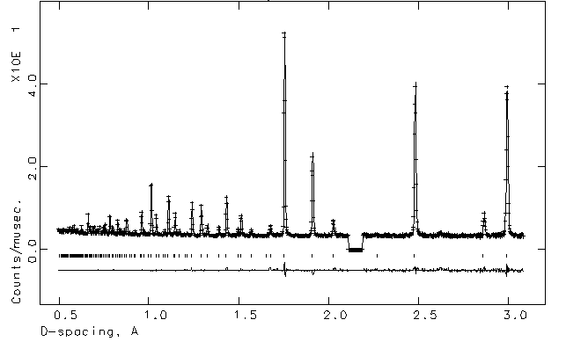
Co_{0.8}Ni_{0.2}Cr₂S₄
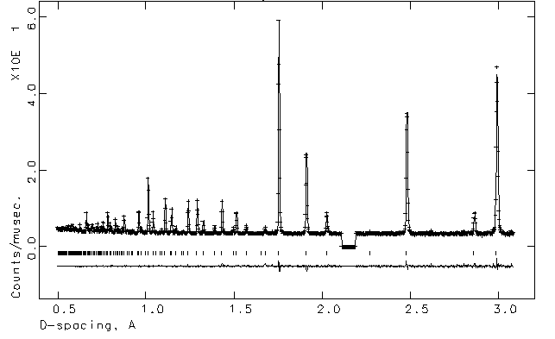
Co_{0.65}Ni_{0.35}Cr₂S₄
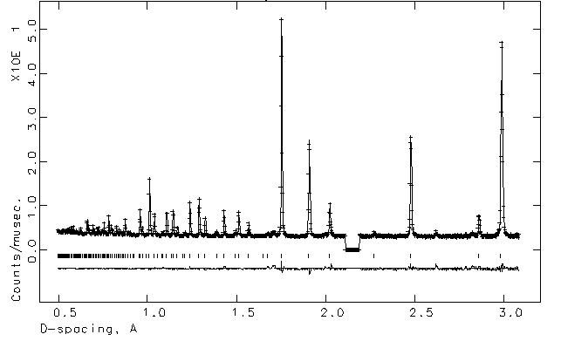
Observed (crosses), calculated (upper full line) and difference (lower full line) profiles for the Cr₃S₄ phases. Reflection positions are marked.

Co_{0.15}Ni_{0.85}Cr₂S₄
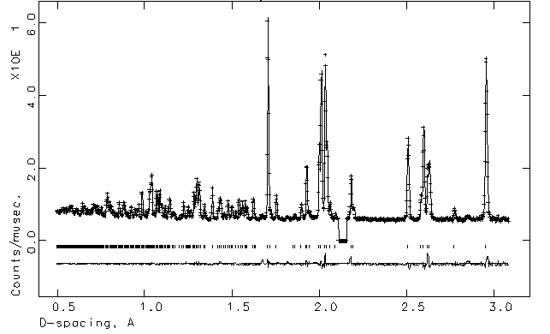

Co_{0.05}Ni_{0.95}Cr₂S₄
