Behavior of organic compounds confined in sol-gel silica glass. Effects of guest-host hydrogen bonding on uptake, release, and isomerization of the guest compounds

Jovica D. Badjić and Nenad M. Kostić*

Department of Chemistry, Iowa State University, Ames, IA 50010, USA

Supporting Information

Table S1. Ultraviolet absorptivities of trans and cis isomers of azobenzene derivatives.

compound | symbol | wavelength (nm) | ε trans (M⁻¹cm⁻¹)
compound | symbol | wavelength (nm) | trans | cis
3,3′-dimethyl  azobenzene | A | 324.6 | 21474 | 1317
3-acetyl  azobenzene | B | 320.0 | 19516 | 1931
3,3′-diacetyl  azobenzene | C | 320.0 | 19354 | 2012
3,5-diacetyl  azobenzene | D | 319.0 | 20243 | 1006
3,3′,5,5′-  tetraacetyl  azobenzene | E | 314.0 | 16896 | 2623

Figure S1. Absorption spectrum of styrene in solution (solid line) and inside sol-gel silica glass (dashed line). In both cases solvent was in CCl₄. Lack of perturbation of the spectrum is evidence against hydrogen bonding between styrene and silica.

Figure S2. Absorption spectra of N,N-diethyl-p-anisidine in solution (dash-dotted line) and inside sol-gel silica glass (solid line), in both cases in a 9 : 1 v/v mixture of CCl₄ and DMF, and inside sol-gel silica glass in CCl₄ (dashed line).

Figure S3. Absorption spectra a compound in solution (dashed line) and inside trimethylsilylated sol-gel silica glass (solid line); in both cases the solvent is CCl₄. The compound is (a) aniline and (b) N,N-diethyl-p-anisidine.

Figure S4. Uptake of (a) aniline and (b) N,N-diethyl-p-anisidine by sol-gel silica glass when it is capable of hydrogen bonding to the guest compounds. The silica glass before the uptake experiments was treated with HCl (), NaOH (), or neither compound (). Glass monolith sized 8 x 8 x 27 mm is soaked in 50.0 mL solution of each solute in CCl₄. The dashed line marks the absorbance of the external solution.

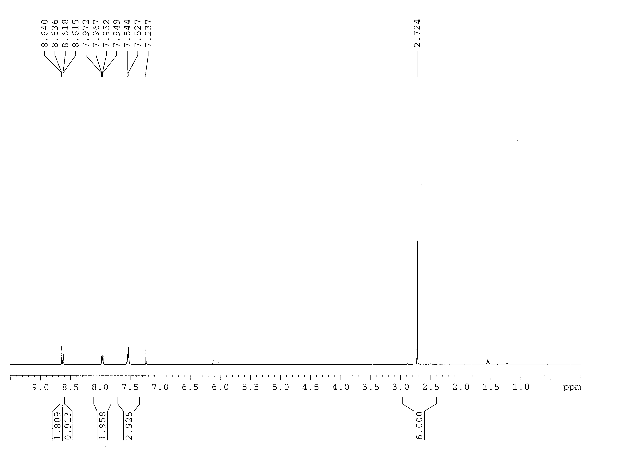

Figure S5. ¹H NMR spectrum of 3,5-diacetyl azobenzene in CDCl₃.

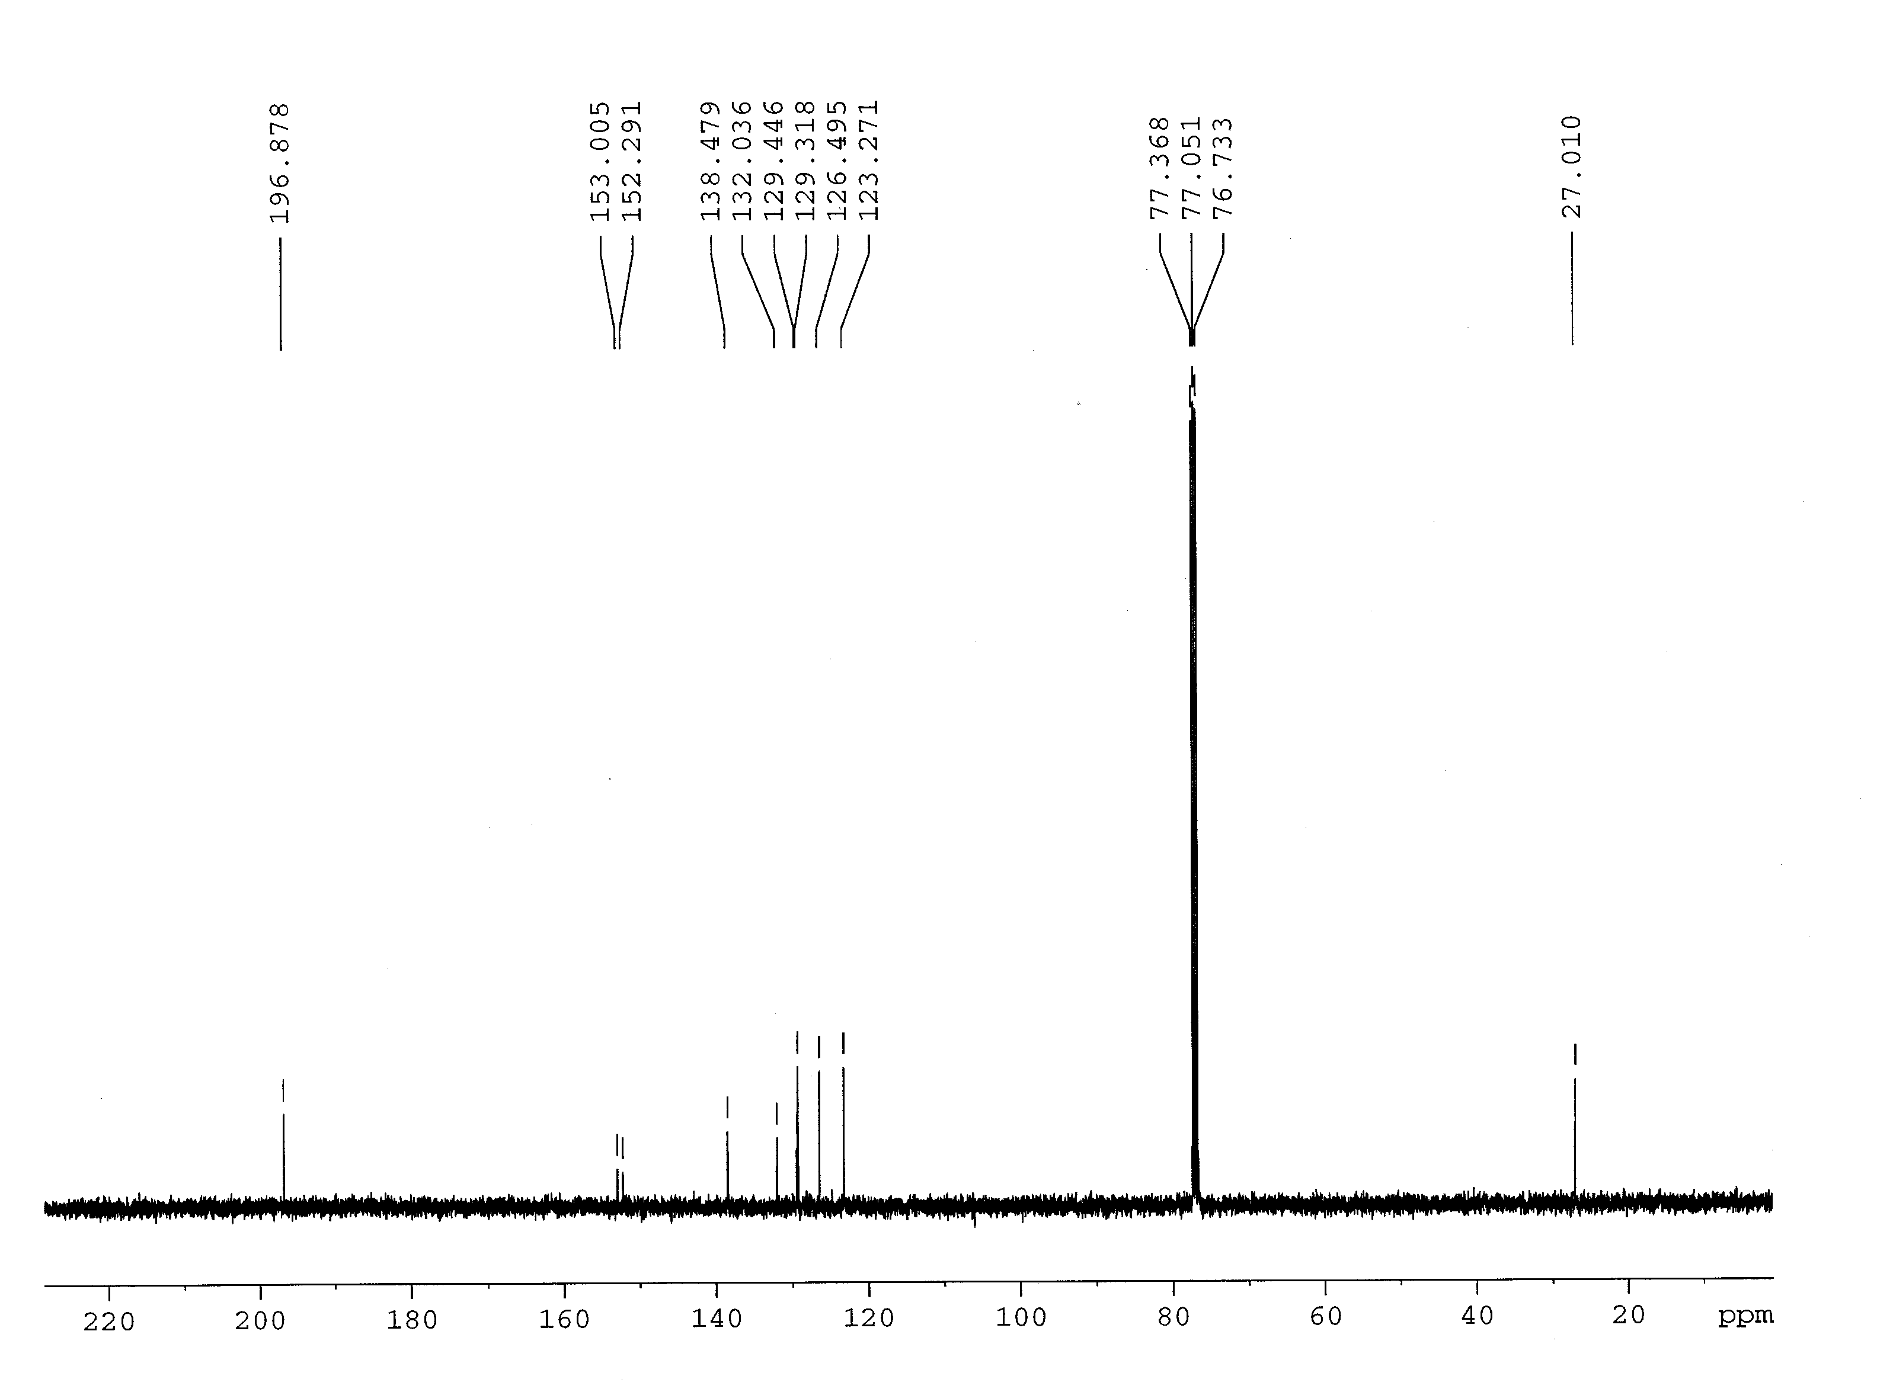

Figure S6. ¹³C NMR spectrum of 3,5-diacetyl azobenzene in CDCl₃.

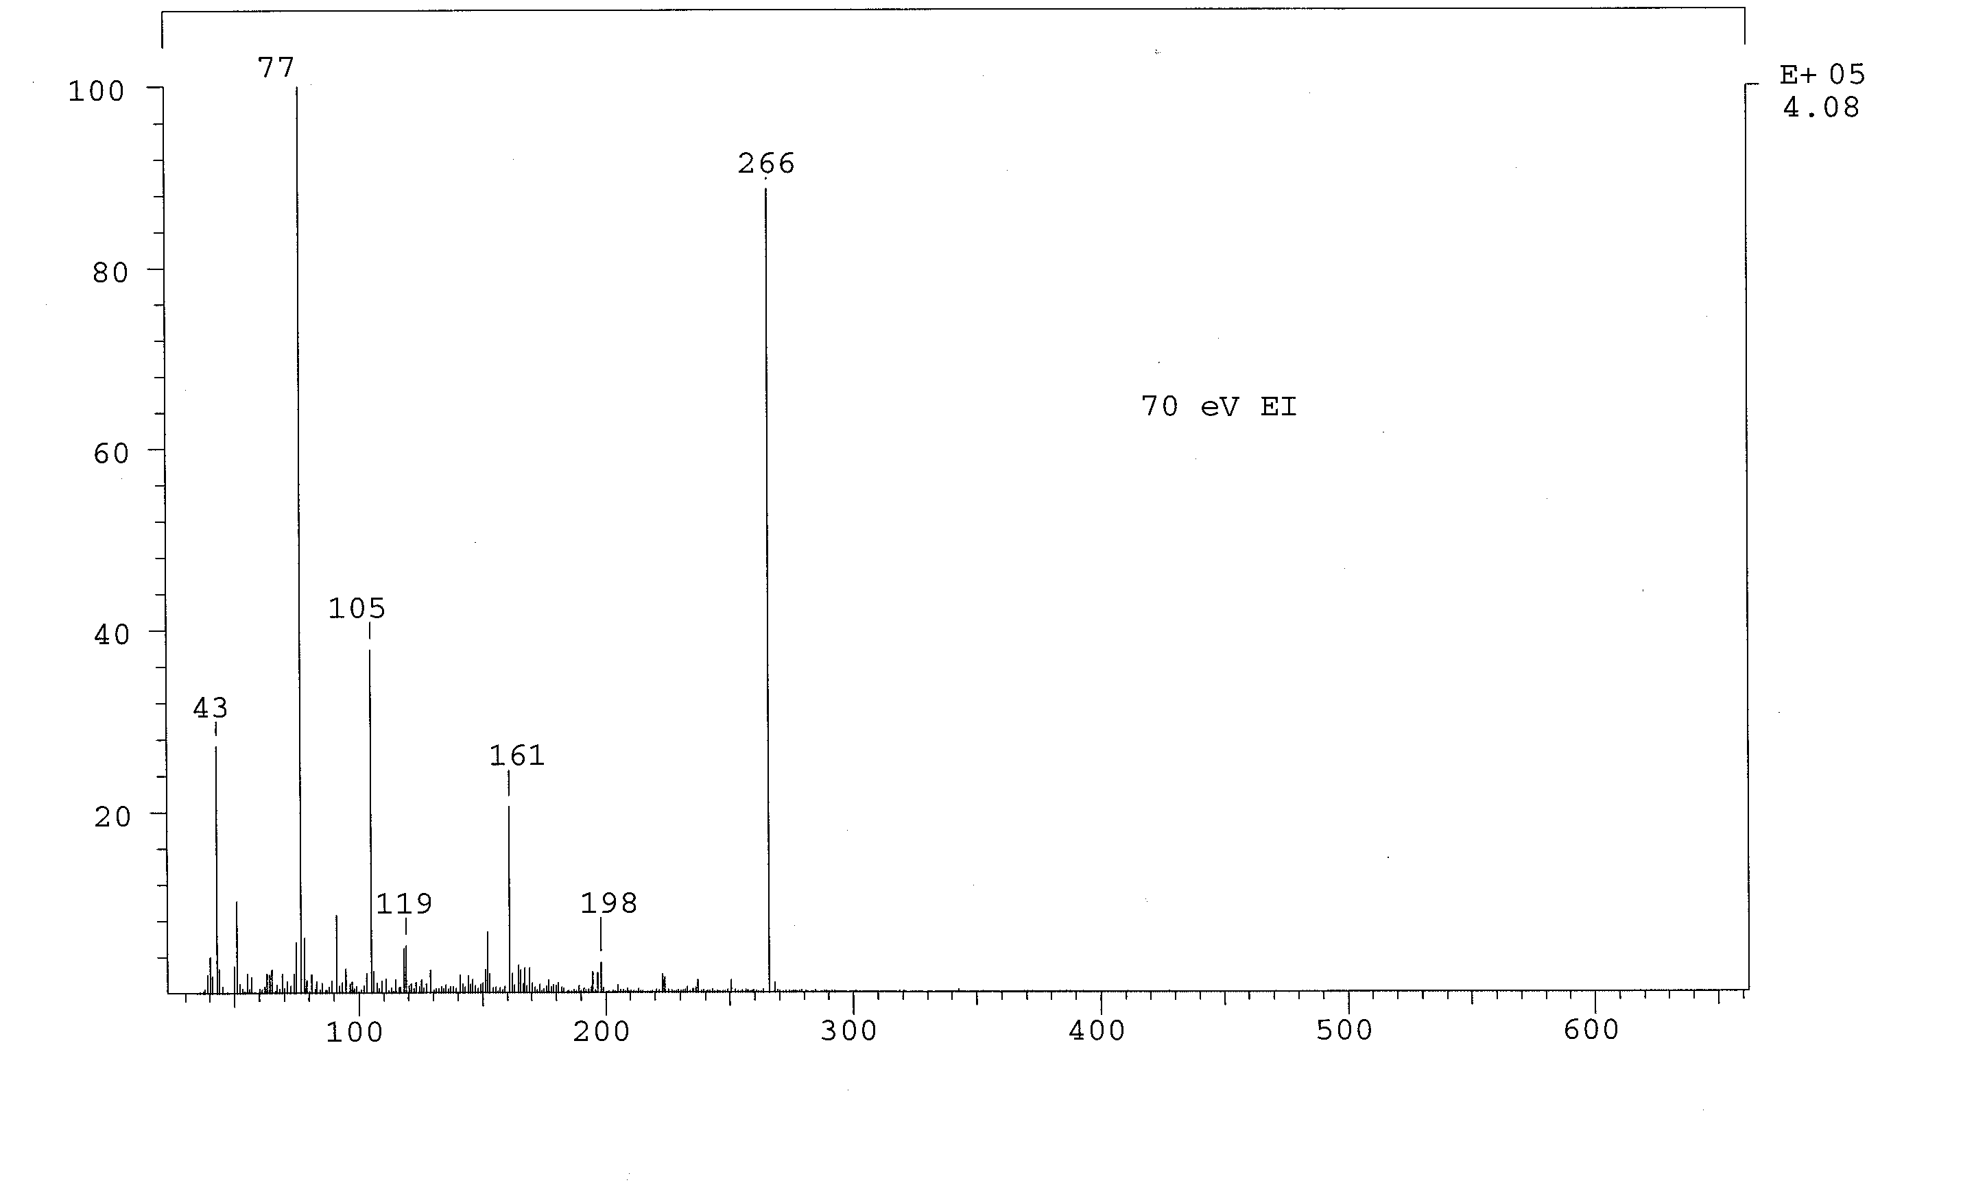

Figure S7. Low-resolution mass spectrum (CI) of 3,5-diacetyl azobenzene.

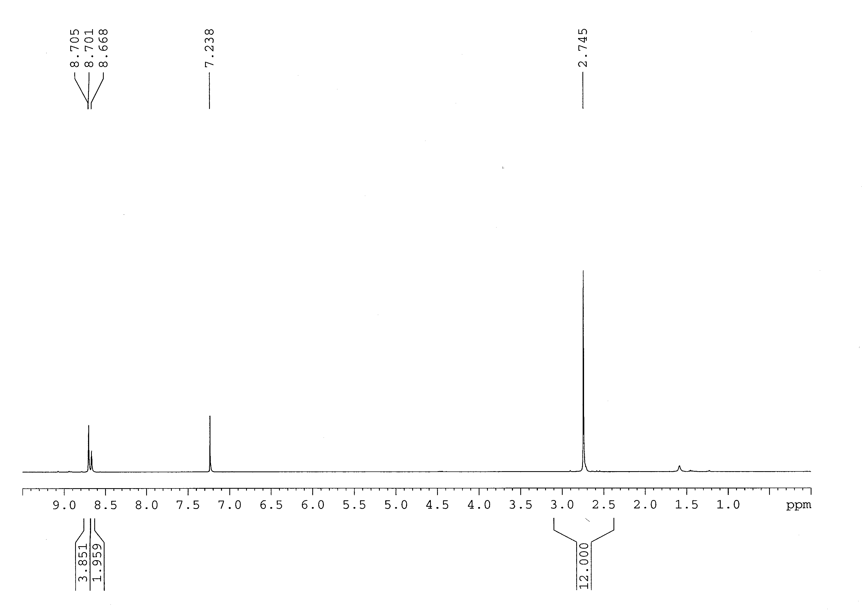

Figure S8. ¹H NMR of 3,3′,5,5′-tetraacetyl azobenzene spectrum in CDCl₃.

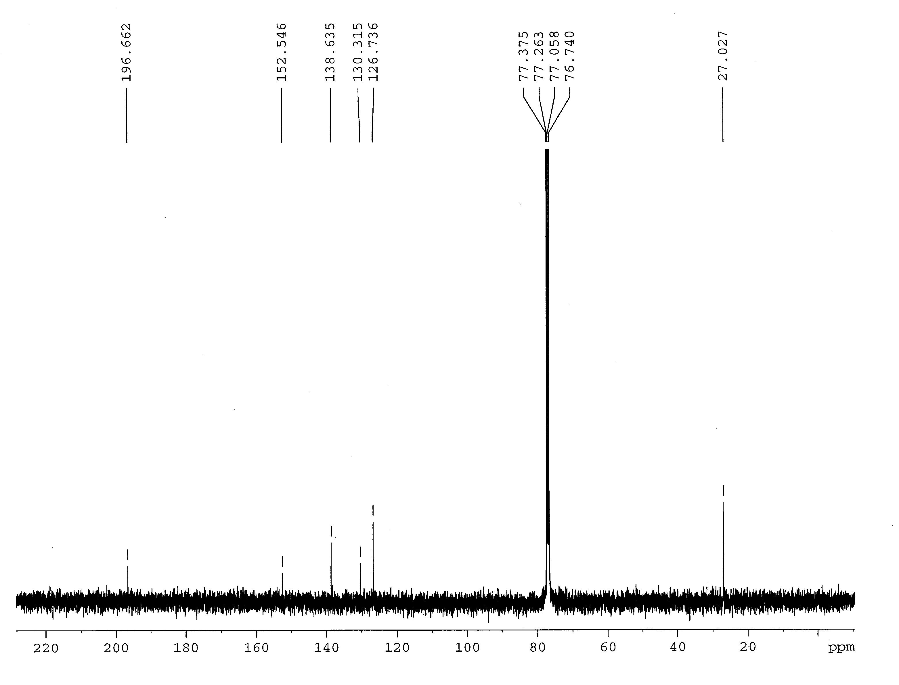

Figure S9. ¹³C NMR of 3,3′,5,5′-tetraacetyl azobenzene in CDCl₃.

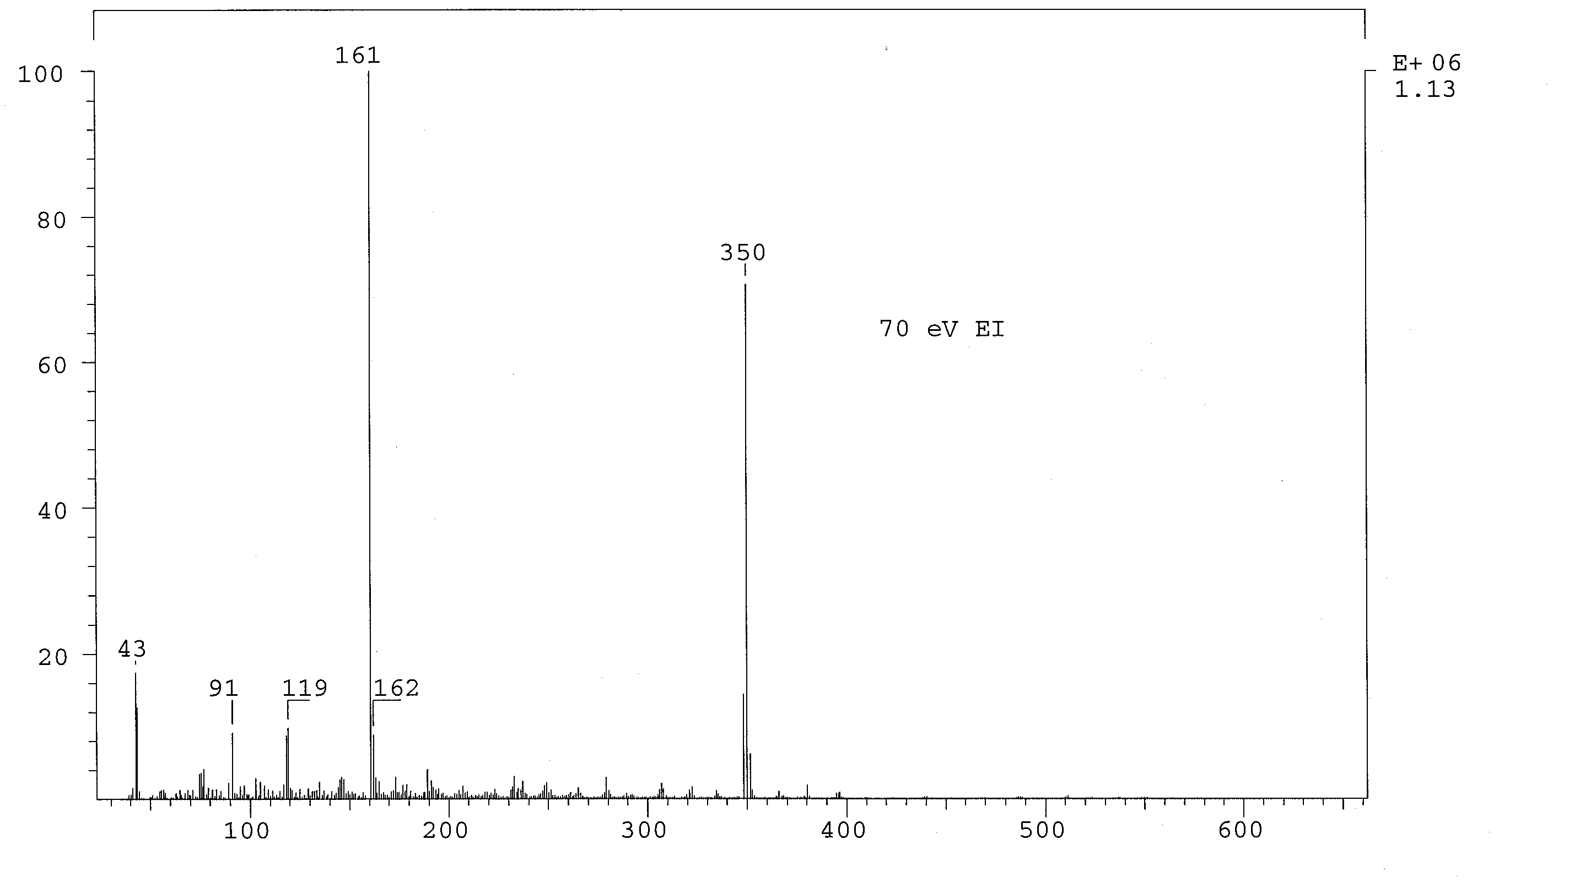

Figure S10. Low-resolution mass spectrum (CI) of 3,3′,5,5′-tetraacetyl azobenzene.

