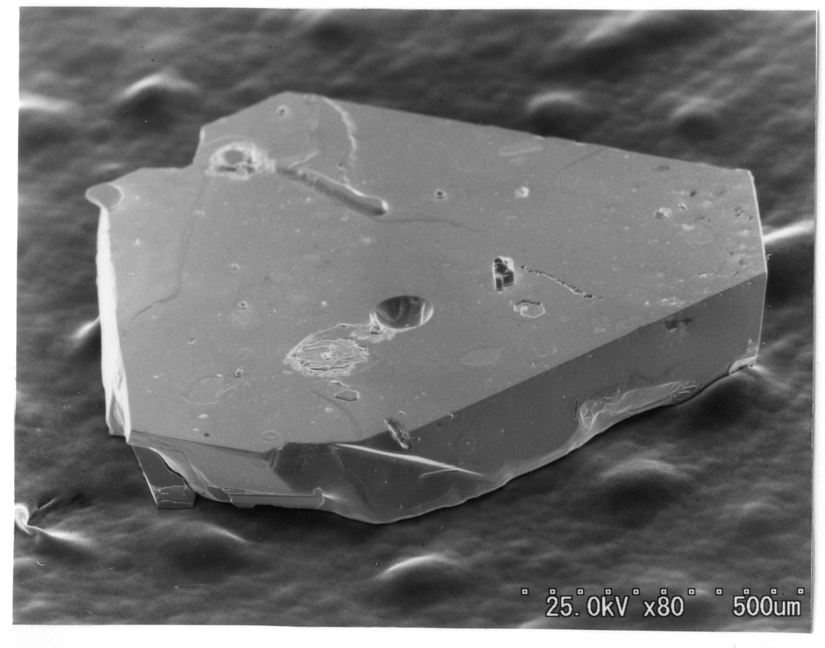

Fig. S2 Scanning electron micrograph of a single crystal of CuAlO₂.

