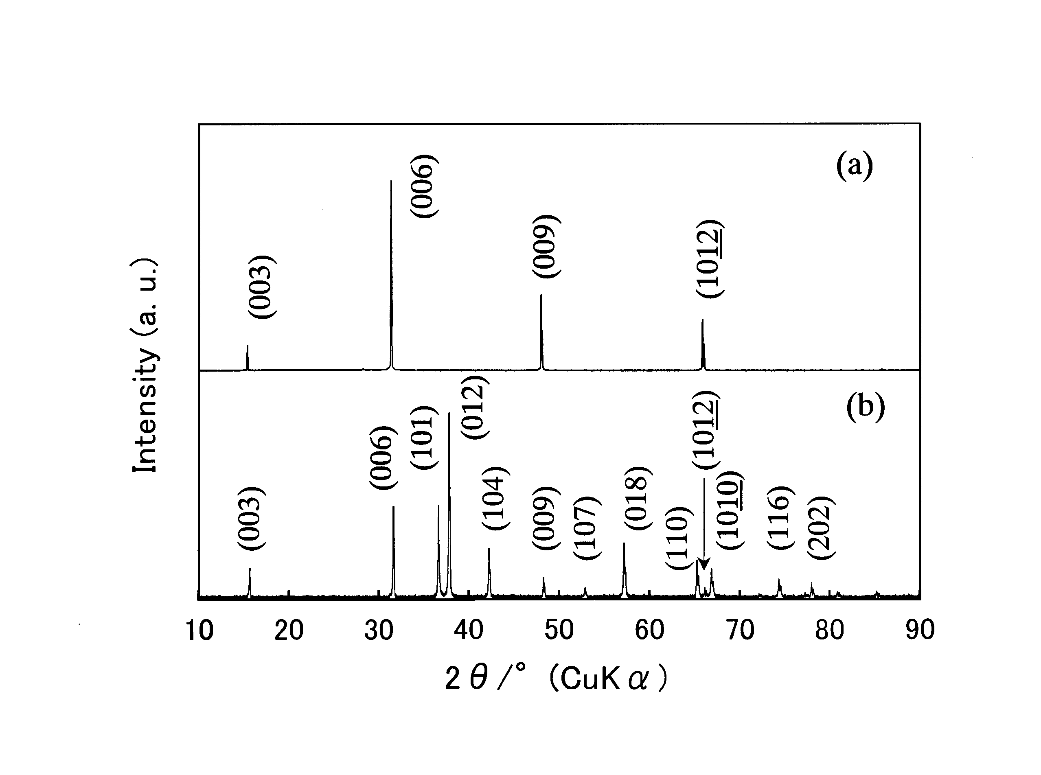

Fig. S3 X-Ray diffraction patterns of (a) CuAlO₂ single crystals and (b) non-oriented powder.

