Supplementary Information:

Intermolecular organisation of triphenylene-based discotic mesogens by interdigitation of alkyl chains

Matthew T. Allen,ª Siegmar Diele,^{b} Kenneth D. M. Harris,^{a*} Torsten Hegmann,^{c}
Benson M. Kariuki,ª Dirk Lose,^{b} Jon A. Preece^{a*} and Carsten Tschierske.^{c}

ª School of Chemistry, The University of Birmingham,
Edgbaston, Birmingham, B15 2TT, United Kingdom.
^{b} Institute of Physical Chemistry, Martin-Luther-University Halle,
Mühlpforte 1, D-06118 Halle, Germany.
^{c} Institute of Organic Chemistry, Martin-Luther-University Halle,
Kurt-Mothes-Strasse 2, D-06120 Halle, Germany.

E-mail: K.D.M.Harris@bham.ac.uk, J.A.Preece@bham.ac.uk

CORRESPONDENCE ADDRESS
Prof. Kenneth D. M. Harris / Dr. Jon A. Preece
School of Chemistry,
University of Birmingham,
Edgbaston,
Birmingham,
B15 2TT,

United Kingdom.
(a)
(d)
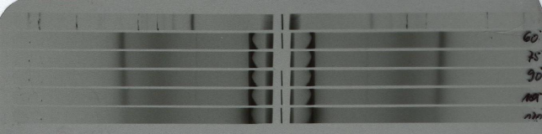
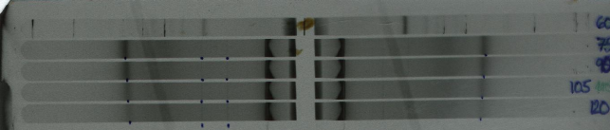
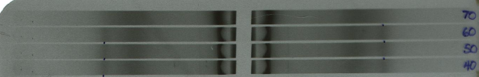
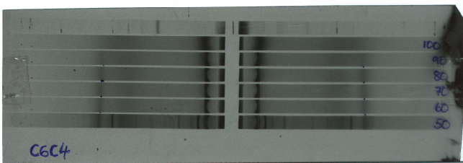
(100)
(001)
(b)
(c)
Supplementary Information:
Figure S1. Examples of variable temperature XRD photographs of (a) C₅C₅, (b) C₅C₃.sym, (c) C₅C₉.sym and (d) C₆C₄.sym.
(200)
(210)
(001)
θ / °
Supplementary Information:
Figure S2. Mesophase X-ray diffractogram of C₅C₃.sym, exhibiting the reflections, d₂₀₀ and d₂₁₀.
Supplementary Information:
Table S1. Quantities of reagents used in synthesis of C₅C_{n} materials.

Supplementary Information:
Table S2. Spectroscopic data for compounds C₅C_{n} materials.

