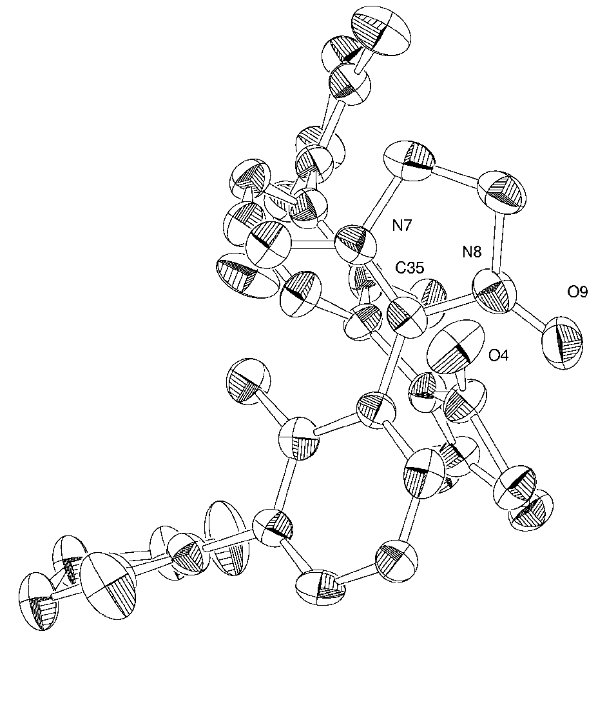
(a)

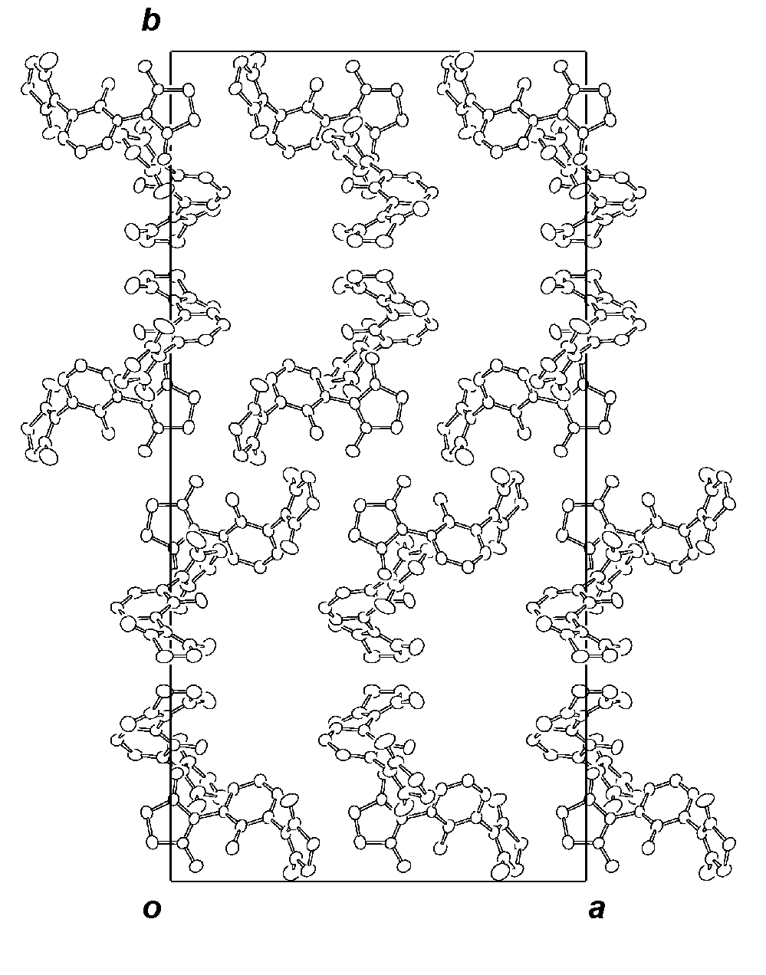

(b)

Fig. S2 Crystal structure of 2a: (a) The neighboring two molecules, A and B, with the short intermolecular atom-atom distances; 3.12 Å (O4-C35) and 3.19 Å (O4-N8). (b) The molecular packing viewed along the c-axis. The methyl groups in the nitronyl nitroxide molecules and the crystal solvent of acetone are omitted for clarity.

