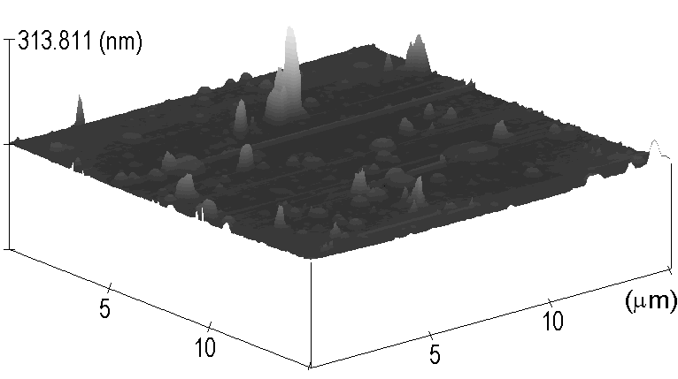

ESI 1: Atomic Force Micrograph of HMDS/TEOS film (90 seconds deposition)

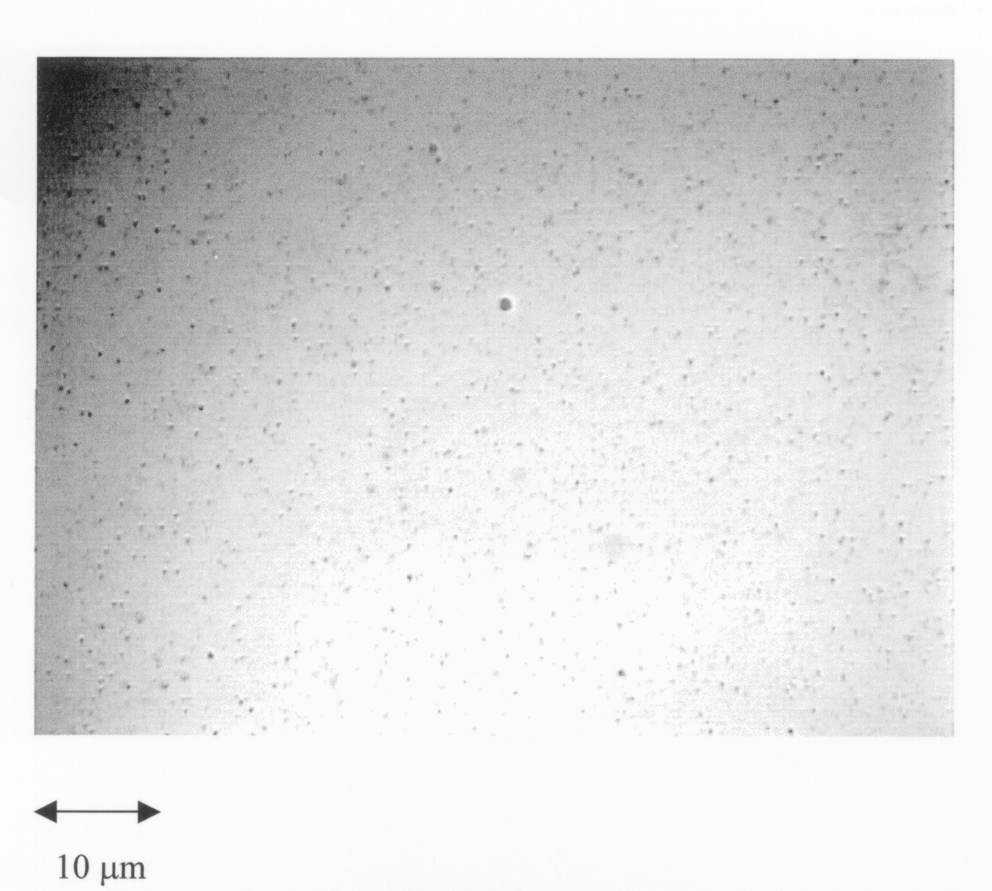

ESI 2: Optical Micrograph of HMDS/TEOS film (90 seconds deposition)

