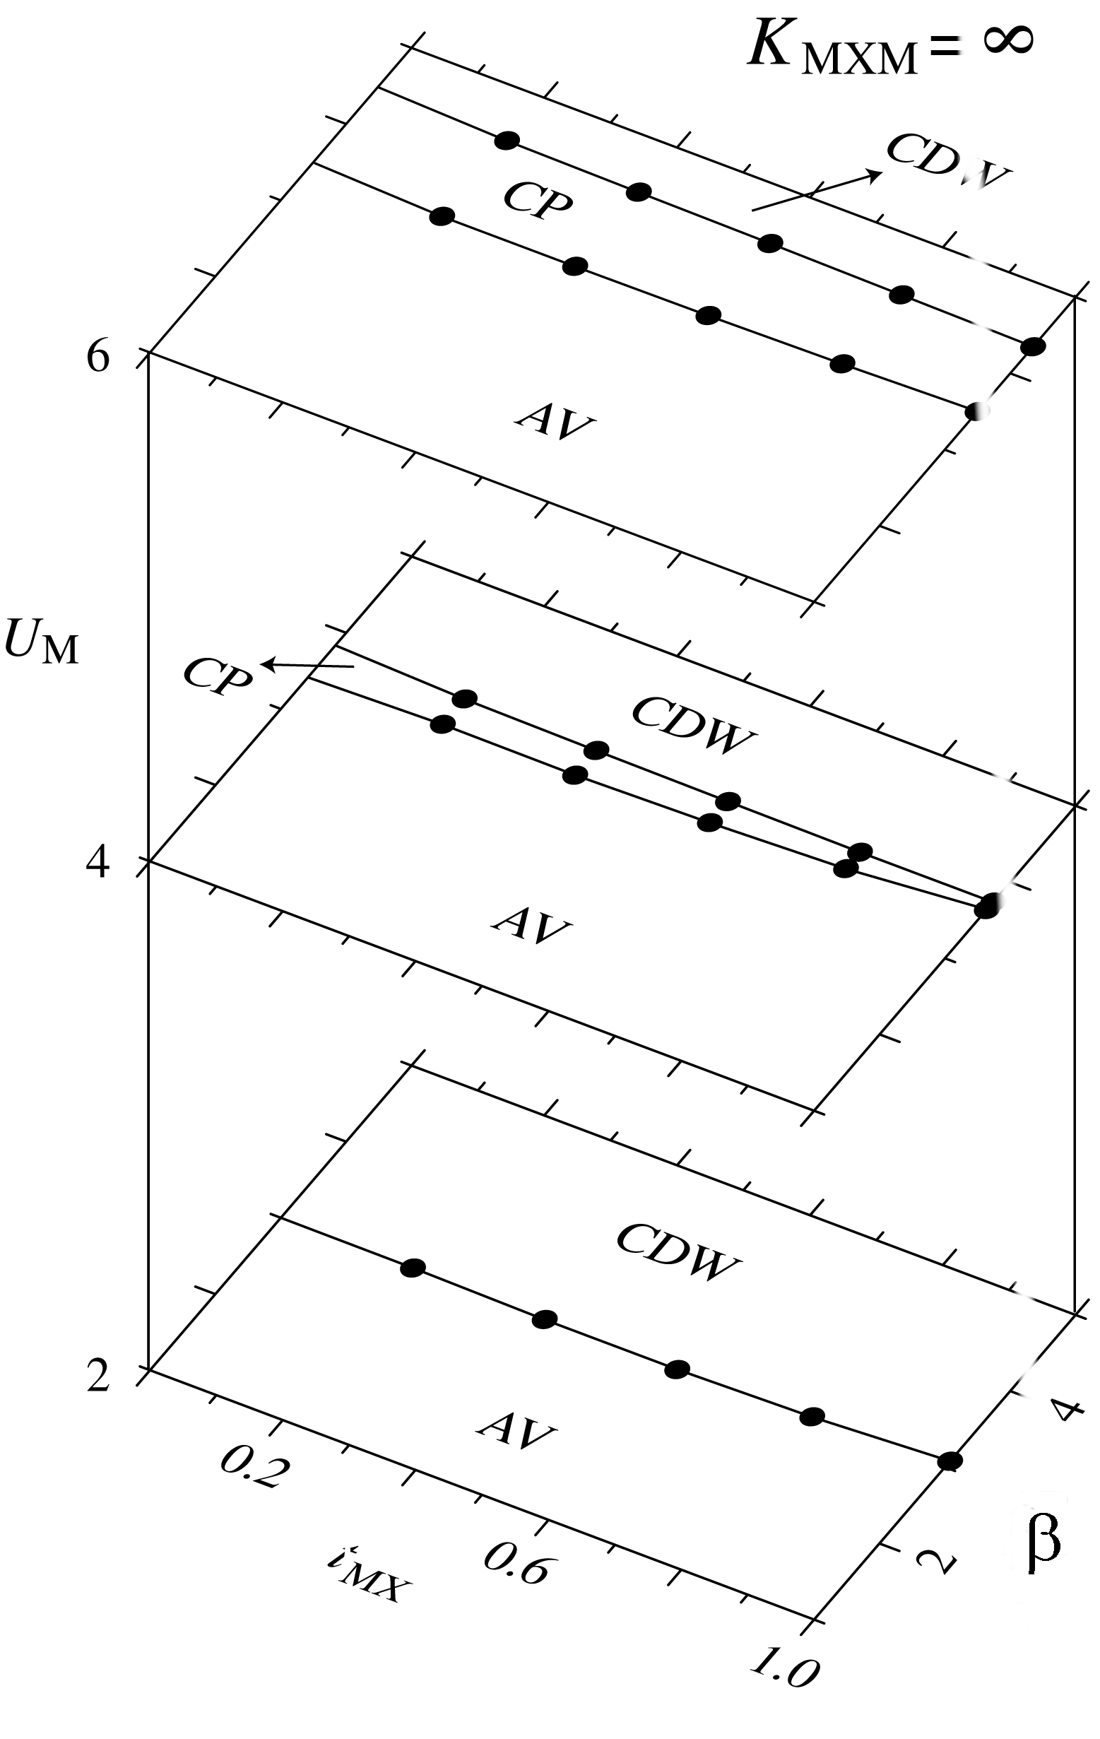

Fig. S1 Ground-state phase diagram of the 18-site two-band model for infinitely large K_{MXM}, in the t_{MX} -β-U_{M} space. The parameters are t_{MM} =1, α =0.2, ε_{M} −ε_{X}=0.5, K_{MX} =6, U_{X} = U_{M} /2, V_{MM} =0, and V_{MX} =0.

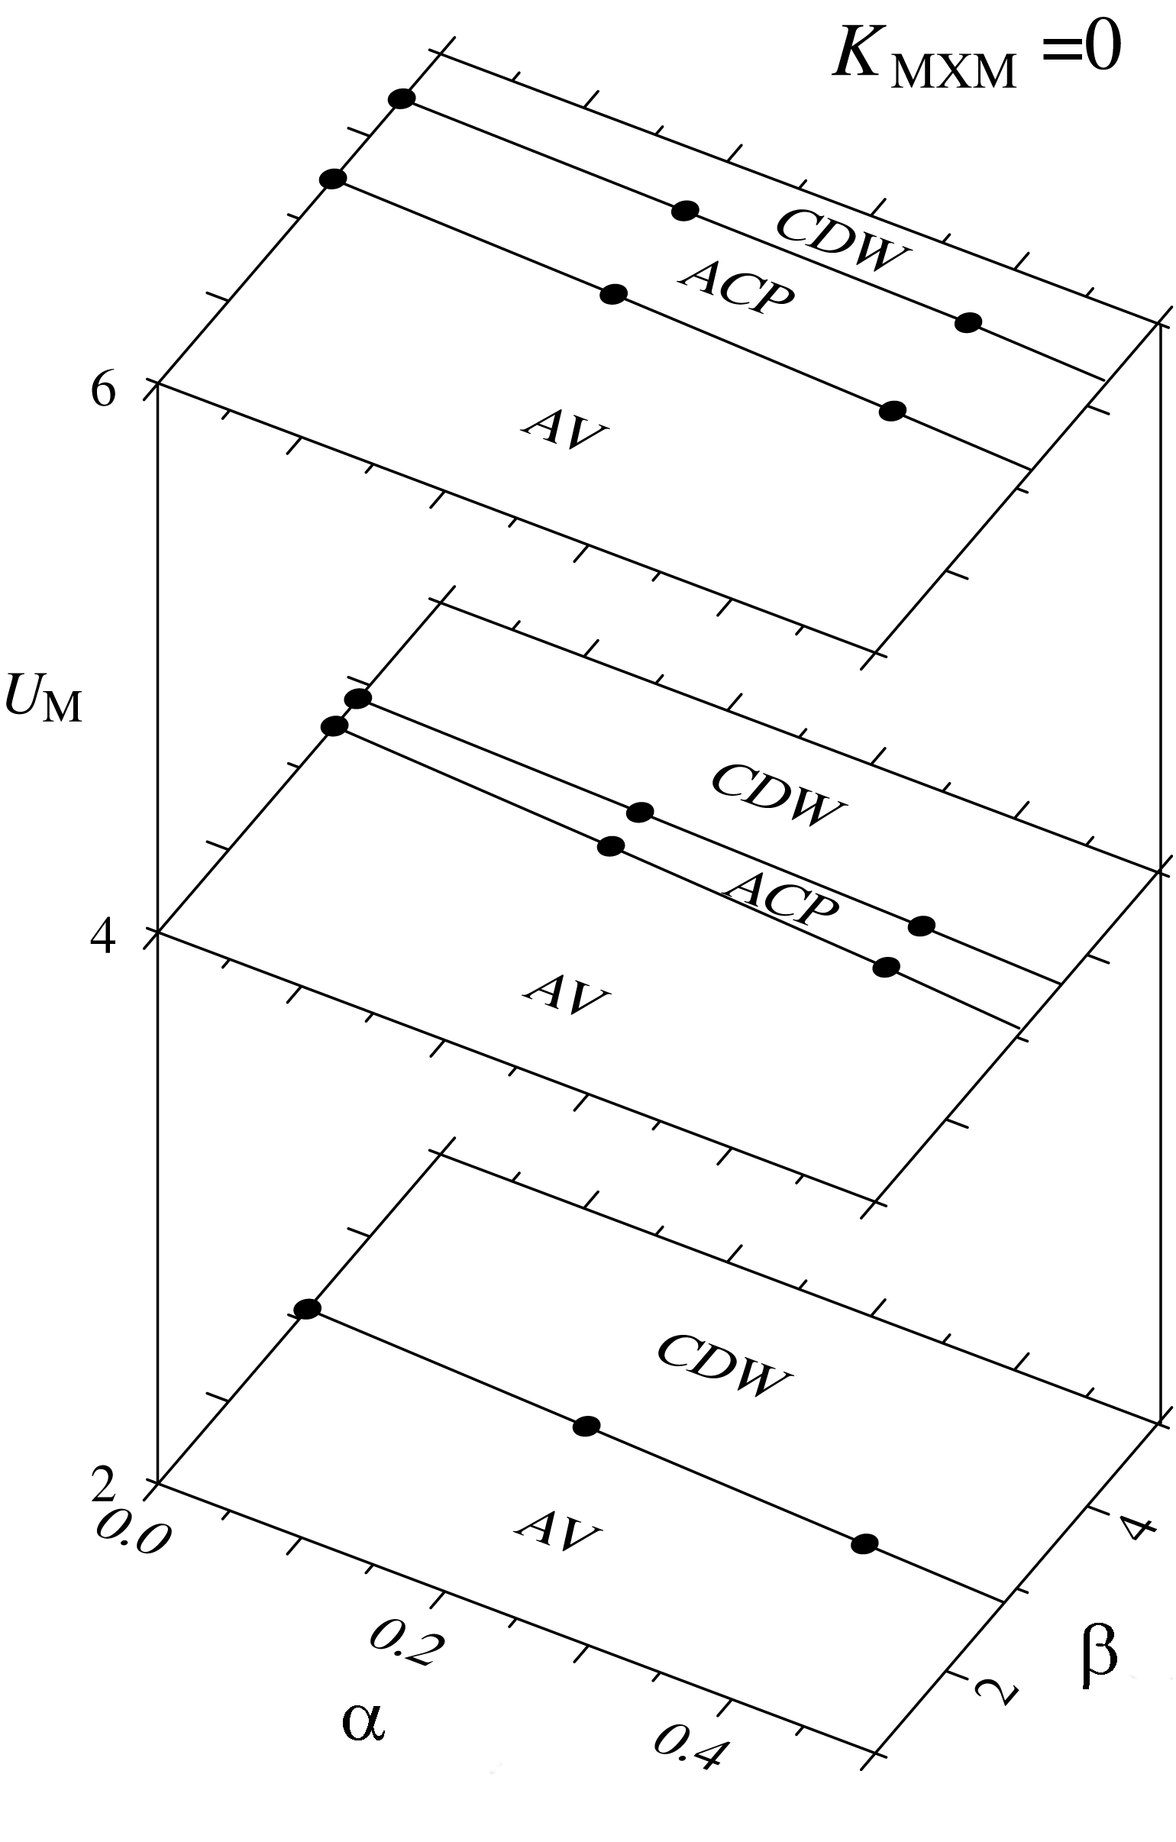

Fig. S2 Ground-state phase diagram of the 18-site two-band model for K_{MXM} =0, in the α -β-U_{M} space. The parameters are t_{MM} =1, t_{MX} =0.8, ε_{M} −ε_{X}=0.5, K_{MX} =6, U_{X} = U_{M} /2, V_{MM} =0, and V_{MX} =0.

