a

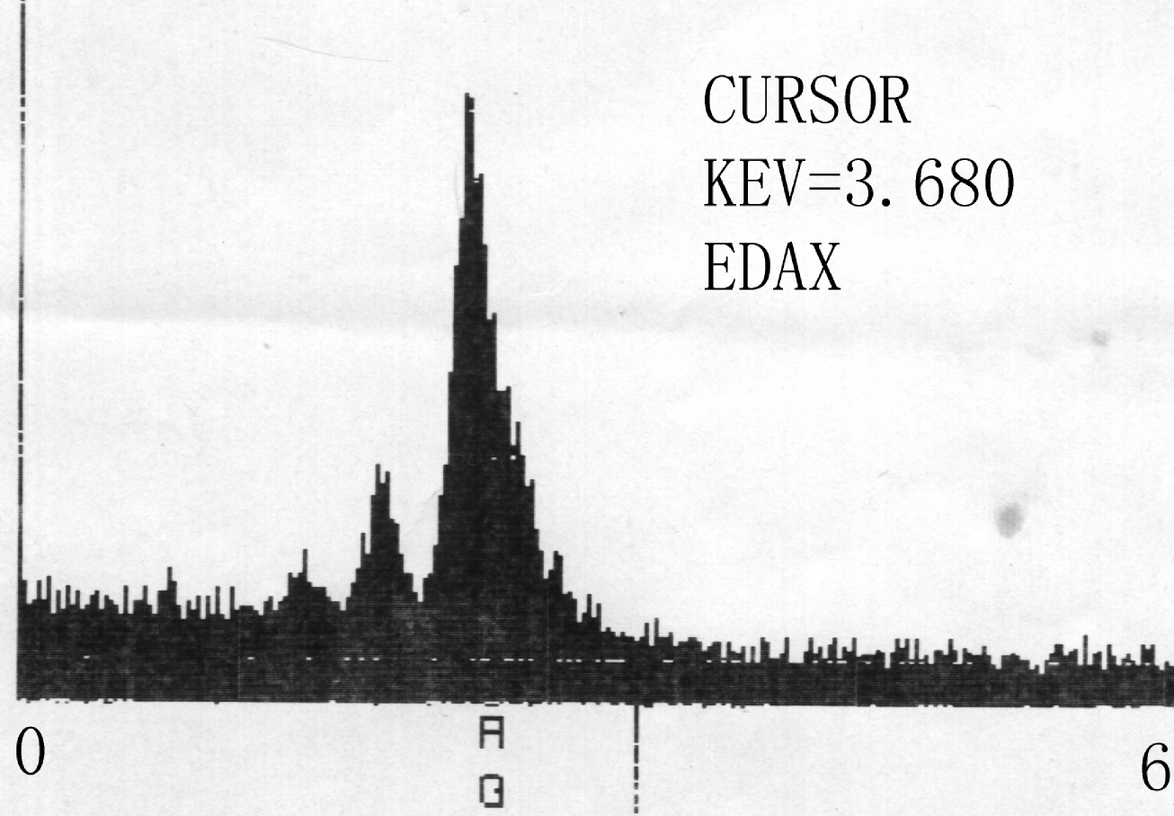
b
Figure S2 (a) XRD pattern of silver nanocomposite. In the 2θ range of 2~15°, the interlayer spacing distance of lamellar structures is ca. 4.5 nm. The reflection peaks are indexed as 100, 110, 111 and 200 planes for Ag phase in the 2θ range of 15-60°, (b) EDX pattern for single silver phase.

