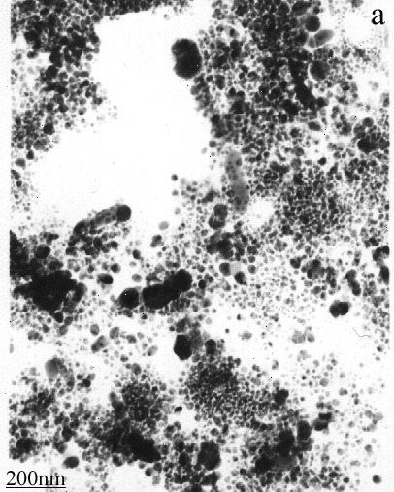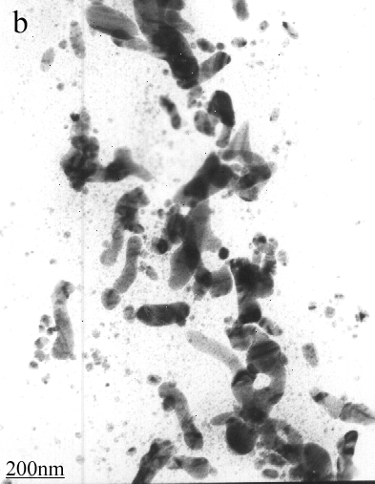
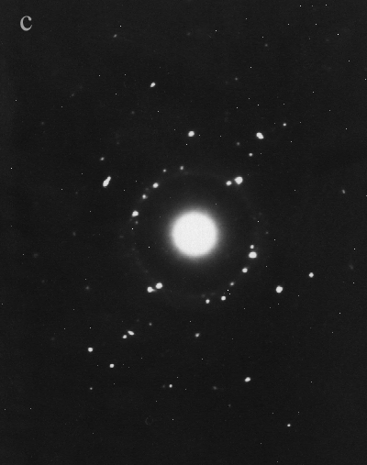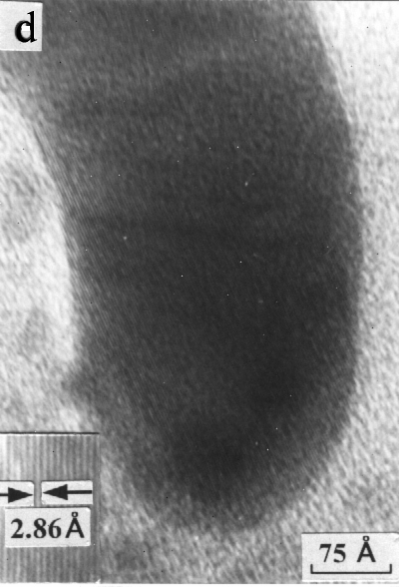

Figure S3 TEM images for silver nanostructures. (a) particles via 6-h UV irradiation, (b) rods via 24-h UV irradiation, (c) ED image for Ag nanowires, (d) HRTEM of Ag nanowire with respect to the 110 plane 2.86 Å.

