J. Mat. Chem.,. "Zeolite syntheses using linear diquats of varying length in fluoride media. The synthesis of ITQ-8, ITQ-10, ITQ-14 and high silica Nu-87". M.J. Díaz-Cabañas, M.A. Camblor, Z. Liu, T. Ohsuna and O. Terasaki,

Supplementary material

¹H and ¹³C NMR spectra of M_{n}BQ²⁺ linear diquats
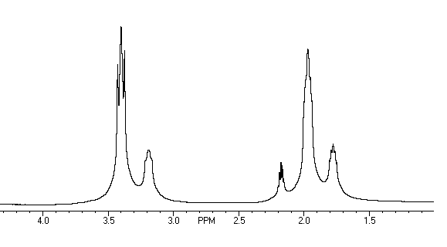
¹H NMR spectrum of 1,4–diquinuclidiniumbutane (M₄BQ²⁺) in D₂O.

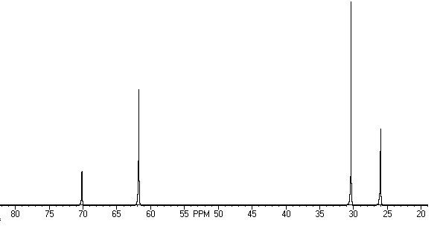
¹³C NMR spectrum of 1,4–diquinuclidiniumbutane (M₄BQ²⁺) in D₂O.
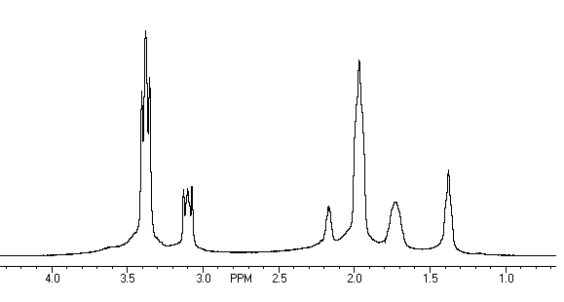
¹H NMR spectrum of 1,6–diquinuclidiniumhexane (M₆BQ²⁺) in D₂O.

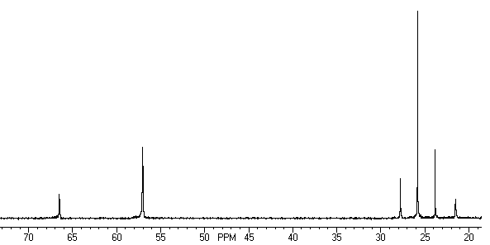
¹³C NMR spectrum of 11,6–diquinuclidiniumhexane (M₆BQ²⁺) in D₂O.

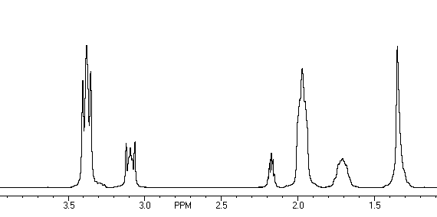
¹H NMR spectrum of 1,8–diquinuclidiniumoctane (M₈BQ²⁺) in D₂O.

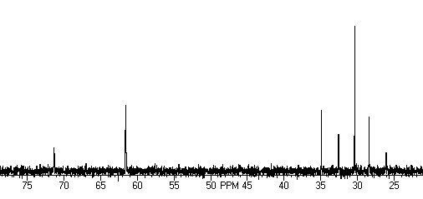
¹³C NMR spectrum of 1,8–diquinuclidiniumoctane (M₈BQ²⁺) in D₂O

XRD pattern for the as-made material identified in Table 4 as "unknown". Arrows point to reflections from zeolite Beta.

