Supplementary Data

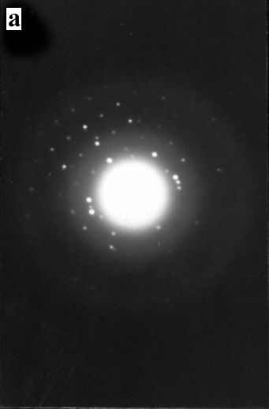
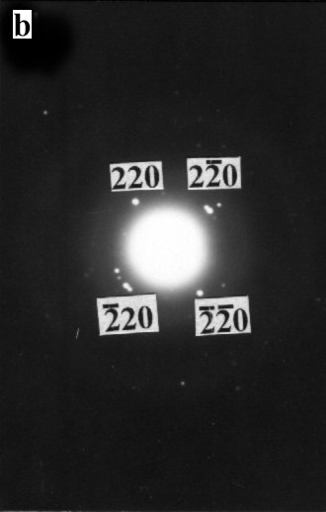
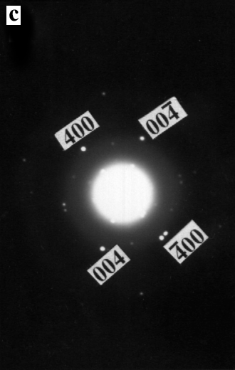

Fig. S1. (a) ED pattern of product (C); (b) ED pattern of product (D); (c) ED pattern of product (E).

Fig. S2. XPS spectra of the samples: (a) In 3d core level spectrum of In₂S₃; (b) S 2p core level spectrum of In₂S₃.

