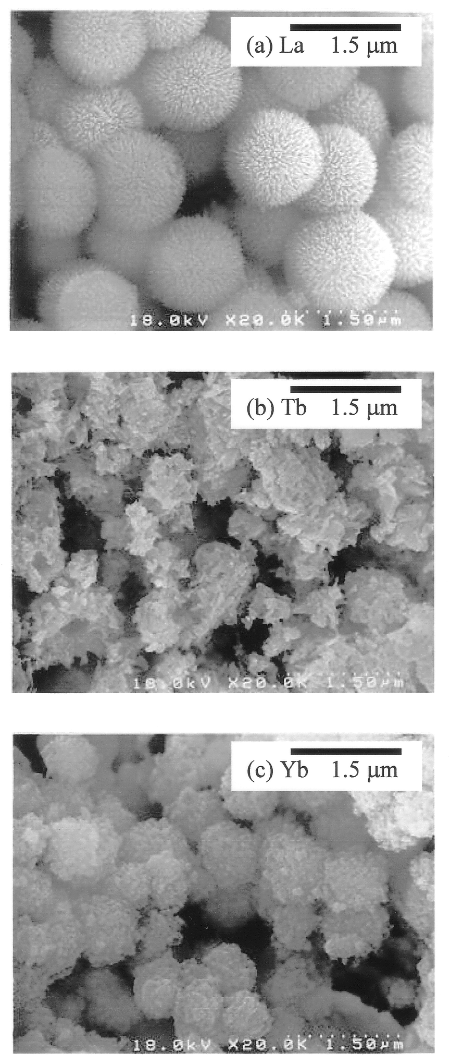

Fig. S1 Scanning electron micrographs of phosphate particles for (a) La, (b) Tb, and (c) Yb, prepared in the homogeneous system, without calcination. [H₃PO₄]_{feed} = 0.3 mol l^{–1} and [Ln]_{feed} = 0.01 mol l^{–1}.

