Electronic Supplementary Information

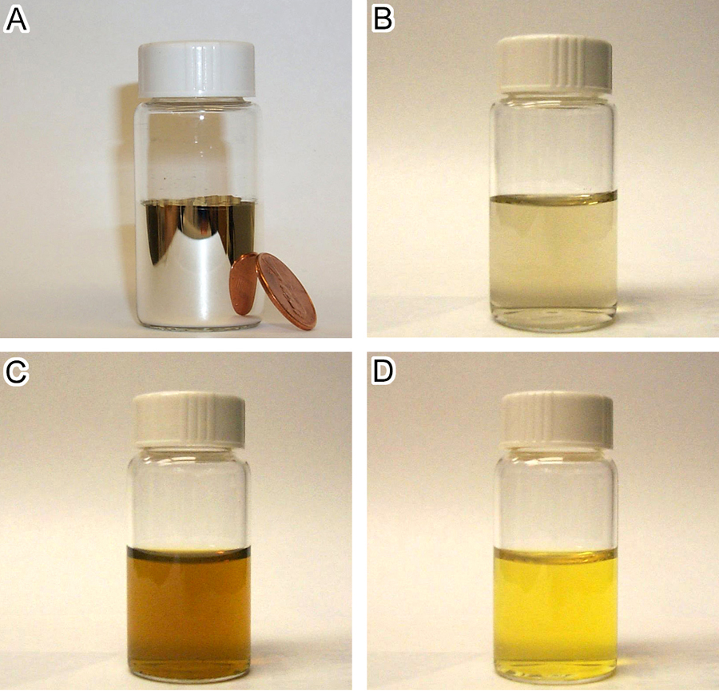

Fig. S-1 (A) Photograph of silver mirror that was formed on the inside surface of a glass vial when concentrated silvering solutions were added. (B-D) Photographs of stable dispersions of silver nanoparticles obtained by mixing diluted silvering solutions under sonication at various times into the reaction: (B) 15; (C) 27; and (D) 33 min, respectively.

