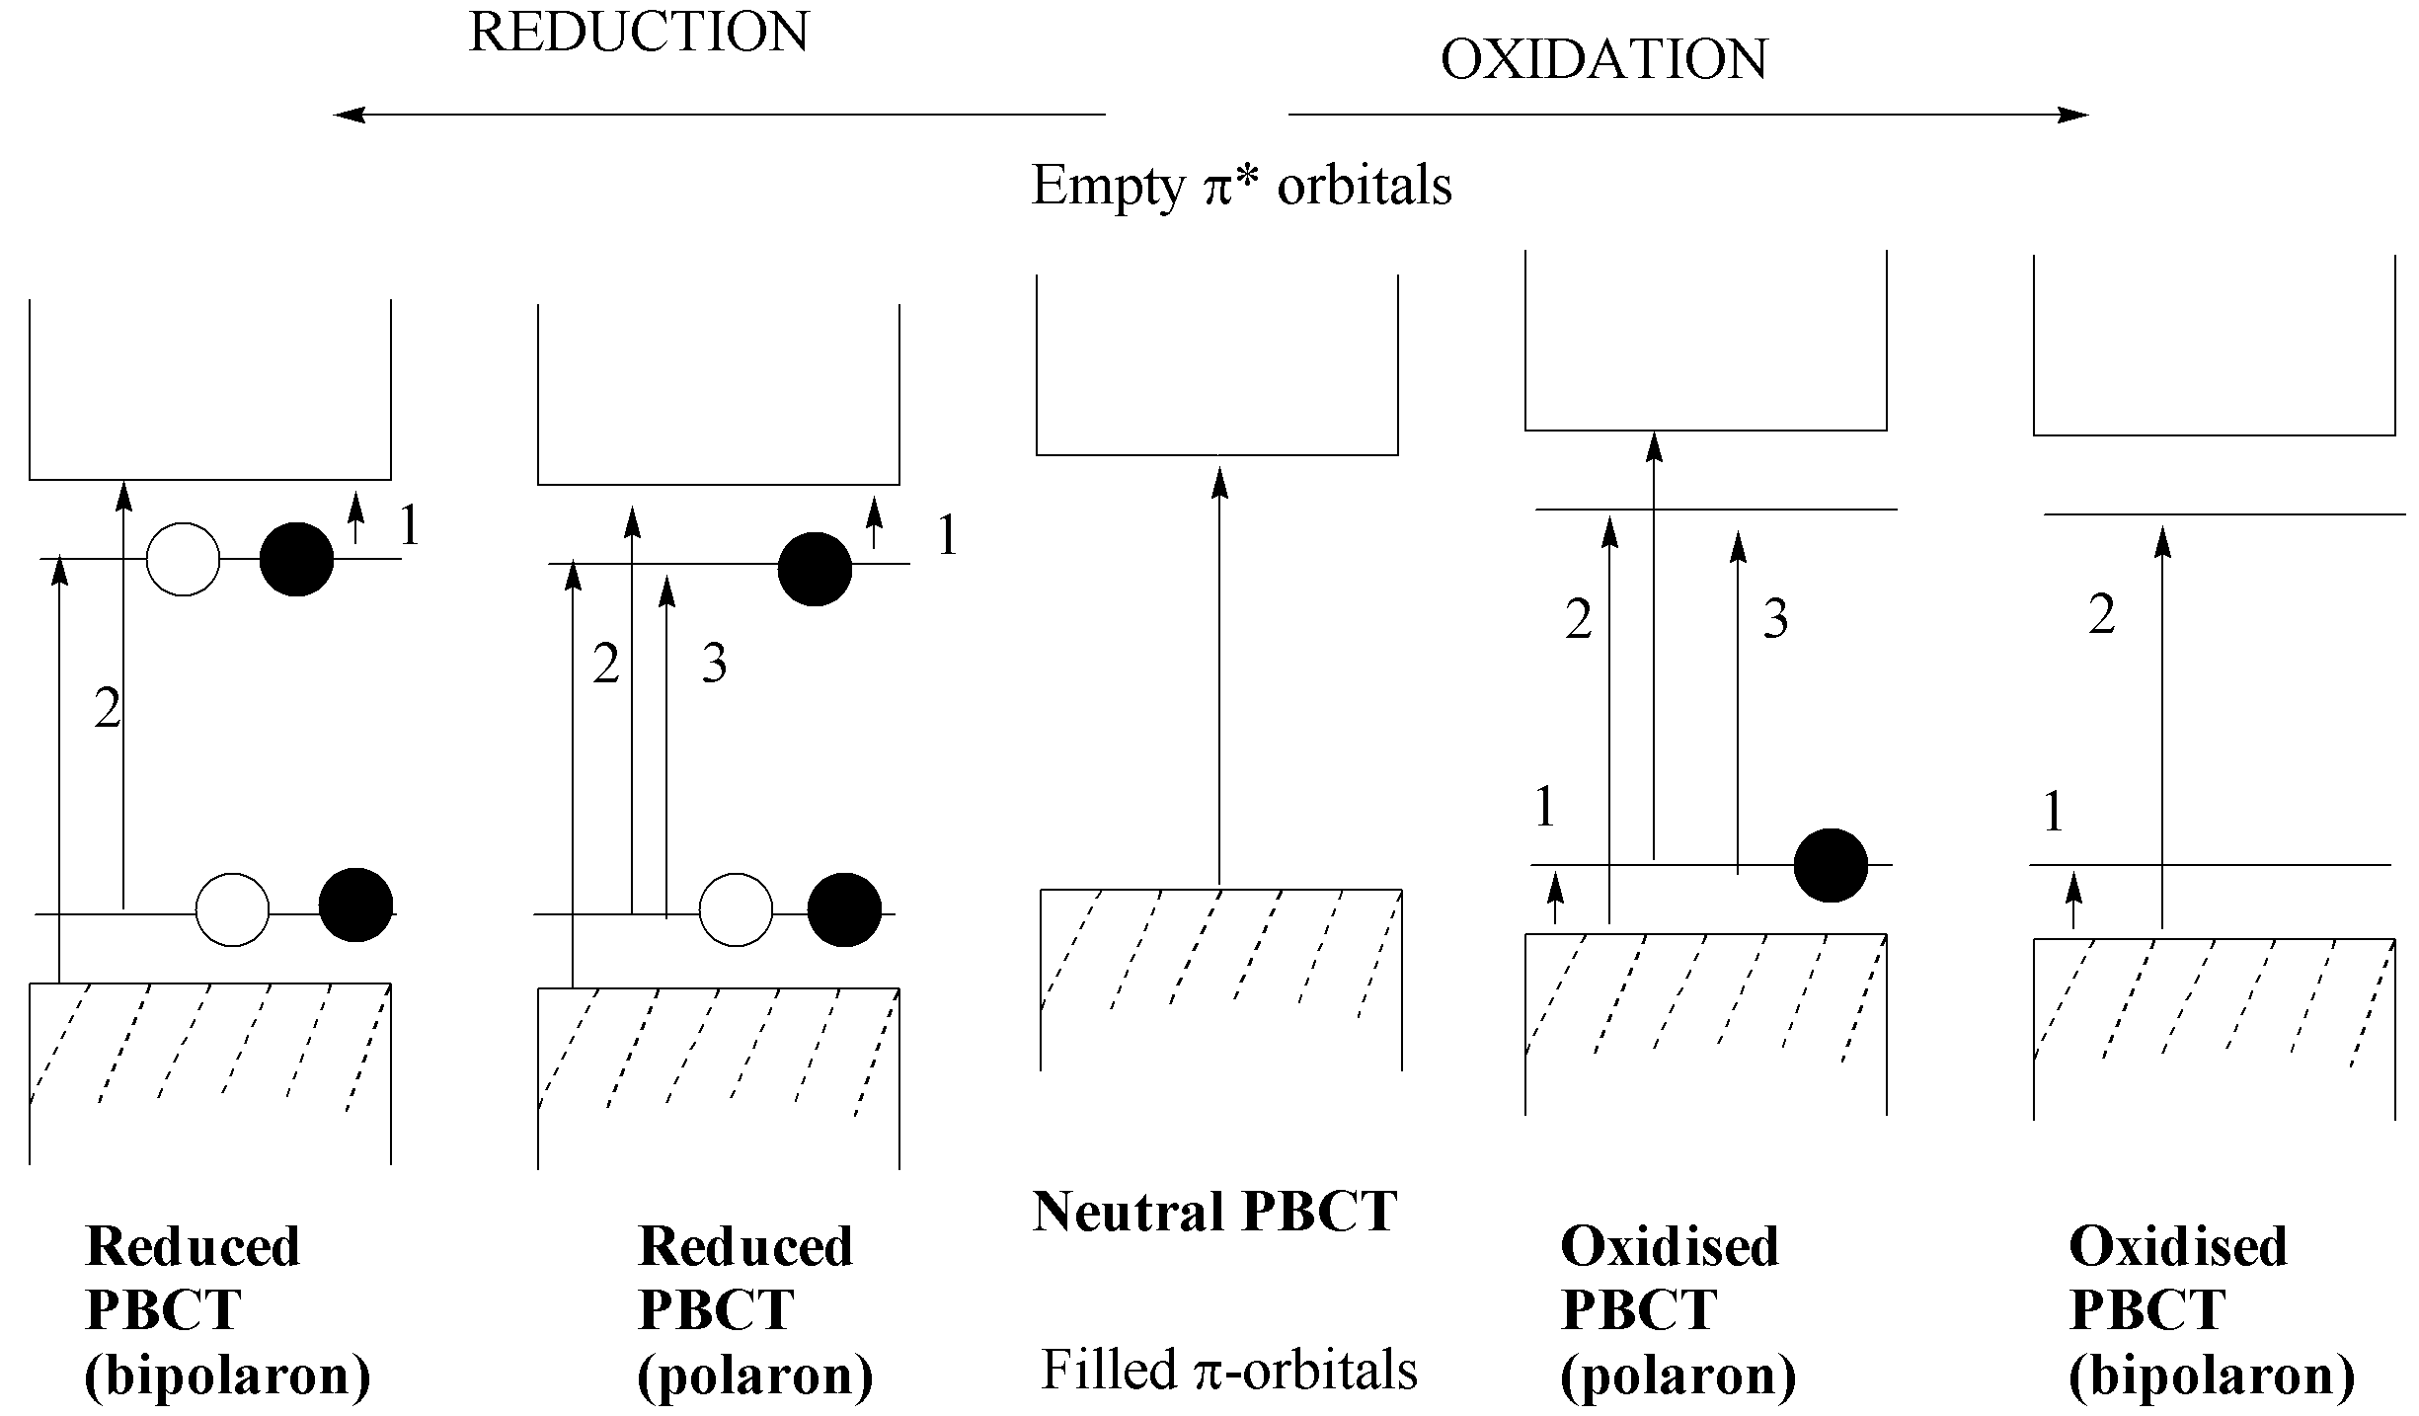

Figure S1. Schematic representation of the energy levels and possible electronic transitions in undoped (centre), p–doped (polaron carrier, right; bipolaron carrier, far right) and n–doped (polaron carrier, left; bipolaron carrier, far left) polybenzo[c]thiophenes.

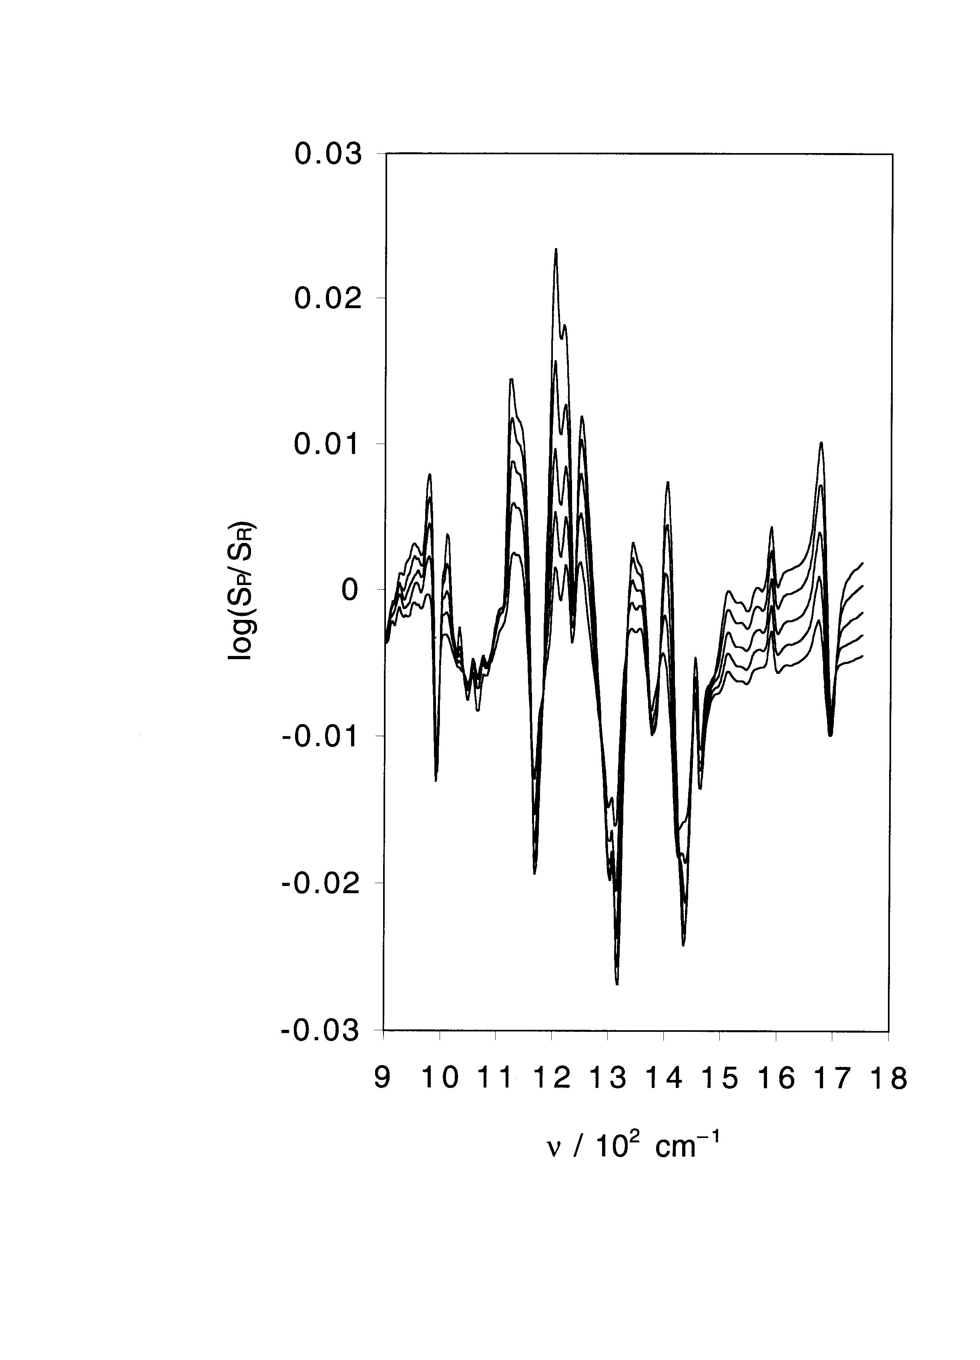

Figure S2. FTIR spectra of a PBCT film, collected at 0.1 V intervals from +0.6 V to +1.0 V, normalised to a reference spectrum taken at +0.5 V, in the region from 900 – 1800 cm^{–1}.

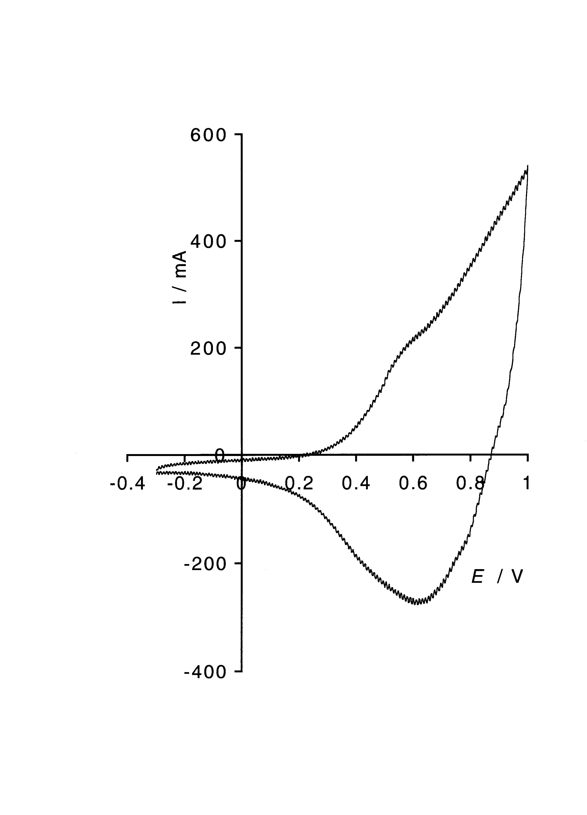
Figure S3. Cyclic voltammogram (p–doping potential region) of PFBCT film grown in the in situ FTIR cell, immediately prior to the film being pushed against the cell window for the p–doping experiment depicted in Figures 3 and S4, S5. Scan rate 98 mV s^{–1}.

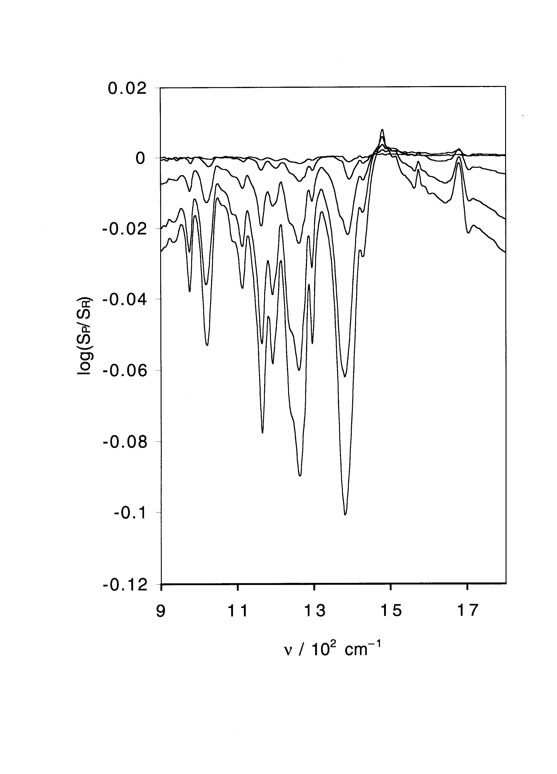

Figure S4 FTIR spectra of a PFBCT film, collected at 0.1 V intervals from 0 V to +0.5 V (in order of increasing band intensity at 6000 cm^{–1}), normalised to a reference spectrum taken at –0.2 V, in the region from 900 – 1800 cm^{–1}.

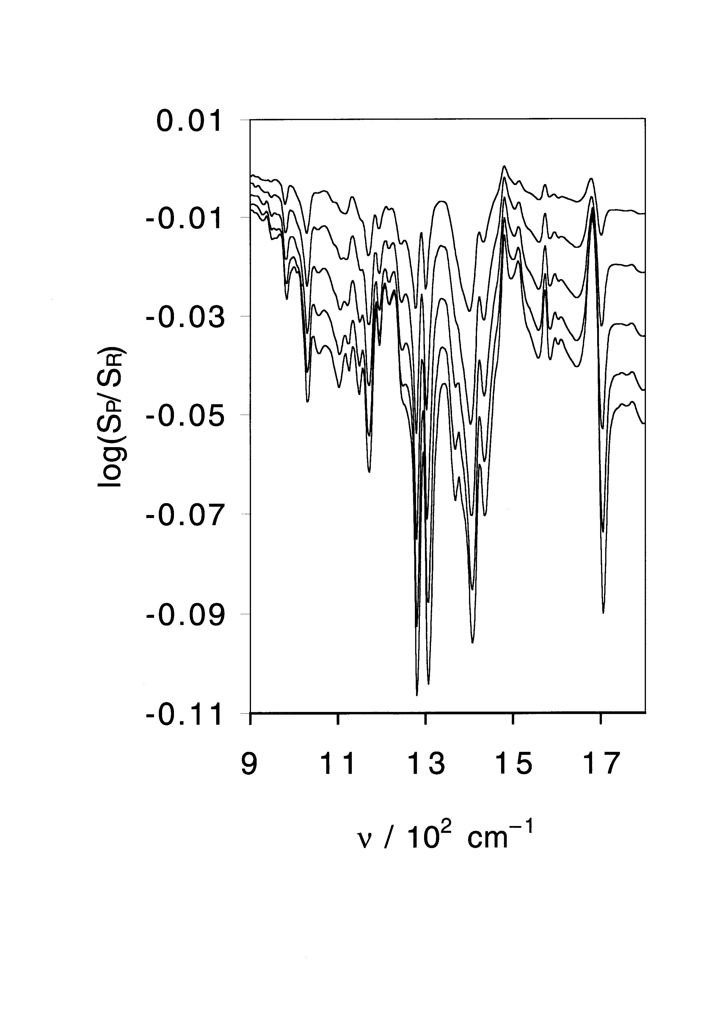

Figure S5. FTIR spectra of a PFBCT film, collected at 0.1 V intervals from +0.6 to +1.0 V inclusive, normalised to the spectrum taken at +0.5 V.

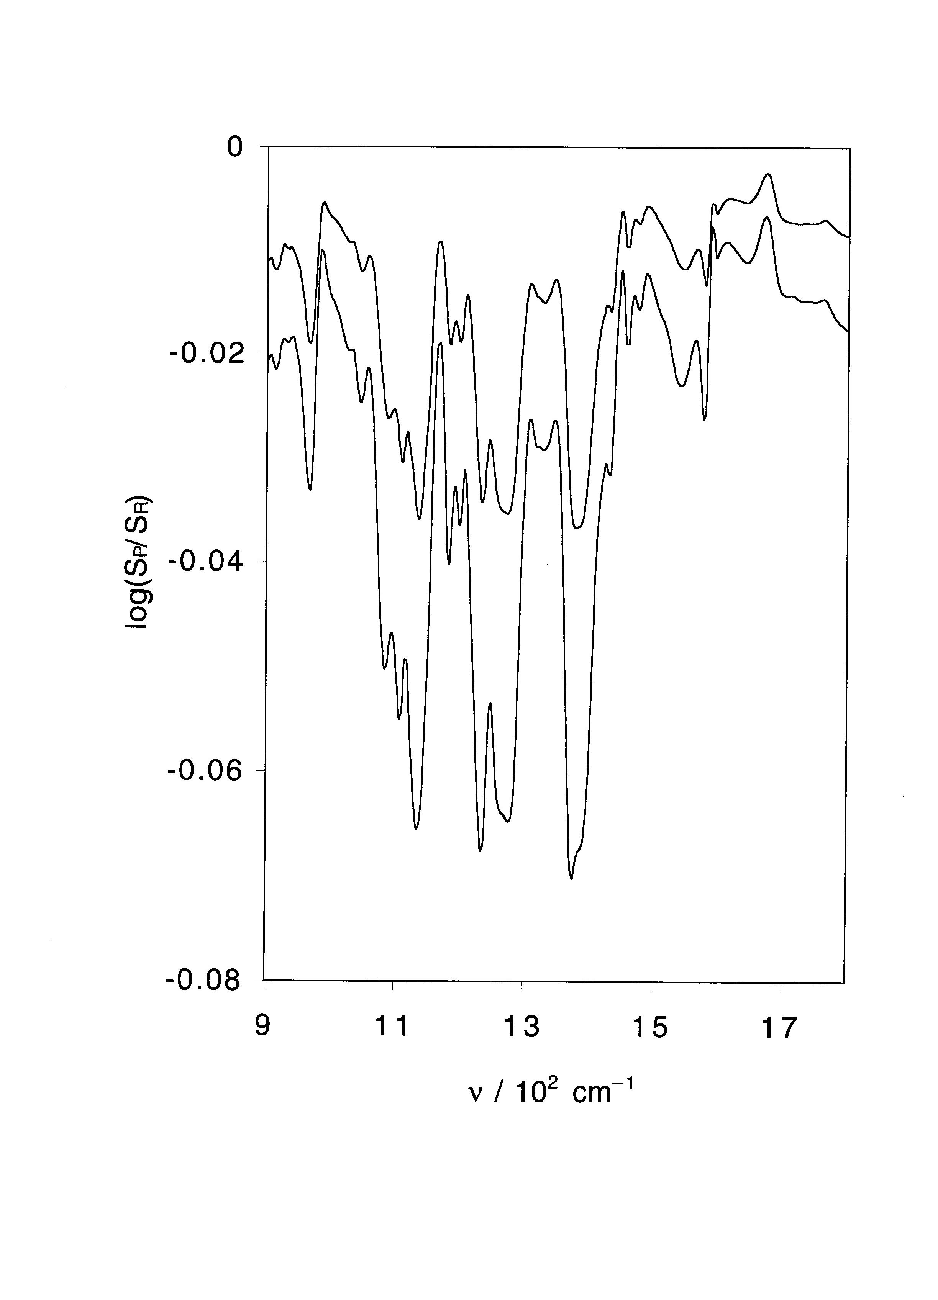

Figure S6. FTIR spectra of a PBCT film, collected at 0.1 V intervals from –1.4 V to –1.5 V, normalised to a reference spectrum taken at –1.3 V, in the region from 900 – 1800 cm^{–1}.

