J. Mater. Chem.

Laser-induced Alloying Au-Pd and Ag-Pd Colloidal Mixtures: The Formation of Dispersed Au/Pd and Ag/Pd Nanoparticles

(Electronic Supplementary Information)

Yu-Hung Chen, Yao-Hung Tseng, and Chen-Sheng Yeh*
Department of Chemistry
National Cheng Kung University
Tainan, Taiwan 701, R.O.C

*Author to whom correspondence should be addressed. E-mail address: csyeh@mail.ncku.edu.tw
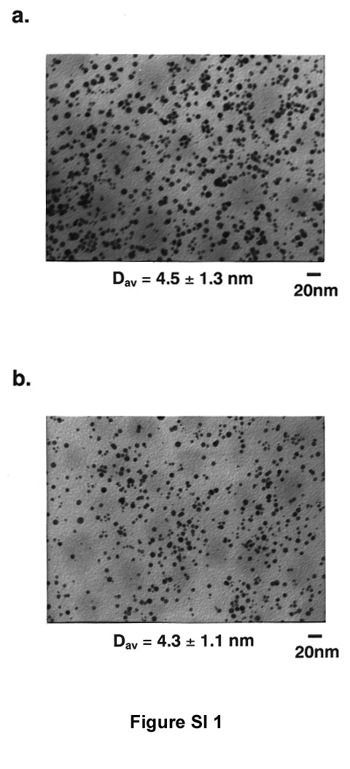
Figure SI 1: TEM images of the 2/1 molar ratio (Au/Pd) colloidal suspensions corresponding to (a) 20 min and (b) 40 min irradiation times.

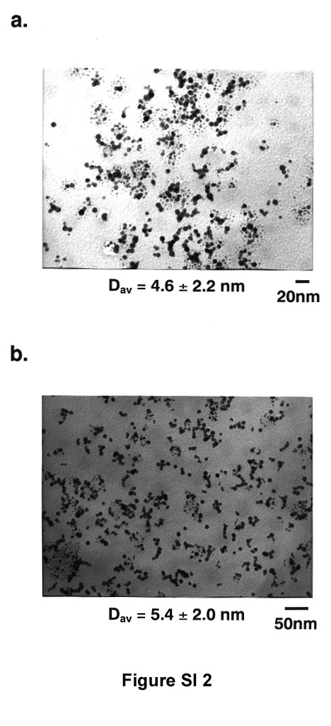
Figure SI 2: TEM images of the Ag/Pd (2/1) colloids corresponding to (a) 10 min and (b) 20 min irradiation times. If the irregular shapes were not precluded from counting, the bimetallic particles would exhibit a much wider size distribution for both (a) and (b) colloids.

