Electronic supplementary information

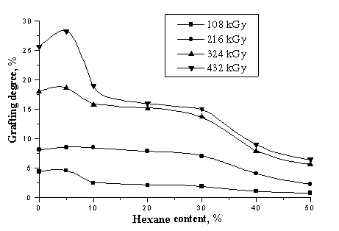

Dependence of the grafting degree on hexane content in the feed mixture at different absorbed doses.

ESI-1

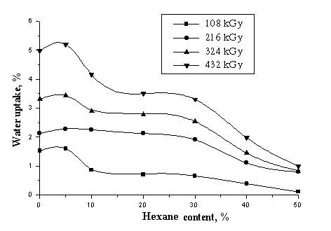
Dependence of water uptake of grafted films on hexane content in
the feed mixture at different absorbed doses
ESI-2

