Journal of Materials Chemistry B205558A

Electronic Supplementary Information

Microwave-assisted elemental-direct-reaction route to nanocrystalline copper chalcogenides CuSe and Cu₂Te
Yong Zhang, Zheng-Ping Qiao*, Xiao-Ming Chen*
School of Chemistry and Chemical Engineering, Sun Yat-Sen University, Guangzhou 510275, P. R. China
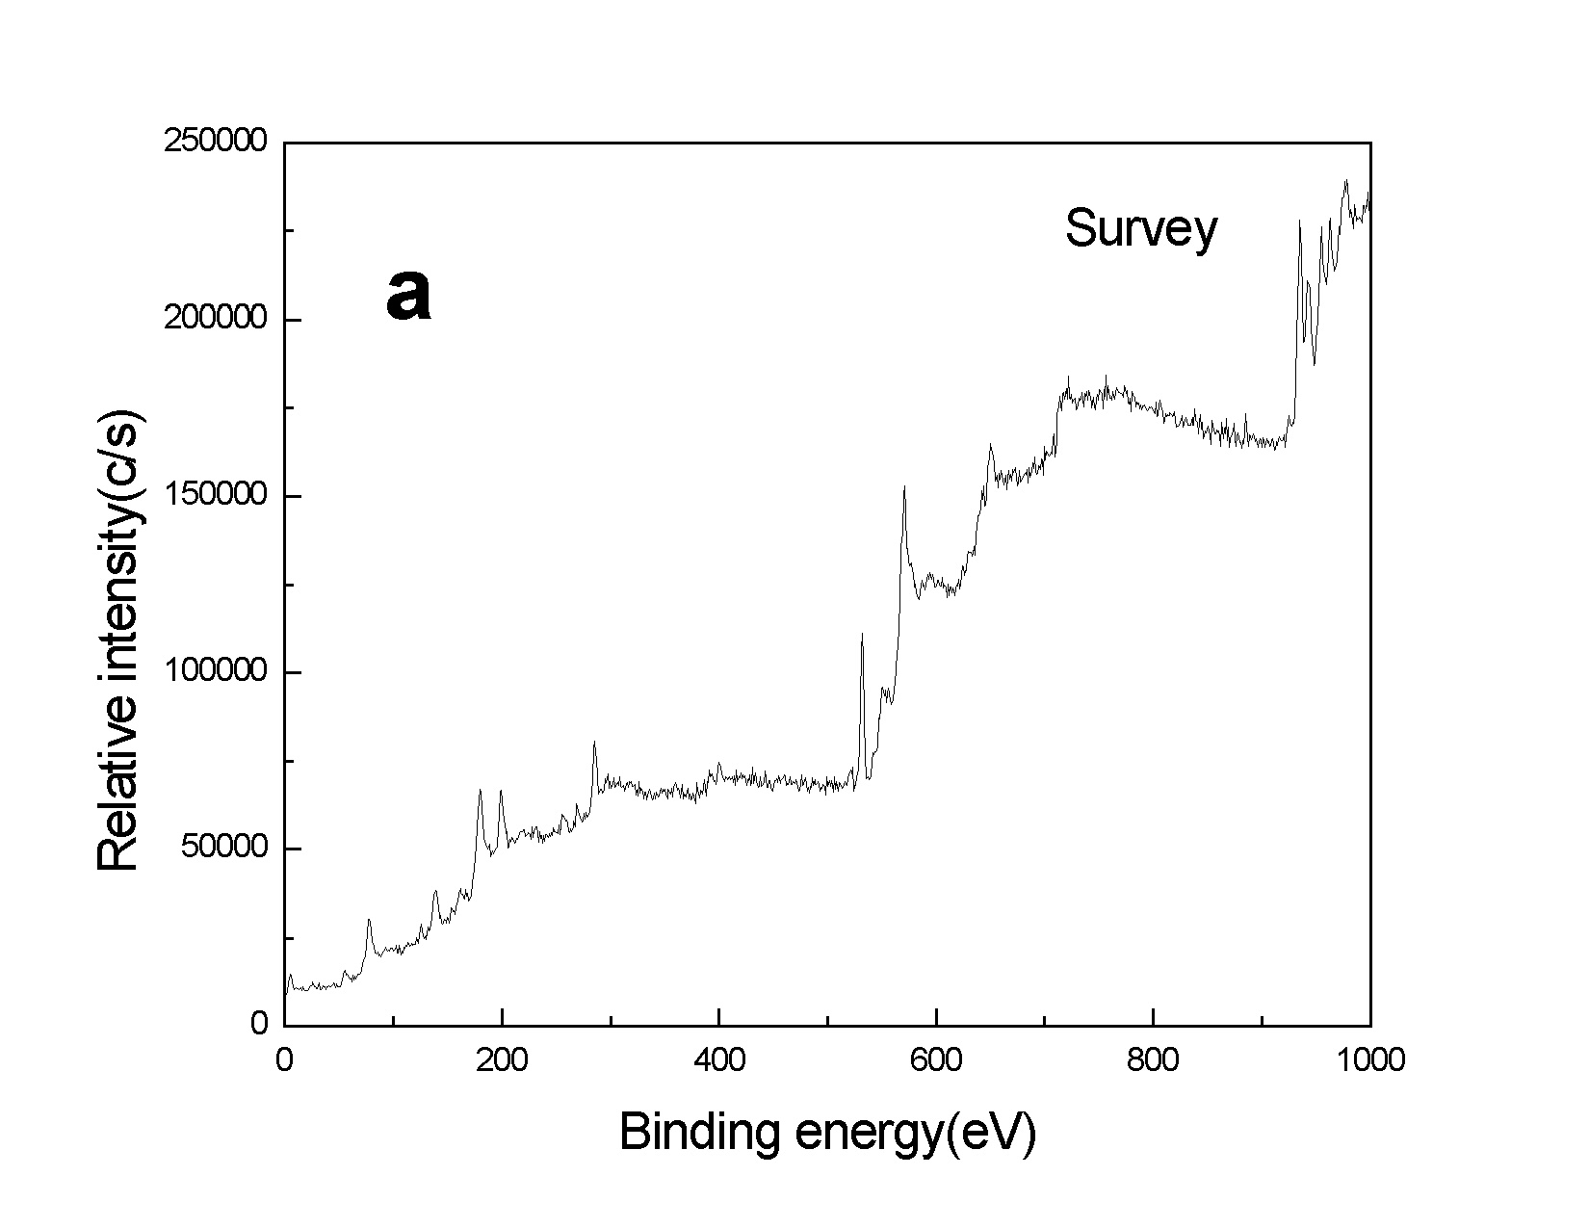
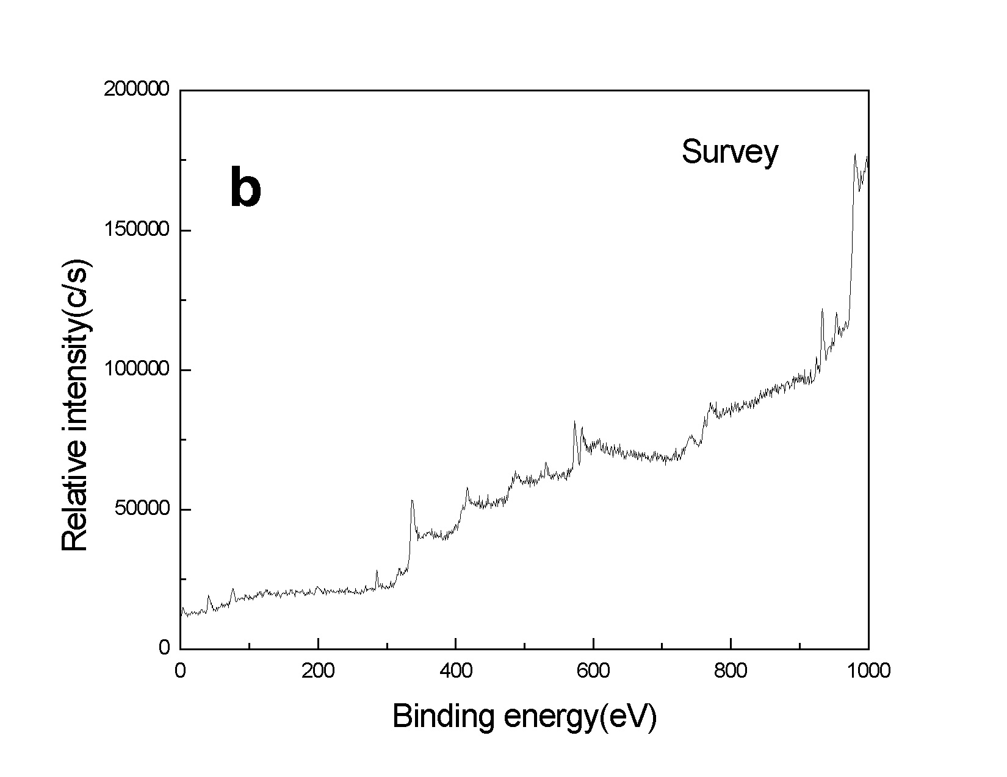
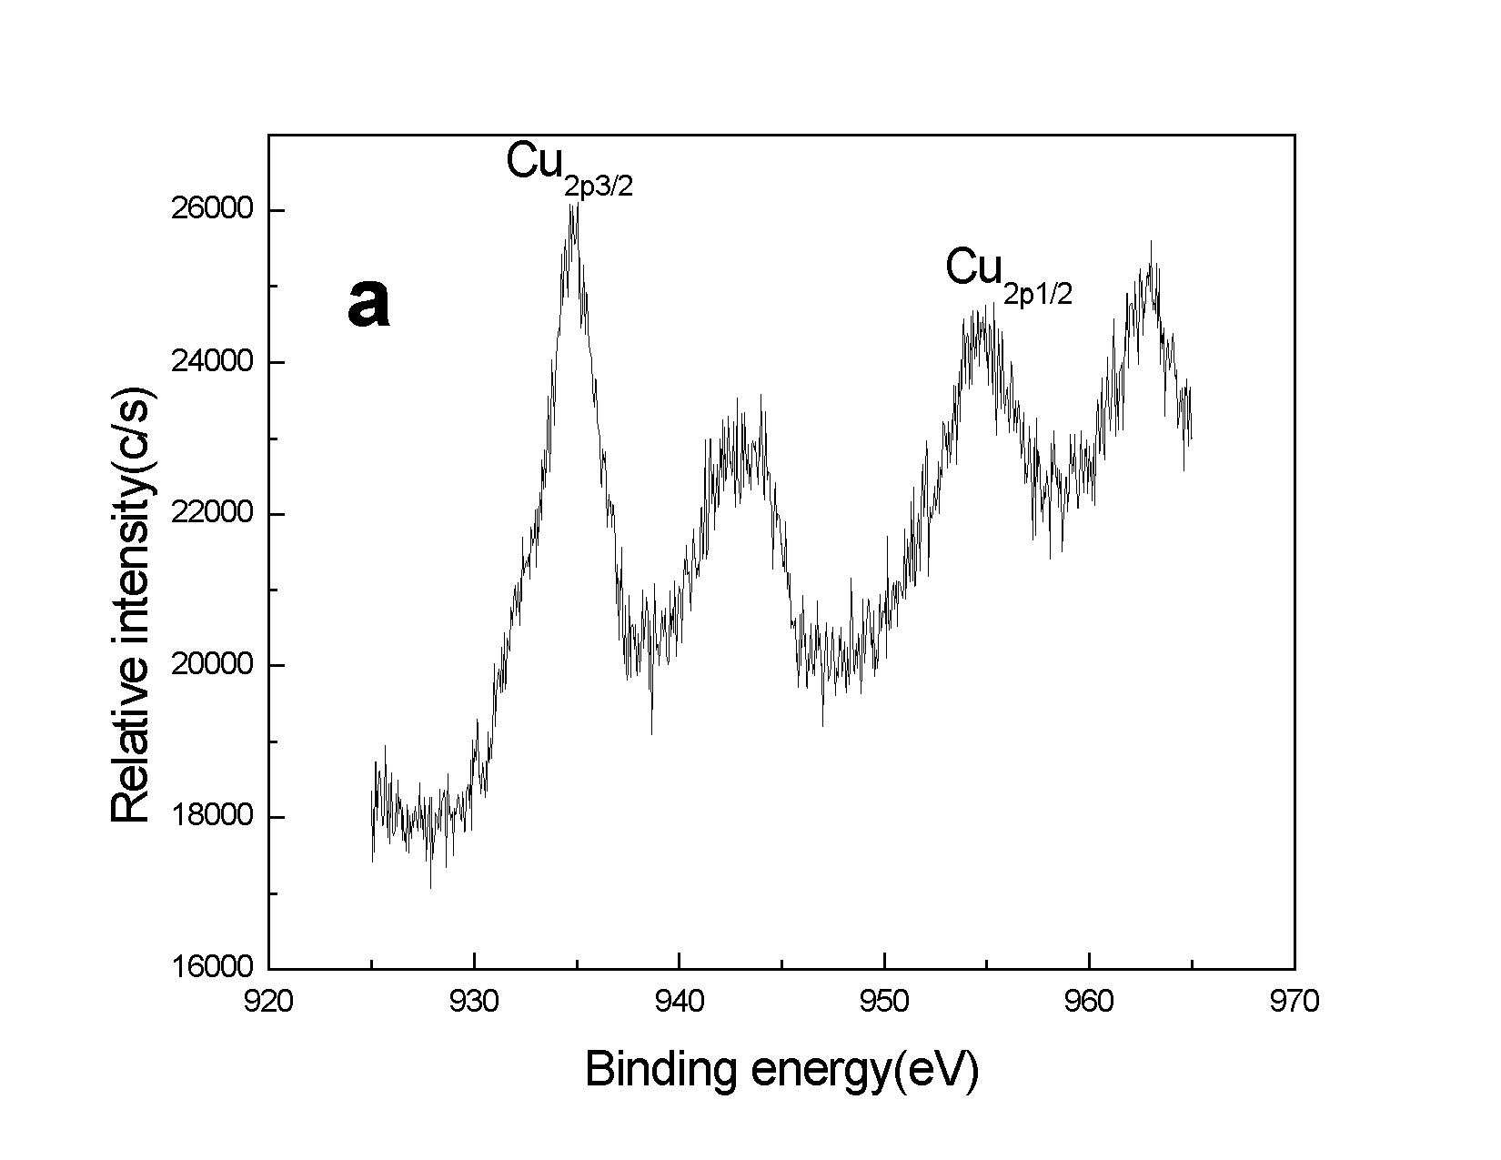
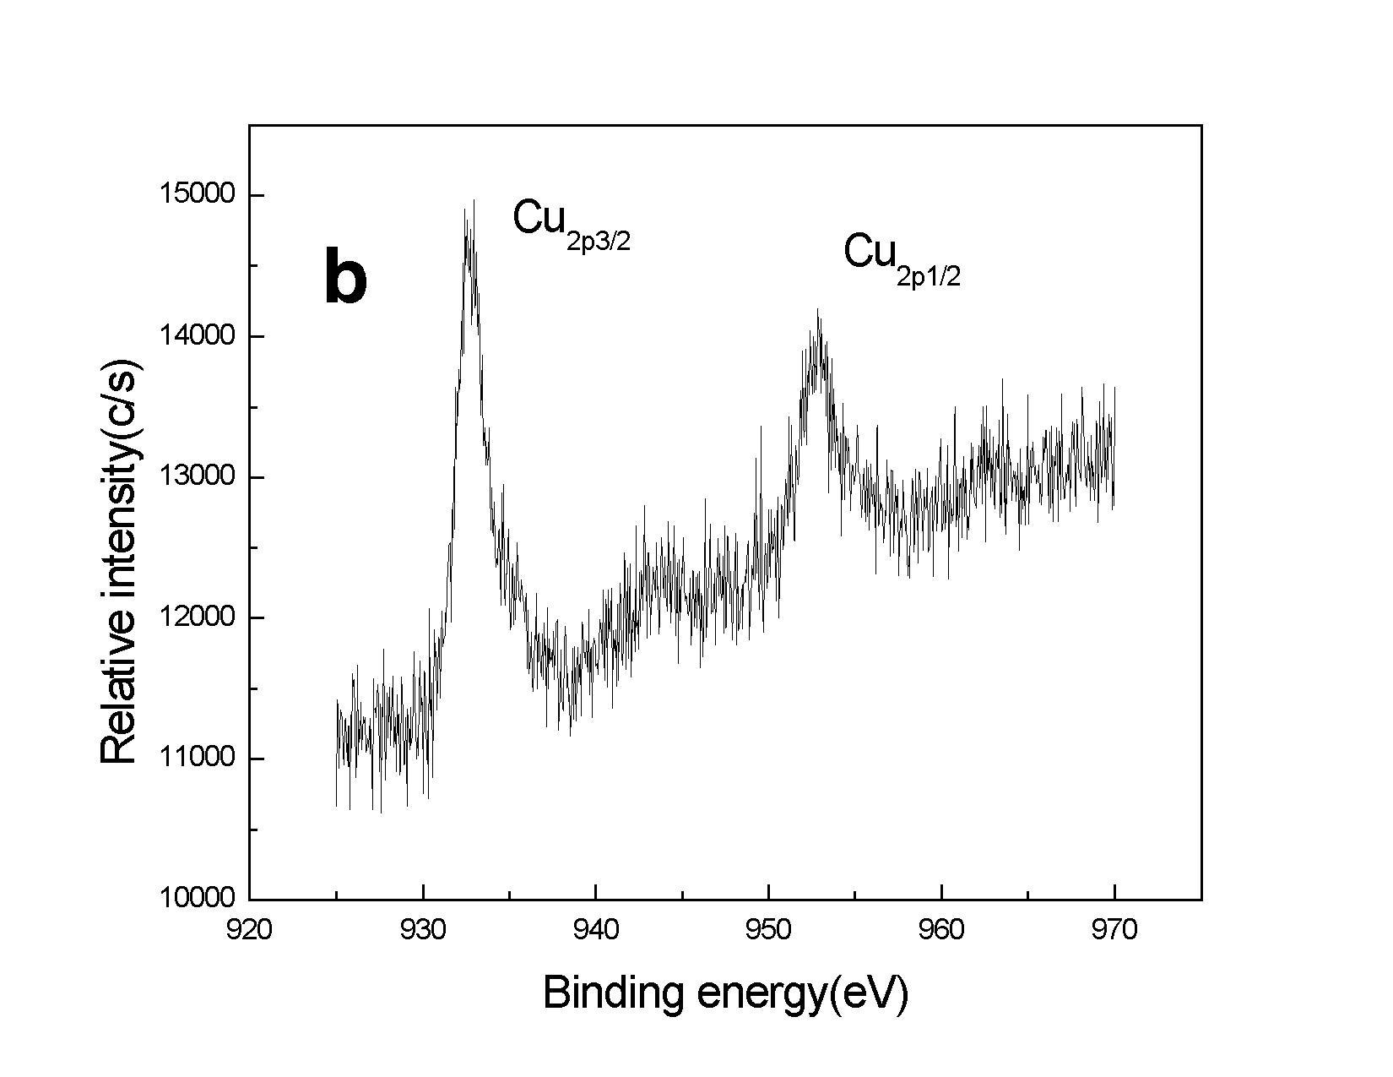

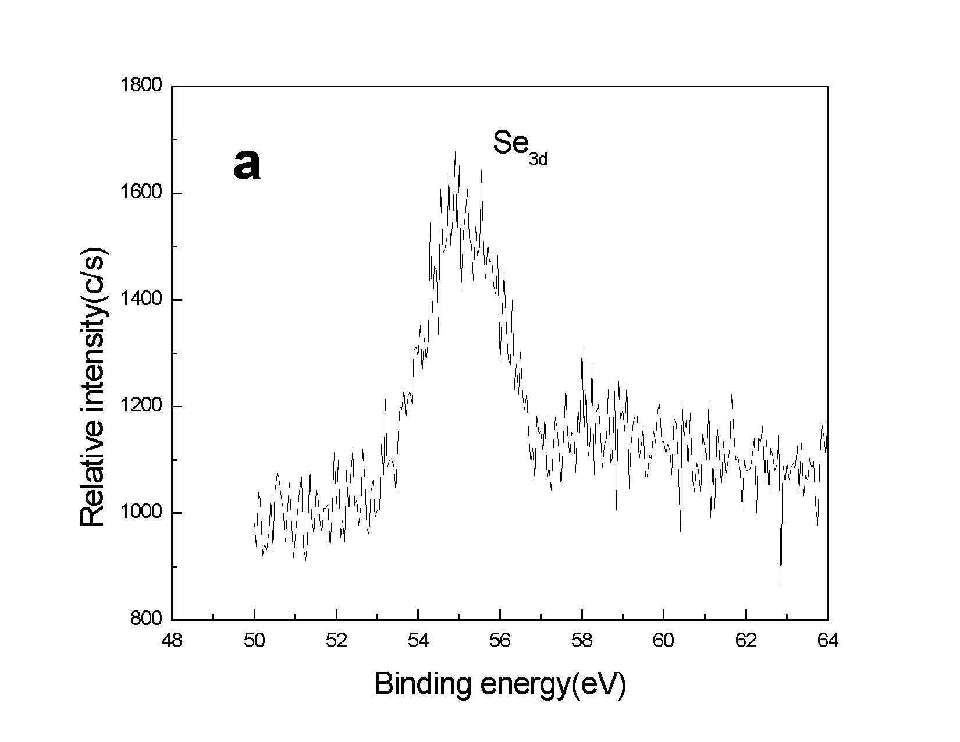
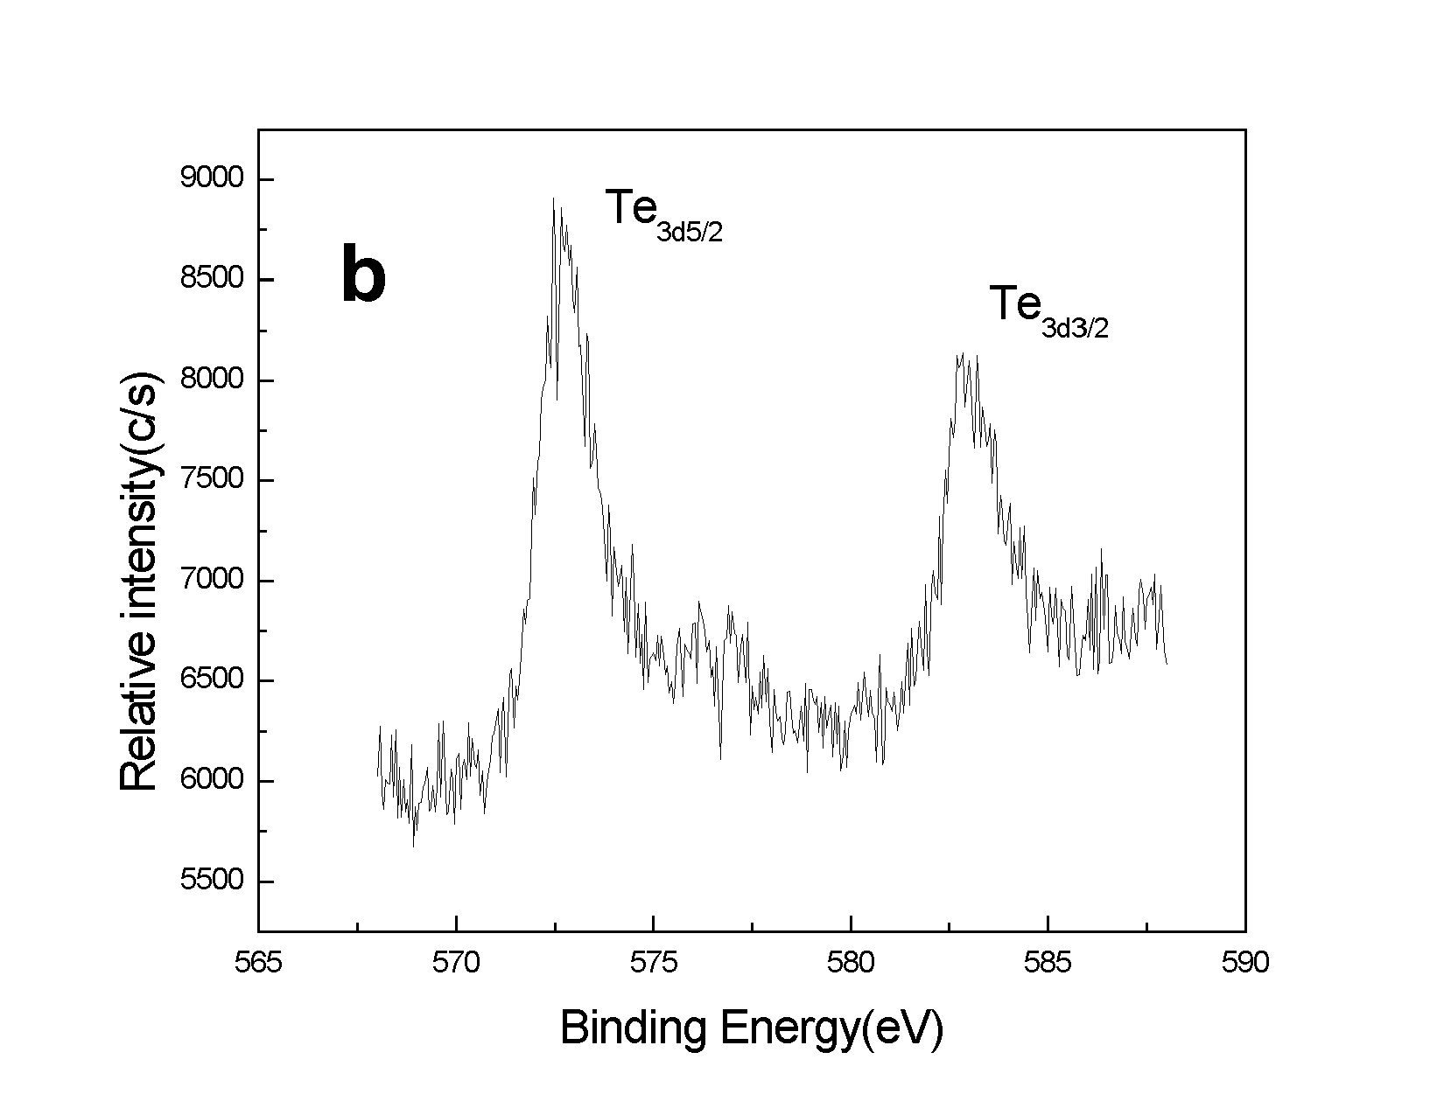

Fig. S1. XPS spectra of the products: (a) CuSe; (b) Cu₂Te.

