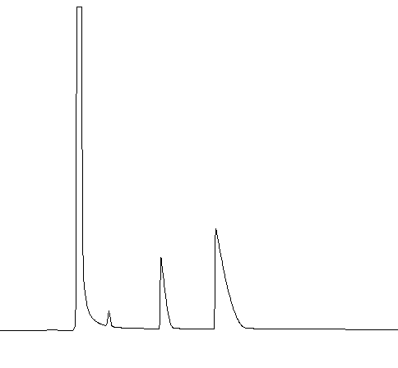
NH₃ (24.7 s)
CH₃NH₂ (31.9 s)
(CH₃)₂NH (43.2 s)
Response (a.u)
Retention time (s)
Ar

Typical GC chromatogram of volatiles eliminated at 170°C during thermal polycondensation of 2-[(CH₃)₂N]-4,6-(CH₃HN)₂B₃N₃H₃ 1 (Used atmosphere : argon).

-N(CH₃)₂
-NHCH₃
-N(CH₃)- bridges
26
28
30
32
36
38
34
(ppm)

¹³C NMR spectrum of oligomer 2 derived from 2-[(CH₃)₂N]-4,6-(CH₃HN)₂B₃N₃H₃ 1.

(a)

(b)

X-ray diffraction patterns of BN fibers prepared at (a) 1600°C (4.2), (b) 1800°C (4.1).

