Revised manuscript No. B209578E

Variation of Sodium Coordination during the Hydration Processes of Layered Sodium Disilicates as Studied by ²³Na MQMAS and ¹H-²³Na CP/MAS NMR Spectroscopy
Xuanjun Aiª, Lei Chenª, Jinxiang Dong ^{b}, Chaohui Yeª and Feng Deng*^{, a}

Figure 1 XRD powder patterns of the series SKS-5 samples as a function of hydration time: (a) as received; (b) 10 days; (c) 3 months; (d) 6 months.

Figure 2 XRD powder patterns of the series SKS-6 samples as a function of hydration time: (a) as received; (b) 3 months; (c) 6 months.

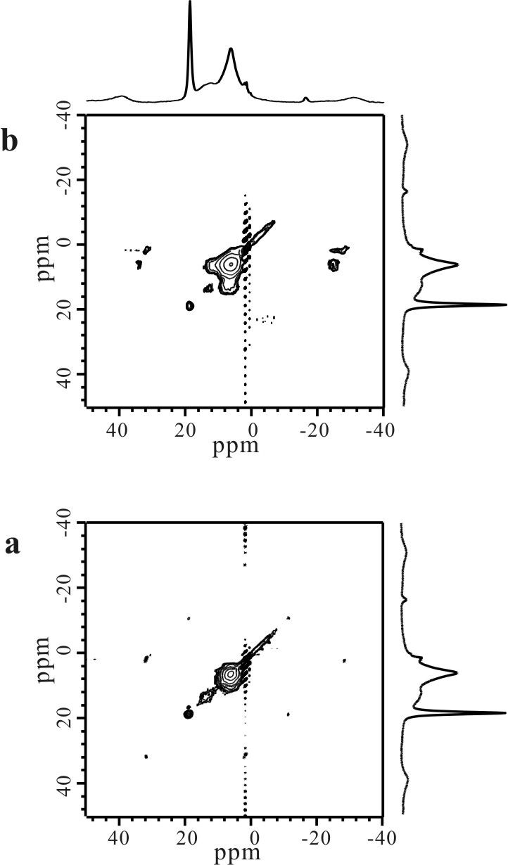

Figure 3 ¹H-¹H NOESY spectra of the six months hydrated sample of SKS-5 with different mixing time: (a) 1ms; (b) 20ms.

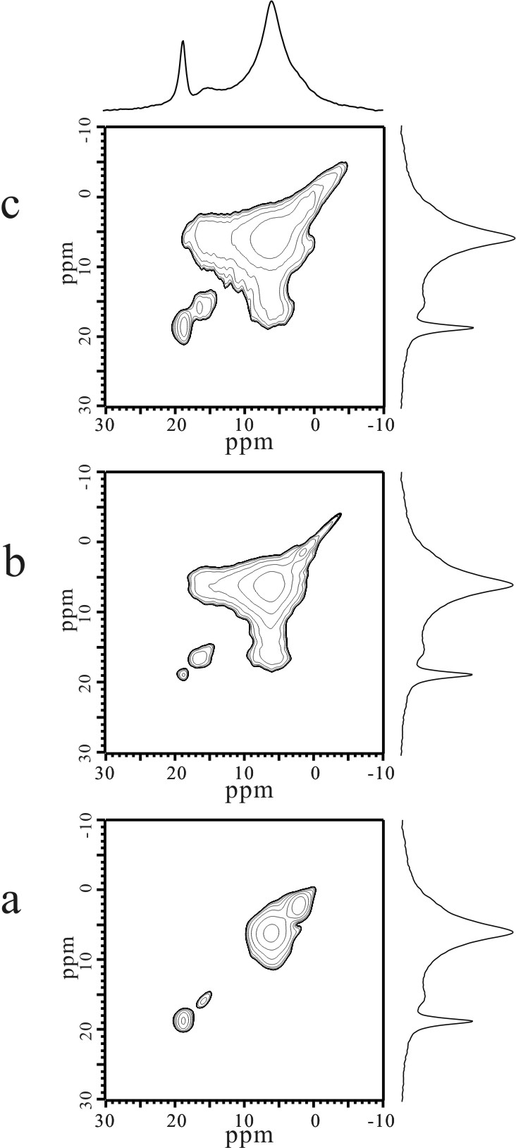

Figure 4 ¹H-¹H NOESY spectra of the six months hydrated sample of SKS-6 with different mixing time: (a) 0.5ms; (b) 20ms; (c) 150ms.

