This Journal is ©The Royal Society of Chemistry 2003

Polarized infrared spectra of the EuW₁₀-C₁₆TA film. The angle between the plane of the substrate and the electric field is either 0° (a) or 45° (b).

UV-vis absorption spectra of: (a) EuW₁₀ aqueous solution (2.0 × 10⁻⁵ M), (b) the EuW₁₀-C₁₆TA film.

XRD pattern of the EuW₁₀-C₁₆TA film in the low angle region. The inset shows the d-spacing as a function of the number of carbon atoms in the alkyl chain.
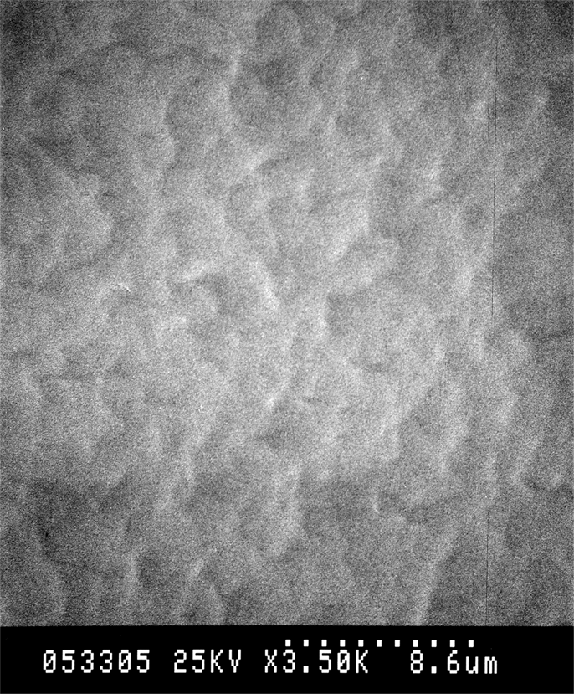

SEM image of the EuW₁₀-C₁₆TA film.

Emission spectra of: (a) EuW₁₀ solid, (b) EuW₁₀ aqueous solution (1.0 × 10⁻⁴ M), (c) the EuW₁₀-C₁₆TA film.

