Supplementary information.
Calculation of the dipole-dipole interactions
The dipole-dipole interaction between the molecules was estimated using the relationship V=μ₁μ₂(1-3cos²θ)/(4πε_{r}ε₀r³), where r is the distance between the centers of dipoles μ₁ and μ₂ and θ is the angle between the dipole μ and the line connecting the centers of the dipoles. In the first instance the literature value for the dipole moment in nitrobenzene (μ₁ = μ₂ = 4.3D)¹ was used along with the distance (r) and angle (θ) between the C-NO₂ dipoles measured from the X-ray crystal structure. The dipolar attraction between the two molecules in this case was V=-5.46 kJ mol⁻¹ (μ=4.3 D, r=8.61 Å, θ=2°, ε₀=4 the bulk value of ε_{r} measured at -100°C, 1kHz, in HAT5-NO₂).² Another estimate was obtained using values for the molecular dipoles estimated using density functional methods. A STO-31G basis-set with B3LYP electron correlation,³ gives a reasonable estimate of μ=4.2D for nitrobenzene;⁴ for HAT6-NO₂ this method calculates μ=5.96D. The vector components of the dipole moments and the position vectors of the molecules with respect to the inversion center are used to calculate r and θ, arriving at an estimate of V=-5.86 kJ mol⁻¹ (μ = 5.96 D, r=10.57 Å, θ=26.1° and ε₀=4), Both values are in good agreement indicating that the C-NO₂ dipole is almost exclusively responsible for the dipole-dipole interaction between the molecules. A similar calculation based upon the C-CN dipole for 4-hexyloxy-4’’-cyanobiphenyl (μ=4.77D, r=10.44Å, θ=25.03°, ε_{r}=4)⁵ yields a calculated stabilision of -2.85kJ mol⁻¹ for nearest neighbors. It should be noted that in this case the molecules are not related through an inversion centre so the effect of non-nearest neighbours is not negligable.
Experimental details.
General procedures and instrumentation.
Nuclear magnetic resonance spectra were recorded on a Bruker DPX300 spectrometer. Chemical shifts are expressed in parts per million (ppm) downfield of tetramethylsilane for ¹H resonance. Mass spectra were recorded on a VG Autospec mass spectrometer. Microanalyses were carried out at Leeds University Microanalytical Laboratory. All C, H, and N analytical figures are percentage values. Thin layer chromatography was carried out using precoated plastic backed silica plate which was visualized using ultraviolet light. Flash chromatography signifies column chromatography on Merck silica gel (230-400). Petroleum ether refers to petroleum ether (b.p. 40-60°C) unless otherwise stated.

Typical procedure for the synthesis of 1,2-dialkyloxybenzene derivatives.
Catechol (15 g, 0.136 mol), potassium carbonate (47.0 g, 0.341 mol) and 1-bromobutane (46.7 g, 0.341 mol) were added to ethanol (100 ml) and heated under reflux for 48 h. After cooling, dichloromethane (100 ml) was added and the solid residues removed by filtration. The solvents were then removed in vacuo and the crude product was distilled under reduced pressure to give 1,2-dibutyloxybenzene (25.7 g, 85%) as a colourless liquid. δ_{H} (CHCl₃) 6.90 (s, 4H, ArH), 4.02 (t, J=7Hz, 4H, ArOCH₂), 1.86 (m, 4H, ArOCH₂CH₂), 1.60-1.53 (m, 4H, ArOCH₂CH₂CH₂), 0.95 (t, J=7Hz, 6H, CH₂CH₃).

Typical procedure for the synthesis of 2,3,6,7,10,11-hexaalkyloxytriphenylene (HATn) derivatives.
Ferric chloride (30.6 g, 0.189 mol) was slowly added to 1,2-dibutyloxybenzene (14.0 g, 0.0631 mol) solution in dichloromethane (200 ml) under nitrogen. The mixture was stirred for 70 min. at room temperature and then poured onto methanol (700 ml). The crude solid product precipitated after 2 h. in the fridge and was filtered and washed with ethanol. The crude product was realkylated with 1-bromo-butane in ethanol. The product was purified by column chromatography on silica gel using dichloromethane and petroleum spirit (1:1) as eluent and then recrystallised from ethanol as a white solid (12.5 g, 90%)

Analytical Data for the HATn derivatives
2,3,6,7,10,11-hexaethoxytriphenylene HAT2. a white solid, 50%. Cr-I 242.5°C. δ_{H} (CHCl₃) 7.84 (s, 6H, ArH), 4.34 (q, J=6.9Hz, 12H, ArOCH₂), 1.56 (t, J=6.9Hz, 18H, ArOCH₂CH₃). MS (FAB), 492 (M⁺, 100%). Calculated for C₃₀H₃₆O₆, C, 73.15, H, 7.37; Found: C, 73.0, H, 7.50.

2,3,6,7,10,11-hexapropoxytriphenylene HAT3. a white solid, 51%. Cr-Col_{hp}, 100°C; Col_{hp}-I 174.3°C. δ_{H} (CHCl₃) 7.84 (s, 6H, ArH), 4.21 (t, J=6.6Hz, 12H, ArOCH₂), 1.96 (m, 12H, ArOCH₂CH₂), 1.15(t, J=7.4Hz, 18H, ArOCH₂CH₂CH₃). MS (FAB), 576 (M⁺, 100%); Calculated for C₃₆H₄₈O₆, C, 74.97, H, 8.39; Found: C, 74.90, H, 8.43.

2,3,6,7,10,11-hexabutoxytriphenylene HAT4. a white solid, 90%. Cr-Col_{h} 90 °C, Col_{h}-I 148 °C; δ_{H} (CHCl₃) 7.85 (s, 6H, ArH), 4.21 (t, J=7Hz, 12H, ArOCH₂), 1.95 (m, 12H, ArOCH₂CH₂), 1.65-1.55 (m, 12H, ArOCH₂CH₂CH₂), 1.06 (t, J=7Hz, 18H, ArOCH₂CH₂CH₂CH₃). MS (EI), 660 (M⁺, 100%); Calculated for C₄₂H₆₀O₆, C, 76.33, H, 9.15; Found: C, 76.60, H, 9.20.

2,3,6,7,10,11-hexahexyloxytriphenylene HAT6. a white solid, 87%. Cr-Col_{h} 67 °C, Col_{h}-I 100 °C; δ_{H} (CHCl₃) 7.86 (s, 6H, ArH), 4.25 (t, J=6.8Hz, 12H, ArOCH₂), 1.95 (m, 12H, ArOCH₂CH₂), 1.55-1.40 (m, 36H, CH₂), 0.95 (t, J=7Hz, 18H, CH₃). MS (EI), 828 (M⁺, 100%); Calculated for C₅₄H₈₄O₆, C, 78.21, H, 10.21; Found: C, 78.40, H, 10.25.

2,3,6,7,10,11-hexanonyloxytriphenylene HAT9. a white solid, 93%. Cr-Col_{h} 59°C, Col_{h}-I 81°C; δ_{H} (CHCl₃) 7.85 (s, 6H, ArH), 4.22 (t, 12H, J 6.8 ArOCH₂), 1.95 (m, 12H, ArOCH₂CH₂), 1.55-1.30 (m, 72H, CH₂), 0.91 (t, J 7, 18H, CH₃). MS (FAB), 1081 ([M+1]⁺, 100%); Calculated for C₇₂H₁₂₀O₆, C, 79.94, H, 11.18; Found: C, 79.80, H, 11.00.

2,3,6,7,10,11-hexaundecyloxytriphenylene HAT11. a white solid, 87%. Cr-Col_{h} 53°C, Col_{h}-I 66°C. δ_{H} (CHCl₃) 7.86 (s, 6H, ArH), 4.20 (t, J=6.8Hz, 12H, ArOCH₂), 1.95 (m, 12H, ArOCH₂CH₂), 1.55-1.30 (m, 96H, CH₂), 0.91 (t, J=7Hz, 18H, CH₃). MS (FAB), 1250 (M⁺, 73%), 176 (100%); Calculated for C₈₄H₁₄₄O₆, C, 80.71, H, 11.61; Found: C, 80.85, H, 11.65.

2,3,6,7,10,11-hexadodecyloxytriphenylene HAT12. a white solid, 70%. Cr-I 64°C δ_{H} (CHCl₃) 7.85 (s, 6H, ArH), 4.21 (t, J=7Hz, 12H, ArOCH₂), 1.95 (m, 12H, ArOCH₂CH₂), 1.55-1.30 (m, 108H, CH₂), 1.06 (t, J=7Hz, 18H, CH₃). MS (FAB) 1332(M⁺, 57%); 1333 ([M+1]⁺, 58%); Calculated for C₉₀H₁₅₆O₆, C, 81.02, H, 11.79; Found: C, 80.75, H, 11.65.

2,3,6,7,10,11-hexatetradecyloxytriphenylene HAT14. a white solid, 70%, Cr-I 56.9°C. δ_{H} (CHCl₃) 7.85 (s, 6H, ArH), 4.21 (t, J=7Hz, 12H, ArOCH₂), 1.95 (m, 12H, ArOCH₂CH₂), 1.55-1.30 (m, 132H, CH₂), 1.06 (t, J=7Hz, 18H, CH₃). MS (FAB), 1501 (M⁺, 79.4%). Calculated for C₁₀₂H₁₈₀O₆, C, 81.54, H, 12.07; Found: C, 81.4, H, 12.35.

2,3,6,7,10,11-hexahexadecyloxytriphenylene HAT16. a white solid, 81%, Cr-I 58.8°C. δ_{H} (CHCl₃) 7.85 (s, 6H, ArH), 4.21 (t, J=7Hz, 12H, ArOCH₂), 1.95 (m, 12H, ArOCH₂CH₂), 1.55-1.30 (m, 156H, CH₂), 1.06 (t, J=7Hz, 18H, CH₃). MS (FAB), 1668 (M⁺, 100%). Calculated for C₁₁₄H₂₀₄O₆, C, 81.95, H, 12.31; Found: C, 81.8, H, 12.3.

Typical procedure for the synthesis of 1-nitro-2,3,6,7,10,11-hexaalkyloxytriphenylene HATn-NO₂ derivatives.
Nitric acid (70%, 0.25 g, 2.78 mmol) was added to HAT4 (1.84 g, 2.78 mmol) solution in dichloromethane (30 ml) and nitromethane (5 ml) at room temperature, and stirred for 15 min. Saturated aqueous sodium hydrogen carbonate solution was then added and the product was extracted with dichloromethane, dried (MgSO₄), concentrated and purified by column chromatography on silica gel using dichloromethane petroleum (1:1) spirit as eluent and then recrystallised from ethanol as a yellow solid (1.57 g, 80%).

Analytical Data for the HATn-NO₂ derivatives
1-Nitro-2,3,6,7,10,11-hexaethoxytriphenylene HAT2-NO₂ . a yellow solid, 50%. Cr-I 179.0°C. δ_{H} (CHCl₃) 7.90 (s, 1H, ArH), 7.78 (s, 1H, ArH), 7.75 (s, 2H, ArH), 7.47(s, 1H, ArH), 4.33 (m, 10H, ArOCH₂), 4.19 (t, J=7.0Hz, 2H, ArOCH₂), 1.59 (m, 12H, ArOCH₂CH₃), 1.41 (t, J=7.0Hz, ArOCH₂CH₃). MS (EI), 537 (M⁺, 100%); Calculated for C₃₀H₃₅NO₈, C, 67.02, H, 6.56; N, 2.61 Found: C, 67.02, H, 6.55, N, 2.55.

1-Nitro-2,3,6,7,10,11-hexapropoxytriphenylene HAT3-NO₂. a yellow solid, 70%. Cr-Colh 131.6°C, Colh-I 147.5°C; δ_{H} (CHCl₃) 7.93 (s, 1H, ArH), 7.81 (s, 1H, ArH), 7.79 (s, 2H, ArH), 7.49 (s, 1H, ArH), 4.21 (m, 10H, ArOCH₂), 4.05 (t, J=6.6Hz, 2H, ArOCH₂), 2.10-1.60 (m, 12H, ArOCH₂CH₂), 1.14 (m, 15H, ArOCH₂CH₂CH3), 1.05 (t, J=7.4Hz, 3H, ArOCH₂CH₂CH₃). MS (EI), 621 (M⁺, 100%); Calculated for C₃₆H₄₇NO₈, C, 69.54, H, 7.62; N, 2.25 Found: C, 69.35, H, 7.65, N, 2.1.

1-Nitro-2,3,6,7,10,11-hexaebutoxytriphenylene HAT4-NO₂. a yellow solid, 80%. Cr-Col_{h} 52 °C, D_{h}-I 143 °C; δ_{H} (CHCl₃) 7.92 (s, 1H, ArH), 7.80 (s, 1H, ArH), 7.78 (s, 2H, ArH), 7.48 (s, 1H, ArH), 4.28-4.20 (m, 10H, ArOCH₂), 4.09 (t, J=6.5Hz, 2H, ArOCH₂), 1.95-1.72 (m, 12H, ArOCH₂CH₂), 1.65-1.45 (m, 12H, ArOCH₂CH₂CH₂), 1.10-0.92 (m, 18H, CH₃). MS (EI), 705 (M⁺, 100%); Calculated for C₄₂H₅₉NO₈, C, 71.46, H, 8.42; N, 1.98 Found: C, 71.25, H, 8.70, N, 1.90.

1-Nitro-2,3,6,7,10,11-hexapentoxytriphenylene HAT5-NO₂. a yellow solid, 81%. Cr-Col_{h} <-20°C, D_{h}-I 141.4°C; δ_{H} (CHCl₃) 7.90 (s, 1H, ArH), 7.79 (s, 1H, ArH), 7.76 (s, 2H, ArH), 7.47 (s, 1H, ArH), 4.23 (m, 10H, ArOCH₂), 4.08 (t, J7, 2H, ArOCH₂), 1.96-1.80 (m, 12H, ArOCH₂CH₂), 1.64-1.38 (m, 24H, CH₂), 0.95 (t, J 7, 18H, CH₃). MS (EI), 789 (M⁺, 100%); Calculated for C₄₈H₇₁NO₈, C, 72.97, H, 9.06; N, 1.77, Found: C, 72.95, H, 9.15, N, 1.7.

1-Nitro-2,3,6,7,10,11-hexahexyloxytriphenylene HAT6-NO₂. a yellow solid , 79%. Cr-Col_{h} <-20°C, D_{h}-I 137 °C; δ_{H} (CHCl₃) 7.88 (s, 1H, ArH), 7.79 (s, 1H, ArH), 7.75 (s, 2H, ArH), 7.50 (s, 1H, ArH), 4.20 (m, 10H, ArOCH₂), 4.05 (t, J7, 2H, ArOCH₂), 1.96-1.80 (m, 12H, ArOCH₂CH₂), 1.64-1.38 (m, 36H, CH₂), 0.95 (t, J 7, 18H, CH₃). MS (EI), 873 (M⁺, 100%); Calculated for C₅₄H₈₃NO₈, C, 74.19, H, 9.57; N, 1.60, Found: C, 74.10, H, 9.80, N, 1.60.

1-Nitro-2,3,6,7,10,11-hexaoctyloxytriphenylene HAT8-NO₂. a yellow solid , 80%. Cr-Col_{h} <-20°C, D_{h}-I 128.4°C; δ_{H} (CHCl₃) 7.88 (s, 1H, ArH), 7.78 (s, 1H, ArH), 7.75 (s, 2H, ArH), 7.47 (s, 1H, ArH), 4.22 (m, 10H, ArOCH₂), 4.07 (t, J=7Hz, 2H, ArOCH₂), 1.96-1.80 (m, 12H, ArOCH₂CH₂), 1.64-1.38 (m, 60H, CH₂), 0.95 (t, J=7Hz, 18H, CH₃). MS (FAB), 1041 (M⁺, 100%); Calculated for C₆₆H₁₀₇NO₈, C, 76.04, H, 10.34; N, 1.34, Found: C, 76.15, H, 10.35, N, 1.25.

1-Nitro-2,3,6,7,10,11-hexanonyloxytriphenylene HAT9-NO₂. a yellow solid, 78%. Cr-Col_{h} 0°C, Col_{h}-I 127 °C; δ_{H} (CHCl₃) 7.87 (s, 1H, ArH), 7.78 (s, 1H, ArH), 7.75 (s, 2H, ArH), 7.50 (s, 1H, ArH), 4.20 (m, 10H, ArOCH₂), 4.05 (t, J=7Hz, 2H, ArOCH₂), 1.96-1.80 (m, 12H, ArOCH₂CH₂), 1.64-1.38 (m, 72H, CH₂), 0.95 (t, J=7Hz, 18H, CH₃). MS (FAB), 1126 ([M+1]⁺, 100%); Calculated for C₇₂H₁₁₉NO₈, C, 76.75, H, 10.64, N, 1.24, Found: C, 76.55, H, 10.85, N, 1.05.

1-Nitro-2,3,6,7,10,11-hexadecyloxytriphenylene HAT10-NO₂. a yellow solid, 75%. Cr-Col_{h} 7.1°C, Col_{h}-I 118.4°C. δ_{H} (CHCl₃) 7.87 (s, 1H, ArH), 7.78 (s, 1H, ArH), 7.75 (s, 2H, ArH), 7.50 (s, 1H, ArH), 4.20 (m, 10H, ArOCH₂), 4.05 (t, J=7Hz, 2H, ArOCH₂), 1.96-1.80 (m, 12H, ArOCH₂CH₂), 1.64-1.38 (m, 84H, CH₂), 0.95 (t, J=7Hz, 18H, CH₃). MS (FAB), 1209 (M⁺, 81%); Calculated for C₇₈H₁₃₁NO₈, C, 77.37, H, 10.90, N, 1.16, Found: C, 77.6, H, 11.1, N, 0.95.

1-Nitro-2,3,6,7,10,11-hexaundecyloxytriphenylene HAT11-NO₂. a yellow solid, 85%. Cr-Col_{h} 37.3°C, Col_{h}-I 116°C; δ_{H} (CHCl₃) 7.87 (s, 1H, ArH), 7.78 (s, 1H, ArH), 7.75 (s, 2H, ArH), 7.50 (s, 1H, ArH), 4.20 (m, 10H, ArOCH₂), 4.05 (t, J=7Hz, 2H, ArOCH₂), 1.96-1.80 (m, 12H, ArOCH₂CH₂), 1.64-1.38 (m, 96H, CH₂), 0.95 (t, J=7Hz, 18H, CH₃). MS (FAB), 1294 ([M+1], 63%), 69 (100%); Calculated for C₈₄H₁₄₃NO₈, C, 77.91, H, 11.13, N, 1.08; Found: C, 78.00, H, 11.35, N, 0.90.

1-Nitro-2,3,6,7,10,11-hexadodecyloxytriphenylene HAT12-NO₂. a yellow solid, 76%. Cr-Col_{h} 39.8°C, Col_{h}-I 107.7°C. δ_{H} (CHCl₃) 7.90 (s, 1H, ArH), 7.79 (s, 1H, ArH), 7.76 (s, 2H, ArH), 7.47 (s, 1H, ArH), 4.22 (m, 10H, ArOCH₂), 4.07 (t, J=7Hz, 2H, ArOCH₂), 1.96-1.80 (m, 12H, ArOCH₂CH₂), 1.64-1.38 (m, 108H, CH₂), 0.95 (t, J= 7Hz, 18H, CH₃). MS (FAB), 1377 (M⁺, 14%); Calculated for C₉₀H₁₅₅NO₈, C, 78.38, H, 11.33, N, 1.02; Found: C, 78.4, H, 11.6, N, 0.9.

1-Nitro-2,3,6,7,10,11-hexatetradecyloxytriphenylene HAT14-NO₂. a yellow solid, 77%. Cr-Col_{h} 52°C, Col_{h}-I 97.0°C. δ_{H} (CHCl₃) 7.92 (s, 1H, ArH), 7.80 (s, 1H, ArH), 7.78 (s, 2H, ArH), 7.48 (s, 1H, ArH), 4.21 (m, 10H, ArOCH₂), 4.07 (t, J7, 2H, ArOCH₂), 1.96-1.80 (m, 12H, ArOCH₂CH₂), 1.64-1.38 (m, 132H, CH₂), 0.95 (t, J 7, 18H, CH₃). MS (FAB), 1547 (M⁺, 8.4%), 1548 ([M+1]⁺, 11%); Calculated for C₁₀₂H₁₇₉NO₈, C, 79.17, H, 11.66, N, 0.91; Found: C, 78.95, H, 11.75, N, 0.85.

1-Nitro-2,3,6,7,10,11-hexahexadecyloxytriphenylene HAT16-NO₂. a yellow solid, 70%. Cr-Col_{h} 63.9°C, Col_{h}-I 86.1°C. δ_{H} (CHCl₃) 7.92 (s, 1H, ArH), 7.80 (s, 1H, ArH), 7.78 (s, 2H, ArH), 7.48 (s, 1H, ArH), 4.21 (m, 10H, ArOCH₂), 4.07 (t, J=7Hz, 2H, ArOCH₂), 1.96-1.80 (m, 12H, ArOCH₂CH₂), 1.64-1.38 (m, 156H, CH₂), 0.95 (t, J= 7Hz, 18H, CH₃). MS (FAB), 1715 (M⁺, 100%); Calculated for C₁₁₄H₂₀₃NO₈, C, 79.80, H, 11.92, N, 0.82; Found: C, 79.6, H, 11.75, N, 0.75.
Summary of Phase Behaviours

Table 1 Phase transition temperatures of HATn and HATn-NO₂ series studied in this investigation as determined by DSC. Heating and Cooling rate 10 °C min⁻¹ in sealed Al pans. Transition temperatures are given in °C (J g⁻¹). References are given to values taken from the literature.
 | Sample | 1st Heating Run | Cooling Run
 | HAT2 | Cr 242.5 (125.8) I | I 239.2 (-134.3) Cr
 | HAT2–NO₂ | Cr 179.0 (66.2) I | I 168.1 (-65.4 ) Cr
 | HAT3 | Cr 99.9 (23.8) Col_{hp} 174.3 (31.6) I | I 173.2 (-33.4) Col_{hp}
 | HAT3^{6,7} | Cr 177 I
 | HAT3–NO₂ | Cr 131.6 (17.6) Col 147.5 (16.0) I | I 147.7 (-15.8) Col 93.3 (-2.2) Cr
 | HAT4⁶⁻⁹ | Cr 89 Col_{hp} 146 I
 | HAT4–NO₂ | Cr 53 (1.3) Col 143.3 (12.6) I | I 142.0 (-12.5 ) Col
 | HAT5^{6,8,9} | Cr 69 Col_{h} 122 I
 | HAT5–NO₂ | Cr <-20 Col 141.4 (7.7) I | I 140.3 (-7.7) Col <-20
 | HAT6⁷ | Cr 68 Col_{h} 100 I
 | HAT6–NO₂ | Cr <-20 Col 137.0 (8.4) I | I 135.9(-8.0) Col < -20
 | HAT7^{6,8,10} | Cr 69 Col_{h} 93 I
 | HAT7–NO₂ | Cr <-20 Col 129.3 (6.3) I | I 126.6 (-5.5) Col < -20
 | HAT8⁶⁻⁸ | Cr 67 Col_{h} 86 I
 | HAT8–NO₂ | Cr <-20 Col 128.4( 5.6) I | I 125.9(-5.8) Col < -20
 | HAT9⁶⁻⁸ | Cr 57 Col_{h} 78 I
 | HAT9–NO₂ | Cr 0 (14.8) Col 127.0 (6.3) I | I 126.0 (-6.1) Col –7.5 (-15.0) Cr
 | HAT10^{6,8} | Cr 58 Col_{h} 69 I
HAT10–NO₂ |  | Cr 7.1 (15.8) Col 118.4 (5.2) I | I 116.4 (-4.9) Col –1.0 (-17.3) Cr
HAT11^{6,8,10} |  | Cr 54 Colh 66 I
HAT11–NO₂ |  | Cr₁ 27.0 (16.1) Cr₂ 37.3 (6.2 ) Col 116.0 (5.2) I | I 116.0 (-5.1) Col 13.2 (-24.9) Cr
HAT12 |  | Cr 64 (71) I | I 45( -71) Cr
HAT12–NO₂ |  | Cr₁ 31.0 (11.6 ) Cr₂ 39.8 (6.9) Col 107.7 (3.6) I | I 105.4 (-3.4) Col 18.5 (-25.0 ) Cr
HAT14 |  | Cr 56.9 (56.0) I | I 47.2 (-62.3) Cr
HAT14–NO₂ |  | Cr₁ 40.6 (16.4 ) Cr₂ 52.0 (18.3 ) Col 97.0 (3.4) I | I 95.0 (-3.2) Col 31.2 (-29.3) Cr
HAT16 |  | Cr₁ 53.4 Cr₂ 58.8 (71.6) I | I 51.6(-74.8) Cr
HAT16–NO₂ |  | Cr₁ 37.5(19) Cr₂ 63.9 (53) Col 86.1(3.4) I | I 84.1(-2.8) Col 42.7 (-42.3 ) Cr2 28.3 (-19.3 ) Cr₁

Crystallographic information and 3-D Structures (CCDC 185127)
Table 1 Crystal data and structure refinement
Formula | C₃₀H₃₅NO₈
Formula weight | 537.59
Size | 0.31 x 0.18 x 0.16 mm
Crystal morphology | Orange prism
Temperature | 100(2) K
Wavelength | 0.71073 Å [Mo-K_{α}]
Crystal system | Triclinic
Space group | P1
Unit cell dimensions | a = 9.4054(2) Å α= 70.1430(10)°
 | B = 10.8386(2) Å β= 73.7890(10)°
 | c = 14.5913(4) Å γ= 89.6730(10)°
Volume | 1336.84(5) Å³
Z | 2
Density (calculated) | 1.336 Mg/m³
Absorption coefficient | 0.097 mm⁻¹
F(000) | 572
Data collection range | 2.86 ≤θ≤ 26°
Index ranges | -11 ≤ h ≤11, -13 ≤ k ≤ 13, -17 ≤ l ≤ 17
Reflections collected | 24207
Independent reflections | 5217 [R(int) = 0.0868]
Observed reflections | 4526 [I >2σ(I)]
Absorption correction | multi-scan
Max. and min. transmission | 0.9847 and 0.9706
Refinement method | Full
Data / restraints / parameters | 5217 / 0 / 359
Goodness of fit | 1.047
Final R indices [I >2σ(I)] | R₁ = 0.0536, wR₂ = 0.1427
R indices (all data) | R₁ = 0.061, wR₂ = 0.1497
Extinction parameter | 0.028(6)
Largest diff. peak and hole | 0.426 and -0.331e.Å⁻³

Comparison of the single crystal structures of HAT2-NO2 with other triphenylene derivatives.
HAT1, HAT2 and HAT2-NO₂.
“Unlike HAT0, HAT1 and HAT2, in HAT2-NO₂ the molecules are arranged in stacks”

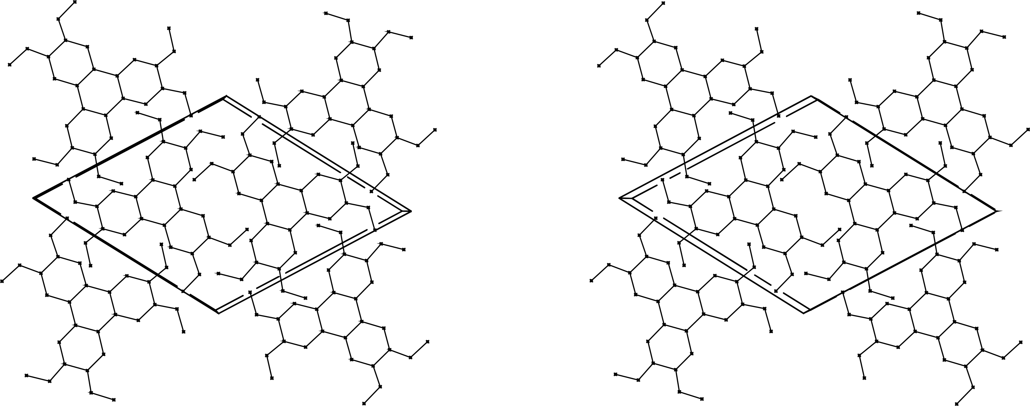Fig 1 Stereo-view of HAT1 as a projection normal to the 001 axis. No stacking or pi-overlap is observed. The illustration was generated from the data available within the CCDC database.¹¹
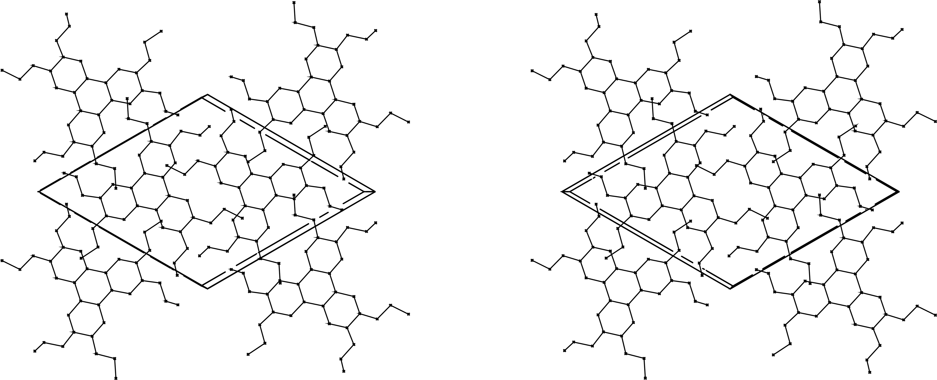Fig 2 Stereo-view of HAT2 as a projection normal to the 001 axis. No stacking or pi-overlap is observed. The illustration was generated from the data available within the CCDC database.¹¹
TP6EO2M and HAT2-NO₂.
Fig 3 Stereo-view of HAT2-NO₂ as a projection normal to the 010 axis. In this case the propensity to stack is more obvious and there is very little lateral displacement between molecules in adjacent layers.
“The stacks are tilted at an angle of ~41° to the ‘best plane’ through the aromatic core. This kind of stacking is reminiscent of that found in TP6EO2M¹²”

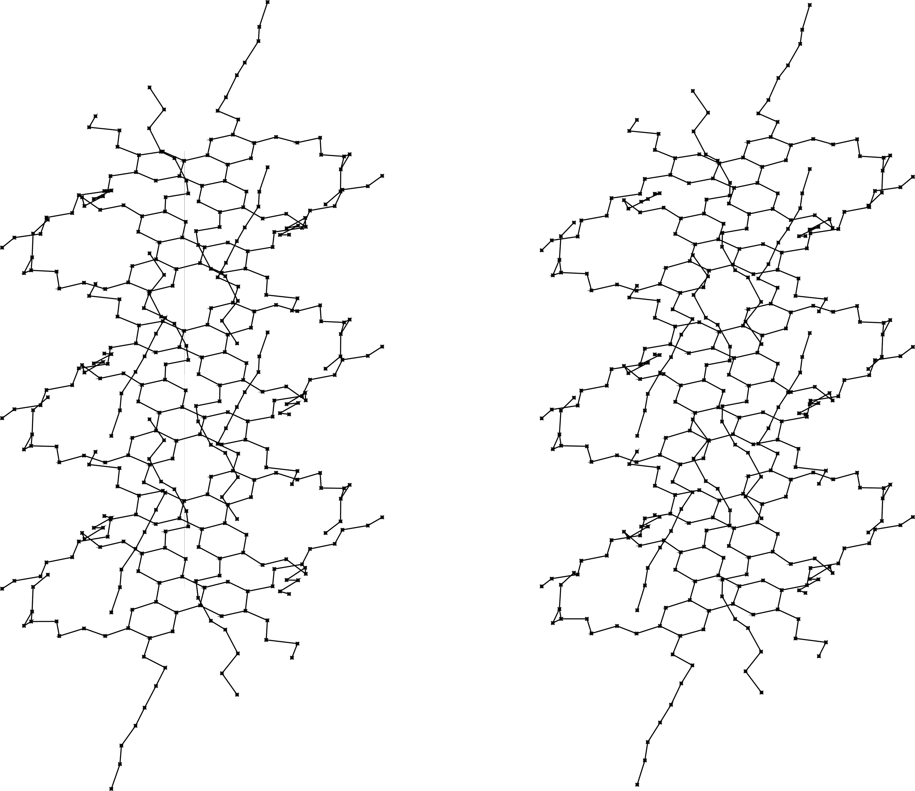Fig 4 Stereo-view of TP6EO2M as a projection normal to the 001 axis. The molecules form tilted stacks. The illustration was generated from the data available within the CCDC database.¹²
References
Fig 5 Stereo-view of HAT2-NO₂ as a projection normal to the 001 axis. The molecules form stacks with a tilt angle of 41°.

1 Boettcher, Physica, 1939, 6, 59.
2 O. R. Lozman, Unpublished Results, 2001.
3 PM3 as implemented in v5.1 HyperCube Inc. 2000. DFT calculations performed in HyperChem v7.00 Evaluation Copy, HyperCube Inc. 2002.
4 Trotter, Acta Crystallogr., Sect. A: Found. Crystallogr., 1959, 12, 884; D. A. Fletcher; R. F. McMeeking; D. Parkin, J Chem Inf Comp Sci, 1996, 36, 746.
5 H. Furuya; S. Okamoto; A. Abe; G. Petekidis; G. Fytas, J Phys Chem-Us, 1995, 99, 6483; K. Hori; Y. Koma; A. Uchida; Y. Ohashi, Mol Cryst Liq Cryst, 1993, 225, 15.
6 C. Destrade; M. C. Mondon; M. Manickam, J. Phys. Colloq., 1979, C3, 17.
7 N. Boden; R. C. Borner; R. J. Bushby; A. N. Cammidge; M. V. Jesudason, Liq Cryst, 1993, 15, 851.
8 C. Destrade; N. H. Tinh; H. Gasparoux; J. Malthete; A. M. Levelut, Mol Cryst Liq Cryst, 1981, 71, 111.
9 C. Vauchier; A. Zann; P. Lebarny; J. C. Dubois; J. Billard, Mol Cryst Liq Cryst, 1981, 66, 423.
10 L. Y. Chiang; C. R. Safinya; N. A. Clark; K. S. Liang; A. N. Bloch, J Chem Soc Chem Comm, 1985, 695.
11 T. L. Andresen; F. C. Krebs; N. Thorup; K. Bechgaard, Chem Mater, 2000, 12, 2428.
12 N. Boden; R. J. Bushby; M. V. Jesudason; B. Sheldrick, J Chem Soc Chem Comm, 1988, 1342.

