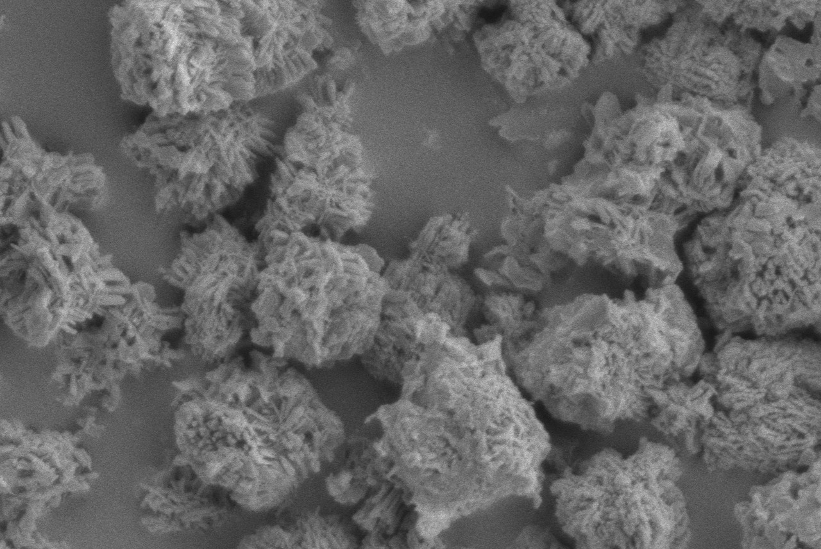
5 μm

Figure I
SEM of initial precipitate formed when NaOH (1 M) is added to Zn(NO₃)₂.6H₂O (0.04 M).

