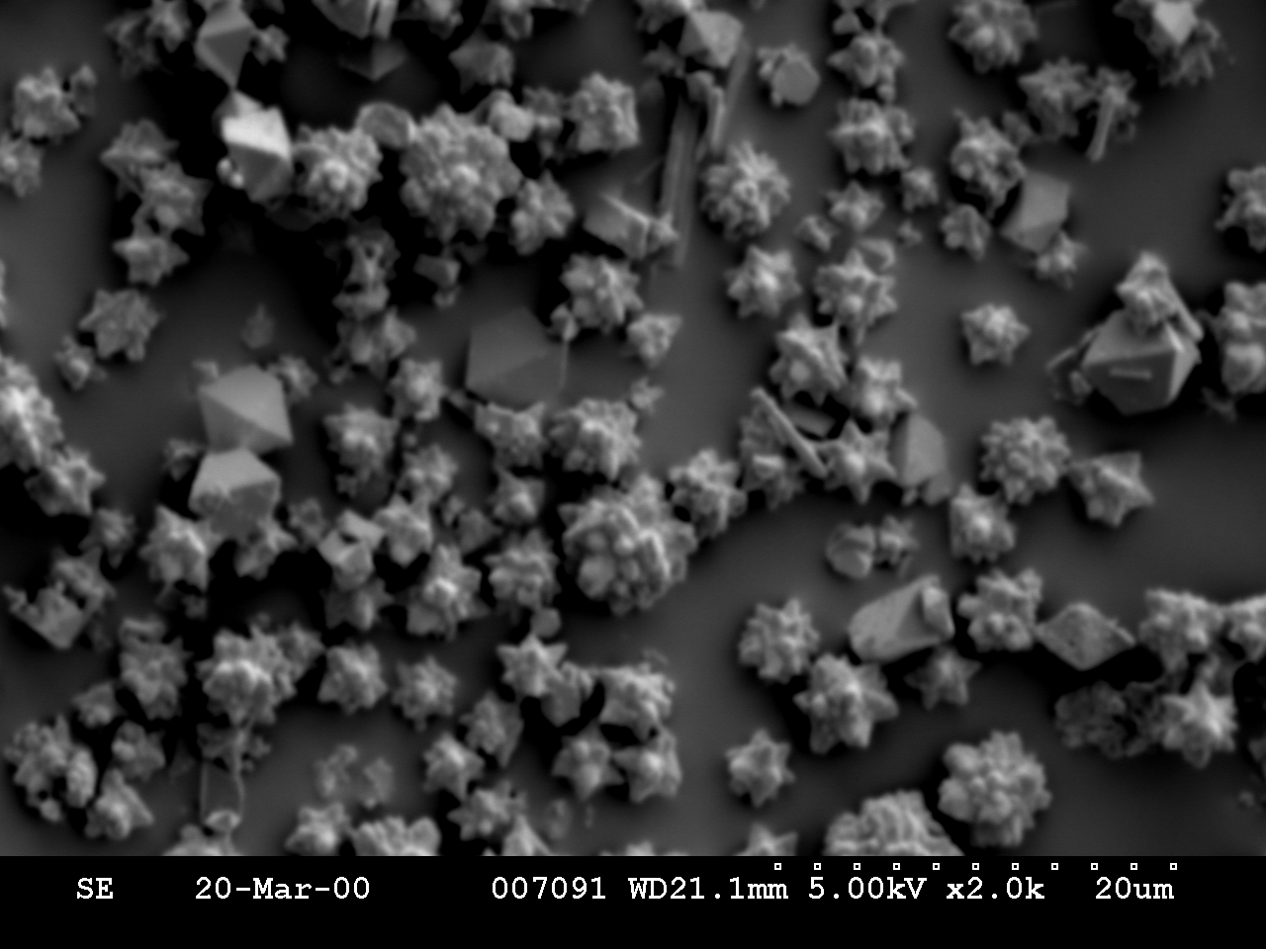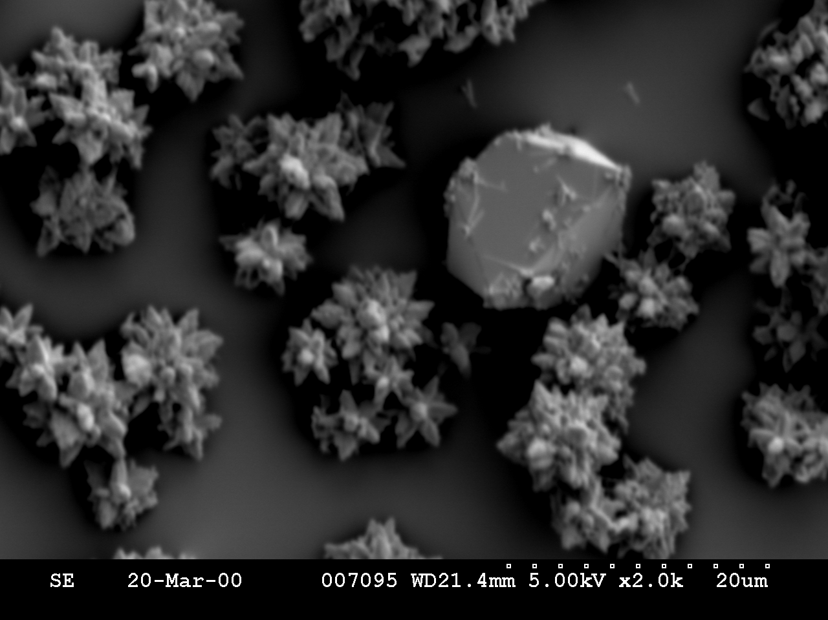
20 μm
20 μm

(A)

(B)

(D)
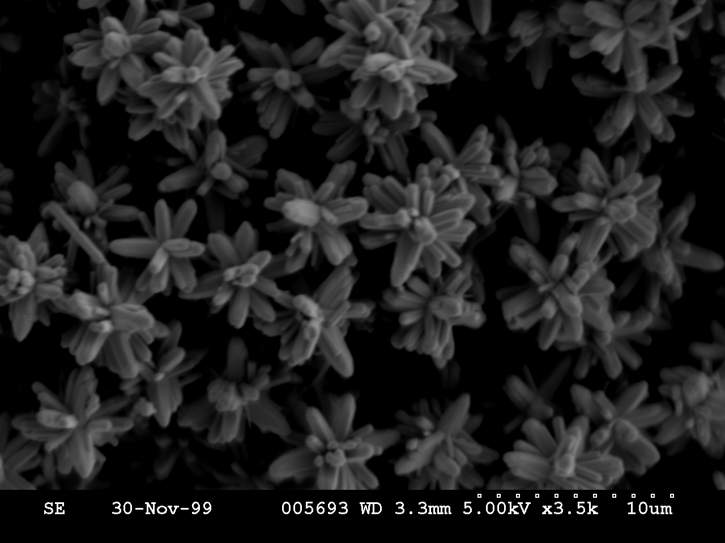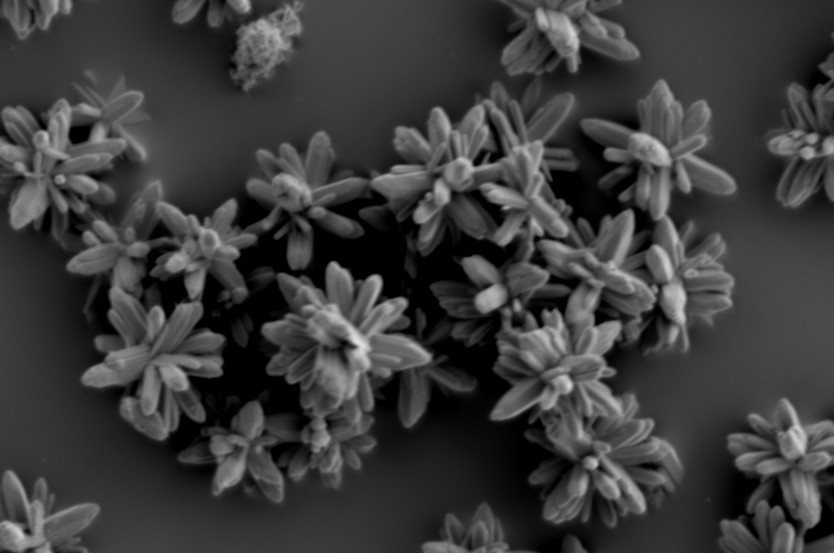
10 μm

10 μm

(C)

(D)

SEI Figure II
SEM of ZnO star-like particles prepared by ageing Zn(NO₃)₂.6H₂O (0.04 M) with NaOH (1 M).
SEM of particles after (A) precipitation, (B) 10 minutes, (C) 30 minutes and (D) 120 minutes after precipitation.

(F)
The few large particles visible up to 10 minutes after precipitation, were identified by Raman microscopy as Zn(OH)₂. However these particles were a minor product and were completely absent when the temperature of the reaction mixture increased above 70 °C.

(C)

