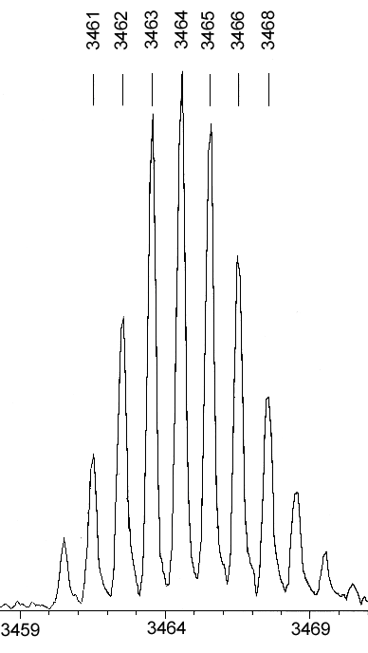

(A)

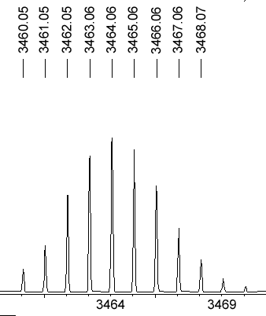

(B)

Figure S1. (A) Experimental and (B) simulated MALDI-TOF mass spectrum of Eu₂[Pc(15C5)₄](TPP)₂ (3) showing the isotopic distribution of the protonated molecular ion.

Figure S2. IR spectra of (A) Eu[Pc(15C5)₄](TPP) (1), (B) its dimeric SM structure (SM1), (C) Eu₂[Pc(15C5)₄]₂(TPP) (3), and (D) its dimeric SM structure (SM3) in the region of 400-1800 cm⁻¹.

