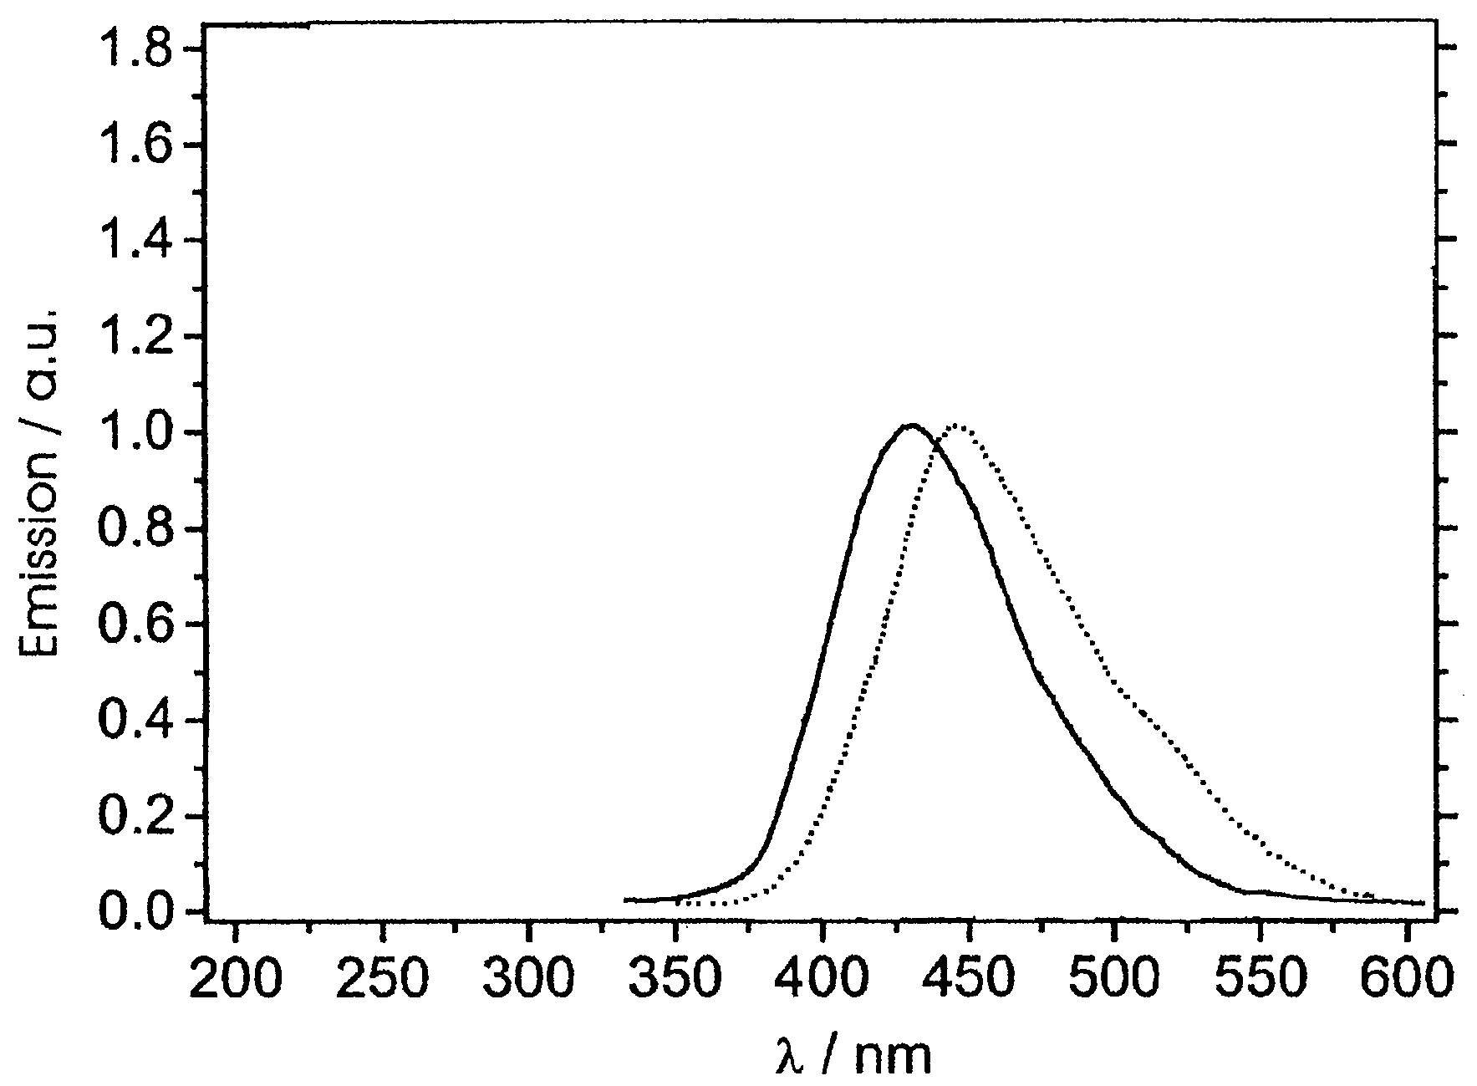

Fig. S-1. Thin film photoluminescence: λ_{ex} 350 nm (—) and electroluminescence spectra ( - - - ) of compound 5 in the device configuration ITO/PEDOT/5/Ca.

