Supplementary information for the Article Ref. B400515E
Journal of Materials Chemistry

The light induced valence change of europium in Sr₂SiO₄:Eu involving transient crystal structure

Abanti Nag and T. R. N. Kutty*

X-ray Diffraction Analyses
Strontium orthosilicate, has two phases, a high-temperature orthorhombic (α'-Sr₂SiO₄) and a low-temperature monoclinic phase (β-Sr₂SiO₄). The transition temperature between the two phases is at ~85ºC. Fig S1 and S2 show the x-ray diffraction patterns of Sr₂SiO₄:Eu with different substituents. The samples prepared in this work are all in α′-phase which is metastable at room temperature. The stability of α′-phase at room temperature cannot be attributed to the surface free energy contribution of the fine powder nature of samples prepared in the present case. This is because of the fact that samples recrystallized at higher temperatures in presence of SrF₂ as flux; with substantial grain growth also stabilized as α′-phase. In Fig. S1(a), the x-ray diffraction pattern of the as-prepared Sr₂SiO₄:Eu is compared with JCPDS data (JCPDS Card No. 39-1256). The phase is identified as α´-Sr₂SiO₄ with the space group, Pnma. The phase remains unchanged after irradiation as shown in Fig. S1(b). The substitution on Sr by Ba or Ca in Sr₂SiO₄ (Sr_{2-x}M′_{x}SiO₄, M′ = Ba, Ca; 0 ≤ x ≤ 0.5) also show similar features [Fig. S1(c) and (d)], except that there is marginal expansion of cell volume in the case of Sr_{2-x}Ba_{x}SiO₄ whereas Sr_{2-x}Ca_{x}SiO₄ shows volume contraction. This can be explained on the basis of the difference in ionic radii which is in the order, r_{Ca}²⁺<r_{Sr}²⁺<r_{Ba}²⁺. On the other hand, the end member Ba₂SiO₄ stabilizes as orthorhombic form (Pnam) which is the only stable modification of Ba-orthosilicate, whereas, Ca₂SiO₄ stabilizes as monoclinic β-form (P2₁/n). This is because of the fact that the transition temperature for β → α′ is much higher for Ca₂SiO₄ (~680ºC) than that of Sr₂SiO₄ (~85ºC).
Fig. S2 shows the XRD pattern of (Sr_{1-x}M′_{x})₂Si_{1-y}M″_{y}O₄:Eu (M′ = Mg, Li; M″ = Al, B; 0 ≤ x ≤ 0.1; 0 ≤ y ≤ 0.1). All the compositions are identified as phase pure Sr₂SiO₄ without the presence of any minor phase. Further, there are only changes of cell parameters. The irradiation experiment was also carried out for substituted Sr₂SiO₄:Eu and found that the phase remains unchanged after irradiation.

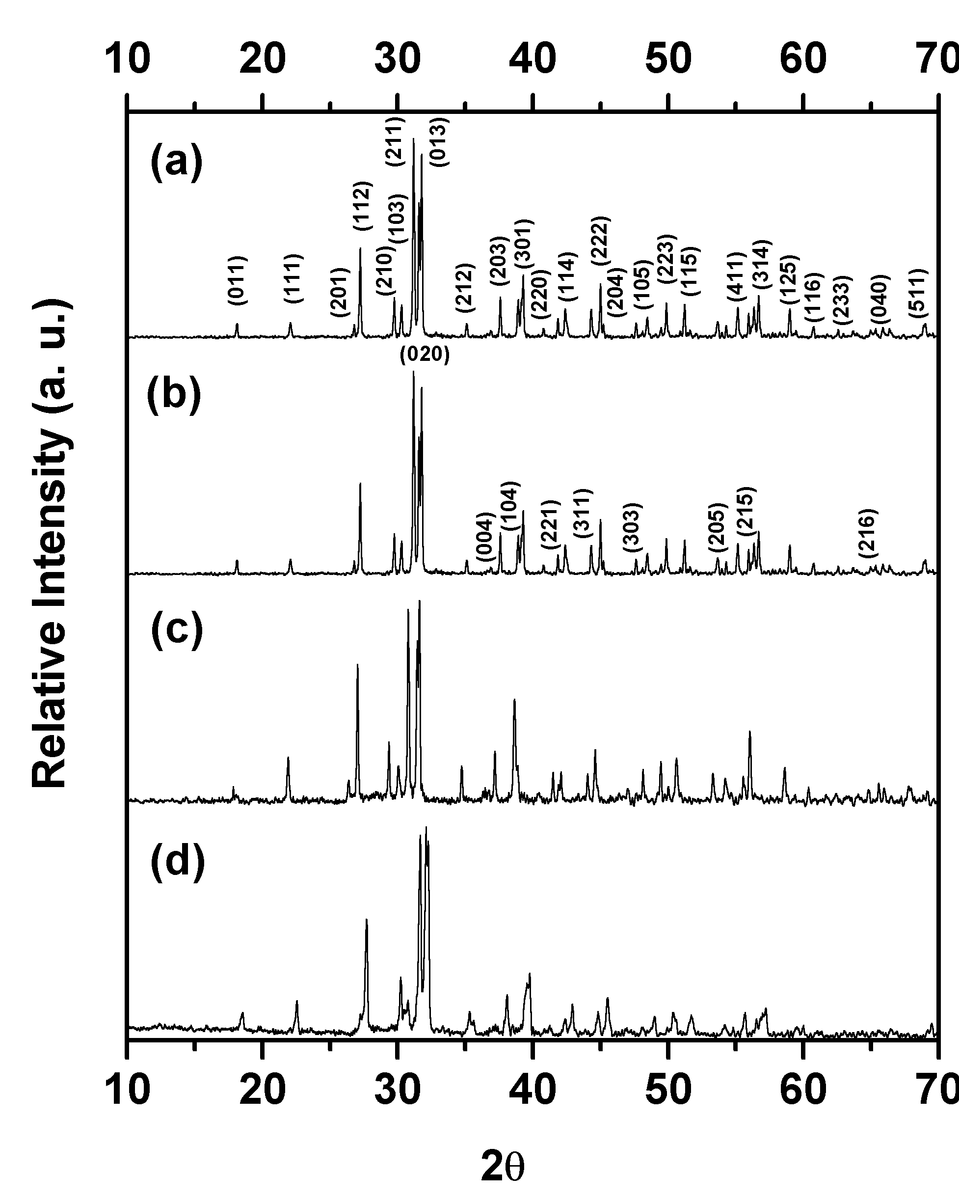

Fig. S1 X-ray diffraction patterns of (a) Sr₂SiO₄:Eu before irradiation, (b) Sr₂SiO₄:Eu after irradiation, (c) Sr_{1.95}Ba_{0.05}SiO₄:Eu after irradiation and (d) Sr_{1.95}Ca_{0.05}SiO₄:Eu after irradiation.

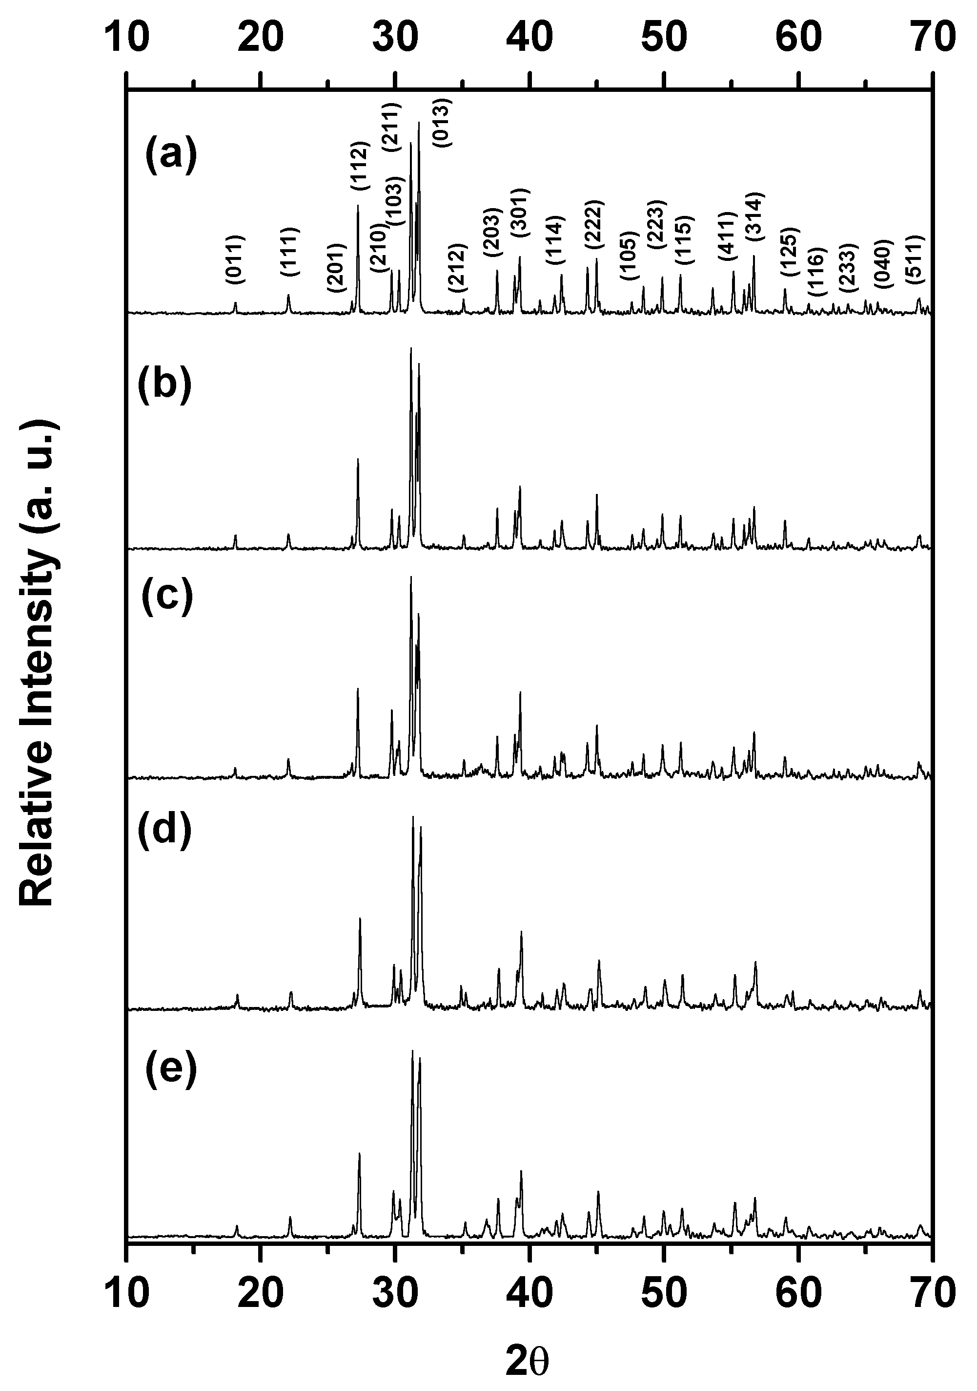

Fig. S2 X-ray diffraction patterns of (a) Sr_{1.95}Mg_{0.05}SiO₄:Eu, (b) Sr_{1.95}Li_{0.05}SiO_{3.975}:Eu, (c) Sr_{1.98}Ce_{0.02}SiO_{4.02}:Eu, (d) Sr₂Si_{0.95}B_{0.05}O_{3.975}:Eu and (e) Sr₂Si_{0.95}Al_{0.05}O_{3.975}:Eu.

Photoluminescence of Ba₂SiO₄:Eu³⁺, Ca₂SiO₄:Eu³⁺ and Sr_{2-x}M′_{x}SiO₄:Eu³⁺ (M′ = Ba, Ca)
The end member, Ba₂SiO₄:Eu³⁺ does not show any emission of Eu³⁺ at room temperature. On the other hand, Ca₂SiO₄:Eu³⁺ shows orange-red emission of Eu³⁺ as shown in Fig S3(a). The broad band seen in the excitation spectrum around 260 nm is due to [Eu³⁺←O²⁻] CT transition and the sharp peaks in the range of 300 to 550 nm are due to the transition from the ground ⁷F₀-level to the excited ⁵D_{J} state (J =1-4) of Eu³⁺. The emission spectrum consists of a series of sharp lines originating from ⁵D₀ level after non-radiative relaxation from excited ⁵D_{J} (J =1-4) states. In Ca₂SiO₄:Eu³⁺, both magnetic (⁵D₀–⁷F₁) and forced electric dipole (⁵D₀–⁷F₂) transitions are observed. However, ⁵D₀–⁷F₂ emission is much stronger than that of ⁵D₀–⁷F₁. The magnetic dipole transition dominates when Eu³⁺ occupies at the site with inversion symmetry, whereas, the electric dipole transition appear for the Eu³⁺ ion occupying the site that has no inversion symmetry. This indicates that Eu³⁺ in Ca₂SiO₄ occupies low symmetry sites i.e. the site that has no inversion symmetry. Moreover, ⁵D₀–⁷F₀ transition (indicated by a downward arrow in Fig. S3a), which was a dominant emission in the case of Sr₂SiO₄:Eu³⁺, has negligible intensity for Ca₂SiO₄:Eu³⁺. Further, unlike Sr₂SiO₄:Eu³⁺, the Eu³⁺ emission in Ca₂SiO₄ does not quench with time. Hence, it can be concluded that there is a periodic relation of Eu³⁺ emission between three alkaline-earth orthosilicates.
The irradiation experiments were also carried out for end-member compositions. Ba₂SiO₄:Eu²⁺ shows broad band PL with its maximum at 500 nm at room temperature. Similarly, Ca₂SiO₄:Eu²⁺ shows peak maximum at 505 nm at room temperature. Hence, it can be expected that both Ba and Ca orthosilicate may show the photoinduced reduction of Eu³⁺→Eu²⁺ under irradiation. However, both Ba₂SiO₄:Eu and Ca₂SiO₄:Eu did not show any photoactivity while irradiated by short UV or x-rays.
The PL and irradiation experiment were carried out with samples in which Sr²⁺ is partially substituted by Ba or Ca (Sr_{2-x}M′_{x}SiO₄, M′= Ca, Ba; 0 ≤ x ≤ 0.5). The substitution at limited concentrations does not alter the PL properties of Sr₂SiO₄:Eu³⁺. Fig S3(b) shows the excitation and emission spectra of Sr_{1.95}Ca_{0.05}SiO₄:Eu³⁺ before irradiation. Like Sr₂SiO₄:Eu³⁺, the excitation spectrum of Sr_{1.95}Ca_{0.05}SiO₄:Eu³⁺ shows peak maximum at 260 nm while monitoring at the emission wavelength of 616 nm whereas excitation band at 315 nm dominates when monitored at λ_{em} = 575 nm. Further, the emission at 616 and 590 nm show comparable intensities when monitored at 260 nm whereas emission at 575 and 622 nm dominate under λ_{exc} = 315 nm. As already mentioned, the distinct difference in relative intensities of the two sets of emission lines depending upon the excitation wavelength is due to varying site symmetry for two different Sr²⁺ positions in which Eu³⁺ is substitutively present. Moreover, Sr_{1.95}Ba_{0.05}SiO₄:Eu³⁺ also shows similar PL properties whereas the emission intensity decreases with Ba-content. Further, both Ba and Ca-substituted compositions show quenching effect of Eu³⁺ emission as it is found in the case of Sr₂SiO₄:Eu³⁺. Furthermore, Sr_{2-x}Ba_{x}SiO₄:Eu shows photoinduced reduction of Eu³⁺→Eu²⁺; however, the yellow-white emission of Eu²⁺ is quenched when the Ba-content is more than 20 mol% (x>0.2). On the other hand, Sr_{2-x}Ca_{x}SiO₄:Eu shows bright yellow-white emission from photoreduced Eu²⁺ after irradiation over a broad compositional range (0≤x≤0.5) [Fig. S3(c)].
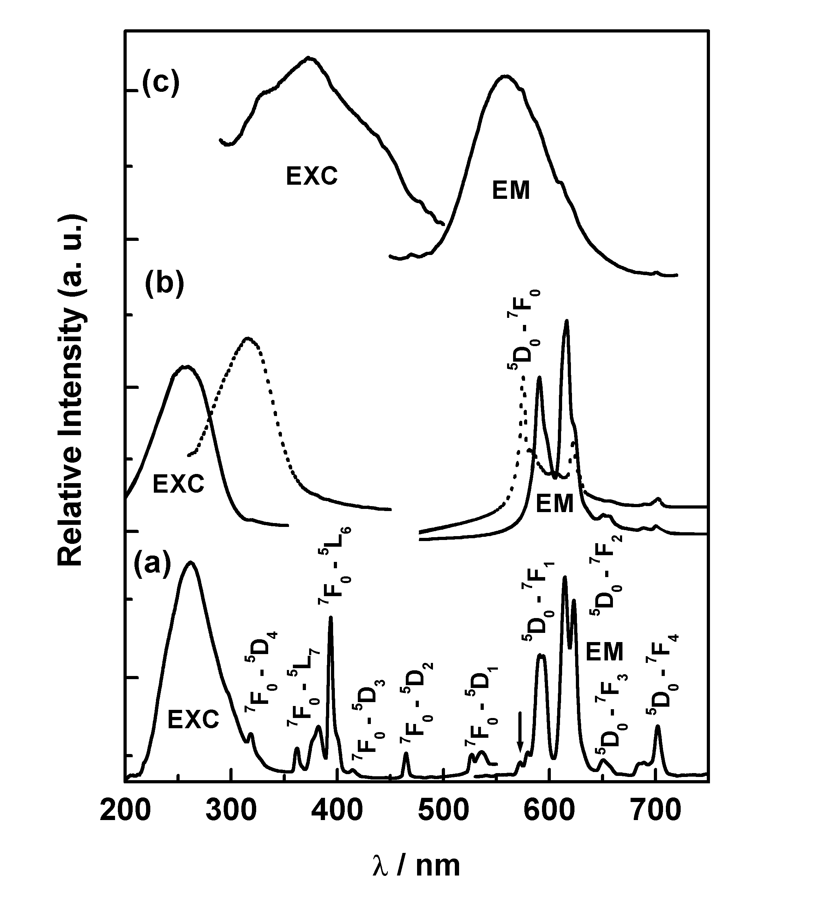

Fig. S3 Excitation (EXC) and emission (EM) spectra of Sr_{2-x}Ca_{x}SiO₄:Eu at room-temperature: (a) x = 2 (Ca₂SiO₄:Eu³⁺), before irradiation (λ_{em} = 615 nm, λ_{exc} = 260 nm), (b) x = 0.05, before irradiation (solid curves: λ_{em} = 616 nm, λ_{exc} = 260 nm; dotted curves: λ_{em} = 575 nm, λ_{exc} = 315 nm) and (c) x = 0.05, after irradiation (λ_{em} = 556 nm, λ_{exc} = 378 nm).
Irradiation Under Different Conditions
It is possible to envisage that photoinduced reduction of Eu³⁺ to Eu²⁺ in Sr₂SiO₄ may be induced by adsorbed H₂O molecules which subsequently diffuse out as H₂ and O₂ from the surface under UV illumination accompanied by the initial decomposition of (H₂O)_{ad} to H₂ and OH• radicals. In order to find whether hydroxyl (OH•) or peroxy hydroxide (OOH•) radicals play any role in the photoactivity, irradiation experiments were carried out in presence of adsorbed H₂O as well as H₂O₂. Experiments were also repeated in presence of strong reducing agent such as ascorbic acid which chemisorbs on Sr₂SiO₄. However, photoactivity is found to be slower in presence of H₂O, H₂O₂ or reducing agents than that in dry atmosphere which ruled out the involvement of hydroxyl or peroxide radicals in the optically assisted reduction process. Furthermore, the irradiation of freshly prepared Sr₂SiO₄:Eu³⁺ was carried out under completely dry environment in presence of strong desiccants such as P₂O₅ or MgClO₄ and ascarite (NaOH mounted on asbestos) in an air-tight glove-box. It is found that photoreduction is more effective in dry atmosphere which again ruled out the involvement of adsorbed H₂O or CO₂ in the photoreduction process.

