Supporting Information

Figure S1 shows the TGA curve of Zn₃Al(DS) powder. It can be seen that the residues of Zn₃Al(DS) powder is about 63%. Consequently, the residues of NC2, NC5, NC10, and NC20 nanocomposites are expected to have residues of 1.3%, 3.2%, 6.3%, and 12.6%, respectively. The higher residues in experiments suggest that the existence of exfoliated Zn₃Al(DS) nanolayers in the nanocomposites promotes the charring process of LLDPE matrix, especially for NC2 sample.

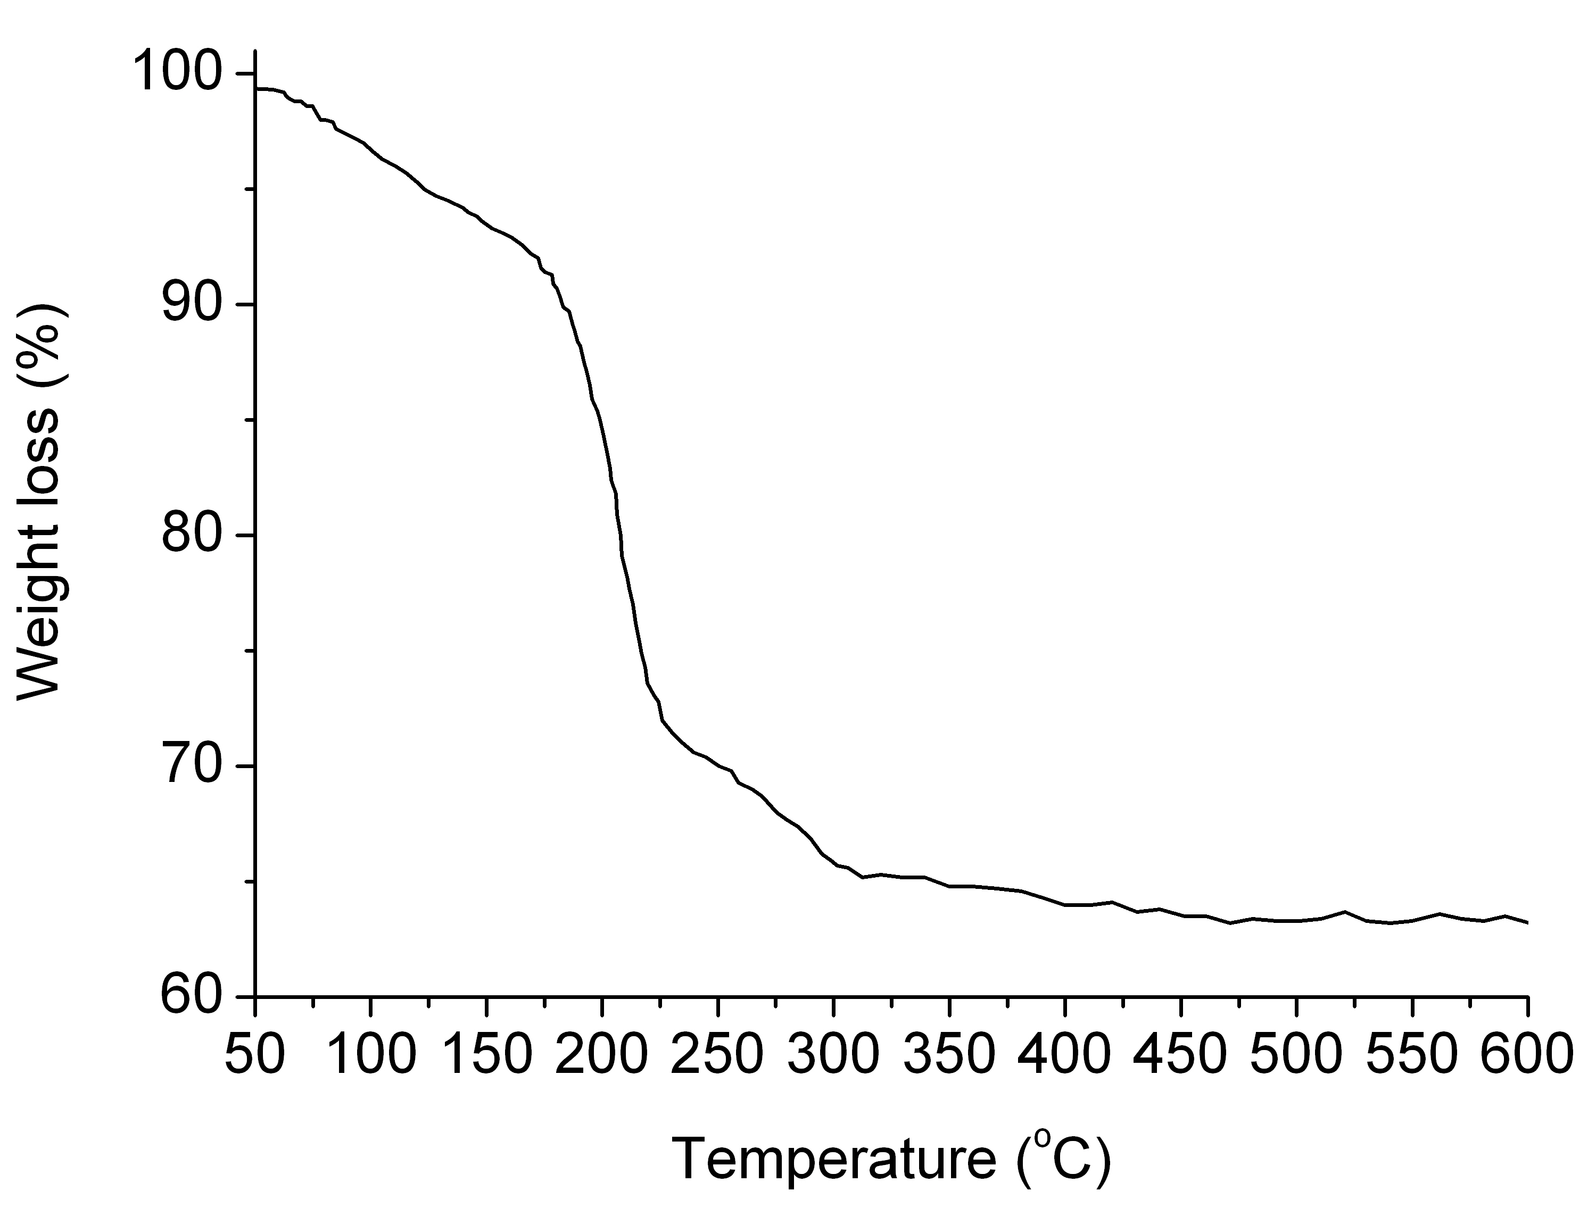
Figure S1. TGA curve of Zn₃Al(DS) with heating rate of 10 ºC/min under an air flow.

Figure S2 shows that the TGA curves of LLDPE and its nanocomposites heated in air at several heating rates between 10 and 40 ºC/min. It is clearly seen that the degradation curves are shifted to higher temperatures with the increasing heating rates.
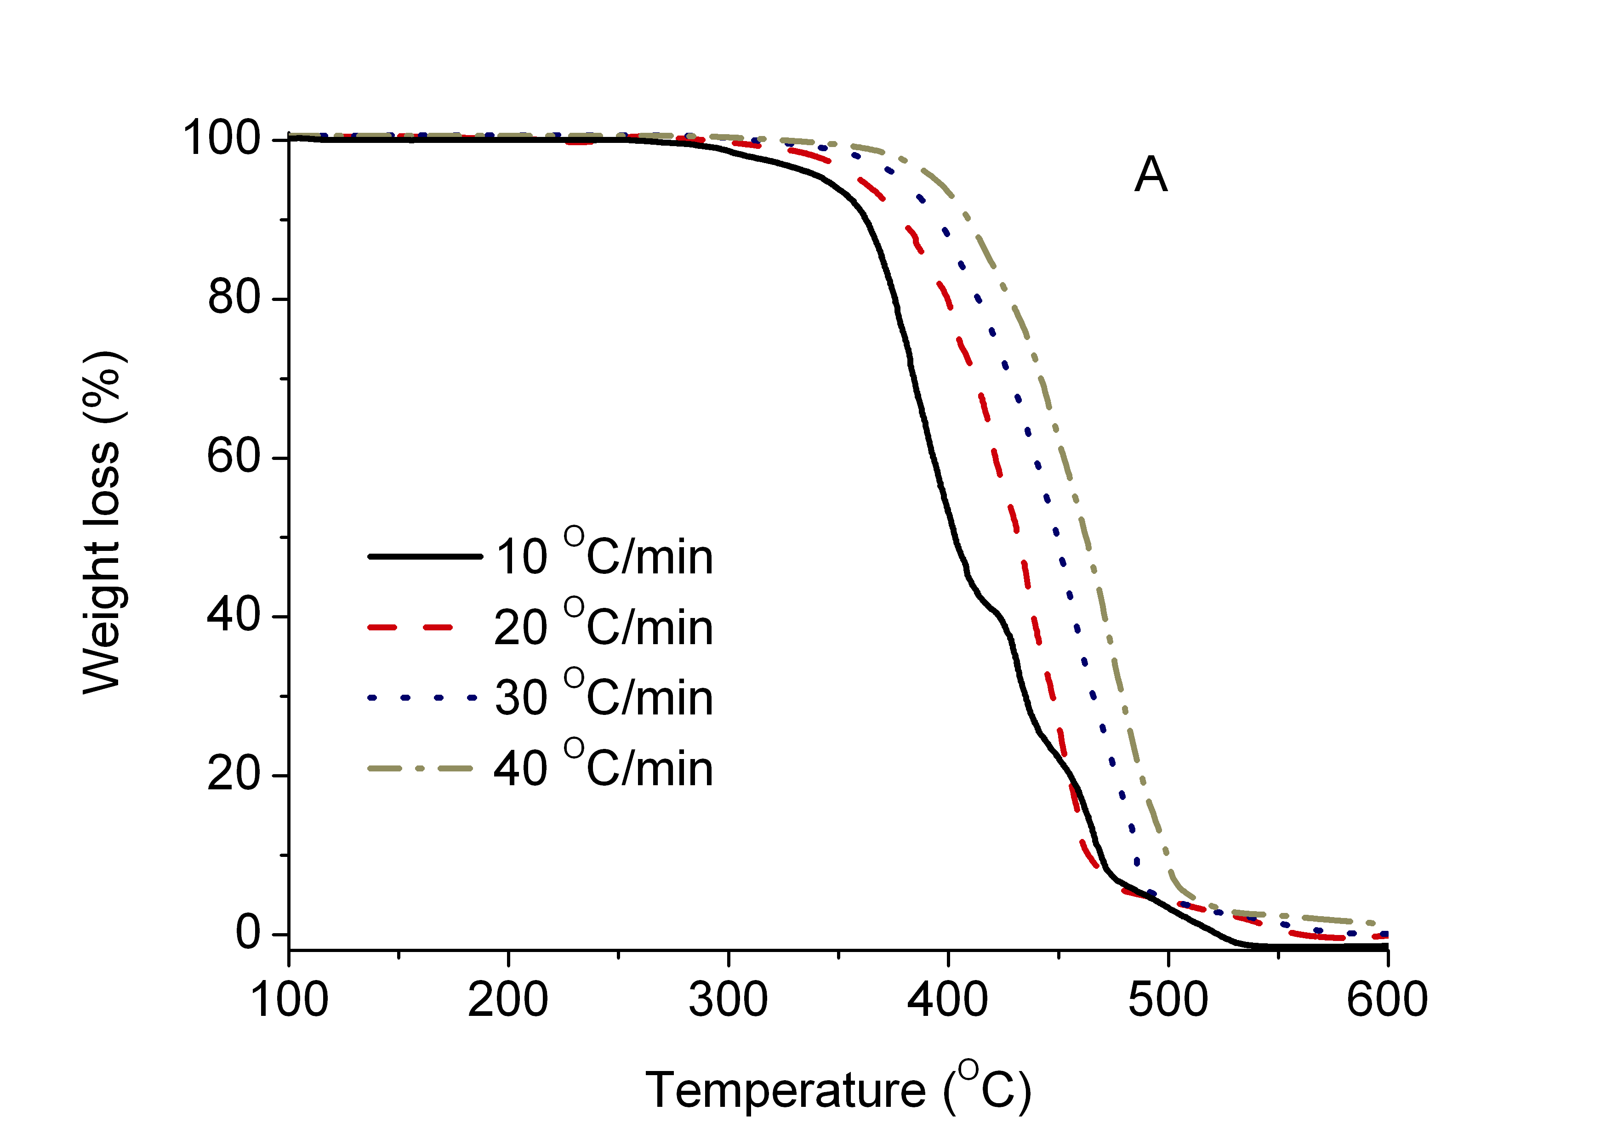
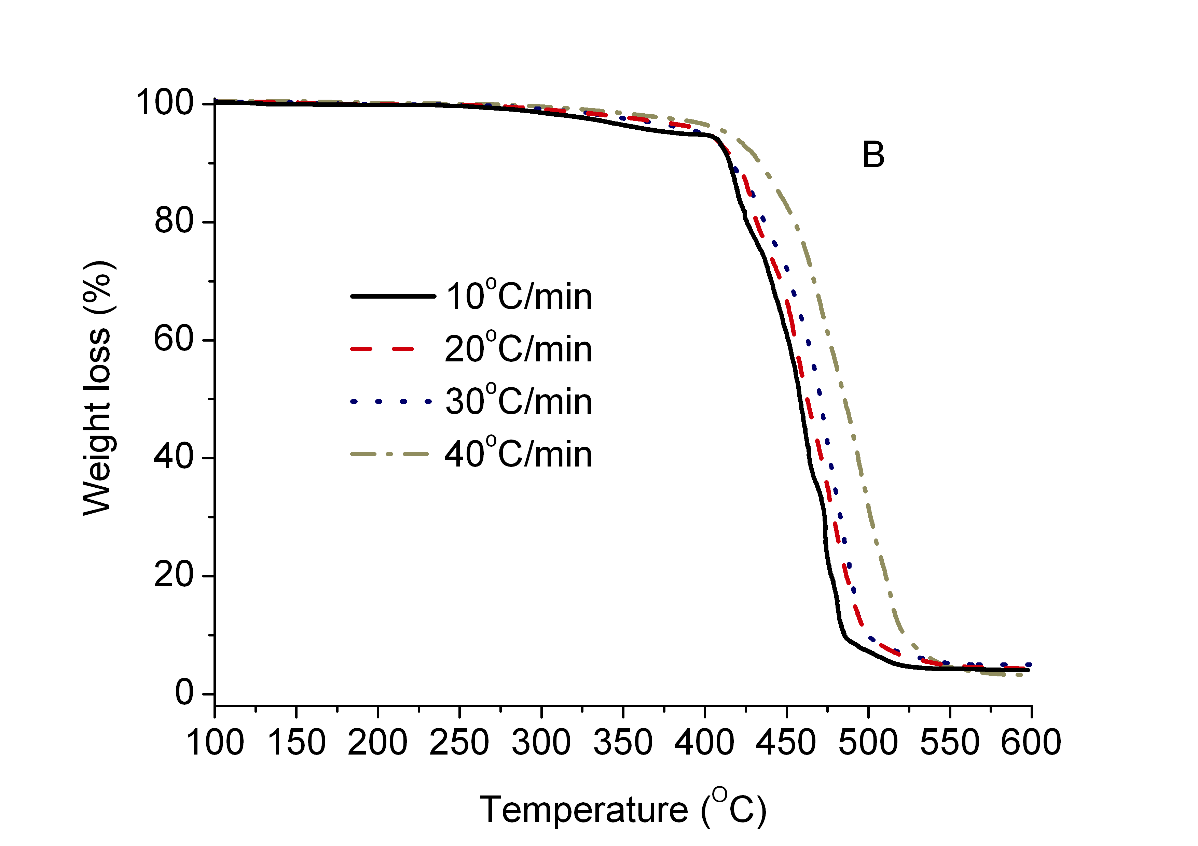
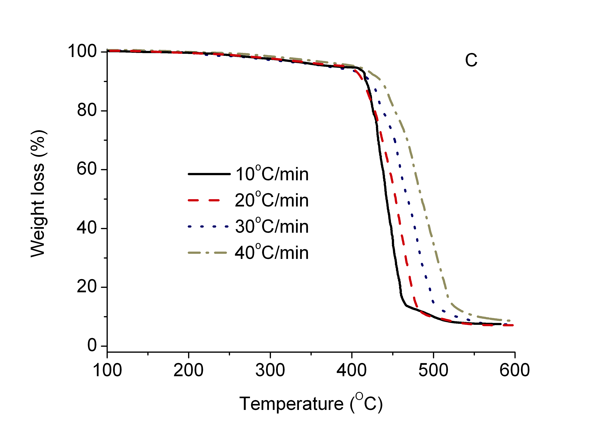

Figure S2. TGA curves at different heating rates for (A) pure LLDPE, (B) NC5, and (C) NC10.

