Supporting Information
Competitive Adsorption and Dynamics of Guest Molecules in 2D Molecular Sieves
Yongtao Shen, Lijin Zeng, Xuemei Zhang, Ke Deng, Yiyu Feng, Wei Feng*, Shengbin Lei, Shufei Li , Lihua Gan*, Qingdao Zeng*, Chen Wang*
TABLE OF CONTENTS
1. STM images of the CuPc molecular arrays instead of 1-phenyloctane molecules. ………. ……………………………………………………. ……...……S2
2. Computational details…………………………………………...……...…………….…...S3

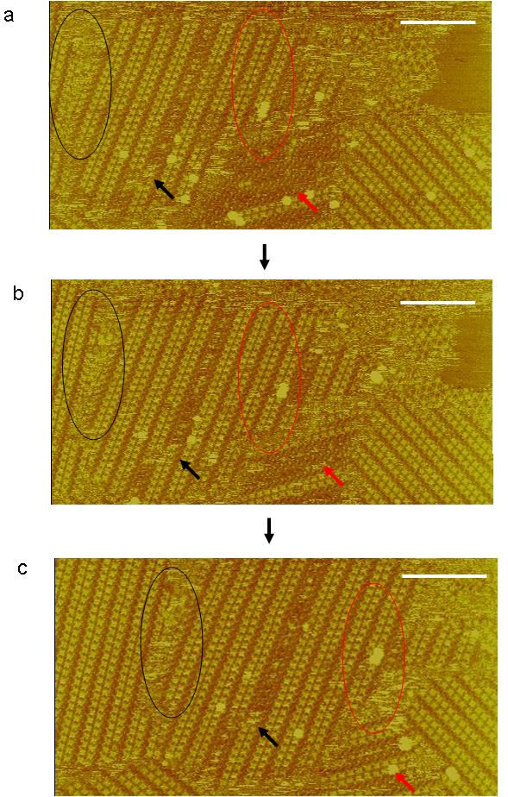
Figure s1. (a-c) Sequential STM images illustrating that the CuPc molecules are instead of 1-phenyloctane in the TCDB networks (I_{set} = 363 pA, V_{bias} = 716 mV). The time of the first image is arbitrarily set to zero (a). The unchanged coordinates are marked by the black arrows and ellipses. The increasing CuPc column is marked by a red ellipse. The reduced of unentrapped TCDB domains is marked by a red arrow. The scale bars correspond to 20 nm.

2. Computational details
Computational Detail: The density functional theory calculations were performed with Dmol3 code [a]. Firstly, geometry optimizations were performed with the local density approximation (LDA) at the LDA/DND (DND: double numerical basis including d-polarization function) level of theory. Then, single-point energy calculations were performed on as-optimized structures with the generalized gradient approximation (GGA) at the PBE/DND (PBE: Perdew, Burke, and Ernzerhof [b]) level of theory. All calculations are all-electron and the convergence in energy is set to be 10⁻⁵ a.u.

[a] A. D. Becke, J. Chem. Phys. 1988, 88, 2547.
[b] J. P. Perdew, K. Burke, and M. Ernzerhof, Phys. Rev. Lett. , 1996, 128, 3865-3868

