Electronic Supplementary Information for

Elemental Fluorine. Part 16. ¹ Versatile thin-film gas-liquid multi-channel microreactors for effective scale-out

Richard D. Chambers,^{a,*} Mark A. Fox,ª Darren Holling,ª Takashi Nakano,ª Takashi Okazoe^{b} and Graham Sandford^{a,}*

ªDepartment of Chemistry, University of Durham, South Road, Durham, UK DH1 3LE
^{b}Asahi Glass Co., 1150, Hazawa-cho, Yokohama, Kanagawa, 221-8755, Japan.
E-mail: r.d.chambers@durham.ac.uk; graham.sandford@durham.ac.uk

Contents

- Cartesian coordinates of MP2/6-31G* optimised geometries for 1-6.

- Table of Energies for 1-6.

Ethyl acetoacetate 1 (keto form)
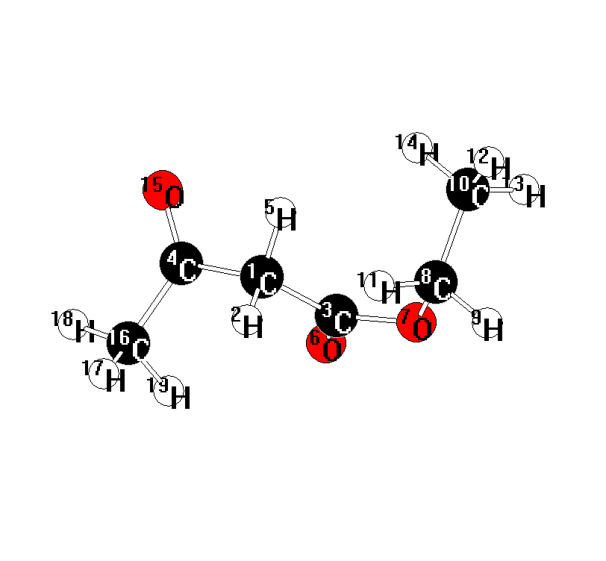
19

C -0.410865 0.401419 0.527930
H -0.370412 0.223842 1.610515
C 0.246332 -0.765571 -0.195000
C -1.854739 0.564419 0.062486
H 0.107600 1.339554 0.314388
O -0.377965 -1.543979 -0.893036
O 1.578491 -0.964123 -0.022129
C 2.408778 0.003744 0.656960
H 3.218445 -0.594814 1.078719
C 2.946318 1.028715 -0.322367
H 1.868268 0.467194 1.485940
H 3.649099 1.698675 0.182160
H 3.467994 0.522741 -1.137089
H 2.142579 1.632602 -0.750576
O -2.143584 1.471184 -0.710421
C -2.869661 -0.407880 0.604067
H -2.907027 -0.345371 1.697095
H -3.850180 -0.173204 0.188808
H -2.578893 -1.424956 0.330268

Ethyl acetoacetate 1 (enol form)
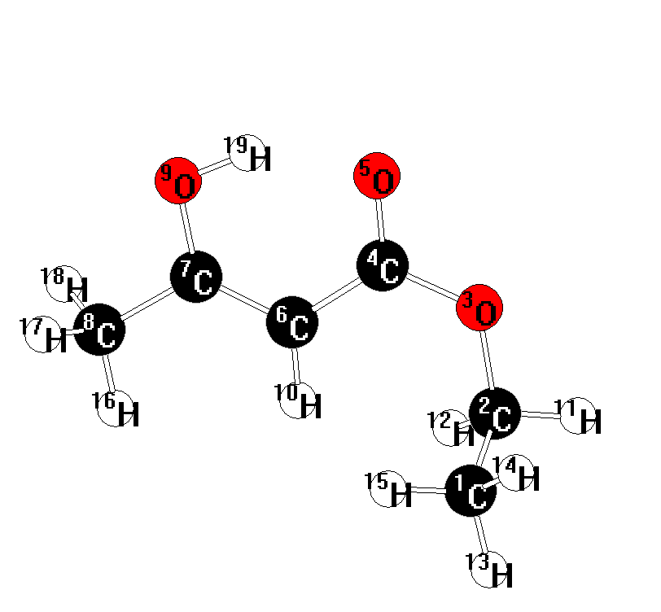19

C 2.689917 -1.164861 0.721186
C 2.419417 -0.389795 -0.554181
O 1.708937 0.836232 -0.283937
C 0.367661 0.841315 -0.084987
O -0.141244 1.937346 0.192794
C -0.413542 -0.379063 -0.210811
C -1.766276 -0.342242 -0.023616
C -2.646319 -1.544197 -0.132855
O -2.449915 0.766436 0.277122
H 0.037899 -1.330802 -0.447418
H 3.352732 -0.049308 -1.006483
H 1.884596 -0.982659 -1.301709
H 3.304444 -2.044202 0.505046
H 3.226863 -0.530326 1.429419
H 1.761338 -1.497077 1.190081
H -2.070864 -2.438447 -0.377209
H -3.173708 -1.698901 0.812710
H -3.401055 -1.375934 -0.906291
H -1.769624 1.500591 0.325608

Ethyl 2-fluoroacetoacetate 2 (keto form)
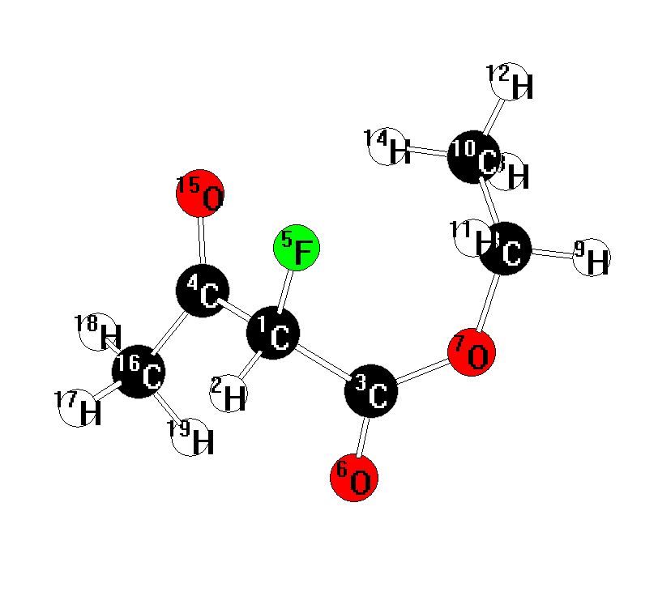
19

C 0.572757 0.117319 0.856279
H 1.140869 0.645724 1.629896
C -0.182096 1.201036 0.075934
C 1.540366 -0.620056 -0.091079
F -0.232025 -0.822080 1.482171
O 0.467766 2.175601 -0.271341
O -1.480056 1.118613 -0.242655
C -2.373873 -0.001800 0.033338
H -3.351640 0.436886 -0.170978
C -2.101580 -1.173460 -0.884209
H -2.321243 -0.269037 1.085997
H -2.874191 -1.934452 -0.735679
H -2.136806 -0.847898 -1.926578
H -1.132094 -1.626277 -0.677017
O 1.281864 -1.769450 -0.424523
C 2.773293 0.122927 -0.522647
H 3.415184 0.299819 0.347300
H 3.310516 -0.479018 -1.255997
H 2.507850 1.099082 -0.934026

Ethyl 2-fluoroacetoacetate 2 (enol form)
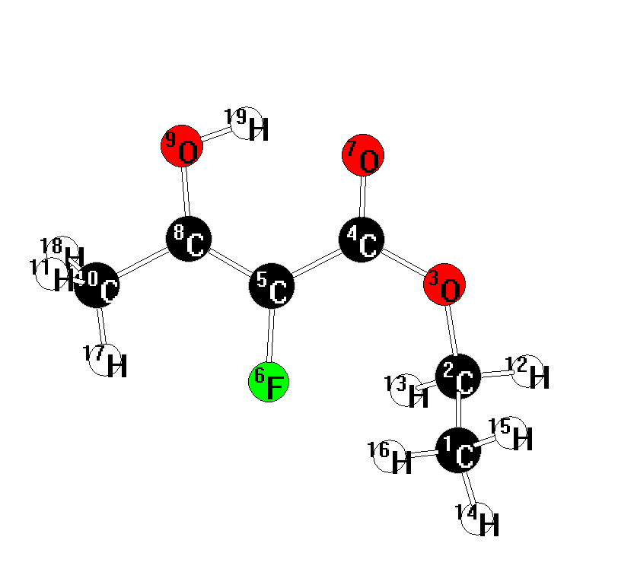
19

C -3.014642 -0.900967 -0.564925
C -2.441757 -0.118943 0.597041
O -1.647893 1.000706 0.116899
C -0.310198 0.993249 -0.004230
C 0.493598 -0.228941 0.032864
F -0.130899 -1.453257 0.071355
O 0.254465 2.083183 -0.169830
C 1.855417 -0.219034 -0.003768
O 2.579830 0.908444 -0.083646
C 2.685862 -1.457024 0.037870
H 3.282427 -1.522214 -0.876427
H -3.233493 0.368151 1.169701
H -1.854816 -0.739319 1.272194
H -3.697645 -1.670892 -0.192721
H -3.572064 -0.233133 -1.225190
H -2.220665 -1.386372 -1.132178
H 2.068554 -2.348459 0.135124
H 3.378682 -1.394758 0.881680
H 1.926215 1.657603 -0.150875

Ethyl 2,4-difluoroacetoacetate 3
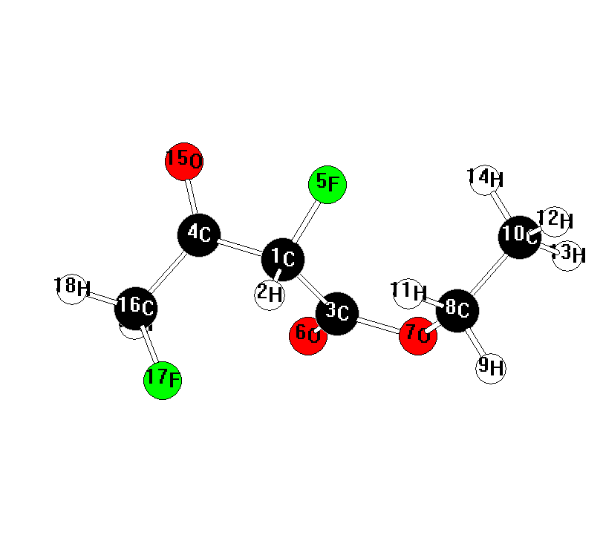
19

C 0.231013 0.406835 -0.410035
H 0.259571 0.068246 -1.451343
C -0.340338 -0.679186 0.507188
C 1.639226 0.745157 0.074361
F -0.557136 1.551603 -0.336230
O 0.356548 -1.197080 1.363935
O -1.619818 -1.057599 0.353293
C -2.511390 -0.475959 -0.634789
H -3.048992 -1.334226 -1.042637
C -3.450079 0.500096 0.039872
H -1.948823 -0.005897 -1.441842
H -4.184847 0.867927 -0.682707
H -3.980306 0.006450 0.856666
H -2.890958 1.348479 0.434897
O 1.899082 1.807092 0.614435
C 2.692583 -0.317382 -0.156503
F 2.179929 -1.308269 -0.999268
H 3.572005 0.131607 -0.626799
H 2.964622 -0.769248 0.799379

Ethyl 2,2-difluoroacetoacetate 4
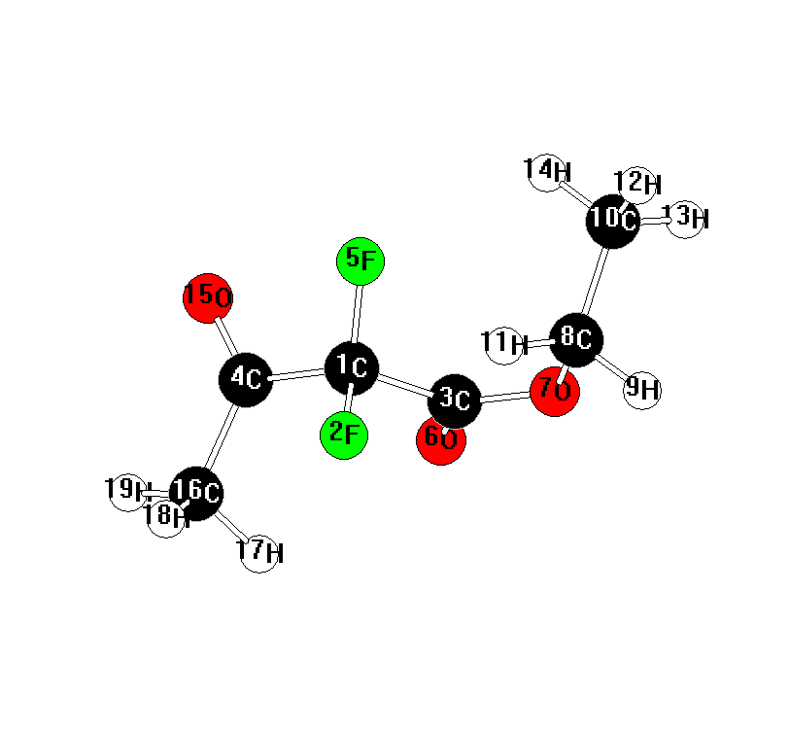
19

C 0.440072 -0.317953 0.218842
F 0.396030 -0.337936 1.599855
C -0.279700 0.943275 -0.283085
C 1.913356 -0.334674 -0.241162
F -0.185312 -1.444767 -0.231363
O 0.374570 1.793519 -0.864128
O -1.584677 1.111817 -0.043845
C -2.432846 0.100286 0.577689
H -3.100458 0.685977 1.211836
C -3.196708 -0.646957 -0.492823
H -1.844944 -0.559727 1.211000
H -3.905439 -1.337322 -0.025484
H -3.752937 0.053974 -1.118322
H -2.513335 -1.221442 -1.119306
O 2.198450 -0.985841 -1.233589
C 2.883115 0.447794 0.595510
H 2.527693 1.474244 0.714808
H 2.967159 -0.001027 1.589378
H 3.855326 0.443069 0.102325

2’-Fluoroethyl acetoacetate 5
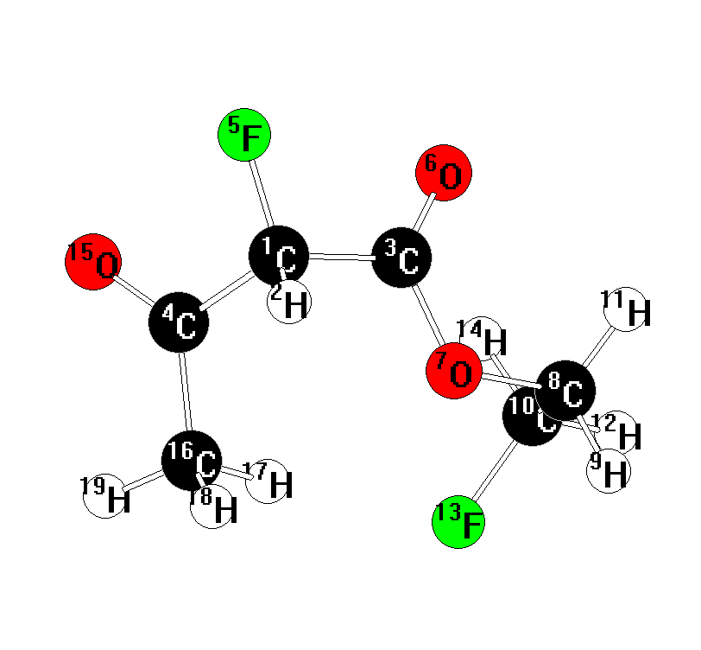

19

C 1.472291 -0.486696 0.527874
H 1.542461 -0.471880 1.622721
C 0.111353 -1.020838 0.113216
C 1.677874 0.937109 -0.031098
F 2.439791 -1.318223 0.015758
O -0.088895 -1.791907 -0.803460
O -0.845587 -0.473239 0.904666
C -2.205772 -0.777730 0.519330
H -2.799454 -0.532518 1.400313
C -2.624153 0.065901 -0.657846
H -2.297386 -1.841130 0.283460
H -3.664180 -0.146781 -0.925299
F -2.527074 1.416840 -0.303099
H -1.980863 -0.110103 -1.522039
O 2.525317 1.114949 -0.893313
C 0.813189 2.033107 0.535249
H -0.218844 1.930042 0.189802
H 0.791488 1.990116 1.628261
H 1.216952 2.991153 0.205357
1’-Fluoroethyl acetoacetate 6
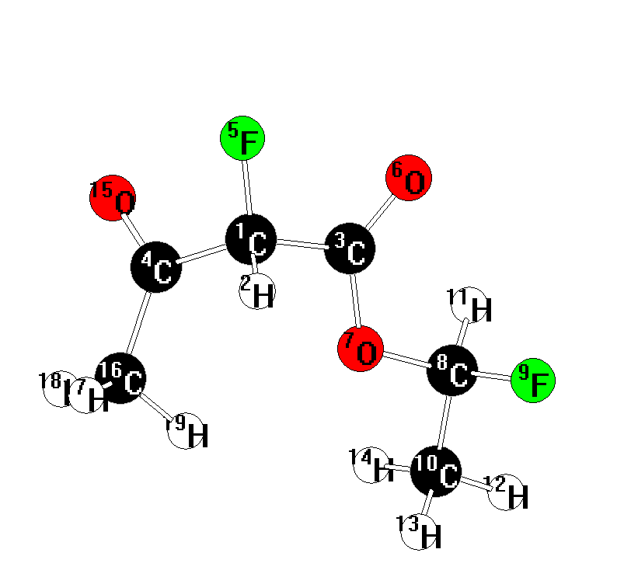

19

C -1.334652 -0.519480 -0.579972
H -1.207764 -0.366259 -1.659228
C 0.019625 -0.827850 0.042477
C -1.954930 0.724860 0.084325
F -2.158298 -1.601184 -0.366762
O 0.303259 -1.836277 0.644385
O 0.860308 0.235427 -0.175558
C 2.194019 0.067117 0.302042
F 2.866956 -0.726064 -0.606703
C 2.830510 1.425470 0.359247
H 2.173194 -0.466382 1.253248
H 3.870530 1.325693 0.676037
H 2.800955 1.876941 -0.634146
H 2.298643 2.064397 1.066713
O -2.654018 0.577415 1.076297
C -1.677048 2.056556 -0.560692
H -2.224097 2.117267 -1.508447
H -2.017830 2.853044 0.101700
H -0.613091 2.167982 -0.780241
Zero point (ZPE), total and relative energies for compounds 1-6.

 | ZPE (NIMAG)  (kcalmol⁻¹) | Total Energy  MP2/6-31G* (au) | Relative Energy (kcalmol⁻¹)
1 (keto form) | 105.59(0) | -458.92280 | 0.0
1 (enol form) | 106.72(0) | -458.92110 | +2.1
2 (keto form) | 100.82(0) | -557.93227 | 0.0
2 (enol form) | 101.10(0) | -557.92508 | +4.8
3 | 96.50(0) | -656.94096 | +18.5
4 | 95.23(0) | -656.95919 | +5.9
5 | 96.55(0) | -656.95609 | +9.0
6 | 95.60(0) | -656.96915 | 0.0

NIMAG = number of imaginary frequencies. More stable minima with different conformations to that reported here with may exist. There are many possible conformations for these compounds.

