Supplementary Material (ESI) for Lab on a Chip
This journal is © The Royal Society of Chemistry 2005

Elemental Fluorine. Part 18. Selective direct fluorination of 1,3-ketoesters and 1,3-diketones using gas/liquid microreactor technology.

Richard D. Chambers,* Mark A. Fox and Graham Sandford*

Department of Chemistry, University of Durham, South Road, Durham, UK DH1 3LE
E-mail: r.d.chambers@durham.ac.uk; graham.sandford@durham.ac.uk

Electronic supplementary Information

Analytical and spectral data for fluorinated ketoesters and diketones

Methyl-2-fluoro-3-oxopentanoate 4a: [Bailey, 2002 #45] (Found: C, 48.6; H, 6.2. C₆H₉FO₃ requires : C, 48.7; H, 6.1%); I.R. 2984m, 2960m, 2948m, 2912w, 2890w (C-H stretch), 1765s, 1737s (C=O), 1459m, 1439m, 1408m, 1353m, 1283s, 1243s, 1139s, 1101s, 1012m, 968m; δ_{H} 1.03 (t, J_{HH} 7.0, 3H, CH₂CH₃), 2.64 (m, 2H, CH₂CH₃), 3.78 (q, J_{HH} 7.0, 3H, OCH₃), 5.21 (d, J_{HF} 49.2, 1H, CHF); δ_{C} 6.4 (s, CH₂CH₃), 31.7 (s, CH₂CH₃), 52.9 (s, OCH₃), 91.0 (d, ¹J_{CF} 197.6, CF), 164.6 (d, ²J_{CF} 24.1, CO₂), 201.6 (d, ²J_{CF} 22.8, COCH₃). δ_{F} -196.4 (d, ²J_{HF} 49.3); m/z (EI⁺) 148 (M⁺, 4%), 117 (M-OMe, 10), 92 (HCF₂CO₂Me, 36), 57 (100, EtCO).
Methyl-2,4-difluoro-3-oxopentanoate 4b: [Bailey, 2002 #45] δ_{H} 1.59 (dd, J_{HF} 24.0, J_{HH} 6.8, 3H, CHFCH₃), 5.20 (m, 1H, CHFCH₃), 5.64 (dd, J_{HF} 47.6, 1.8, 1H, CHF); δ_{C} 16.7 (d, ²J_{CF} 21.9, CHFCH₃), 52.8 (s, OCH₃), 88.2 (dd, J_{CF} 195.0, J_{CF} 2.2, CH₂F), 90.5 (d, ¹J_{CF} 178.6, CF), 163.8 (d, ²J_{CF} 23.4, CO₂), 197.8 (dd, ²J_{CF} 23.3, ²J_{CF} 20.5, COCHF); δ_{F} -189.9 (dq, ²J_{HF} 48.2, ³J_{HF} 24.1, CHFCH₃), -200.5 (d, ²J_{HF} 47.4, CHF);
Methyl-2,5-difluoro-3-oxopentanoate 4c: δ_{H} 3.02 (m, 2H, CH₂CF), 3.79 (s, 3H, OCH₃), 4.67 (dt, J_{HF} 46.8, J_{HH} 5.4, 2H, CH₂F), 5.25 (d, J_{HF} 48.8, 1H, CHF); δ_{C} 38.9 (²J_{CF} 22.6, CH₂CF), 53.2 (s, OCH₃), 77.5 (dd, ¹J_{CF} 166.8, ⁵J_{CF} 2.2, CFHCH₃)91.1 (d, 197.6, CFH), 164.0 (d, ²J_{CF} 23.4, CO₂), 197.9 (dd, ²J_{CF} 23.4, ³J_{CF} 3.6, COCH₂); δ_{F} -196.1 (d, ¹J_{HF} 49.7, CFH), -221.4 (tt, ¹J_{HF} 46.1, ²J_{HF} 23.1, CFHCH₃).
Methyl-2-fluoro-3-oxobutanoate 6a: (Found: C, 44.5; H, 5.3. C₅H₇FO₃ requires : C, 44.8; H, 5.3%); I.R. 3018w, 2961w (C-H stretch), 1765s, 1736s (C=O), 1439m, 1363m, 1287m, 1265m, 1164m, 1109m; Keto form: δ_{H} 2.27 (d, ⁴J_{HF} 3.2, 3H, COCH₃), 3.77 (s, 3H, OCH₃), 5.17 (d, J_{HF} 49.2, 1H, CHF); δ_{C} 25.8 (s, COCH₃), 53.0 (s, OCH₃), 91.1 (d, ¹J_{CF} 197.6, CF), 164.4 (d, ²J_{CF} 23.4, CO₂), 198.9 (d, ²J_{CF} 23.4, COCH₃). δ_{F} -194.2 (dq, ²J_{HF} 48.8, ⁴J_{HF} 3.8); Enol form: δ_{F} -179.6 (q); m/z (EI⁺) 134 (M⁺, 11%), 103 (M-OMe, 36), 92 (FCH₂CO₂Me, 49), 60 (72), 43 (100, CH₃CO).
Methyl-2,4-difluoro-3-oxobutanoate 6b: δ_{H} 3.80 (s, 3H, OCH₃), 5.16 (d, J_{HF} 46.4, 2H, CH₂F), 5.46 (d, J_{HF} 48.0, 1H, CHF); δ_{C} 53.3 (s, OCH₃), 83.0 (dd, J_{CF} 183.7, J_{CF} 2.9, CH₂F), 89.4 (d, ¹J_{CF} 196.2, CF), 163.5 (d, ²J_{CF} 23.3, CO₂), 195.0 (dd, ²J_{CF} 22.5, ²J_{CF} 17.5, COCH₃); δ_{F} -204.4 (d, ²J_{HF} 47.6, CHF), -236.2 (td, ²J_{HF} 46.6, ⁴J_{HF} 1.9, CH₂F); m/z (EI⁺) 152 (M⁺, 7%), 124 (44), 92 (FCH₂CO₂Me, 50), 61 (100, COCH₂F).
Methyl-2,2-difluoro-3-oxobutanoate 6c: δ_{H} 2.34 (s, 3H, COCH₃), 3.85 (s, 3H, OCH₃); δ_{C} 23.9 (s, COCH₃), 53.8 (s, OCH₃), 107.9 (t, ¹J_{CF} 263.4, CF), 161.5 (t, ²J_{CF} 30.8, CO₂),194.6 (t, ²J_{CF} 28.2, COCH₃);δ_{F} -114.1 (s); m/z (EI⁺) 152 (M⁺, 1%), 121 (M-OMe, 6), 110 (HCF₂CO₂Me, 12), 59 (64), 43 (100, COCH₃).
3-Acetyl-3-fluoro-3,4,5-trihydrofuran-2-one 8a: δ_{H} 2.34 (d, J_{HF} 5.2, 3H, COCH₃), 2.49 (m, 1H, CH₂CF), 2.75 (m, 1H, CH₂CF), 4.33 (m, 1H, CH₂O), 4.42 (m, 1H, CH₂O); δ_{C} 25.2 (COCH₃), 31.6 (d, ²J_{CF} 21, CFCH₂), 65.5 (d, ³J_{CF} 4.5, OCH₂), 94.6 (d, ¹J_{CF} 204, CF), 169.1 (d, ²J_{CF} 24, CO₂), 203.1 (d, ²J_{CF} 31.2, COCH₃); δ_{F} -163.4 (ddq, J_{HF} 22.9, J_{HF} 11.5, J_{HF} 4.7); m/z (EI⁺) 104 (M-COCH₂, 20%), 59 (8), 43 (COMe, 100).
3-Acetyl-3-(fluoroacetyl)-3,4,5-trihydrofuran-2-one 8b: δ_{H} 2.47 (m, 1H, CH₂CF), 2.74 (m, 1H, CH₂CF), 4.35 (m, 1H, CH₂O), 4.40 (m, 1H, CH₂O), 5.37 (dd, 2H, J_{HF} 46.8, J_{HF} 2.4, CH₂F); δ_{C} 31.5 (d, ²J_{CF} 21, CFCH₂), 65.9 (d, ³J_{CF} 4.5, OCH₂), 82.7 (dd, ¹J_{CF} 184, ³J_{CF} 4.8, CH₂F), 92.0 (d, ¹J_{CF} 184, CF), 168.2 (d, ²J_{CF} 23, CO₂), 198.1 (d, ²J_{CF} 30.2, ²J_{CF} 14.8, COCH₂F); δ_{F} -173.8 (ddd, J_{HF} 24.0, J_{HF} 16.5, J_{FF} 7.3, CHF), -237.9 (td, J_{HF} 46.2, J_{FF} 7.3, CH₂F); m/z (EI⁺) 136 (M-CO, 2%), 87 (CH₂CH₂CHFCO, 100).
Ethyl 1-fluoro-2-oxocyclohexanecarboxylate 10: δ_{H} 1.26 (t, J_{HH} 7.2, 3H, CH₃), 1.65-2.70 (m, 8H, CH₂), 4.24 (q, J_{HH} 7.2, 2H, CH₂CH₃); δ_{C} 13.6 (s, CH₃), 20.7 (d, ³J_{CF} 5.9, CH₂CH₂CF), 26.2 (s, COCH₂CH₂), 35.7 (d, ²J_{CF} 21.2, CH₂CF), 39.3 (s, COCH₂), 62.0 (s, OCH₂), 95.5 (d, ¹J_{CF} 180.2, CF), 166.5 (d, ²J_{CF} 24.9, CO₂), 201.4 (d, ²J_{CF} 19.7, CO); δ_{F} -161.1 (ddd, J_{HF} 20.1, J_{HF} 13.7, J_{HF} 4.5); m/z (EI⁺) 188 (M⁺, 1%), 67 (60), 42 (61), 29 (Et, 100).
Ethyl 2-chloro-2-fluoro-3-oxobutanoate 12a: [Resnati, 1991 #46;Gupta, 2003 #47] δ_{H} 1.35 (t, J_{HH} 7.0, 3H, CH₂CH₃), 2.39 (d, J_{HF} 2.8, 3H, COCH₃), 4.37 (q, J_{HH} 7.2, 2H, CH₂); δ_{C} 13.7 (s, CH₂CH₃), 23.7 (s, COCH₃), 64.2 (s, CH₂CH₃), 100.8 (d, ¹J_{CF} 264, CF), 162.2 (d, ²J_{CF} 27, CO₂Et), 193.5 (d, ²J_{CF} 27, COCH₃); δ_{F} -123.5 (s); MS(EI) 183 (M⁺, 2%), 140 (37), 112 (59), 43 (100).
Ethyl 2-chloro-2,4-difluoro-3-oxobutanoate 12b: δ_{H} 1.35 (t, J_{HH} 7.0, 3H, CH₂CH₃), 4.37 (q, J_{HH} 7.0, 2H, CH₂CH₃), 5.36 (d, J_{HF} 46.4, 2H, CH₂F); δ_{C} 13.6 (s, CH₂CH₃), 64.7 (s, CH₂CH₃), 81.6 (d, ¹J_{CF} 187, COCH₂F), 100.7 (d, ¹J_{CF} 264, CF), 161.3 (d, ²J_{CF} 27, CO₂Et), 193.2 (d, ²J_{CF} 27, COCH₃); δ_{F} -127.5 (s, CFCl), -234.6 (t, 46.1, CFH₂); MS(EI) 200 (M⁺, 3%), 172 (46), 140 (61), 94 (78), 61 (100).
2’-Fluoroethyl 2-chloro-2-fluoro-3-oxobutanoate 12c: δ_{H} 2.39 (d, J_{HF} 2.8, 3H, COCH₃), 4.72-4.32 (m, 4H, CH₂CH₂F); δ_{C} 23.5 (s, COCH₃), 66.3 (d, 21, CH₂CH₂F), 80.3 (d, ¹J_{CF} 172, CH₂CH₂F), 100.7 (d, ¹J_{CF} 264, CFCl), 162.1 (d, ²J_{CF} 27, CO₂), 193.5 (d, ²J_{CF} 27, COCH₃), δ_{F} -123.7 (s, CFCl), -225.8 (m, CFH₂).
Ethyl 2-methyl-2-fluoro-3-oxobutanoate 14a: δ_{H} 1.20 (t, J_{HH} 7.2, 3H, CH₂CH₃), 1.60 (d, J_{HF} 22.2, 3H, CFCH₃), 2.25 (d, J_{HF} 4.5, 3H, COCH₃), 4.20 (q, J_{HH} 6.9, 2H, CH₂); δ_{C} 13.7 (s, CH₂CH₃), 19.5 (d, ²J_{CF} 22.7, CFCH₃), 24.7 (s, COCH₃), 62.6 (s, CH₂CH₃), 97.0 (d, ¹J_{CF} 193.3, CF), 167.9 (d, ²J_{CF} 25.6, CO₂Et), 202.4 (d, ²J_{CF} 27.8, COCH₃); δ_{F} -157.6 (qq, J_{HF} 22.6, J_{HF} 4.5); m/z (EI⁺) 162 (M⁺, 4%), 119 (M-MeCO, 84), 91 (MeCFCO₂, 100), 88 (MeCOCFMe, 41), 42 (CH₂CO, 98).
Ethyl 2-fluoropropionate 14b: [Thenappan, 1989 #48;Bhadury, 1999 #49] δ_{H} 1.23 (t, J_{HH} 7.2, 3H, CH₂CH₃), 1.60 (dd, J_{HF} 24.0, J_{HH} 7.2, 3H, CHFCH₃), 4.22 (q, J_{HH} 7.2, 2H, CH₂CH₃), 5.00 (dq, J_{HF} 48.8, J_{HH} 6.8, 1H, CHF); δ_{C} 13.6 (s, CH₂CH₃), 17.7 (d, ²J_{CF} 22.6, CFCH₃), 61.2 (s, CH₂CH₃), 85.0 (d, ¹J_{CF} 180.8, CHF), 171.0 (d, ²J_{CF} 23.3, CO); δ_{F} -184.6 (dq, J_{HF} 48.4, J_{HF} 24.7).
2’-Fluoroethyl 2-methyl-3-oxobutanoate 14c: δ_{H} 1.31 (s, 3H, CHCH₃), 2.17 (s, 3H, COCH₃), 3.50 (q, J_{HH} 7.4, CHCH₃), 4.41 (dm, J_{HF} 28.2, 2H, CH₂CH₂F), 4.62 (dm, J_{HF} 47.4, 2H, CH₂CH₂F); δ_{C} 13.8 (s, CHCH₃), 28.2 (s, COCH₃), 53.4 (s, CHCH₃), 62.6 (d, 19.8, CH₂CH₂F), 80.8 (d, ¹J_{CF} 170.5, CH₂CH₂F), 170.2 (s, CO₂), 204.5 (s, COCH₃); δ_{F} -225.3 (tt, J_{HF} 47.1, J_{HF} 29.3).
Ethyl 2-methyl-2,4-difluoro-3-oxobutanoate 14d: δ_{H} 1.24 (t, J_{HH} 7.2, 3H, CH₂CH₃), 1.70 (d, J_{HF} 22.8, 3H, CFCH₃), 4.22 (q, J_{HH} 7.1, 2H, CH₂CH₃), 5.24 (dd, J_{HF} 46.4, J_{HF} 2.0, 2H, CH₂F); δ_{C} 13.6 (s, CH₂CH₃), 19.3 (d, ²J_{CF} 22.7, CFCH₃), 62.7 (s, CH₂CH₃), 82.3 (dd, ¹J_{CF} 183.7, ³J_{CF} 5.8, COCH₂F), 97.0 (d, ¹J_{CF} 190.4, CF), 165.4 (d, ²J_{CF} 24.9, CO₂Et), 197.8 (dd, ²J_{CF} 27.8, ²J_{CF} 15.4, COCH₃); δ_{F} -166.6 (q, J_{HF} 22.8, CFCH₃), -236.6 (td, J_{HF} 46.5, J_{HF} 3.6, CFH₂); m/z (EI⁺) 180 (M⁺, 7%), 119 (M-FCH₂CO, 83), 106 (MeCFCOCH2F, 62), 101 (COCFMeCO, 90), 73 (CO₂Et, 100), 60 (FCHCO, 61).
2’-Fluoroethyl 2-methyl-2-fluoro-3-oxobutanoate 14e: δ_{H} 1.66 (d, J_{HF} 22.0, 3H, CFCH₃), 2.29 (d, J_{HF} 4.4, 3H, COCH₃), 4.41 (dm, J_{HF} 28.0, 2H, CH₂CH₂F), 4.56 (dm, J_{HF} 47.2, 2H, CH₂CH₂F); δ_{C} 19.3 (d, ²J_{CF} 22.7, CFCH₃), 24.3 (s, COCH₃), 64.7 (d, 20.5, CH₂CH₂F), 80.4 (d, ¹J_{CF} 170.5, CH₂CH₂F), 97.2 (d, ¹J_{CF} 193.9, CF), 166.4 (d, ²J_{CF} 25.6, CO₂), 201.5 (d, ²J_{CF} 27.8, COCH₃); δ_{F} -157.8 (qq, J_{HF} 22.8, J_{HF} 4.5, CFCH₃), -225.9 (tt, J_{HF} 46.5, J_{HF} 28.4, CFH₂). m/z (EI⁺) 180 (M⁺, 6%), 137 (M-MeCO, 53), 91 (MeCFCO₂, 58), 89 (MeCOCFMe, 60), 42 (CH₂CO, 100).
Ethyl 2-ethyl-2-fluoro-3-oxobutanoate 16a: (Found: C, 53.2; H, 7.3. C₈H₁₃FO₃ requires : C, 54.5; H, 7.4%); I.R. 2985m, 2943m (C-H stretch), 1757s, 1735s (C=O), 1464m, 1359m, 1300m, 1256s, 1211m, 1141s, 1101m, 1020m; δ_{H} 0.91 (t, J_{HH} 7.2, 3H, CFCH₂CH₃), 1.25 (t, J_{HH} 7.2, 3H, OCH₂CH₃), 2.13 (m, 2H, CFCH₂), 2.26 (d, J_{HF} 4.8, 3H, COCH₃), 4.22 (q, J_{HH} 6.8, 1H, OCH₂), 4.23 (q, J_{HH} 6.8, 1H, OCH₂); δ_{C} 6.9 (d, ³J_{CF} 4.4, CFCH₂CH₃), 13.9 (s, CH₂CH₃), 25.7 (s, COCH₃), 27.1 (d, ²J_{CF} 21.9, CFCH₂), 62.4 (s, OCH₂CH₃), 100.6 (d, ¹J_{CF} 196.9, CF), 166.2 (d, ²J_{CF} 25.7, CO₂Et), 202.1 (d, ²J_{CF} 29.3, COCH₃); δ_{F} -169.8 (ddq, J_{HF} 25.6, J_{HF} 25.2, J_{HF} 4.5); m/z (EI⁺) 176 (M⁺, 14%), 133 (M-MeCO, 88), 105 (M-MeCO-Et, 98), 90 (M-MeCO-Me-Et, 93), 43 (MeCO, 100).
Ethyl 2-fluorobutyrate 16b: [Thenappan, 1989 #48] δ_{H} 1.02 (t, J_{HH} 7.4, 3H, CFCH₂CH₃), 1.26 (t, J_{HH} 7.2, 3H, OCH₂CH₃), 2.08 (m, 2H, CFCH₂), 4.23 (m, 2H, OCH₂CH₃), 4.88 (ddd, J_{HF} 49.2, J_{HH} 6.8, J_{HH} 4.4, 1H, CHF); δ_{C} 8.3 (d, ³J_{CF} 4.3, CFCH₂CH₃), 13.8 (s, OCH₂CH₃), 25.4 (d, ²J_{CF} 21.2, CFCH₂), 61.1 (s, OCH₂CH₃), 89.2 (d, ¹J_{CF} 183.7, CHF), 172.5 (d, ²J_{CF} 24.1, CO); δ_{F} -194.1 (dt, J_{HF} 49.1, J_{HF} 25.6).
2’-Fluoroethyl 2-ethyl-3-oxobutanoate 16c: δ_{H} 0.88 (t, J_{HH} 7.6, 3H, CHCH₂CH₃), 1.98 (m, CHCH₂), 2.21 (s, 3H, COCH₃), 3.61 (t, J_{HH} 7.2, CHCH₂), 4.33 (dm, J_{HF} 28.8, 2H, CH₂CH₂F), 4.53 (dm, J_{HF} 48.4, 2H, CH₂CH₂F); δ_{C} 11.6 (s, CHCH₂CH₃), 21.4 (s, CHCH₂), 28.6 (s, COCH₃), 61.5 (s, CHCH₂), 63.8 (d, 20.5, CH₂CH₂F), 80.9 (d, ¹J_{CF} 170.5, CH₂CH₂F), 169.5 (s, CO₂), 202.8 (s, COCH₃); δ_{F} -225.5 (tt, J_{HF} 47.4, J_{HF} 29.2). m/z (EI⁺) 176 (M⁺, 1%), 133 (M-MeCO, 33), 100 (M-MeCO-CH₂F, 31), 43 (MeCO, 100).
Ethyl 2-ethyl-4-fluoro-3-oxobutanoate 16d: δ_{H} 0.89 (t, J_{HH} 7.2, 3H, CFCH₂CH₃), 1.23 (t, J_{HH} 7.2, 3H, CH₂CH₃), 1.84 (m, 2H, CFCH₂), 3.54 (dt, J_{HH} 7.2, J_{HF} 2.8, CH), 4.24 (m, 2H, OCH₂CH₃), 4.88 (m, J_{HF} 47.6, 2H, CH₂F); δ_{C} 11.5 (s, CHCH₂CH₃), 13.8 (s, OCH₂CH₃), 20.5 (s, CHCH₂), 55.6 (s, CH), 61.3 (s, OCH₂CH₃), 84.4 (d, ¹J_{CF} 185.2, CH₂F), 168.8 (s, CO₂Et), 201.5 (d, ²J_{CF} 19.7, COCH₃); δ_{F} -227.8 (td, J_{HF} 47.4, J_{HF} 2.8, CFH₂).
Ethyl 2-ethyl-2,4-difluoro-3-oxobutanoate 16e: δ_{H} 0.71 (t, J_{HH} 7.2, 3H, CFCH₂CH₃), 1.26 (t, J_{HH} 7.2, 3H, CH₂CH₃), 1.90 (m, 2H, CFCH₂), 4.24 (m, 2H, CH₂CH₃), 5.22 (dd, J_{HF} 47.2, J_{HF} 2.4, 1H, CH₂F), 5.23 (dd, J_{HF} 46.4, J_{HF} 2.0, 1H, CH₂F); δ_{C} 6.5 (d, ³J_{CF} 4.3, CFCH₂CH₃), 13.8 (s, OCH₂CH₃), 27.1 (d, ²J_{CF} 21.2, CFCH₂), 61.0 (s, OCH₂CH₃), 83.0 (dd, ¹J_{CF} 184.4, ³J_{CF} 6.5, COCH₂F), 100.3 (d, ¹J_{CF} 193.2, CF), 164.9 (d, ²J_{CF} 24.9, CO₂Et), 197.5 (dd, ²J_{CF} 28.6, ²J_{CF} 15.4, COCH₃); δ_{F} -179.2 (tm, J_{HF} 24.7, CFCH₂), -236.2 (td, J_{HF} 46.7, J_{HF} 4.5, CFH₂); m/z (EI⁺) 194 (M⁺, 4%), 133 (M-FCH₂CO, 88), 87 (M-CH₂F-OEt, 100), 60 (FCH₂CO, 79), 29 (Et, 90).
2’-Fluoroethyl 2-ethyl-2-fluoro-3-oxobutanoate 16f: δ_{H} 0.90 (t, J_{HH} 7.6, 3H, CFCH₂CH₃), 2.15 (m, 2H, CFCH₂), 2.25 (d, J_{HF} 4.8, 3H, COCH₃), 4.40 (dm, J_{HF} 27.0, 2H, CH₂CH₂F), 4.56 (dm, J_{HF} 46.7, 2H, CH₂CH₂F); δ_{C} 6.8 (d, ³J_{CF} 4.4, CFCH₂CH₃), 25.5 (s, COCH₃), 27.1 (d, ²J_{CF} 21.9, CFCH₂), 64.7 (d, 20.5, CH₂CH₂F), 80.6 (d, ¹J_{CF} 171.2, CH₂CH₂F), 100.5 (d, ¹J_{CF} 198.3, CF), 166.0 (d, ²J_{CF} 25.7, CO₂), 201.6 (d, ²J_{CF} 28.6, COCH₃); δ_{F} -170.0 (ddd, J_{HF} 25.4, J_{HF} 21.1, J_{HF} 4.7, CFCH₃), -225.9 (tt, J_{HF} 47.6, J_{HF} 27.3, CFH₂); m/z (EI⁺) 194 (M⁺, 1%), 151 (M-MeCO, 30), 105 (M-CH₂CH₂F-MeCO, 17), 90 (M-MeCO-Me-CH₂CH₂F, 26), 43 (MeCO, 100).
Ethyl 2-(2’-fluoroethyl)-3-oxobutanoate 16g: δ_{H} 1.23 (t, J_{HH} 7.2, 3H, OCH₂CH₃), 2.16 (m, 2H, CFCH₂),2.18 (s, 3H, COCH₃), 3.67 (t, J_{HH} 7.2, 1H, CHCH₂), 4.23 (m, OCH₂), 4.44 (dt, J_{HF} 47.2, J_{HH} 6.6, 2H, CH₂F); δ_{C} 13.6 (s, OCH₂CH₃), 29.1 (s, COCH₃), 28.5 (d, ²J_{CF} 19.8, CFCH₂), 55.2 (d, ³J_{CF} 2.9, CFCH₂CH), 61.4 (s, OCH₂), 81.4 (d, ¹J_{CF} 165.4, CH₂F), 169.0 (s, CO₂Et), 202.2 (s, COCH₃); δ_{F} -221.0 (tt, J_{HF} 47.6, J_{HF} 26.5, CH₂F).
Ethyl 2-(2’-fluoroethyl)-2-fluoro-3-oxobutanoate 16h: δ_{H} 1.26 (t, J_{HH} 7.2, 3H, OCH₂CH₃), 2.29 (d, J_{HF} 4.8, 3H, COCH₃), 2.50 (m, 2H, CFCH₂), 4.24 (m, 2H, OCH₂), 4.56 (ddd, J_{HF} 46.8, J_{HH} 6.4, J_{HH} 5.6, 2H, CH₂F); δ_{C} 13.7 (s, OCH₂CH₃), 25.0 (s, COCH₃), 34.4 (dd, ²J_{CF} 20.5, ²J_{CF} 20.5, CFCH₂), 62.6 (s, OCH₂), 78.0 (dd, ¹J_{CF} 167.4, ³J_{CF} 4.4, CH₂F), 97.2 (dd, ¹J_{CF} 198.3, ³J_{CF} 2.2, CF), 165.7 (d, ²J_{CF} 25.7, CO₂Et), 201.2 (d, ²J_{CF} 28.5, COCH₃); δ_{F} -169.5 (tdq, J_{HF} 20.3, J_{HF} 4.8, J_{FF} 3.0, CF), -220.3 (ttd, J_{HF} 47.6, J_{HF} 25.6, J_{FF} 2.6, CH₂F); m/z (EI⁺) 194 (M⁺, 1%), 151 (M-MeCO, 42), 123 (M-Et-MeCO, 32), 90 (M-MeCO-Me-CH₂CH₂F, 51), 43 (MeCO, 100).
3-fluoro-2,4-pentanedione 18a: [Zajc, 1982 #50] (Found: C, 51.3; H, 6.0. C₅H₇FO₂ requires : C, 50.9; H, 6.0%); I.R. 3452w (OH stretch), 3018w, 2929w (C-H stretch), 1745s, 1721s (C=O), 1600w (C=C stretch), 1420m, 1361s, 1324m, 1272m, 1210m, 1172m, 1096s; Keto form: δ_{H} 2.24 (d, J_{HF} 4.2, 6H, CH₃), 5.19 (d, J_{HF} 50.2, 1H, CHF); δ_{C} 26.0 (s, CH₃), 98.2 (d, ¹J_{CF} 199.7, CF), 199.1 (d, ²J_{CF} 22.6, CO); δ_{F} -192.1 (d of septets, J_{HF} 50.2, J_{HF} 4.1). Enol form: δ_{H} 2.11 (d, J_{HF} 3.6, 6H, CH₃), 2.50 (br, 1H, OH); δ_{C} 19.6 (s, CH₃), 143.7 (d, ¹J_{CF} 224.7, CF), 179.2 (d, ²J_{CF} 27.8, CO); δ_{F} -173.7 (septet, J_{HF} 3.7); m/z (EI⁺) 118 (M⁺, 88%), 103 (M-CH₃⁺, 90), 76 (26), 43 (CH₃CO⁺, 100).
1,3-difluoro-2,4-pentanedione 18b: δ_{H} 2.33 (d, J_{HF} 4.1, 3H, CH₂CH₃), 5.09 (ddd, J_{HF} 46.6, J_{HF} 16.8, J_{HH} 0.8, 1H, CH₂F), 5.17 (ddd, J_{HF} 46.8, J_{HF} 16.8, J_{HF} 1.4, 1H, CH₂F), 5.42 (dd, J_{HF} 48.4, J_{HH} 0.8, 1H, CHF); δ_{C} 26.3 (s, CH₃), 83.1 (dd, ¹J_{CF} 184.4, ³J_{CF} 2.9, CH₂F), 96.0 (d, ¹J_{CF} 198.3, CHF), 195.3 (dd, ²J_{CF} 22.3, ²J_{CF} 17.3, COCH₂F), 198.6 (d, ²J_{CF} 21.9, COCH₃), δ_{F} -202.4 (d, 49.3, CHF), -235.7 (t, 46.7, CFH₂); m/z (EI⁺) 136 (M⁺, 6%), 103 (M-CH₂F⁺, 14), 43 (CH₃CO⁺, 100).
3,3-difluoro-2,4-pentanedione 18c: [Zajc, 1980 #52;Xu, 1992 #51] δ_{H} 2.34 (t, J_{HF} 1.6, 6H, CH₃); δ_{C} 24.8 (s, COCH₃), 109.2 (t, 265.6, CF₂), 196.5 (t, ²J_{CF} 28.7, COCH₃); δ_{F} -115.4 (s); m/z (EI⁺) 136 (M⁺, 2%), 111 (M-CH₃⁺, 18), 61 (41), 43 (CH₃CO⁺, 100).
3-fluoro-3-methyl-2,4-pentanedione 20a: [Gupta, 2003 #47] δ_{H} 1.60 (d, J_{HF} 22.0, 3H, CFCH₃), 2.25 (d, J_{HF} 4.2, 6H, COCH₃); δ_{C} 19.7 (d, ²J_{CF} 22.9, CFCH₃), 25.2 (s, COCH₃), 103.5 (d, ¹J_{CF} 194.0, CF), 202.1 (d, ²J_{CF} 27.1, CO); δ_{F} -157.9 (q of septets, J_{HF} 21.8, J_{HF} 4.5); m/z (EI⁺) 132 (M⁺, 2%), 90 (CH₃COCFCH₃⁺, 96), 75 (76), 43 (CH₃CO⁺, 100).
1,3-difluoro-3-methyl-2,4-pentanedione 20b: δ_{H} 1.64 (d, J_{HF} 22.0, 3H, CFCH₃), 2.30 (d, J_{HF} 4.0, 3H, COCH₃), 5.11 (ddd, J_{HF} 46.5, J_{HH} 17.2, J_{HF} 1.8, 2H, CH₂F), 5.19 (ddd, J_{HF} 46.5, J_{HH} 17.2, J_{HF} 1.8, 2H, CH₂F); δ_{C} 19.8 (d, ²J_{CF} 22.3, CFCH₃), 24.6 (s, COCH₃), 82.7 (dd, ¹J_{CF} 185.0, ³J_{CF} 4.8, CH₂F), 102.5 (d, ¹J_{CF} 191.6, CHF), 197.8 (dd, ²J_{CF} 27.2, ²J_{CF} 16.3, COCH₂F), 201.3 (d, ²J_{CF} 25.6, COCH₃); δ_{F} -165.7 (q, 21.1, CFMe), -235.1 (t, 46.6, CFH₂); m/z (EI⁺) 150 (M⁺, 1%), 108 (CH₂FCOCFCH₃⁺, 71), 88 (86), 43 (CH₃CO⁺, 100).
3-chloro-3-fluoro-2,4-pentanedione 22a: [Resnati, 1991 #46] δ_{H} 2.36 (d, J_{HF} 2.6, CH₃); δ_{C} 24.6 (s, CH₃), 102.9 (d, ¹J_{CF} 265.6, CF), 195.1 (d, ²J_{CF} 26.2, CO); δ_{F} -126.1 (septet, J_{HF} 2.8); m/z (EI⁺) 152 (M⁺, 1%), 117 (CH₃COCFCOCH₃⁺, 41), 109 (CH₃COFCl⁺, 66), 43 (CH₃CO⁺, 100).
3-chloro-1,3-difluoro-2,4-pentanedione 22b: δ_{H} 2.41 (d, J_{HF} 2.8, 3H, COCH₃), 5.25 (d, J_{HF} 46.0, 2H, CH₂F); δ_{C} 23.7 (s, COCH₃); 82.7 (d, ¹J_{CF} 174.9, CH₂F); 102.1 (d, ¹J_{CF} 267.8, CClF); 191.2 (dd, ²J_{CF} 25.7, ²J_{CF} 17.6, COCH₂F); 201.0 (d, ²J_{CF} 30.8, COCH₃); δ_{F} -129.9 (s, CClF), -234.7 (td, 46.6, 6.4, CFH₂); m/z (EI⁺) 135 (M-Cl⁺, 18%), 61 (79), 43 (CH₃CO⁺, 100).
1-fluoro-butan-2-one 23:[Welch, 1988 #54] δ_{H} 1.00 (t, J_{HH} 7.2, 3H, CH₃), 2.50 (dq, 2H, CH₂CH₃), 4.77 (d, J_{HF} 47.6, 2H, CH₂F); δ_{C} 6.4 (d, 2.9, CH₂CH₃), 31.3 (s, CH₂CH₃), 84.7 (d, ¹J_{CF} 184.1, CFH), 207.6 (d, ²J_{CF} 19.0, COCH₃); δ_{F} -228.9 (t, J_{HF} 47.5, CH₂F).
Fluoroacetone 24: [Welch, 1988 #54] δ_{H} 2.22 (d, J_{HF} 4.4, 3H, COCH₃), 4.77 (d, J_{HF} 47.8, 2H, CH₂F), δ_{C} 25.5 (s, COCH₃), 84.9 (d, ¹J_{CF} 185.1, CFH), 204.8 (d, ²J_{CF} 20.1, COCH₃); δ_{F} -225.8 (tq, J_{HF} 49.9, J_{HF} 3.6, CH₂F).
2-Fluorocyclohexanone 25: [Middleton, 1980 #55;Welch, 1988 #54] δ_{H} 1.55-2.70 (m, 8H, CH₂), 4.90 (ddd, J_{HF} 48.8, J_{HH} 11.2, 6.0, 1H, CHF); δ_{C} 22.5 (d, ³J_{CF} 10.3, CH₂CH₂CF), 26.7 (d, J_{CF} 1.0, COCH₂CH₂), 34.0 (d, ²J_{CF} 19.0, CH₂CF), 40.0 (s, COCH₂), 92.6 (d, ¹J_{CF} 190.3, CF), 206.0 (d, ²J_{CF} 14.0, CO); δ_{F} -188.5 (dddd, J_{HF} 49.3, J_{HF} 12.8, J_{HF} 6.4, J_{HF} 2.8); m/z (EI⁺) 116 (M⁺, 14%), 72 (10), 59 (22), 55 (100), 42 (73).
1-fluoro-1-chloroacetone 26: δ_{H} 1.35 (d, J_{HF} 2.8, 3H, CH₃), 5.12 (d, J_{HF} 51.4, 1H, CHF); δ_{C} 23.2 (s, CH₃), 95.8 (d, ¹J_{CF} 257, CHF), 197.5 (d, ²J_{CF} 27, COCH₃); δ_{F} -147.7 (d, J_{HF} 51.2).

Calculated NMR data
All ab initio computations were carried out with the Gaussian 98 package. All geometries discussed here were optimised at the HF/6-31G* level of theory with no symmetry constraints unless otherwise stated. Frequency calculations were computed on these optimised geometries at the HF/6-31G* level for imaginary frequencies –none were found in all cases. Optimisation of these geometries were then carried out at the MP2/6-31G* level of theory. Calculated NMR shifts at the GIAO-B3LYP/6-311G* level were obtained from MP2-optimized geometries. Theoretical ¹³C and ¹H chemical shifts at the GIAO-B3LYP/6-311G*//MP2/6-31G* level were referenced to TMS: δ(¹³C) = 178.81 - σ(¹³C); δ(¹H) = 32.28 - σ(¹H). ¹⁹F chemical shifts were referenced to HF and converted to the usual CFCl₃ scale; δ(¹⁹F) = 188.0 - σ(¹⁹F). Relative energies were computed at the MP2/6-31G* level with ZPE (calculated at HF/6-31G*) corrections scaled by 0.89.
Methyl-2-fluoro-3-oxopentanoate 4a: δ_{H} 1.09 (CH₂CH₃), 2.44 (CH₂CH₃), 3.75 (OCH₃), 5.54 (CHF); δ_{C} 9.8 (CH₂CH₃), 37.2 (CH₂CH₃), 55.3 (OCH₃), 98.4 (CF), 175.4 (CO₂), 209.7 (COCH₃). δ_{F} -201.5.
Methyl-2,4-difluoro-3-oxopentanoate 4b: δ_{H} 1.49 (CHFCH₃), 5.32 (CHFCH₃), 6.17 (CHF); δ_{C} 20.0 (CHFCH₃), 55.8 (OCH₃), 92.5 (CF), 99.2 (CH₂F), 174.6 (CO₂), 216.3 (COCHF); δ_{F} -191.6 (CHFCH₃), -209.2 (CHF).
Methyl-2,5-difluoro-3-oxopentanoate 4c: δ_{H} 2.99 (CH₂CF), 3.69 (OCH₃), 4.84 (CH₂F), 5.28 (CHF); δ_{C} 43.5 (CH₂CF), 56.2 (OCH₃), 79.8 (CFHCH₃), 99.1 (CFH), 175.4 (CO₂), 216.6 (COCH₂); δ_{F} -196.5 (CFH), -218.4 (CFHCH₃).
Methyl-2-fluoro-3-oxobutanoate 6a: Keto form: δ_{H} 2.25 (COCH₃), 3.74 (OCH₃), 5.60 (CHF); δ_{C} 28.9 (COCH₃), 55.6 (OCH₃), 96.2 (CF), 174.0 (CO₂), 206.0 (COCH₃). δ_{F} -197.8. Enol form: δ_{H} 2.03 (C(OH)CH₃), 3.81 (OCH₃), 8.84 (OH); δ_{C} 16.7 (COCH₃), 54.8 (OCH₃), 141.8 (CF), 171.8 (C(OH)CH₃), 176.3 (CO₂). δ_{F} -175.1.
Methyl-2,4-difluoro-3-oxobutanoate 6b: δ_{H} 3.73 (OCH₃), 5.04 (CH₂F), 5.50 (CHF); δ_{C} 55.7 (OCH₃), 87.3 (CH₂F), 96.0 (CF), 174.0 (CO₂), 202.9 (COCH₃); δ_{F} -208.3 (CHF), -235.1 (CH₂F).
3-Acetyl-3-fluoro-3,4,5-trihydrofuran-2-one 8a: δ_{H} 1.99, 3.03 (CH₂CF), 2.54 (COCH₃), 4.36 4.43 (CH₂O); δ_{C} 30.2 (COCH₃), 35.8 (CFCH₂), 70.4 (OCH₂), 101.8 (CF), 178.5 (CO₂), 216.9 (COCH₃); δ_{F} -164.3.
3-Acetyl-3-(fluoroacetyl)-3,4,5-trihydrofuran-2-one 8b: δ_{H} 2.04, 3.05 (CH₂CF), 4.40, 4.43 (CH₂O), 5.59 (CH₂F); δ_{C} 35.6 (CFCH₂), 70.6 (OCH₂), 90.1 (CH₂F), 102.5 (CF), 178.0 (CO₂), 212.7 (COCH₂F); δ_{F} -176.0 (CHF), -243.4 (CH₂F).
Ethyl 1-fluoro-2-oxocyclohexanecarboxylate 10: δ_{H} 1.35 (CH₃), 2.12, 1.80 (COCH₂CH₂), 2.16, 1.66 (CFCH₂CH₂), 2.35, 2.31 (CFCH₂), 3.09, 2.33 (COCH₂), 4.20 (CH₂CH₃); δ_{C} 16.0 (CH₃), 25.3 (CH₂CH₂CF), 33.8 (COCH₂CH₂), 40.5 (CH₂CF), 43.7 (COCH₂), 67.3 (OCH₂), 102.3 (CF), 179.9 (CO₂), 218.6 (CO); δ_{F} -164.3.
Ethyl 2-chloro-2-fluoro-3-oxobutanoate 12a: δ_{H} 1.40 (CH₂CH₃), 2.22 (COCH₃), 4.65 (CH₂); δ_{C} 17.3 (CH₂CH₃), 27.4 (COCH₃), 72.2 (CH₂CH₃), 114.1 (CF), 172.2 (CO₂Et), 201.0 (COCH₃); δ_{F} -110.8.
Ethyl 2-chloro-2,4-difluoro-3-oxobutanoate 12b: δ_{H}1.41 (CH₂CH₃), 4.59 (CH₂CH₃), 5.15 (CH₂F); δ_{C} 17.2 (CH₂CH₃), 72.5 (CH₂CH₃), 87.2 (COCH₂F), 113.5 (CF), 171.5 (CO₂Et), 199.0 (COCH₃); δ_{F} -119.5 (CFCl), -241.0 (CFH₂).
2’-fluoroethyl 2-chloro-2-fluoro-3-oxobutanoate 12c: δ_{H} 2.46 (COCH₃), 3.84 (CH₂CH₂F), 4.52 (CH₂F), δ_{C} 25.6 (COCH₃), 70.6 (CH₂CH₂F), 83.2 (CH₂CH₂F), 114.1 (CFCl), 167.9 (CO₂), 209.7 (COCH₃); δ_{F} -108.4 (CFCl), -237.4 (CFH₂).
Ethyl 2-methyl-2-fluoro-3-oxobutanoate 14a: δ_{H} 1.32 (CH₂CH₃), 1.76 (CFCH₃), 2.31 (COCH₃), 4.28 (CH₂); δ_{C} 16.7 (CH₂CH₃), 26.1 (CFCH₃), 28.1 (COCH₃), 66.7 (CH₂CH₃), 103.3 (CF), 176.8 (CO₂Et), 209.6 (COCH₃); δ_{F} -161.1.
Ethyl 2-fluoropropionate 14b: δ_{H} 1.31 (CH₂CH₃), 1.51 (CHFCH₃), 4.09 (CH₂CH₃), 5.05 (CHF); δ_{C} 16.2 (CH₂CH₃), 22.3 (CFCH₃), 66.3 (CH₂CH₃), 90.6 (CHF), 180.8 (CO); δ_{F} -190.8.
2’-Fluoroethyl 2-methyl-3-oxobutanoate 14c: δ_{H} 1.27 (CHCH₃), 1.93 (COCH₃), 3.38 (CHCH₃), 4.37 (CH₂CH₂F), 4.63 (CH₂CH₂F); δ_{C} 17.2 (CHCH₃), 26.8 (COCH₃), 59.4 (CHCH₃), 66.2 (CH₂CH₂F), 81.3 (CH₂CH₂F), 184.4 (CO₂), 213.9 (COCH₃); δ_{F} -237.2.
Ethyl 2-methyl-2,4-difluoro-3-oxobutanoate 14d: δ_{H} 1.29 (CH₂CH₃), 1.58 (CFCH₃), 4.31 (CH₂CH₃), 5.33 (CH₂F); δ_{C} 16.5 (CH₂CH₃), 24.2 (CFCH₃), 67.0 (CH₂CH₃), 87.4 (COCH₂F), 100.2 (CF), 176.4 (CO₂Et), 207.3 (COCH₃); δ_{F} -159.9 (CFCH₃), -240.7 (CFH₂).
2’-Fluoroethyl 2-methyl-2-fluoro-3-oxobutanoate 14e: δ_{H} 1.72 (CFCH₃), 2.30 (COCH₃), 4.33 (CH₂CH₂F), 4.59 (CH₂CH₂F); δ_{C} 25.9 (CFCH₃), 27.7 (COCH₃), 66.5 (CH₂CH₂F), 81.4 (CH₂CH₂F), 103.5 (CF), 177.2 (CO₂), 208.7 (COCH₃); δ_{F} -160.3 (CFCH₃), -236.5 (CFH₂).
Ethyl 2-ethyl-2-fluoro-3-oxobutanoate 16a: δ_{H} 0.98 (CFCH₂CH₃), 1.40 (OCH₂CH₃), 2.05 (CFCH₂), 2.26 (COCH₃), 4.10, 4.14 (OCH₂); δ_{C} 9.5 (CFCH₂CH₃), 16.0 (CH₂CH₃), 29.7 (COCH₃), 32.1 (CFCH₂), 67.7 (OCH₂CH₃), 106.3 (CF), 181.0 (CO₂Et), 216.0 (COCH₃); δ_{F} -172.7.
Ethyl 2-fluorobutyrate 16b: δ_{H} 1.21 (CFCH₂CH₃), 1.30 (OCH₂CH₃), 1.80 (CFCH₂), 4.09 (OCH₂CH₃), 4.81 (CHF); δ_{C} 13.3 (CFCH₂CH₃), 16.1 (OCH₂CH₃), 32.9 (CFCH₂), 66.2 (OCH₂CH₃), 95.3 (CHF), 180.5 (CO); δ_{F} -202.8.
2’-Fluoroethyl 2-ethyl-3-oxobutanoate 16c: δ_{H} 1.01 (CHCH₂CH₃), 1.94 (CHCH₂), 2.24 (COCH₃), 3.38 (CHCH₂), 4.09 (CH₂CH₂F), 4.71 (CH₂CH₂F); δ_{C} 16.1 (CHCH₂CH₃), 28.3 (CHCH₂), 32.5 (COCH₃), 61.9 (CHCH₂), 70.5 (CH₂CH₂F), 84.5 (CH₂CH₂F), 185.1 (CO₂), 214.0 (COCH₃); δ_{F} -223.0.
Ethyl 2-ethyl-4-fluoro-3-oxobutanoate 16d: δ_{H} 1.10 (CFCH₂CH₃), 1.36 (CH₂CH₃), 1.92 (CFCH₂), 3.70 (CH), 4.11 (OCH₂CH₃), 5.01 (CH₂F); δ_{C} 16.0 (CHCH₂CH₃), 16.1 (OCH₂CH₃), 26.7 (CHCH₂), 60.5 (CH), 67.2 (OCH₂CH₃), 90.6 (CH₂F), 183.7 (CO₂Et), 219.3 (COCH₃); δ_{F} -229.4 (CFH₂).
Ethyl 2-ethyl-2,4-difluoro-3-oxobutanoate 16e: δ_{H} 1.09 (FCH₂CH₃), 1.38 (CH₂CH₃), 2.28 (CFCH₂), 4.04 (CH₂CH₃), 4.50, 5.36 (CH₂F); δ_{C} 11.5 (CFCH₂CH₃), 16.0 (OCH₂CH₃), 36.8 (CFCH₂), 68.1 (OCH₂CH₃), 87.9 (COCH₂F), 109.8 (CF), 176.2 (CO₂Et), 218.7 (COCH₃); δ_{F} -177.4 (CFCH₂), -229.8 (CFH₂).
2’-Fluoroethyl 2-ethyl-2-fluoro-3-oxobutanoate 16f: δ_{H} 0.92 (CFCH₂CH₃), 2.24 (CFCH₂), 2.48 (COCH₃), 4.15 (CH₂CH₂F), 4.78 (CH₂CH₂F); δ_{C} 9.2 (CFCH₂CH₃), 29.3 (COCH₃), 31.6 (CFCH₂), 69.6 (CH₂CH₂F), 84.5 (CH₂CH₂F), 110.2 (CF), 178.3 (CO₂), 218.1 (COCH₃); δ_{F} -175.1 (CFCH₃), -237.1 (CFH₂).
Ethyl 2-(2’-fluoroethyl)-3-oxobutanoate 16g: δ_{H} 1.37 (OCH₂CH₃), 2.19 (COCH₃), 2.20 (CFCH₂), 3.11 (CHCH₂), 4.12 (OCH₂), 4.48 (CH₂F); δ_{C} 16.1 (OCH₂CH₃), 30.9 (COCH₃), 35.0 (CFCH₂), 57.7 (CFCH₂CH), 67.6 (OCH₂), 87.0 (CH₂F), 184.3 (CO₂Et), 214.8 (COCH₃); δ_{F} -216.4.
Ethyl 2-(2’-fluoroethyl)-2-fluoro-3-oxobutanoate 16h: δ_{H} 1.44 (OCH₂CH₃), 2.22 (COCH₃), 2.40 (CFCH₂), 4.16 (OCH₂), 4.55 (CH₂F); δ_{C} 15.9 (OCH₂CH₃), 28.7 (COCH₃), 38.4 (CFCH₂), 68.4 (OCH₂), 82.6 (CH₂F), 103.4 (CF), 180.5 (CO₂Et), 215.0 (COCH₃); δ_{F} -169.1 (CF), -230.2 (CH₂F).
3-fluoro-2,4-pentanedione 18a: Keto form: δ_{H} 2.27 (CH₃), 5.29 (CHF); δ_{C} 29.9 (CH₃), 108.1 (CF), 208.8 (CO); δ_{F} -193.9. Enol form: δ_{H} 2.11 (CH₃), 10.44 (OH); δ_{C} 22.5 (CH₃), 152.2 (CF), 187.9 (CO); δ_{F} -170.3.
1,3-difluoro-2,4-pentanedione 18b: δ_{H} 2.44 (CH₂CH₃), 4.86, 5.12 (CH₂F), 5.00 (CHF); δ_{C} 29.7 (CH₃), 89.8 (CH₂F), 102.7 (CHF), 212.2 (COCH₂F), 216.6 (COCH₃), δ_{F} -189.7 (CHF), -231.8 (CFH₂).
3,3-difluoro-2,4-pentanedione 18c: δ_{H} 2.42 (CH₃); δ_{C} 29.5 (COCH₃), 114.8 (CF₂), 213.1 (COCH₃); δ_{F} -107.3.
3-fluoro-3-methyl-2,4-pentanedione 20a: δ_{H} 1.56 (CFCH₃), 2.30 (COCH₃); δ_{C} 26.1 (CFCH₃), 29.9 (COCH₃), 116.8 (CF), 213.8 (CO); δ_{F} -161.3.
1,3-difluoro-3-methyl-2,4-pentanedione 20b: δ_{H} 1.64 (CFCH₃), 2.30 (COCH₃), 4.90, 5.14 (CH₂F); δ_{C} 21.8 (CFCH₃), 28.5 (COCH₃), 89.8 (CH₂F), 106.8 (CHF), 206.7 (COCH₂F), 221.0 (COCH₃); δ_{F} -158.5 (CFMe), -242.2 (CFH₂).
3-chloro-3-fluoro-2,4-pentanedione 22a: δ_{H} 2.47 (CH₃); δ_{C} 29.6 (CH₃), 108.3 (CF), 211.0 (CO); δ_{F} -115.6.
3-chloro-1,3-difluoro-2,4-pentanedione 22b: δ_{H} 2.32 (COCH₃), 5.30 (CH₂F); δ_{C} 26.6 (COCH₃); 88.5 (CH₂F); 114.0 (CClF); 206.6 (COCH₂F); 210.3 (COCH₃); δ_{F} -129.4 (CClF), -240.2 (CFH₂).
3-Acetyl-3-fluoropropan-1-ol 27: δ_{H} 0.47 (OH), 2.01, 2.15 (CH₂CF), 2.29 (COCH₃), 3.88, 4.10 (CH₂O), 4.72 (CHF); δ_{C} 29.1 (COCH₃), 39.8 (CFCH₂), 67.2 (OCH₂), 101.3 (CF), 221.8 (COCH₃); δ_{F} -194.5.
3-Acetyl-3-fluoropropan-1-ol 28: δ_{H} 0.70 (OH), 1.46 (C(OH)CH₃), 1.95, 2.48 (CH₂CF), 4.13, 4.24 (CH₂O), 4.81 (CHF); δ_{C} 23.6 (COCH₃), 35.3 (CFCH₂), 71.9 (OCH₂), 101.0 (CF), 112.0 (COH); δ_{F} -193.4.
3-Acetyl-3-fluoropropan-1-ol condensed dimer 29: δ_{H} 1.49 (CO₂CH₃), 1.85, 1.92 (CH₂CF), 1.96, 2.31 (CH₂CFring), 2.28 (COCH₃), 3.71, 3.92 (CH₂O), 4.00, 4.22 (CH₂Oring), 4.69 (CHFring), 4.78 (CHF); δ_{C} 17.9 (CO₂CH₃), 29.2 (COCH₃), 35.0 (CFCH₂ring), 38.8 (CFCH₂), 61.6 (OCH₂), 71.2 (OCH₂), 101.1 (CF), 101.3 (CFring), 114.1 (CO₂), 222.1 (COCH₃); δ_{F} -191.0 (CFCO₂), -194.2 (CFCO).
1-fluoro-butan-2-one 23: δ_{H} 1.09 (CH₃), 2.14 (CH₂CH₃), 4.97 (CH₂F); δ_{C} 9.1 (CH₂CH₃), 33.9 (CH₂CH₃), 88.8 (CFH), 213.9 (COCH₃); δ_{F} -237.6 (CH₂F).
Fluoroacetone 24: δ_{H} 1.88 (COCH₃), 4.93 (CH₂F), δ_{C} 26.0 (COCH₃), 88.3 (CFH), 209.3 (COCH₃); δ_{F} -234.3 (CH₂F).
2-Fluorocyclohexanone 25: δ_{H} 2.00, 1.69 (COCH₂CH₂), 1.92, 1.75 (CFCH₂CH₂), 2.41, 1.84 (CFCH₂), 2.37, 2.28 (COCH₂), 5.00 (CHF); δ_{C} 28.9 (CH₂CH₂CF), 32.9 (COCH₂CH₂), 40.3 (CH₂CF), 45.3 (COCH₂), 98.6 (CF), 214.4 (CO); δ_{F} -190.0.
1-fluoro-1-chloroacetone 26: δ_{H} 2.07 (CH₃), 5.99 (CHF); δ_{C} 26.4 (CH₃), 103.9 (CHF), 205.7 (COCH₃); δ_{F} -137.6.

¹⁹F, ¹³C and ¹H NMR shifts generated from MP2-optimised geometries. Graphs 1-3 show that there is very good agreement between observed and computed carbon, fluorine and proton NMR shifts for all the fluorinated products characterised here.
Graph 1. Observed vs calculated carbon NMR shifts (in ppm) for all fluorinated products characterised in this study.

Graph 2. Observed vs calculated fluorine NMR shifts (in ppm) for all fluorinated products characterised.

Graph 3. Observed vs calculated proton NMR shifts (in ppm) for all fluorinated products characterised.

Table. Zero point (in kcal/mol), MP2/6-31G* (in au) and relative energies (in kcal/mol) for fully optimised MP2/6-31G* geometries. All are true minima (have no imaginary frequencies i.e. NIMAG=0).

Compound |  | ZPE | MP2 (au) | E(diff)
Methyl 3-oxopentanoate | Mop | 105.91 | -458.93223
Methyl 3-oxopentanoate | Mop enol | 107.01 | -458.92906
Methyl 2-fluoro-3-oxopentanoate | mopf | 100.91 | -557.93814
Methyl 2,4-difluoro-3-oxopentanoate | Mopf24 | 96.12 | -656.95491 | 8.10
Methyl 2,4-difluoro-3-oxopentanoate other isomer | Mopf24 | 96.04 | -656.94876 | 11.88
Methyl 2,5-difluoro-3-oxopentanoate | Mopf25 | 96.58 | -656.95311 | 9.64
Methyl 2,2-difluoro-3-oxopentanoate | Mopf22 | 95.45 | -656.96686 | 0.00
Fluoromethyl 2-fluoro-3-oxopentanoate | Mopfch2 | 96.37 | -656.95962 | 5.36
1-Fluoro-2-butanone | Mopfdec | 71.48 | -330.69577
Methyl 3-oxobutanoate | Mob | 86.64 | -419.76490 | 0.00
Methyl 3-oxobutanoate (enol form) | Mob enol | 87.68 | -419.76296 | 2.14
Methyl 2-fluoro-3-oxobutanoate | Mobf | 81.62 | -518.77115 | 0.00
Methyl 2-fluoro-3-oxobutanoate (enol form) | Mobf enol | 82.22 | -518.76726 | 2.97
Methyl 2,4-difluoro-3-oxobutanoate | Mobf24 | 77.29 | -617.77447 | 16.89
Methyl 2,2-difluoro-3-oxobutanoate | Mobf22 | 76.15 | -617.79977 | 0.00
Fluoromethyl 2-fluoro-3-oxobutanoate | Mobfch2 | 77.23 | -617.79448 | 4.28
2-Fluoroacetone | Mobfdec | 52.11 | -291.52898
3-Acetyl-3,4,5-trihydrofuran-2-one | lac | 92.23 | -457.76508
3-Acetyl-3,4,5-trihydrofuran-2-one | Lac enol | 92.83 | -457.75674
3-Fluoro-3-acetyl-3,4,5-trihydrofuran-2-one | lacf | 86.78 | -556.77761
3-Fluoro-3-(1’-fluoroacetyl)-3,4,5-trihydrofuran-2-one | Lacf24 | 82.37 | -655.78167
3-Acetyl-3-fluoropropan-1-ol | Lacfdec | 93.98 | -444.89575 | 8.11
3-Acetyl-3-fluoro-propanol hemiacetal form | Lacfoh | 95.81 | -444.90276 | 5.34
3-Acetyl-3-fluoro-propanol hemiacetal form 2nd isomer | Lacfoh 2 | 95.84 | -444.91131 | 0.00
3-Acetyl-3-fluoro-propanol dimer | Lacfdimer | 173.84 | -813.61581 | 0.00
3-Acetyl-3-fluoro-propanol dimer 2nd isomer | Lacfdimer 2 | 173.83 | -813.61571 | 0.05
3-Acetyl-3-fluoro-propanol dimer 3nd isomer | Lacfdimer 3 | 173.81 | -813.60702 | 5.48
3-Acetyl-3-fluoro-propanol dimer 4th isomer | Lacfdimer 4 | 173.82 | -813.60711 | 5.52
Ethyl 2-oxocyclohexanecarboxylate | cx | 150.36 | -575.27236
Ethyl 2-oxocyclohexanecarboxylate | Cx enol | 151.04 | -575.26960
Ethyl 2-fluoro-2-oxocyclohexanecarboxylate | cxf | 144.94 | -674.28682
2-fluorocyclohexanone | Cxfdec | 96.92 | -407.86887
Ethyl 2-chloro-3-oxobutanoate | clb | 99.48 | -917.94471 | 6.13
Ethyl 2-chloro-3-oxobutanoate (enol form) | Clb enol | 100.38 | -917.95576 | 0.00
Ethyl 2-fluoro-2-chloro-3-oxobutanoate | clbf | 93.87 | -1016.96102 | 3.52
Ethyl 2,4-difluoro-2-chloro-3-oxobutanoate | Clbf24 | 89.46 | -1115.96349 | 16.68
1’-fluoroethyl 2-fluoro-2-chloro-3-oxobutanoate | Clbf2ch | 88.88 | -1115.98925 | 0.00
2’-fluoroethyl 2-fluoro-2-chloro-3-oxobutanoate | Clbf2ch2 | 89.37 | -1115.96779 | 13.90
2’-fluoroethyl 2-chloro-3-oxobutanoate | Clbfch2 | 95.17 | -1016.96848 | 0.00
2’-fluoroethyl 2-chloro-3-oxobutanoate (enol form) | Clbfch2 enol | 95.96 | -1016.96482 | 3.00
1-chloro-1-fluoroacetone | Clbdec | 46.22 | -750.55927
Ethyl 2-methyl-3-oxobutanoate | 2mea | 124.66 | -498.10603
Ethyl 2-methyl-3-oxobutanoate | 2mea enol
Ethyl 2-fluoro-2-methyl-3-oxobutanoate | 2meaf | 119.31 | -597.11696 | 0.00
Ethyl 2-fluoropropanoate | 2meaester | 94.34 | -444.92323
Ethyl 2,4-difluoro-2-methyl-3-oxobutanoate | 2meaf24 | 114.93 | -696.12058 | 3.13
2’-fluoroethyl 2-methyl-3-oxobutanoate | 2meafch2 | 120.23 | -597.11493 | 2.09
2’-fluoroethyl 2-fluoro-2-methyl-3-oxobutanoate | 2meaf2ch2 | 114.89 | -696.12552 | 0.00
3-Fluoro-2-butanone | 2meadec | 71.11 | -330.70843
Ethyl 2-ethyl-3-oxobutanoate | 2e | 143.76 | -537.27211
Ethyl 2-ethyl-3-oxobutanoate | 2e enol | 144.68 | -537.26680
Ethyl 2-fluoro-2-ethyl-3-oxobutanoate | 2ef | 138.33 | -636.28849 | 0.00
Ethyl 2-fluorobutyrate | 2efester | 113.52 | -484.08980
Ethyl 2,4-difluoro-2-ethyl-3-oxobutanoate | 2ef24 | 134.05 | -735.29254 | 5.45
Ethyl 4-fluoro-2-ethyl-3-oxobutanoate | 2ef4 | 139.56 | -636.28421 | 3.78
2’-fluoroethyl 2-fluoro-2-ethyl-3-oxobutanoate | 2ef2ch2 | 133.93 | -735.30105 | 0.00
2’-fluoroethyl 2-ethyl-3-oxobutanoate | 2efch2 | 139.38 | -636.28210 | 4.95
Ethyl 2-(2’-fluoroethyl)-3-oxobutanoate | 2ef2f | 139.36 | -636.28462 | 3.35
Ethyl 2-fluoro-2-(2’-fluoroethyl)-3-oxobutanoate | 2ef2f2 | 133.88 | -735.29959 | 0.88
3-fluoro-2-pentanone | 2efdec | 90.39 | -369.87539
2,4-pentanedione | pd | 82.26 | -344.71784 | 0.00
2,4-pentanedione – enol form | Pd enol | 83.42 | -344.71772 | 1.11
3-fluoro-2,4-pentanedione | Pdf | 77.33 | -443.72953 | 0.00
3-fluoro-2,4-pentanedione – enol form | Pdf enol | 78.05 | -443.72688 | 2.30
1,3-difluoro-2,4-pentanedione | Pdf13 | 73.10 | -542.73386 | 14.83
3,3-difluoro-2,4-pentanedione | Pdf33 | 72.02 | -542.75597 | 0.00
1,3,3-trifluoro-2,4-pentanedione | Pdf3 | 67.66 | -641.76300
3-methyl-2,4-pentanedione | Mpd | 101.31 | -383.88598 | 0.00
3-methyl-2,4-pentanedione (enol form) | Mpd enol | 102.19 | -383.88175 | 3.44
3-fluoro-3-methyl-2,4-pentanedione | Mpdf | 95.87 | -482.90698
1,3-difluoro-3-methyl-2,4-pentanedione | Mpdf13 | 91.65 | -581.91660
3-hydroxy-3-methyl-2,4-pentanedione | mpdoh | 104.72 | -458.92527
3-chloro-2,4-pentanedione | clpd | 76.44 | -803.74315 | 0.00
3-chloro-2,4-pentanedione (enol form) | Clpd enol | 77.23 | -803.74237 | 1.19
3-fluoro-3-chloro-2,4-pentanedione | clpdf | 70.96 | -902.75957
1,3-difluoro-3-chloro-2,4-pentanedione | Clpdf13 | 66.55 | -1001.76329
1,3,5-trifluoro-3-chloro-2,4-pentanedione | Clpdf3 | 62.14 | -1100.76555

Methyl 2-fluoro-3-oxopentanoate
NIMAG= 0 ZPE= 100.91471
MP2=-557.93814
Mopf
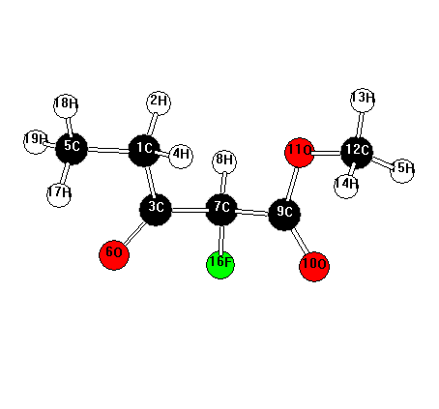
19
C6H9FO3 << C1 >> E(RHF) / 6-31G(d) = -556.464915452 C= 11
C 1.496832 -1.127513 -0.197438
H 1.248393 -1.409357 -1.228113
C 1.231700 0.350572 -0.015347
H 0.784205 -1.678164 0.429100
C 2.930614 -1.498817 0.157503
O 2.000325 1.106593 0.560719
C -0.069498 0.917168 -0.614567
H -0.095181 0.713777 -1.692684
C -1.293752 0.298025 0.044123
O -1.933813 0.806876 0.941487
O -1.547985 -0.911453 -0.508930
C -2.665562 -1.607684 0.090164
H -2.730378 -2.550795 -0.447751
H -2.480876 -1.774115 1.152236
H -3.578323 -1.023966 -0.032602
F -0.106394 2.276413 -0.406036
H 3.152055 -1.234459 1.192676
H 3.087939 -2.572432 0.027763
H 3.639493 -0.964844 -0.479135

Methyl 2,4-difluoro-3-oxopentanoate
NIMAG= 0 ZPE= 96.12398
MP2=-656.95491
Mopf24
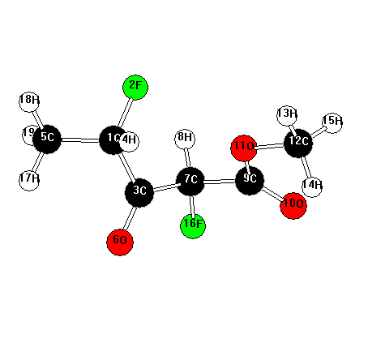
19
C6H8F2O3 << C1 >> E(RHF) / 6-31G(d) = -655.314322020 C= 12
C 1.671875 -0.760682 0.100439
F 1.311467 -1.234022 -1.172089
C 0.922164 0.535767 0.374325
H 1.339366 -1.507148 0.829377
C 3.170365 -0.559964 0.152057
O 1.221877 1.248194 1.321685
C -0.222095 0.920710 -0.566686
H 0.014715 0.640355 -1.597701
C -1.518227 0.234140 -0.143919
O -2.598039 0.780982 -0.070006
O -1.277844 -1.068893 0.126481
C -2.455711 -1.820563 0.502673
H -2.098693 -2.833216 0.675554
H -2.895851 -1.399133 1.406966
H -3.187313 -1.796932 -0.305547
F -0.418119 2.283102 -0.498841
H 3.452308 -0.161829 1.128314
H 3.679428 -1.511033 -0.016411
H 3.477731 0.148505 -0.620813

Methyl 2,4-difluoro-3-oxopentanoate other isomer
NIMAG= 0 ZPE= 96.04224
MP2=-656.94876
Mop24a
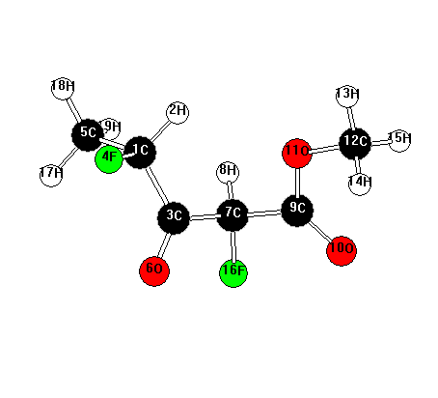
19
C6H8F2O3 << C1 >> E(RHF) / 6-31G(d) = -655.307683109 C= 12
C 1.689273 -0.697390 -0.220585
H 1.046904 -1.398033 -0.764321
C 0.856627 0.436306 0.354598
F 2.276510 -1.385071 0.837124
C 2.791842 -0.142656 -1.106879
O 1.096057 0.946005 1.436779
C -0.294067 0.964598 -0.514502
H -0.092977 0.808814 -1.582316
C -1.582168 0.241427 -0.136648
O -2.571859 0.766961 0.323906
O -1.431915 -1.081159 -0.385825
C -2.581669 -1.885253 -0.027257
H -2.296610 -2.906366 -0.269349
H -2.792858 -1.779164 1.037060
H -3.450576 -1.572641 -0.607057
F -0.458821 2.309579 -0.275872
H 3.420047 0.526747 -0.514606
H 3.403781 -0.965475 -1.482495
H 2.385804 0.408902 -1.959432

Methyl 2,5-difluoro-3-oxopentanoate
NIMAG= 0 ZPE= 96.58168
MP2=-656.9531078
Mopf25
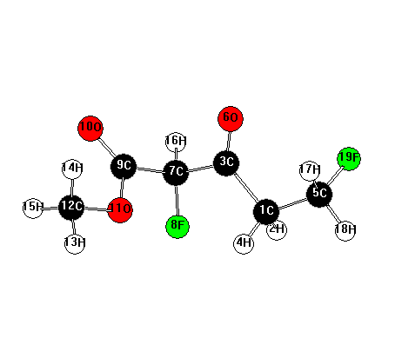
19
C6H8F2O3 << C1 >> E(RHF) / 6-31G(d) = -655.315153143 C= 12
C -1.645676 0.184290 -0.798517
H -1.916393 -0.718212 -1.354438
C -0.735379 -0.176217 0.350554
H -1.065709 0.807812 -1.492816
C -2.890033 0.898630 -0.326920
O -0.849801 0.272098 1.484427
C 0.440037 -1.108468 0.045758
F 0.411642 -1.504923 -1.290478
C 1.731875 -0.356124 0.321314
O 2.490834 -0.588282 1.242358
O 1.879331 0.628285 -0.589194
C 3.072289 1.424923 -0.404501
H 3.046941 2.158678 -1.206807
H 3.050954 1.909740 0.572169
H 3.958501 0.793990 -0.480214
H 0.398619 -1.993481 0.686726
H -2.646507 1.732173 0.335214
H -3.479176 1.259468 -1.175229
F -3.672622 -0.011653 0.389205

Methyl 2,2-difluoro-3-oxopentanoate
NIMAG= 0 ZPE= 95.45404
MP2=-656.96686
Mopf22
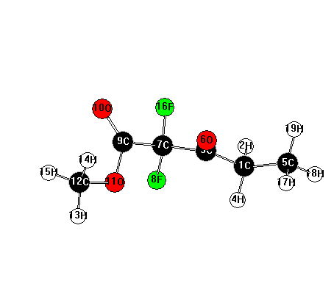
19
C6H8F2O3 << C1 >> E(RHF) / 6-31G(d) = -655.325876084 C= 12
C -2.420300 -0.021217 0.444139
H -2.672742 1.033499 0.276715
C -1.081079 -0.275104 -0.192033
H -2.293425 -0.122942 1.529230
C -3.500437 -0.954440 -0.083472
O -0.824112 -1.204912 -0.947728
C 0.016727 0.756372 0.105681
F -0.033941 1.117983 1.427979
C 1.412126 0.235894 -0.239073
O 2.062760 0.605109 -1.194757
O 1.763846 -0.692083 0.663354
C 3.039227 -1.318363 0.392630
H 3.171018 -2.042388 1.193054
H 3.011110 -1.809401 -0.580662
H 3.833062 -0.570883 0.405652
F -0.249157 1.868666 -0.639729
H -3.235958 -1.997046 0.102491
H -4.454263 -0.743845 0.405984
H -3.628467 -0.830601 -1.160895

Fluoromethyl 2-fluoro-3-oxopentanoate
NIMAG= 0 ZPE= 96.36693
MP2=-656.95962
Mopfch2
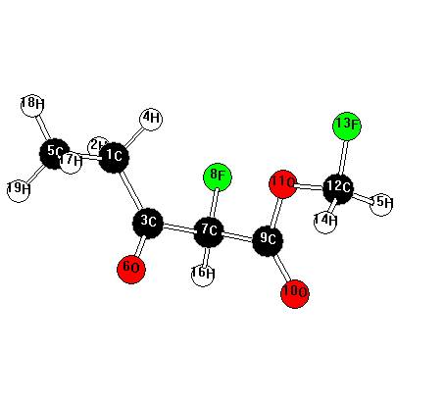
19
C6H8F2O3 << C1 >> E(RHF) / 6-31G(d) = -655.321521969 C= 12
C 2.184422 0.708417 0.505489
H 2.686493 0.236309 1.359165
C 1.481774 -0.368823 -0.275116
H 1.408719 1.346313 0.948193
C 3.155036 1.505126 -0.353280
O 1.653052 -0.591930 -1.468236
C 0.449041 -1.218866 0.478182
F 0.434627 -0.890716 1.830735
C -0.915848 -0.946239 -0.126036
O -1.520664 -1.700515 -0.864936
O -1.339543 0.286208 0.235449
C -2.606393 0.646402 -0.326815
F -2.867724 1.896778 0.148438
H -2.535069 0.669081 -1.415447
H -3.373866 -0.050105 0.014139
H 0.679227 -2.281623 0.363237
H 2.633938 1.987802 -1.182434
H 3.644846 2.276297 0.246106
H 3.922638 0.855162 -0.778269

1-Fluoro-2-butanone-
NIMAG= 0 ZPE= 71.48416
MP2=-330.69577
Mopfdec
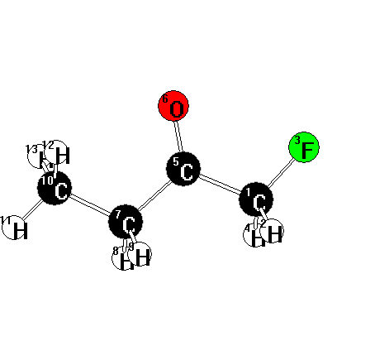
13
C4H7FO << C1 >> E(RHF) / 6-31G(d) = -329.833788719 C= 7
C 1.342235 -0.692903 0.000054
H 1.390550 -1.334782 0.888389
F 2.425026 0.165246 0.000033
H 1.390660 -1.334967 -0.888140
C 0.037065 0.089761 -0.000103
O 0.030864 1.313343 -0.000045
C -1.227718 -0.746324 -0.000099
H -1.200785 -1.410658 -0.874553
H -1.200656 -1.410897 0.874169
C -2.490121 0.104537 0.000103
H -3.379410 -0.530471 0.000080
H -2.520576 0.748574 0.880834
H -2.520694 0.748810 -0.880450

Methyl 2-fluoro-3-oxobutanoate
NIMAG= 0 ZPE= 81.62353
MP2=-518.77115
Mobf
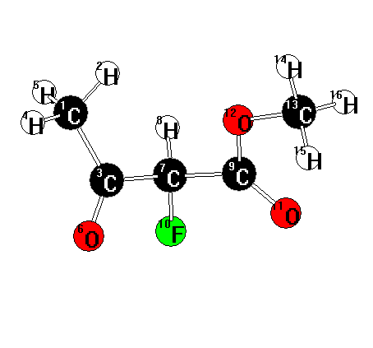
16
C5H7FO3 << C1 >> E(RHF) / 6-31G(d) = -517.429471539 C= 10
C -1.436303 1.911757 -0.219347
H -0.404520 2.264157 -0.276737
C -1.489221 0.451600 0.147886
H -1.999205 2.483903 0.518862
H -1.890838 2.051265 -1.206645
O -2.229416 -0.009176 1.004476
C -0.571127 -0.500685 -0.640780
H -0.522968 -0.201767 -1.695404
C 0.832982 -0.495097 -0.047377
F -1.068310 -1.780388 -0.549941
O 1.309015 -1.391017 0.617302
O 1.461019 0.663543 -0.363020
C 2.792952 0.777519 0.191183
H 3.153727 1.748186 -0.141429
H 2.752811 0.726056 1.279775
H 3.425136 -0.025670 -0.188404
Methyl 2-fluoro-3-oxobutanoate (enol form 2)
NIMAG= 0 ZPE= 82.21530
MP2=-518.76726
Mobfenol2
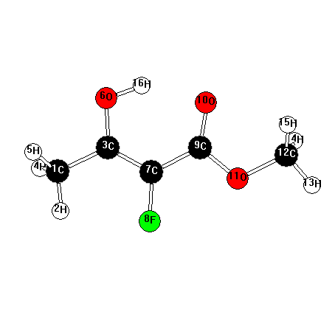
16
C5H7FO3 << C1 >> E(RHF) / 6-31G(d) = -517.425314488 C= 10
C 2.945111 -0.445896 -0.000009
H 2.841243 -1.530164 -0.001711
C 1.612155 0.219154 -0.000072
H 3.507458 -0.132275 0.884059
H 3.508797 -0.129508 -0.882219
O 1.678675 1.566757 -0.000028
C 0.434339 -0.457341 0.000024
F 0.434289 -1.819773 0.000003
C -0.861458 0.204380 0.000046
O -0.989546 1.436742 0.000049
O -1.894356 -0.650585 0.000034
C -3.189735 -0.010822 -0.000061
H -3.902744 -0.832077 -0.000901
H -3.306020 0.607256 0.890896
H -3.305309 0.608515 -0.890227
H 0.747319 1.906045 0.000069

Methyl 2,4-difluoro-3-oxobutanoate
NIMAG= 0 ZPE= 77.29231
MP2=-617.77447
Mobf24
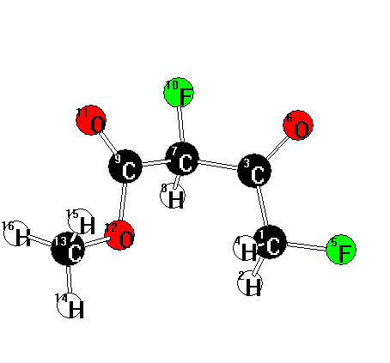
16
C5H6F2O3 << C1 >> E(RHF) / 6-31G(d) = -616.265816971 C= 11
C -1.453257 -1.193766 0.159398
H -1.214399 -1.501485 1.183248
C -1.253190 0.304026 -0.022175
H -0.799364 -1.745273 -0.523087
F -2.770292 -1.505407 -0.121537
O -2.062943 1.001398 -0.606447
C 0.009888 0.928887 0.594633
H 0.014183 0.742756 1.677315
C 1.282955 0.349673 -0.007876
F -0.008689 2.282057 0.365038
O 2.037319 0.933902 -0.755448
O 1.432783 -0.927266 0.421740
C 2.601519 -1.597414 -0.110680
H 2.570308 -2.597697 0.314925
H 2.551287 -1.631813 -1.199479
H 3.504059 -1.069039 0.196997

Methyl 2,2-difluoro-3-oxobutanoate
NIMAG= 0 ZPE= 76.15141
MP2=-617.79977
Mobf22
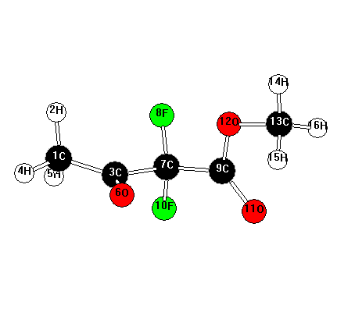
16
C5H6F2O3 << C1 >> E(RHF) / 6-31G(d) = -616.290074555 C= 11
C -2.709580 -0.762734 0.284617
H -2.652696 -0.968383 1.357457
C -1.324039 -0.689936 -0.287854
H -3.264892 -1.555463 -0.217009
H -3.216440 0.198100 0.159011
O -0.833433 -1.502389 -1.061699
C -0.496111 0.535826 0.123008
F -0.656527 0.763296 1.466055
C 0.987267 0.375268 -0.208960
F -0.995784 1.617133 -0.543899
O 1.545386 0.941590 -1.125985
O 1.533949 -0.497200 0.649945
C 2.923264 -0.794201 0.377828
H 3.210077 -1.513852 1.140747
H 3.021541 -1.220301 -0.621143
H 3.521181 0.114688 0.451610

Fluoromethyl 2-fluoro-3-oxobutanoate
NIMAG= 0 ZPE= 77.23322
MP2=-617.79448
Mobfch2
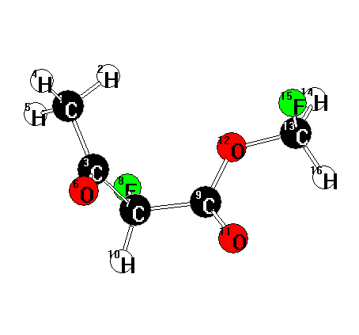
16
C5H6F2O3 << C1 >> E(RHF) / 6-31G(d) = -616.286323124 C= 11
C 2.108185 -0.739017 -1.306754
H 1.228948 -0.615022 -1.945787
C 1.720317 -0.537236 0.130435
H 2.529009 -1.737881 -1.422866
H 2.837097 0.017586 -1.609702
O 1.897668 -1.350221 1.027639
C 1.013190 0.786635 0.465009
F 1.196825 1.705135 -0.561822
C -0.462937 0.488310 0.651020
H 1.411911 1.191480 1.398672
O -0.977599 0.211502 1.712933
O -1.100451 0.518058 -0.557936
C -2.466077 0.136446 -0.515188
H -2.895707 0.500199 -1.446718
F -2.551796 -1.232547 -0.477399
H -2.949526 0.544803 0.371170

2-Fluoroacetone
NIMAG= 0 ZPE= 52.10589
MP2=-291.52898
Mobfdec
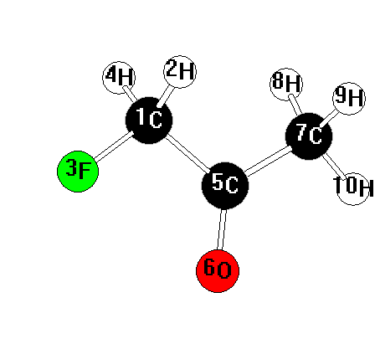

10
C3H5FO << C1 >> E(RHF) / 6-31G(d) = -290.798011737 C= 6
C 0.740792 -0.730513 -0.021245
H 0.708567 -1.406398 0.842423
F 1.905037 0.011040 0.021746
H 0.733971 -1.341283 -0.932726
C -0.475820 0.181273 -0.008709
O -0.358331 1.398729 -0.007514
C -1.813116 -0.523974 0.011166
H -1.876936 -1.271842 -0.785643
H -1.949968 -1.045012 0.964718
H -2.605450 0.214634 -0.111650

3-Fluoro-3-acetyl-3,4,5-trihydrofuran-2-one
NIMAG= 0 ZPE= 86.77612
MP2=-556.77761
lacf
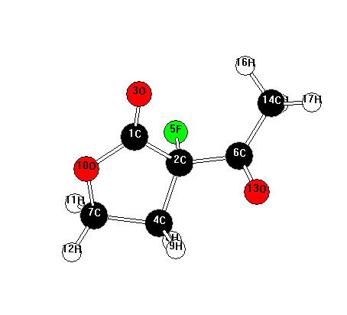
17
C6H7FO3 << C1 >> E(RHF) / 6-31G(d) = -555.309461432 C= 11
C 0.676453 0.968226 -0.219409
C -0.067132 -0.286006 0.275341
O 0.198301 2.061074 -0.431020
C 0.881118 -1.402674 -0.076010
F -0.153711 -0.147314 1.674130
C -1.466594 -0.359599 -0.328285
C 2.237990 -0.709526 0.032617
H 0.771622 -2.259727 0.592756
H 0.676135 -1.713461 -1.104019
O 1.992578 0.666318 -0.364312
H 2.622090 -0.705091 1.056175
H 2.996858 -1.103777 -0.643859
O -1.609384 -0.870008 -1.434568
C -2.570002 0.277294 0.463798
H -2.680243 -0.216361 1.432693
H -2.307022 1.322747 0.653384
H -3.498988 0.216136 -0.103412

3-Fluoro-3-(1’-fluoroacetyl)-3,4,5-trihydrofuran-2-one
NIMAG= 0 ZPE= 82.37112
MP2=-655.78167
Lacf24
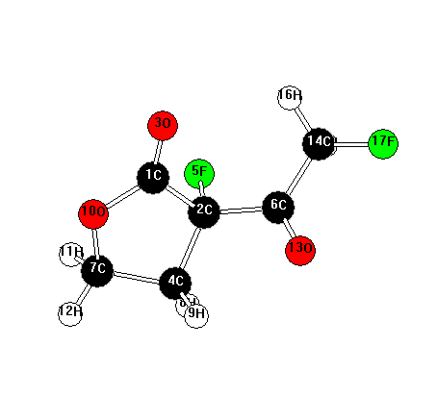
17
C6H6F2O3 << C1 >> E(RHF) / 6-31G(d) = -654.146893113 C= 12
C 1.009655 0.974418 -0.229833
C 0.312765 -0.297604 0.287037
O 0.491694 2.052433 -0.422942
C 1.283070 -1.391700 -0.069464
F 0.228584 -0.142397 1.686593
C -1.092259 -0.419300 -0.284893
C 2.622918 -0.658667 -0.013160
H 1.217055 -2.239993 0.615887
H 1.057401 -1.726786 -1.085939
O 2.326117 0.706396 -0.413493
H 3.041678 -0.632757 0.996277
H 3.368610 -1.038598 -0.711835
O -1.280265 -0.937389 -1.375475
C -2.186839 0.204786 0.552839
H -2.256278 -0.298827 1.522190
H -1.939663 1.259602 0.720713
F -3.393588 0.101757 -0.110724

3-Acetyl-3-fluoropropan-1-ol
NIMAG= 0 ZPE= 93.98155
MP2=-444.89575
Laconef
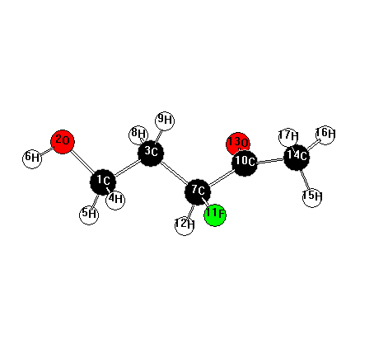
17
C5H9FO2 << C1 >> E(RHF) / 6-31G(d) = -443.724956984 C= 9
C 2.179119 0.210274 -0.245355
O 3.198760 -0.465019 0.489454
C 0.858683 -0.391289 0.197139
H 2.181828 1.288223 -0.040839
H 2.308927 0.070637 -1.329491
H 4.048930 -0.055085 0.259241
C -0.323143 0.223241 -0.526893
H 0.858095 -1.468679 0.006984
H 0.742588 -0.241488 1.276103
C -1.632705 -0.417785 -0.084802
F -0.358488 1.604544 -0.259290
H -0.226826 0.105489 -1.613503
O -1.823824 -1.601359 -0.346516
C -2.608907 0.442618 0.670957
H -2.918453 1.289970 0.052764
H -3.473547 -0.160423 0.948965
H -2.132925 0.859128 1.563605

3-Acetyl-3-fluoro-propanol hemiacetal form
NIMAG= 0 ZPE= 95.80613
MP2=-444.90276
Lacoh
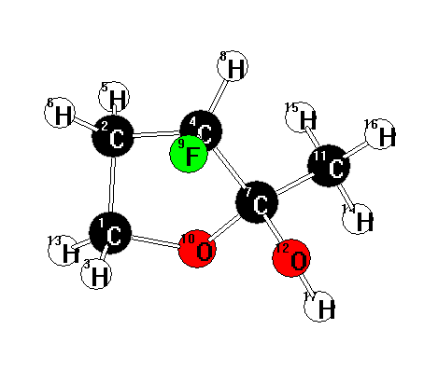
17
C5H9FO2 << C1 >> E(RHF) / 6-31G(d) = -443.725608862 C= 9
C 1.200318 -1.169333 -0.589276
C 1.556796 -0.390934 0.669291
H 1.480313 -0.615576 -1.493747
C 0.476980 0.677460 0.653175
H 1.444079 -1.038693 1.544332
H 2.554322 0.055438 0.675503
C -0.732089 -0.038323 -0.008243
H 0.227689 1.094997 1.633662
F 0.914527 1.730123 -0.148984
O -0.227526 -1.288590 -0.484716
C -1.858567 -0.356575 0.955809
O -1.166633 0.771597 -1.075772
H 1.609559 -2.180275 -0.636005
H -2.594038 -0.992869 0.454369
H -1.478665 -0.899945 1.825099
H -2.343974 0.566200 1.282017
H -1.837389 0.241799 -1.544989

3-Acetyl-3-fluoro-propanol hemiacetal form 2nd isomer
NIMAG= 0 ZPE= 95.83501
MP2=-444.91131
Lacoh2
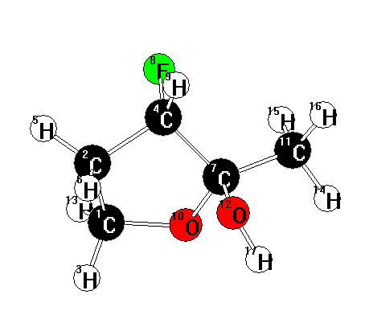
17
C5H9FO2 << C1 >> E(RHF) / 6-31G(d) = -443.734596780 C= 9
C -1.366082 -0.907413 -0.728005
C -1.593146 -0.152860 0.589113
H -1.649408 -1.962182 -0.662924
C -0.362919 0.726042 0.674141
H -2.508371 0.443794 0.589636
H -1.607666 -0.834997 1.441347
C 0.704461 -0.165802 0.053627
F -0.539775 1.844198 -0.152891
H -0.102165 1.074507 1.676264
O 0.047473 -0.809189 -1.022658
C 1.934458 0.523765 -0.487315
O 1.017472 -1.096450 1.085120
H -1.902301 -0.448219 -1.563233
H 2.578108 -0.214817 -0.973851
H 1.646813 1.278670 -1.218900
H 2.485646 0.991363 0.331593
H 1.497132 -1.823189 0.647037

3-Acetyl-3-fluoro-propanol dimer
NIMAG= 0 ZPE= 173.84323
MP2=-813.61581
Lacdimer
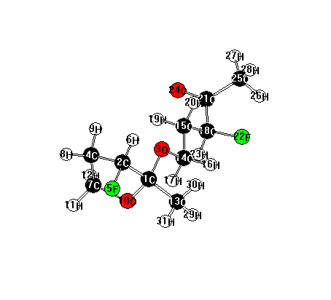
31
C10H16F2O3 << C1 >> E(RHF) / 6-31G(d) = -811.448143132 C= 16
C 2.092375 -0.535367 0.013714
C 3.056495 0.187072 -0.921656
O 0.820097 -0.261307 -0.571724
C 2.862856 1.634239 -0.516286
F 4.362910 -0.208942 -0.604245
H 2.876179 -0.032250 -1.976586
C 2.550326 1.525391 0.985510
H 3.760241 2.221191 -0.725547
H 2.022038 2.057426 -1.069062
O 2.246946 0.135149 1.248308
H 3.407704 1.784766 1.611827
H 1.697789 2.146749 1.277883
C 2.347165 -2.007498 0.235923
C -0.296905 -0.658961 0.229615
C -1.491091 0.130116 -0.274049
H -0.482202 -1.734478 0.126862
H -0.097723 -0.433155 1.284173
C -2.762396 -0.226491 0.472093
H -1.311976 1.202617 -0.153636
H -1.633604 -0.068755 -1.342187
C -3.938096 0.617221 -0.006201
F -3.045681 -1.589593 0.272434
H -2.641620 -0.074832 1.552293
O -3.887102 1.833852 0.147499
C -5.090903 -0.098308 -0.656297
H -5.526122 -0.819937 0.040767
H -5.838529 0.634424 -0.960621
H -4.741059 -0.667153 -1.522754
H 1.700380 -2.386803 1.029667
H 2.148618 -2.559392 -0.686224
H 3.386330 -2.149634 0.532585

3-Acetyl-3-fluoro-propanol dimer 2nd isomer
NIMAG= 0 ZPE= 173.82996
MP2=-813.61571
Lacdimer2
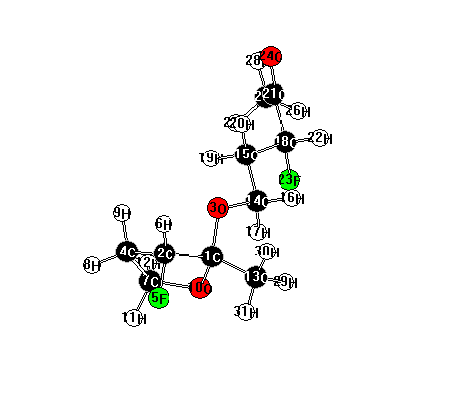
31
C10H16F2O3 << C1 >> E(RHF) / 6-31G(d) = -811.447918077 C= 16
C 2.100671 -0.523771 0.041703
C 3.064964 0.203039 -0.889999
O 0.854419 -0.413860 -0.645577
C 2.723104 1.655329 -0.624880
F 4.373951 -0.048094 -0.456759
H 2.978748 -0.116147 -1.931219
C 2.315121 1.640908 0.857883
H 3.580964 2.300977 -0.826959
H 1.891313 1.955385 -1.265021
O 2.110997 0.255305 1.220321
H 3.101346 2.025598 1.512511
H 1.395102 2.205220 1.041049
C 2.459856 -1.944645 0.406725
C -0.279994 -0.840441 0.114446
C -1.490381 -0.153542 -0.490912
H -0.390756 -1.932801 0.055203
H -0.160039 -0.555091 1.163611
C -2.779551 -0.585235 0.180490
H -1.376163 0.931711 -0.391071
H -1.564523 -0.385751 -1.557609
C -3.986851 0.096320 -0.451917
H -2.916156 -1.671834 0.110283
F -2.714276 -0.261193 1.547474
O -4.238251 -0.132679 -1.631178
C -4.792373 1.028616 0.411748
H -5.196317 0.487887 1.272276
H -4.152776 1.822169 0.809131
H -5.600793 1.454980 -0.182512
H 1.788984 -2.314093 1.185115
H 2.377155 -2.584263 -0.475578
H 3.482129 -1.969951 0.784109

3-Acetyl-3-fluoro-propanol dimer 3nd isomer
NIMAG= 0 ZPE= 173.80739
MP2=-813.60702
Lacdimer3
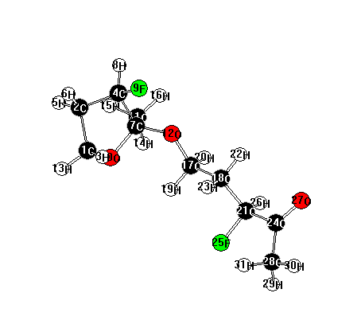
31
C10H16F2O3 << C1 >> E(RHF) / 6-31G(d) = -811.439252429 C= 16
C -2.836438 -0.481100 1.673181
C -3.949430 0.244047 0.930398
H -2.172472 0.226098 2.185338
C -3.172136 0.806865 -0.245889
H -4.696230 -0.480252 0.590255
H -4.445442 1.038411 1.493732
C -2.085276 -0.272303 -0.510399
H -3.768651 1.022639 -1.137675
F -2.581694 2.002889 0.161246
O -2.143677 -1.157953 0.611652
C -2.364384 -1.105240 -1.748332
O -0.852841 0.408451 -0.568695
H -3.174057 -1.243526 2.377772
H -1.714671 -1.982752 -1.765772
H -3.400233 -1.455420 -1.732501
H -2.196913 -0.508324 -2.648832
C 0.286265 -0.446745 -0.706789
C 1.484578 0.372155 -0.263731
H 0.174344 -1.334796 -0.078418
H 0.407347 -0.764216 -1.752852
C 2.783090 -0.393267 -0.429650
H 1.549282 1.293688 -0.850175
H 1.357057 0.652780 0.787390
C 3.975427 0.447381 0.008305
F 2.723343 -1.568679 0.341150
H 2.933538 -0.695886 -1.473459
O 4.257152 1.449667 -0.641480
C 4.725030 0.005069 1.235919
H 5.144894 -0.992467 1.079232
H 5.518610 0.722399 1.446125
H 4.043326 -0.068747 2.088382

3-Acetyl-3-fluoro-propanol dimer 4th isomer
NIMAG= 0 ZPE= 173.82327
MP2=-813.60711
Lacdimer4
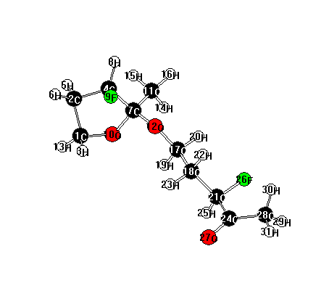
31
C10H16F2O3 << C1 >> E(RHF) / 6-31G(d) = -811.439407985 C= 16
C -3.060770 -1.048944 -1.272032
C -4.064164 -0.770050 -0.162372
H -2.424999 -1.908949 -1.028323
C -3.151845 -0.160905 0.887273
H -4.799332 -0.036844 -0.508660
H -4.584549 -1.648445 0.227507
C -2.077806 0.584529 0.045340
H -3.646851 0.499711 1.605816
F -2.569508 -1.201532 1.609948
O -2.290939 0.164177 -1.305715
C -2.244330 2.093041 0.072068
O -0.825561 0.154770 0.527600
H -3.496849 -1.183994 -2.263652
H -1.629468 2.555188 -0.702878
H -3.287557 2.352187 -0.128786
H -1.954764 2.485864 1.050342
C 0.293671 0.670658 -0.200648
C 1.476443 -0.203336 0.172731
H 0.097149 0.619507 -1.278159
H 0.492603 1.712856 0.075526
C 2.755938 0.260184 -0.496938
H 1.609891 -0.184677 1.260081
H 1.285404 -1.238889 -0.123209
C 3.921768 -0.656156 -0.147388
H 2.645252 0.283763 -1.588238
F 3.044199 1.572520 -0.078551
O 3.893688 -1.817925 -0.541977
C 5.034175 -0.080357 0.686538
H 5.498281 0.760410 0.163463
H 4.636253 0.312380 1.626894
H 5.771335 -0.859129 0.882995

Ethyl 2-fluoro-2-oxocyclohexanecarboxylate
NIMAG= 0 ZPE= 144.94248
MP2=-674.28682
cxf
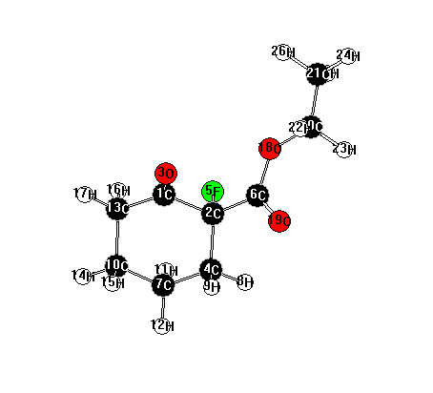
26
C9H13FO3 << C1 >> E(RHF) / 6-31G(d) = -672.423976674 C= 14
C 0.926297 1.026543 -0.361485
C 0.435646 -0.323230 0.178458
O 0.302793 1.635184 -1.224765
C 1.457642 -1.405612 -0.134817
F 0.358656 -0.185435 1.578081
C -0.944289 -0.626034 -0.381861
C 2.827947 -1.019411 0.425267
H 1.102275 -2.351951 0.288158
H 1.494215 -1.531367 -1.222626
C 3.289091 0.340321 -0.102411
H 2.772862 -0.992718 1.518878
H 3.559525 -1.790816 0.160178
C 2.259478 1.445933 0.198593
H 4.256128 0.613507 0.334053
H 3.436882 0.281181 -1.188495
H 2.162446 1.574817 1.282753
H 2.540274 2.403317 -0.248964
O -1.898992 -0.003756 0.324874
O -1.126522 -1.315971 -1.371475
C -3.239377 -0.159687 -0.213026
C -4.157280 0.632145 0.688366
H -3.243071 0.208145 -1.242308
H -3.487238 -1.224345 -0.231181
H -5.187544 0.551800 0.330351
H -4.112684 0.252106 1.711050
H -3.871146 1.685777 0.693843

2-fluorocyclohexanone
NIMAG= 0 ZPE= 96.92459
MP2=-407.86887
Cxfdec
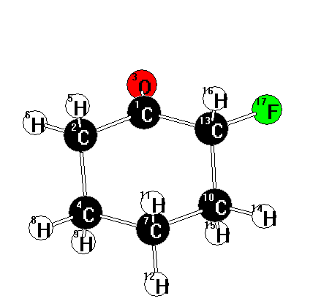

17
C6H9FO << C1 >> E(RHF) / 6-31G(d) = -406.749023063 C= 9
C 0.532186 0.899111 0.091429
C -0.879832 1.340780 0.413628
O 1.373337 1.622398 -0.427192
C -1.892274 0.423827 -0.291453
H -1.032281 1.280317 1.500303
H -0.986640 2.386674 0.112922
C -1.636288 -1.043646 0.053244
H -2.911335 0.714371 -0.013606
H -1.806322 0.564158 -1.376258
C -0.204272 -1.451615 -0.297497
H -1.813109 -1.203964 1.125332
H -2.343776 -1.687918 -0.479880
C 0.807382 -0.561734 0.414997
H -0.005461 -2.496141 -0.035652
H -0.032749 -1.347581 -1.376019
H 0.740338 -0.705366 1.503632
F 2.093692 -0.902674 0.016742

Ethyl 2-fluoro-2-chloro-3-oxobutanoate
NIMAG= 0 ZPE= 93.86964
MP2=-1016.96102
Mf2
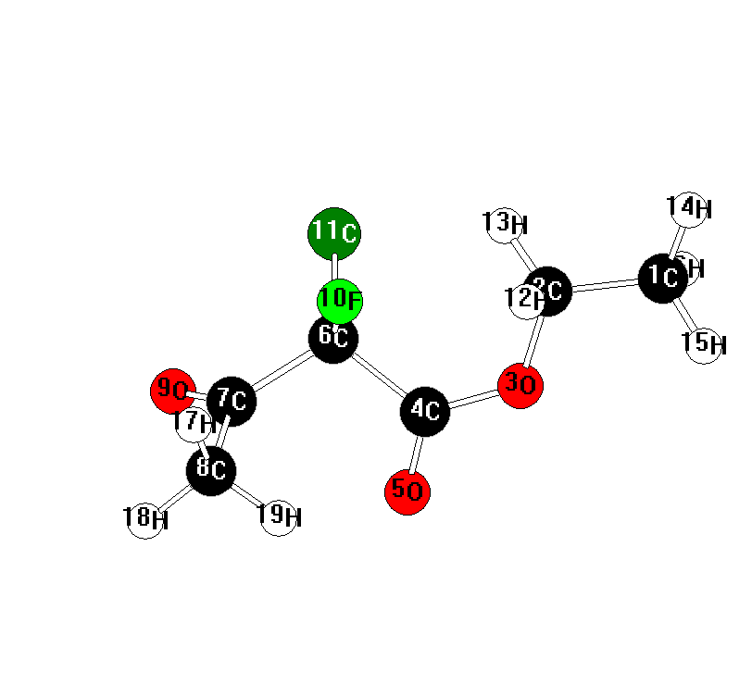
19
C6H8ClFO3 << C1 >> E(RHF) / 6-31G(d) = -1015.34937563 C= 16
C 3.816144 -0.135416 0.101008
C 2.369546 -0.091505 0.534045
O 1.627939 -0.788995 -0.510859
C 0.305321 -0.692479 -0.693472
O -0.255398 -1.319067 -1.576336
C -0.543615 0.220631 0.204109
C -2.030407 -0.209513 0.096140
C -2.365098 -1.471251 0.846496
O -2.833449 0.458109 -0.529554
F -0.171358 0.062704 1.535138
Cl -0.322938 1.903438 -0.271162
H 2.208927 -0.617034 1.476929
H 2.009740 0.932281 0.629260
H 4.440882 0.346150 0.858718
H 4.147753 -1.168218 -0.021707
H 3.946466 0.390203 -0.846833
H -2.316661 -1.283504 1.922678
H -3.373898 -1.779442 0.571337
H -1.655118 -2.266388 0.607157

Ethyl 2,4-difluoro-2-chloro-3-oxobutanoate
NIMAG= 0 ZPE= 89.46185
MP2=-1115.96349
Mf3
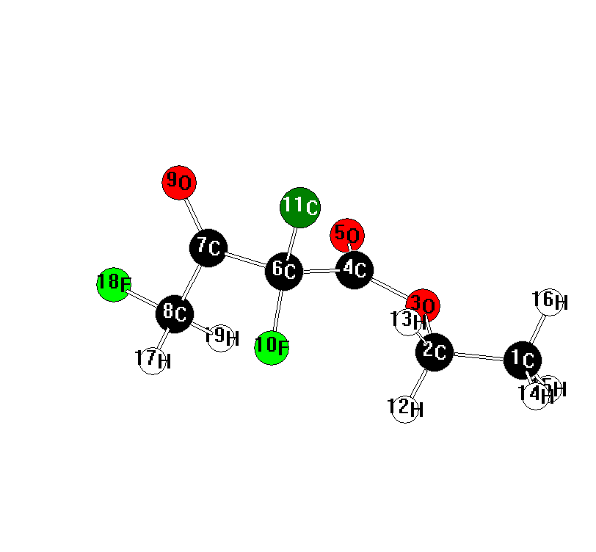
19
C6H7ClF2O3 << C1 >> E(RHF) / 6-31G(d) = -1114.18460153 C= 17
C -4.058594 -0.625215 -0.174774
C -2.616949 -0.402073 -0.566165
O -1.826522 -0.879912 0.564231
C -0.537073 -0.587694 0.763157
O 0.087505 -1.074702 1.690291
C 0.197570 0.381792 -0.176834
C 1.723368 0.220740 0.028653
C 2.304529 -1.000591 -0.662264
O 2.382047 1.012684 0.669881
F -0.065210 0.038894 -1.502420
Cl -0.308984 2.039562 0.122238
H -2.337609 -0.982887 -1.446997
H -2.409403 0.651163 -0.750594
H -4.712920 -0.315796 -0.994689
H -4.238564 -1.680606 0.038011
H -4.307670 -0.040202 0.712512
H 2.239371 -0.873885 -1.747815
F 3.626583 -1.141057 -0.295387
H 1.745814 -1.897187 -0.374066

1’-fluoroethyl 2-fluoro-2-chloro-3-oxobutanoate
NIMAG= 0 ZPE= 88.88470
MP2=-1115.98925
Mf4
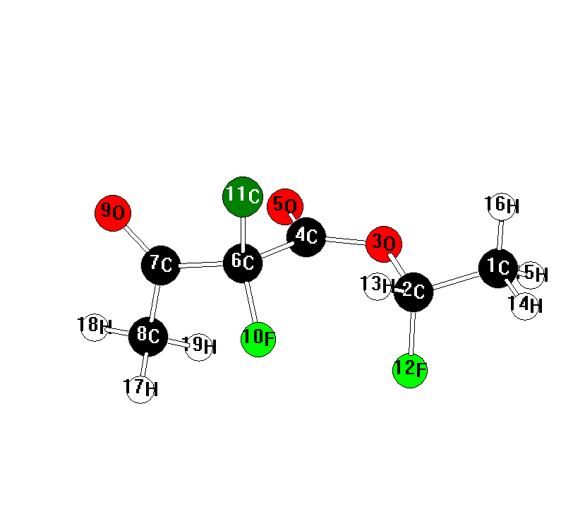
19
C6H7ClF2O3 << C1 >> E(RHF) / 6-31G(d) = -1114.20915035 C= 17
C -3.599498 0.324033 0.243665
C -2.212663 -0.012047 -0.220983
O -1.445050 -0.279444 0.952963
C -0.092404 -0.352156 0.961333
O 0.490457 -0.800115 1.928436
C 0.727979 0.199985 -0.215330
C 2.194631 -0.288389 -0.076226
C 2.410858 -1.716204 -0.499160
O 3.067737 0.460165 0.322966
F 0.244780 -0.288414 -1.419214
Cl 0.626605 1.961193 -0.214981
F -2.240503 -1.167144 -0.976235
H -1.750375 0.769770 -0.820762
H -4.244895 0.474742 -0.623961
H -3.983244 -0.503649 0.842317
H -3.584852 1.232989 0.847482
H 2.322390 -1.794420 -1.586384
H 3.409788 -2.021807 -0.187638
H 1.661831 -2.374070 -0.052045

2’-fluoroethyl 2-fluoro-2-chloro-3-oxobutanoate
NIMAG= 0 ZPE= 89.37497
MP2=-1115.96779
Mf5
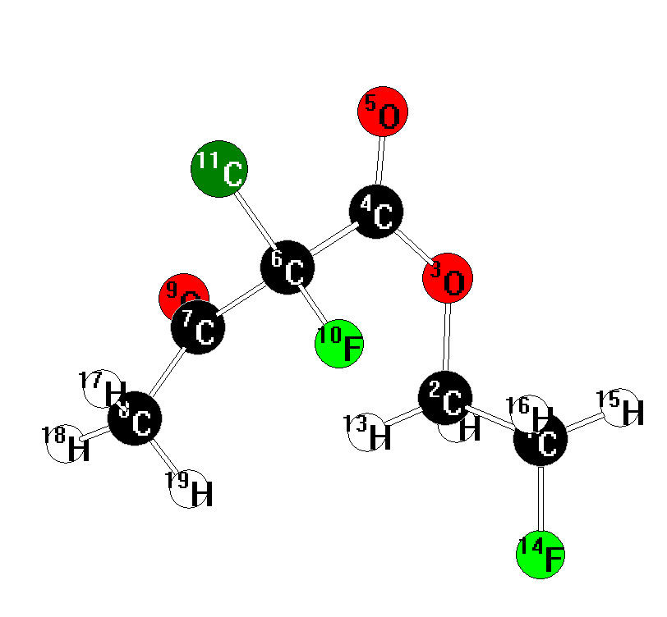
19
C6H7ClF2O3 << C1 >> E(RHF) / 6-31G(d) = -1114.18928617 C= 17
C 2.870269 -0.323738 -0.517064
C 1.910425 -0.092925 0.632027
O 1.057910 -1.247013 0.754443
C -0.240817 -1.309651 0.378750
O -0.880674 -2.318336 0.564577
C -0.852931 -0.049579 -0.275076
C -1.025366 1.099292 0.734532
C -1.114991 2.485225 0.161306
O -1.085916 0.823188 1.925248
F -0.030203 0.370979 -1.315708
Cl -2.442137 -0.406390 -0.945745
H 2.452810 -0.025463 1.576575
H 1.363444 0.835717 0.481845
F 3.729255 0.776986 -0.556432
H 3.458109 -1.230491 -0.356770
H 2.334491 -0.390926 -1.465539
H -1.852970 2.519298 -0.644093
H -1.390594 3.176331 0.958238
H -0.150534 2.778013 -0.264333

2’-fluoroethyl 2-chloro-3-oxobutanoate
NIMAG= 0 ZPE= 95.16608
MP2=-1016.96848
Clbfch2mono
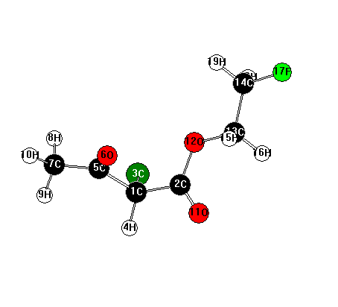
19
C6H8ClFO3 << C1 >> E(RHF) / 6-31G(d) = -1015.36799484 C= 16
C 1.450042 0.253470 0.570288
C 0.015385 0.079013 1.032094
Cl 1.675833 1.747035 -0.380693
H 2.069273 0.348551 1.467478
C 1.888555 -0.999227 -0.203617
O 1.189798 -2.003846 -0.137867
C 3.187439 -0.944477 -0.961542
H 3.061477 -0.359267 -1.876656
H 3.967752 -0.459149 -0.368464
H 3.481725 -1.962522 -1.218292
O -0.291592 -0.160329 2.184620
O -0.844465 0.180105 0.002507
C -2.222366 -0.074933 0.352211
C -2.991683 0.054888 -0.942635
H -2.318827 -1.077892 0.774085
H -2.564483 0.653690 1.090944
F -4.337329 -0.172716 -0.648259
H -2.885879 1.057474 -1.364372
H -2.658416 -0.685878 -1.673477

2’-fluoroethyl 2-chloro-3-oxobutanoate (enol form)
NIMAG= 0 ZPE= 95.96080
MP2=-1016.96482
Clbfenol
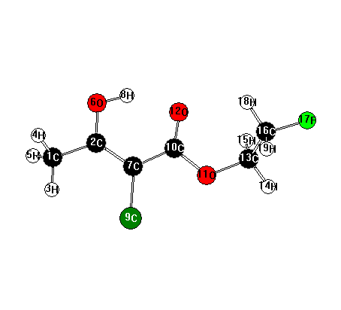
19
C6H8ClFO3 << C1 >> E(RHF) / 6-31G(d) = -1015.36156600 C= 16
C 3.660739 -0.366470 0.318157
C 2.226005 -0.699385 0.081840
H 3.830786 0.705088 0.390666
H 3.987745 -0.854045 1.241021
H 4.257613 -0.778584 -0.500561
O 2.034717 -2.025718 0.003576
C 1.204906 0.204534 -0.046316
H 1.065043 -2.178871 -0.157675
Cl 1.494612 1.913485 0.058935
C -0.161380 -0.255314 -0.274207
O -1.061235 0.739409 -0.379767
O -0.474823 -1.452428 -0.365129
C -2.421414 0.321392 -0.638505
H -2.906049 1.194928 -1.074647
H -2.434888 -0.510244 -1.344247
C -3.098063 -0.064450 0.661734
F -4.440589 -0.313681 0.365504
H -2.656698 -0.969506 1.083327
H -3.040695 0.753166 1.385025

1-chloro-1-fluoroacetone
NIMAG= 0 ZPE= 46.21723
MP2=-750.55927
Clbdec
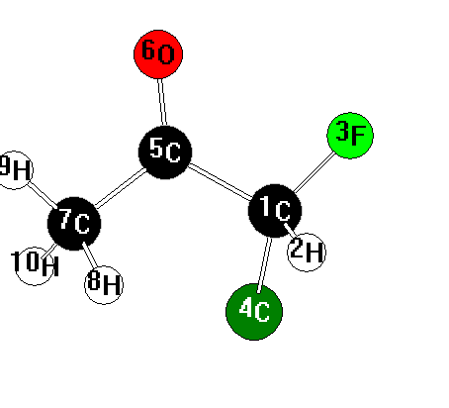
10
C3H4ClFO << C1 >> E(RHF) / 6-31G(d) = -749.695711244 C= 11
C 0.353795 0.374919 0.509763
H 0.437761 0.223193 1.589701
F 0.673581 1.666140 0.214452
Cl 1.523903 -0.723025 -0.264347
C -1.058564 0.060918 -0.001907
O -1.689658 0.926231 -0.588290
C -1.585833 -1.323977 0.273502
H -1.293501 -1.676674 1.266729
H -2.672488 -1.304893 0.185389
H -1.179470 -2.026461 -0.459819

Ethyl 2-fluoro-2-methyl-3-oxobutanoate
NIMAG= 0 ZPE= 119.31366
MP2=-597.11696
2meaf
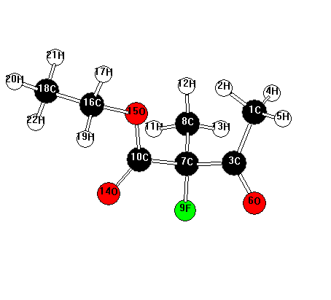
22
C7H11FO3 << C1 >> E(RHF) / 6-31G(d) = -595.507236218 C= 12
C -1.704559 1.966175 0.172107
H -0.666897 2.291728 0.261307
C -1.791608 0.542286 -0.320573
H -2.169569 2.043537 1.160598
H -2.248968 2.603918 -0.525484
O -2.561537 0.193397 -1.204943
C -0.887684 -0.521190 0.345001
C -0.816337 -0.394631 1.859951
F -1.423537 -1.762064 0.042455
C 0.504334 -0.486127 -0.290074
H -0.224460 -1.224604 2.254259
H -0.353635 0.546295 2.158248
H -1.824873 -0.459078 2.277249
O 0.969668 -1.371249 -0.978872
O 1.135500 0.671370 0.032260
C 2.477848 0.812819 -0.515713
H 2.643584 1.891065 -0.524580
C 3.485648 0.089248 0.351956
H 2.476986 0.432605 -1.538947
H 4.497034 0.269906 -0.024330
H 3.429758 0.449088 1.381848
H 3.297975 -0.985510 0.334228

Ethyl 2-fluoropropanoate
NIMAG= 0 ZPE= 94.33869
MP2=-444.92323
2meaester
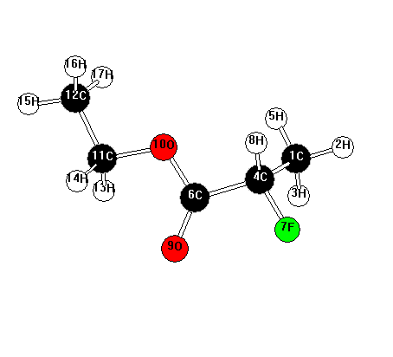
17
C5H9FO2 << C1 >> E(RHF) / 6-31G(d) = -443.752870467 C= 9
C -1.727360 1.484662 0.530469
H -2.635662 2.014515 0.235749
H -1.854151 1.110482 1.549361
C -1.491193 0.318330 -0.409555
H -0.881234 2.173668 0.501501
C -0.266098 -0.485178 -0.006645
F -2.592316 -0.530044 -0.368940
H -1.364385 0.662368 -1.441902
O -0.274194 -1.604529 0.466490
O 0.846072 0.256467 -0.231610
C 2.089117 -0.389543 0.148567
C 3.199061 0.584371 -0.171847
H 2.045182 -0.635715 1.212823
H 2.181860 -1.324954 -0.409415
H 4.164961 0.146852 0.095556
H 3.207524 0.819826 -1.238078
H 3.070560 1.511991 0.389884

Ethyl 2,4-difluoro-2-methyl-3-oxobutanoate
NIMAG= 0 ZPE= 114.92503
MP2= -696.12058
2meaf24
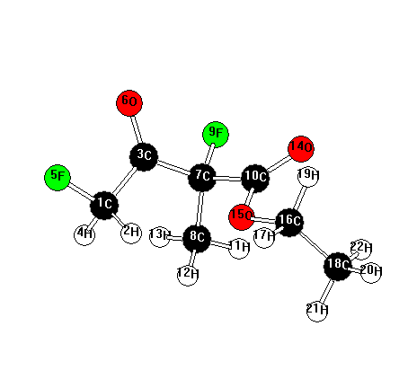
22
C7H10F2O3 << C1 >> E(RHF) / 6-31G(d) = -694.344514962 C= 13
C 1.866727 -1.230100 0.545763
H 0.949285 -1.809160 0.682757
C 1.577509 0.044306 -0.231548
H 2.277475 -0.978194 1.530895
F 2.793444 -1.986968 -0.145821
O 2.202707 0.346515 -1.233961
C 0.461029 0.970280 0.294571
C 0.363784 1.033100 1.812444
F 0.736167 2.243811 -0.172925
C -0.875591 0.552436 -0.322106
H -0.408654 1.757894 2.081558
H 0.099668 0.062485 2.236138
H 1.315980 1.372230 2.228778
O -1.581091 1.272357 -0.997358
O -1.147721 -0.732595 0.016209
C -2.409099 -1.254317 -0.496593
H -2.260343 -2.334841 -0.503042
C -3.558177 -0.840940 0.397859
H -2.539983 -0.895519 -1.519034
H -4.485429 -1.303153 0.046407
H -3.378189 -1.164917 1.425454
H -3.684563 0.242779 0.377331

2’-fluoroethyl 2-methyl-3-oxobutanoate
NIMAG= 0 ZPE= 120.23497
MP2=-597.11493
2meaf5mono
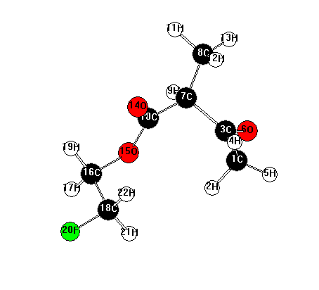
22
C7H11FO3 << C1 >> E(RHF) / 6-31G(d) = -595.510650883 C= 12
C 1.344538 -1.537900 1.090965
H 0.316889 -1.822872 0.842347
C 1.977518 -0.873144 -0.109421
H 1.302438 -0.859062 1.947851
H 1.909837 -2.435450 1.344196
O 2.809556 -1.437525 -0.810409
C 1.587830 0.579087 -0.405977
C 2.496741 1.526382 0.380891
H 1.736020 0.713470 -1.482311
C 0.131694 0.827676 -0.093925
H 2.253834 2.565530 0.148368
H 2.370408 1.387768 1.456806
H 3.539149 1.336817 0.113833
O -0.299227 1.505627 0.824043
O -0.657073 0.158725 -0.981091
C -2.079630 0.350617 -0.809439
H -2.522428 0.109968 -1.776289
C -2.607630 -0.584393 0.259806
H -2.290075 1.388776 -0.546976
F -3.997034 -0.442635 0.283451
H -2.364497 -1.623618 0.020655
H -2.210680 -0.322183 1.242725

2’-fluoroethyl 2-fluoro-2-methyl-3-oxobutanoate
NIMAG= 0 ZPE= 114.88993
MP2=-696.12552
2meaf25
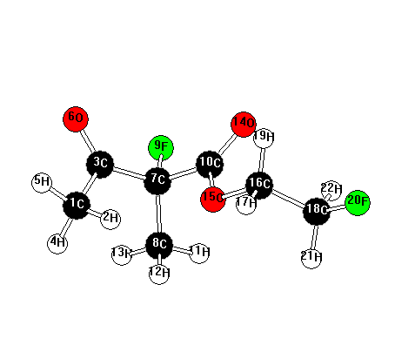
22
C7H10F2O3 << C1 >> E(RHF) / 6-31G(d) = -694.350352089 C= 13
C -2.038955 2.007311 0.148044
H -0.992035 2.289854 0.270164
C -2.173760 0.587804 -0.345890
H -2.530968 2.106174 1.121467
H -2.534000 2.666915 -0.565750
O -2.942595 0.266155 -1.240729
C -1.323199 -0.510790 0.336815
C -1.298666 -0.398524 1.854416
F -1.885827 -1.731095 0.004259
C 0.084180 -0.513325 -0.260073
H -0.746782 -1.249002 2.262701
H -0.820510 0.526230 2.177714
H -2.322995 -0.436396 2.234604
O 0.529507 -1.377438 -0.985716
O 0.766142 0.597440 0.138779
C 2.096452 0.729617 -0.419434
H 2.339414 1.789175 -0.336248
C 3.078530 -0.101269 0.382053
H 2.094707 0.423882 -1.466938
F 4.354501 0.197483 -0.100371
H 3.030871 0.160290 1.442691
H 2.892311 -1.168811 0.250349

3-Fluoro-2-butanone
NIMAG= 0 ZPE= 71.10665
MP2=-330.70843
2meadec
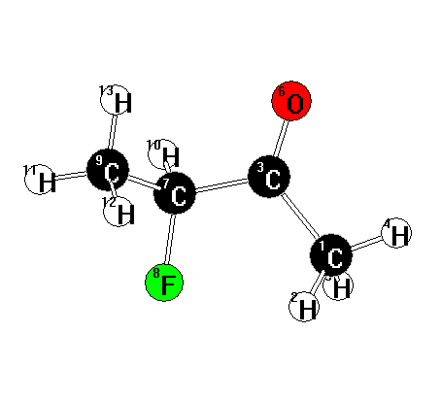
13
C4H7FO << C1 >> E(RHF) / 6-31G(d) = -329.845345827 C= 7
C -1.624719 0.846896 0.365338
H -1.207896 1.285670 1.276525
C -0.756818 -0.287706 -0.107925
H -2.631385 0.472016 0.551166
H -1.646478 1.641453 -0.385846
O -1.159004 -1.438424 -0.253556
C 0.705443 0.017620 -0.412022
F 0.948423 1.387070 -0.216280
C 1.635275 -0.783373 0.474852
H 0.886940 -0.198533 -1.471395
H 2.675498 -0.568068 0.222119
H 1.466215 -0.521063 1.522415
H 1.438244 -1.848337 0.338530

Also reported as most stable isomer at MP2/6-31G** in
R.J. Abraham, C.F. Tormena and R. Rittner, J. Chem. Soc., Perkin Trans. 2, 1999, 1663.

Ethyl 2-fluoro-2-ethyl-3-oxobutanoate
NIMAG= 0 ZPE= 138.33036
MP2= -636.28849
2ef
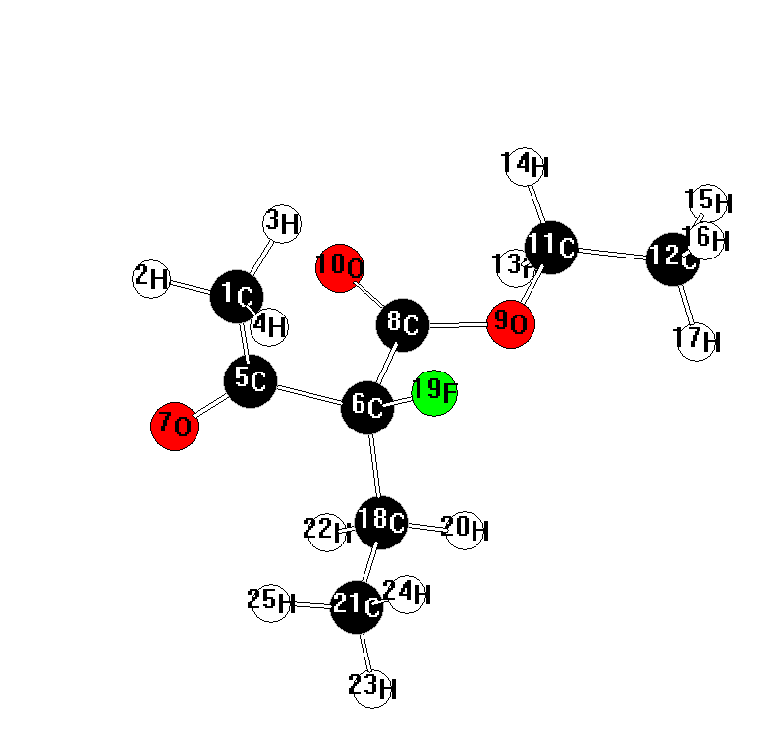

25
C8H13FO3 << C1 >> E(RHF) / 6-31G(d) = -634.549481102 C= 13
C 2.034567 -1.742591 1.083929
H 2.789265 -2.473147 0.791470
H 1.099011 -2.249689 1.337474
H 2.362425 -1.196026 1.972217
C 1.811102 -0.785488 -0.055513
C 0.660536 0.217815 0.111785
O 2.476271 -0.781992 -1.084087
C -0.628715 -0.470395 -0.334331
O -1.705820 0.194162 0.116539
O -0.659598 -1.477646 -1.024614
C -2.980930 -0.387255 -0.272561
C -4.053352 0.492095 0.325953
H -3.028962 -0.423751 -1.364038
H -3.023211 -1.413154 0.102472
H -5.040452 0.099408 0.066423
H -3.963689 0.519683 1.413696
H -3.972615 1.511249 -0.057539
C 0.884629 1.518843 -0.641113
F 0.528176 0.500784 1.485085
H -0.024847 2.118544 -0.534595
C 2.097900 2.288875 -0.126661
H 1.006070 1.267847 -1.699409
H 2.183366 3.245843 -0.648142
H 1.999515 2.490018 0.942053
H 3.019289 1.728522 -0.299488

Ethyl 2-fluorobutyrate
NIMAG= 0 ZPE= 113.52236
MP2= -484.08980
2efester
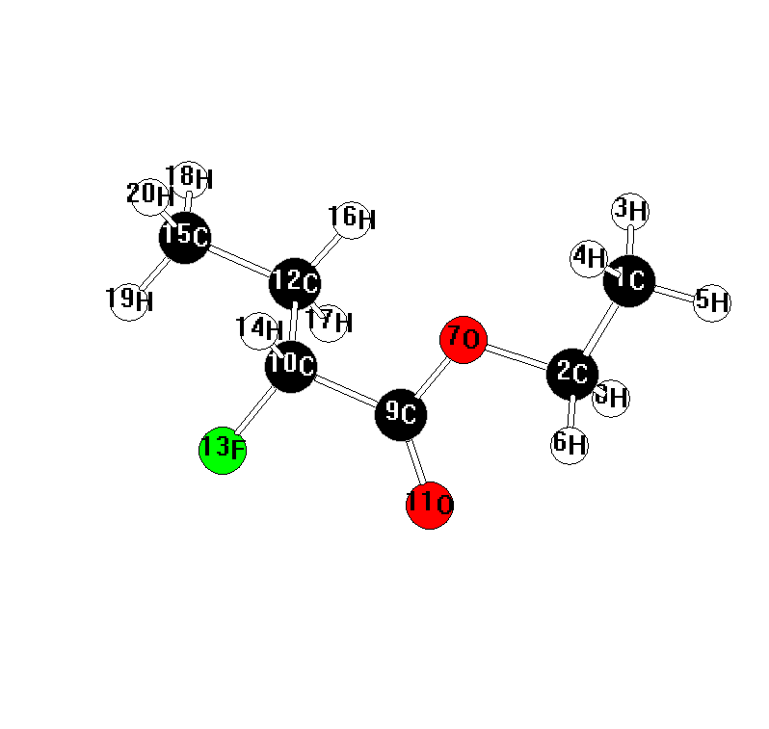
20
C6H11FO2 << C1 >> E(RHF) / 6-31G(d) = -482.787980050 C= 10
C 3.395655 -1.092728 -0.179966
C 2.521690 0.089263 0.169690
H 3.056901 -1.989287 0.343466
H 3.369860 -1.284780 -1.254595
H 4.429521 -0.888906 0.112435
H 2.826885 1.001176 -0.350163
O 1.173691 -0.253011 -0.245972
H 2.515181 0.299808 1.242480
C 0.247439 0.705590 0.000667
C -1.118691 0.202987 -0.431678
O 0.477389 1.782066 0.516136
C -1.633006 -0.886400 0.495842
F -1.999686 1.280880 -0.404341
H -1.060072 -0.159830 -1.465030
C -3.023052 -1.366590 0.092233
H -0.912904 -1.710634 0.486752
H -1.652234 -0.475865 1.512040
H -3.381709 -2.136316 0.780480
H -3.730970 -0.535960 0.104946
H -3.012132 -1.792498 -0.915775

Ethyl 2,4-difluoro-2-ethyl-3-oxobutanoate
NIMAG= 0 ZPE= 134.05158
MP2= -735.29254
2ef24
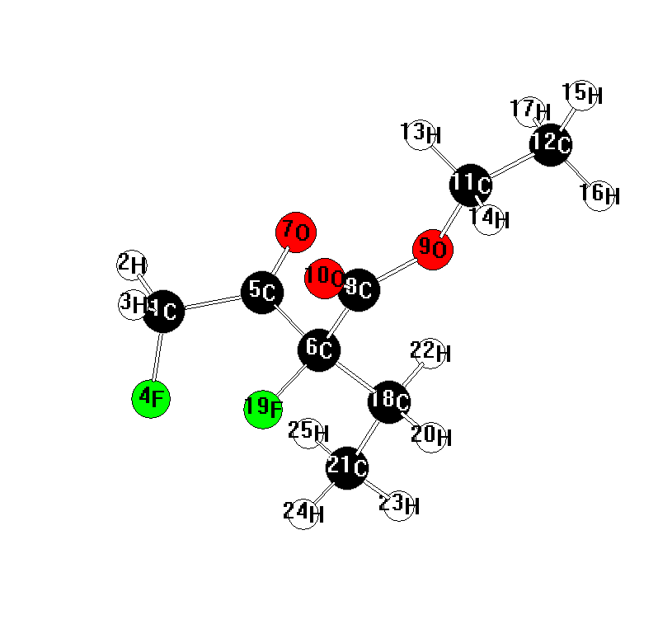
25
C8H12F2O3 << C1 >> E(RHF) / 6-31G(d) = -733.385801439 C= 14
C -2.257657 -1.373924 0.672085
H -2.519055 -1.795033 1.645638
H -2.095657 -2.166092 -0.064595
F -3.296597 -0.553945 0.232044
C -1.004687 -0.529699 0.832024
C -0.470141 0.178048 -0.419150
O -0.428026 -0.414949 1.906798
C 0.915596 -0.405221 -0.710093
O 1.855768 0.208296 0.028951
O 1.109912 -1.326940 -1.481707
C 3.193041 -0.346865 -0.109786
C 4.079878 0.435803 0.829443
H 3.153359 -1.410169 0.140246
H 3.501270 -0.254603 -1.154439
H 5.104170 0.057020 0.772362
H 4.085215 1.494169 0.560759
H 3.727195 0.337065 1.857980
C -0.481807 1.691073 -0.249767
F -1.276570 -0.180615 -1.500569
H -0.004927 2.128291 -1.134215
C -1.891629 2.248312 -0.072662
H 0.149635 1.922425 0.611845
H -1.854008 3.338986 -0.009875
H -2.526278 1.969362 -0.915029
H -2.359221 1.873197 0.841151

Ethyl 4-fluoro-2-ethyl-3-oxobutanoate
NIMAG= 0 ZPE= 139.56169
MP2= -636.28421
2ef4
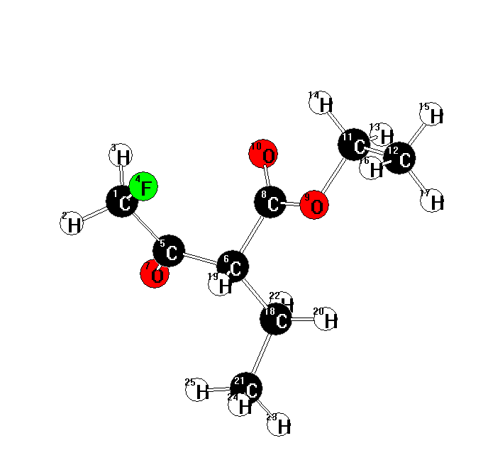
25
C8H13FO3 << C1 >> E(RHF) / 6-31G(d) = -634.548723617 C= 13
C -1.669909 -1.957073 -0.305370
H -2.577303 -2.259371 -0.836356
H -1.525501 -2.592642 0.571825
F -0.574337 -2.109330 -1.159900
C -1.801946 -0.512653 0.146659
C -0.672501 0.429348 -0.232668
O -2.780434 -0.179350 0.803477
C 0.582562 -0.124318 0.409786
O 1.691014 0.323408 -0.214099
O 0.590370 -0.847946 1.395447
C 2.939817 -0.125771 0.375958
C 4.049131 0.476189 -0.454737
H 2.973438 0.202279 1.418286
H 2.955886 -1.218638 0.364930
H 5.019788 0.169305 -0.055186
H 3.977502 0.140093 -1.491167
H 3.994656 1.566709 -0.436229
C -0.926488 1.871444 0.220146
H -0.531634 0.395067 -1.320459
H 0.014505 2.424793 0.131295
C -2.013161 2.560822 -0.600513
H -1.205019 1.857883 1.278742
H -2.142481 3.596012 -0.271927
H -1.747339 2.577105 -1.662340
H -2.970099 2.048547 -0.486483

2’-fluoroethyl 2-fluoro-2-ethyl-3-oxobutanoate
NIMAG= 0 ZPE= 133.92956
MP2= -735.30105
2ef2ch2/mp2
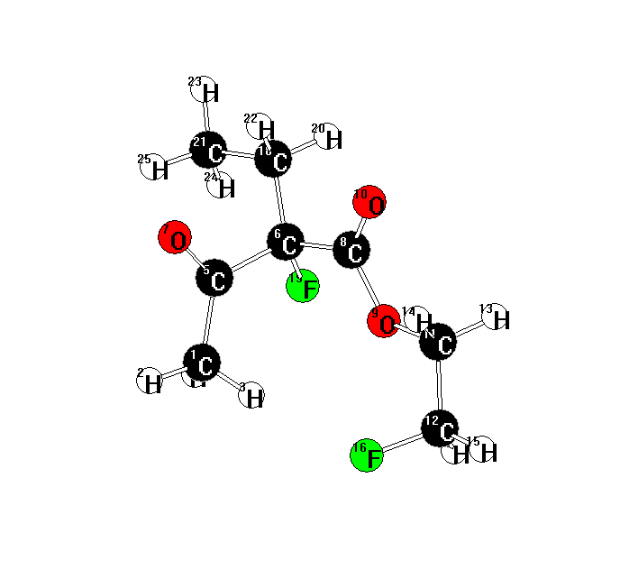
25
C8H12F2O3 << C1 >> E(RHF) / 6-31G(d) = -733.393178157 C= 14
C 0.352578 2.251274 -0.123703
H 0.430794 3.131515 0.515375
H -0.697572 1.970590 -0.254618
H 0.762612 2.459235 -1.114638
C 1.095783 1.115087 0.523175
C 1.102853 -0.230961 -0.233663
O 1.637227 1.182396 1.621198
C -0.123793 -0.986946 0.269259
O -1.220730 -0.605291 -0.420490
O -0.115937 -1.761412 1.208857
C -2.480435 -1.057765 0.117047
C -3.511415 -0.098774 -0.411416
H -2.679340 -2.082130 -0.214825
H -2.441986 -1.039239 1.208465
H -4.513830 -0.397532 -0.088881
F -3.240552 1.173473 0.099204
H -3.474885 -0.043722 -1.502257
C 2.380903 -1.018673 -0.026371
F 0.928410 0.036697 -1.599935
H 2.258512 -1.988528 -0.520750
C 3.605398 -0.288683 -0.569415
H 2.472839 -1.205410 1.045696
H 4.495122 -0.914338 -0.461619
H 3.478424 -0.055540 -1.628837
H 3.782875 0.640666 -0.022525

2’-fluoroethyl 2-ethyl-3-oxobutanoate
NIMAG= 0 ZPE= 139.38494
MP2= -636.28210
2efch2
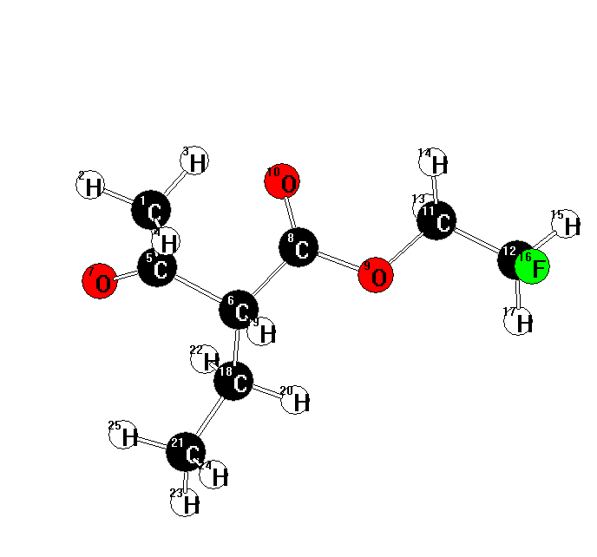
25
C8H13FO3 << C1 >> E(RHF) / 6-31G(d) = -634.547119764 C= 13
C 2.206115 -1.897109 1.106407
H 3.126125 -2.468364 0.976880
H 1.345394 -2.526289 0.863083
H 2.109750 -1.580439 2.150297
C 2.234084 -0.694428 0.195149
C 1.026795 0.245422 0.260030
O 3.170166 -0.468643 -0.564335
C -0.154699 -0.461182 -0.371284
O -1.315063 0.168357 -0.060222
O -0.093557 -1.446360 -1.090871
C -2.489915 -0.417786 -0.659665
C -3.666248 0.384599 -0.179271
H -2.407001 -0.381676 -1.750793
H -2.576697 -1.462647 -0.351646
H -4.578262 0.050311 -0.684929
F -3.824625 0.196884 1.192689
H -3.514143 1.450953 -0.366867
C 1.283919 1.587374 -0.439552
H 0.770358 0.430282 1.312769
H 0.331545 2.120385 -0.523101
C 2.296833 2.448494 0.309335
H 1.644290 1.380685 -1.451916
H 2.433235 3.407522 -0.198582
H 1.955291 2.655401 1.328786
H 3.268065 1.952794 0.358359

Ethyl 2-(2’-fluoroethyl)-3-oxobutanoate
NIMAG= 0 ZPE= 139.35822
MP2= -636.28462
2ef2f

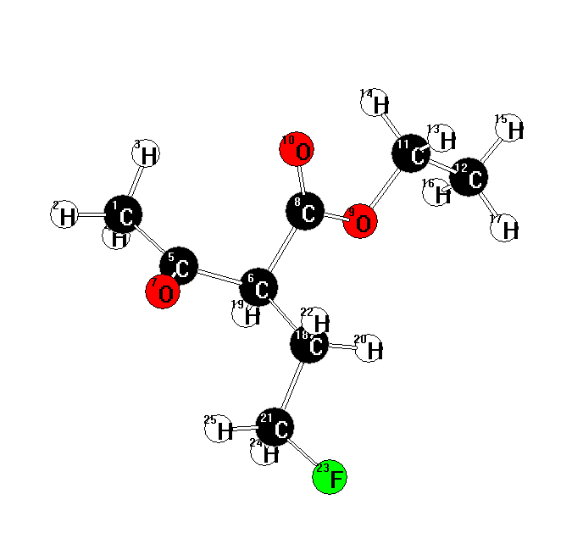
25

C 0.878101 -2.033260 2.030185
H 0.708087 -2.452597 3.022590
H 1.859327 -1.551264 2.002864
H 0.869676 -2.829692 1.279441
C -0.185220 -1.002716 1.739191
C -0.282144 -0.496411 0.298151
O -0.943448 -0.583360 2.607878
C 1.014646 0.198063 -0.071775
O 1.170106 0.241307 -1.413092
O 1.795166 0.694625 0.726481
C 2.340676 0.974783 -1.865164
C 2.319323 0.931262 -3.375223
H 2.285667 1.994635 -1.475625
H 3.232400 0.501318 -1.446011
H 3.183038 1.471187 -3.773115
H 2.360344 -0.100276 -3.731052
H 1.410287 1.398062 -3.760019
C -1.449261 0.475195 0.083795
H -0.394187 -1.361275 -0.371384
H -1.360251 0.930229 -0.907510
C -2.799957 -0.208479 0.165379
H -1.402947 1.269196 0.834384
F -3.785388 0.720743 -0.189963
H -2.861330 -1.047002 -0.538173
H -3.013186 -0.560412 1.175902

Ethyl 2-fluoro-2-(2’-fluoroethyl)-3-oxobutanoate
NIMAG= 0 ZPE= 133.88354
MP2= -735.29959
2ef2f2/mp2
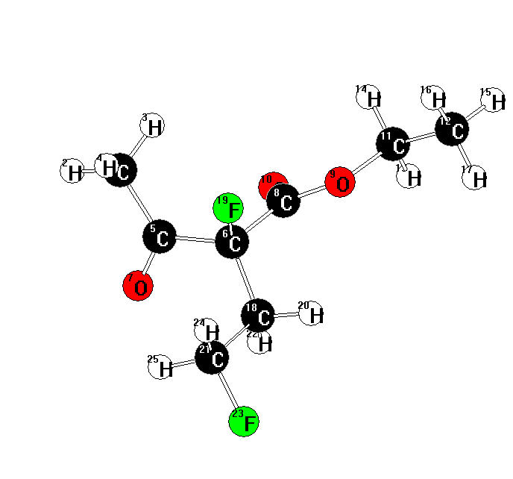
25
C8H12F2O3 << C1 >> E(RHF) / 6-31G(d) = -733.394674189 C= 14
C -1.122426 2.592251 0.877751
H -1.701361 3.447279 0.527835
H -0.062008 2.855277 0.931052
H -1.442418 2.306639 1.883319
C -1.323338 1.442662 -0.071734
C -0.458594 0.196760 0.178792
O -2.113352 1.458765 -1.007802
C 0.930431 0.466937 -0.396914
O 1.844122 -0.346736 0.151355
O 1.147102 1.300478 -1.263113
C 3.195102 -0.175176 -0.364549
C 4.062754 -1.170957 0.367780
H 3.178304 -0.345905 -1.444015
H 3.502914 0.858789 -0.188875
H 5.095864 -1.085296 0.019679
H 4.040092 -0.982253 1.442862
H 3.717120 -2.190168 0.183769
C -1.040566 -1.078523 -0.403667
F -0.327444 0.042474 1.572753
H -0.329028 -1.891412 -0.230700
C -2.372082 -1.454804 0.221423
H -1.166665 -0.945647 -1.481896
F -2.743847 -2.705310 -0.285059
H -2.287031 -1.538387 1.307578
H -3.154826 -0.738336 -0.036666

3-fluoro-2-pentanone
NIMAG= 0 ZPE= 90.39397
MP2= -369.87539
2efdec
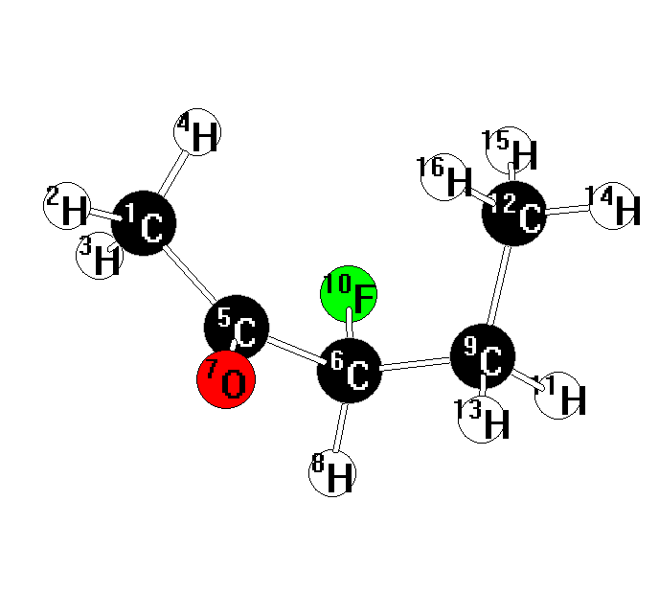
16
C5H9FO << C1 >> E(RHF) / 6-31G(d) = -368.879782655 C= 8
C -1.889513 0.454149 0.752524
H -2.717808 -0.171600 1.085936
H -2.265220 1.335470 0.224874
H -1.319500 0.819277 1.611781
C -0.996657 -0.352319 -0.151125
C 0.211180 0.345887 -0.767593
O -1.192018 -1.534359 -0.420094
H 0.046077 0.420865 -1.850044
C 1.506245 -0.386561 -0.466765
F 0.291546 1.658900 -0.269631
H 2.318282 0.126907 -0.992142
C 1.801247 -0.455901 1.028799
H 1.416412 -1.390898 -0.891975
H 2.769102 -0.930525 1.208980
H 1.827841 0.546865 1.461016
H 1.042035 -1.043120 1.553968

3-fluoro-2,4-pentanedione
NIMAG= 0 ZPE= 77.33347
MP2=-443.72953
Pdfr (pdf = same)

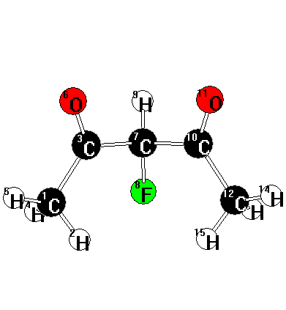
15
C5H7FO2 << C1 >> E(RHF) / 6-31G(d) = -442.564163122 C= 9
C -2.054562 -0.696517 0.731779
H -1.426167 -1.219482 1.459219
C -1.253905 0.342723 -0.008257
H -2.429505 -1.450081 0.033925
H -2.885103 -0.203930 1.237799
O -1.535342 1.532838 -0.043977
C 0.000002 -0.146786 -0.740300
F 0.000022 -1.545310 -0.804561
H -0.000016 0.255989 -1.757936
C 1.253898 0.342719 -0.008257
O 1.535392 1.532825 -0.043988
C 2.054504 -0.696542 0.731813
H 2.429469 -1.450124 0.033991
H 2.885035 -0.203973 1.237867
H 1.426064 -1.219485 1.459230

3-fluoro-2,4-pentanedione – enol form
NIMAG= 0 ZPE= 78.04902
MP2=-443.72688
Pdfenolr
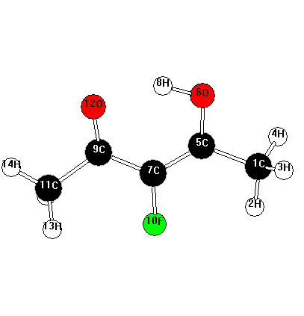
15
C5H7FO2 << C1 >> E(RHF) / 6-31G(d) = -442.558468341 C= 9
C -2.509995 -0.583551 0.000266
H -2.333048 -1.658373 0.000636
H -3.093132 -0.307121 -0.882812
H -3.093061 -0.306486 0.883190
C -1.225074 0.169445 -0.000047
O -1.368443 1.505594 -0.000347
C 0.005789 -0.415449 -0.000151
H -0.448090 1.890202 -0.000783
C 1.259424 0.310124 -0.000301
F 0.096610 -1.783692 -0.000010
C 2.535419 -0.485602 -0.000062
O 1.264452 1.560496 0.000554
H 2.578210 -1.133179 -0.880534
H 3.380512 0.203217 0.000350
H 2.577669 -1.133561 0.880157

1,3-difluoro-2,4-pentanedione
NIMAG= 0 ZPE= 73.09841
MP2=-542.73386
Pd13f2 (pd13f2r = -542.73386)
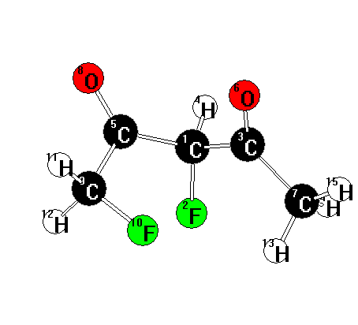
15
C5H6F2O2 << C1 >> E(RHF) / 6-31G(d) = -541.408005896 C= 10
C 0.101390 -0.498889 0.808429
F 0.249971 0.612994 1.643666
C 1.209570 -0.543816 -0.243017
H 0.131197 -1.407275 1.420455
C -1.259726 -0.409138 0.133721
O 1.052345 -1.278901 -1.211535
C 2.423713 0.303834 0.001481
O -2.070152 -1.322842 0.153530
C -1.573106 0.916538 -0.534632
F -0.387778 1.584185 -0.848663
H -2.141148 0.736903 -1.450021
H -2.156550 1.543362 0.147215
H 2.134349 1.357203 -0.026158
H 2.840052 0.103339 0.993016
H 3.163769 0.094626 -0.771392

3,3-difluoro-2,4-pentanedione
NIMAG= 0 ZPE= 72.01799
Mp2= -542.75597
Pd33f2

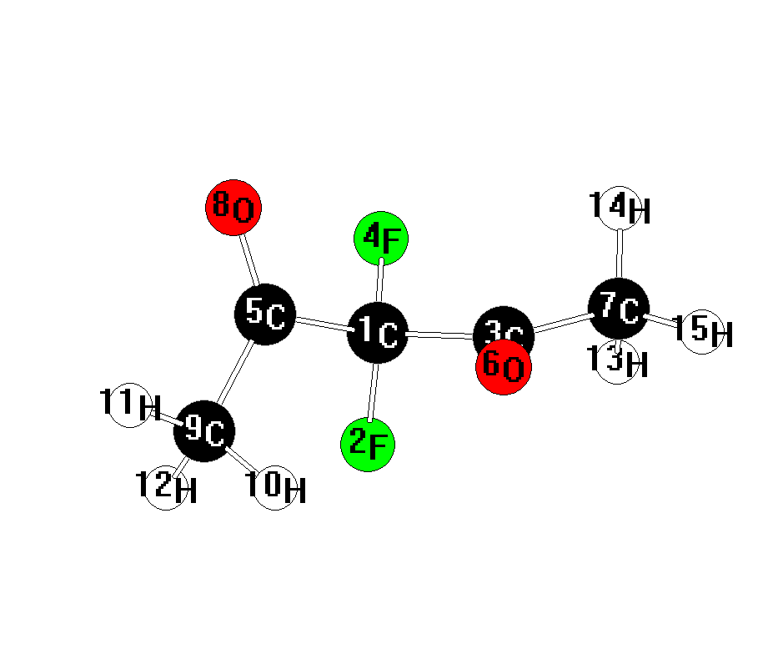
15
C5H6F2O2 << C1 >> E(RHF) / 6-31G(d) = -541.422647044 C= 10
C 0.061208 -0.439389 0.187977
F 0.064435 -0.577524 1.562796
C 1.128864 0.610271 -0.149411
F 0.419149 -1.643477 -0.345408
C -1.340661 -0.045127 -0.305577
O 0.773552 1.765988 -0.352208
C 2.549785 0.128811 -0.161855
O -1.657750 -0.371458 -1.440387
C -2.194843 0.746053 0.639988
H -1.659919 1.654319 0.932235
H -3.129748 1.004122 0.142080
H -2.395268 0.168437 1.546392
H 2.754869 -0.451930 0.742006
H 2.705470 -0.532266 -1.019312
H 3.219800 0.986381 -0.225866

1,3,3-trifluoro-2,4-pentanedione
NIMAG= 0 ZPE= 67.65721
Mp2= -641.76300
Pdf3 (Pdf3r = -641.75923)
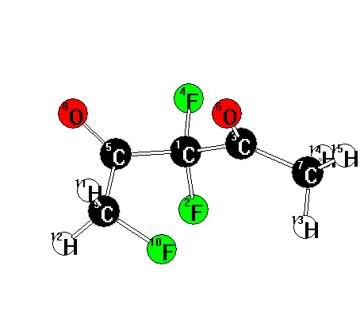

15
C5H5F3O2 << C1 >> E(RHF) / 6-31G(d) = -640.262035852 C= 11
C 0.167198 0.629779 -0.259795
F 0.290089 0.385435 -1.606322
C 1.180251 -0.184437 0.547562
F 0.433342 1.950608 -0.050638
C -1.275625 0.320739 0.158334
O 0.862242 -0.494566 1.690196
C 2.487051 -0.497561 -0.111978
O -2.020413 1.181012 0.593474
C -1.727517 -1.112656 -0.033881
F -0.668489 -1.896533 -0.495683
H -2.077683 -1.509317 0.922412
H -2.538990 -1.145155 -0.766665
H 2.315532 -1.214554 -0.920293
H 2.912349 0.407173 -0.556111
H 3.171537 -0.920486 0.623634

3-fluoro-3-methyl-2,4-pentanedione
NIMAG= 0 ZPE= 95.86769
MP2=-482.90698
Mpdf

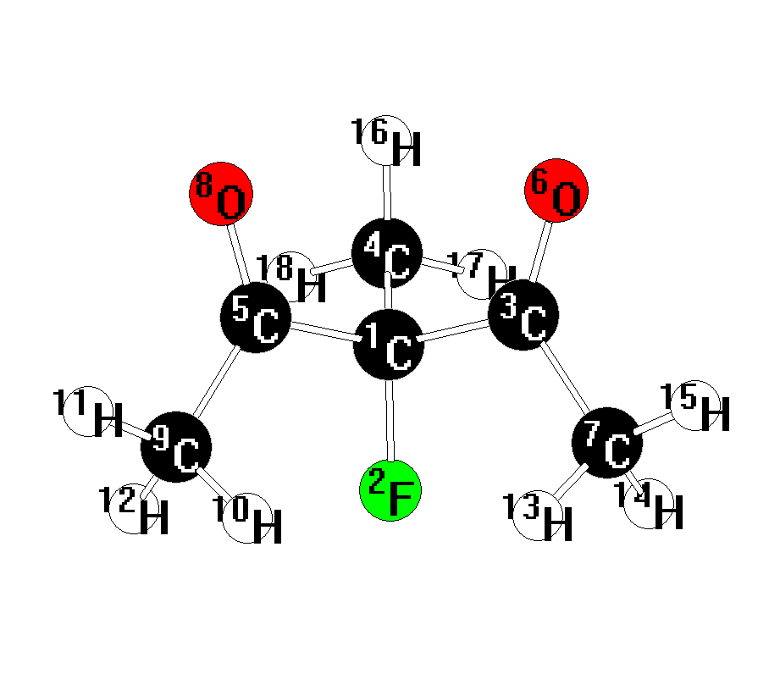
18
C6H9FO2 << C1 >> E(RHF) / 6-31G(d) = -481.606005889 C= 10
C -0.000009 -0.109919 0.526300
F -0.000070 1.086765 1.272644
C 1.246643 -0.114785 -0.370103
C 0.000033 -1.291115 1.473883
C -1.246604 -0.114906 -0.370162
O 1.563769 -1.149408 -0.944394
C 2.011154 1.177941 -0.492122
O -1.563426 -1.149492 -0.944697
C -2.011428 1.177653 -0.491989
H -1.354864 1.983799 -0.832385
H -2.830679 1.035069 -1.197240
H -2.400829 1.476250 0.485139
H 1.354334 1.984014 -0.832183
H 2.400853 1.476491 0.484907
H 2.830205 1.035570 -1.197648
H 0.000083 -2.205594 0.880631
H 0.890644 -1.262210 2.106444
H -0.890593 -1.262293 2.106428

1,3-difluoro-3-methyl-2,4-pentanedione
NIMAG= 0 ZPE= 91.65361
Mp2= -581.91660
mpd13f2 (mpd13f2r = -581.90931)
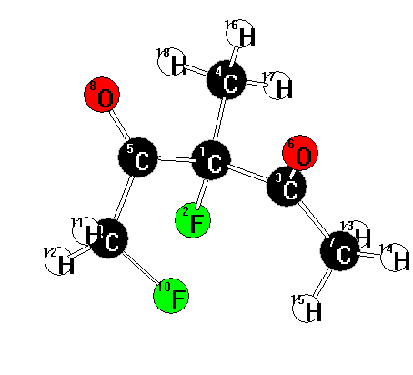
18
C6H8F2O2 << C1 >> E(RHF) / 6-31G(d) = -580.450361017 C= 11
C 0.133353 0.639026 -0.320367
F 0.230026 0.167011 -1.645566
C 1.179555 -0.060548 0.548353
C 0.345199 2.136088 -0.309928
C -1.264814 0.248218 0.156994
O 1.043370 -0.007124 1.766688
C 2.330903 -0.722443 -0.152659
O -2.051891 1.048612 0.640194
C -1.666737 -1.198465 -0.065816
F -0.536555 -2.012023 -0.160513
H -2.283542 -1.535072 0.770470
H -2.232694 -1.278268 -0.999419
H 2.803195 -0.031423 -0.856980
H 3.053463 -1.058760 0.591695
H 1.956128 -1.571805 -0.728342
H 0.258048 2.504850 0.713289
H 1.338651 2.370707 -0.700928
H -0.411074 2.621727 -0.929581

3-fluoro-3-chloro-2,4-pentanedione
NIMAG= 0 ZPE= 70.95820
Mp2= -902.75957
Pdclf (pdclfr = -902.75942)

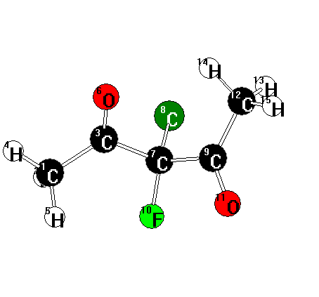

15
C5H6ClFO2 << C1 >> E(RHF) / 6-31G(d) = -901.458823137 C= 14
C 2.476361 -0.723637 0.097528
H 2.841240 0.233347 0.480275
C 1.122175 -0.554953 -0.528622
H 3.160285 -1.122035 -0.652002
H 2.406714 -1.409006 0.946767
O 0.828215 -0.927883 -1.656817
C 0.058662 0.143995 0.343477
Cl 0.005774 1.857499 -0.147790
C -1.324971 -0.540209 0.226751
F 0.456884 0.085564 1.655291
O -1.639928 -1.307900 1.123793
C -2.166808 -0.258875 -0.984078
H -2.560097 0.760554 -0.941717
H -1.563035 -0.352779 -1.889003
H -2.994045 -0.969306 -0.995665

1,3-difluoro-3-chloro-2,4-pentanedione
NIMAG= 0 ZPE= 66.54990
MP2= -1001.76329
Pdclf24r (pdclf24 same)
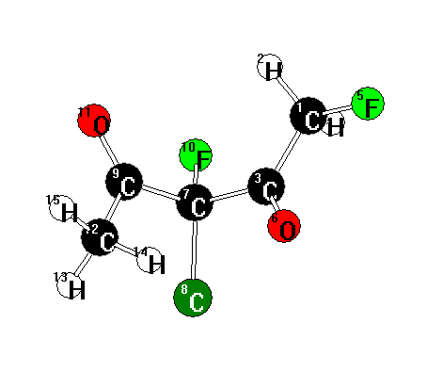
15
C5H5ClF2O2 << C1 >> E(RHF) / 6-31G(d) = -1000.29459221 C= 15
C 2.137687 0.184763 -0.480825
H 1.951276 1.142696 -0.979392
C 0.937411 -0.192628 0.365111
H 2.306648 -0.576889 -1.249018
F 3.247984 0.284370 0.331980
O 0.991711 -0.411259 1.562835
C -0.398891 -0.206693 -0.396919
Cl -1.283689 -1.702039 -0.072651
C -1.212962 1.050610 -0.000098
F -0.120367 -0.132871 -1.743833
O -1.189172 1.999949 -0.768692
C -1.916116 1.033964 1.326111
H -2.829595 0.436797 1.252509
H -1.282812 0.579556 2.091993
H -2.174444 2.059383 1.592238

1,3,5-trifluoro-3-chloro-2,4-pentanedione
NIMAG= 0 ZPE= 62.13694
MP2=-1100.76555
Pdclf3r
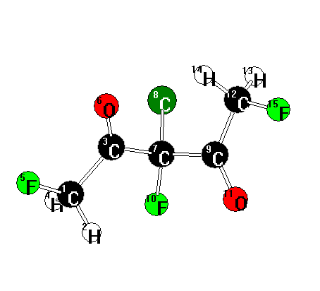

15
C5H4ClF3O2 << C1 >> E(RHF) / 6-31G(d) = -1099.13040138 C= 16
C 2.392773 -0.490399 0.433606
H 2.145810 -1.004638 1.369029
C 1.129474 -0.264201 -0.371176
H 2.856275 0.470938 0.679761
F 3.265800 -1.256568 -0.308821
O 0.940122 -0.719698 -1.485837
C 0.045555 0.568902 0.337427
Cl -0.274530 2.037784 -0.602830
C -1.229482 -0.280924 0.531725
F 0.515333 0.925886 1.579306
O -1.422587 -0.804405 1.613827
C -2.136151 -0.465239 -0.669098
H -2.662335 0.469626 -0.887654
H -1.541950 -0.749267 -1.543631
F -3.057143 -1.452093 -0.378065

